Technical Design Document
Monthly Expense Analyzer
1. Problem Statement
The program collects a list of the user's monthly expenses, prompting for both the type and the amount of each expense. Using Python's reduce method, it analyzes the collected data and displays the total of all expenses along with the highest and lowest expense, each clearly labeled with its type.
2. Inputs and Outputs
Inputs
- Expense type — a text label such as “Rent” or “Groceries.”
- Expense amount — a non-negative number representing the cost.
- Sentinel value — typing “done” for the expense type ends data entry.
Outputs
- Total expense — the sum of all entered amounts.
- Highest expense — the type and amount of the largest expense.
- Lowest expense — the type and amount of the smallest expense.
3. Data Structures
Each expense is stored as a (type, amount) tuple. All expenses are collected into a single list of tuples, which is the structure passed to reduce for analysis.
4. Algorithm / Logic
- Prompt the user repeatedly for an expense type. If the user types “done,” stop collecting.
- For each type, prompt for an amount and validate that it is a non-negative number, re-prompting on bad input.
- Append each valid (type, amount) pair to the expenses list.
- If no expenses were entered, report that there is nothing to analyze and exit.
- Otherwise compute the three results with reduce and lambda functions, then print the labeled summary.

Calculation | reduce / lambda expression
Total | reduce (lambda acc, item: acc + item [1], expenses, 0)
Highest | reduce (lambda a, b: a if a[1] >= b [1] else b, expenses)
Lowest | reduce (lambda a, b: a if a[1] <= b [1] else b, expenses)
The total accumulator starts at 0 and adds each amount. The highest and lowest reductions carry the winning tuple forward by comparing the amount element, so the result retains both the type and the amount for labeling.
5. Functions
- get_expenses() — handles all user prompting, input validation, and returns the list of expense tuples.
- main() — calls get_expenses(), guards against an empty list, runs the reduce calculations with lambdas, and prints the labeled summary.
6. Error Handling
- Non-numeric amounts are caught with a try/except around float(), prompting the user to re-enter.
- Negative amounts are rejected and re-prompted.
- Empty expense types are rejected; an empty expense list is reported instead of crashing on reduce.
7. Test Cases
Input | Expected Result | Purpose
Rent 1200, Groceries 350.50, Utilities 140, Gym 45 | Total $1735.50; Highest Rent $1200.00; Lowest Gym $45.00 | Normal multi-item case
Single expense: Rent 1200 | Total, highest, and lowest all equal Rent $1200.00 | Single-element reduce
“done” entered immediately | Message: nothing to analyze | Empty-list guard
Amount = “abc” then 50 | Re-prompts, then accepts 50 | Invalid-number handling
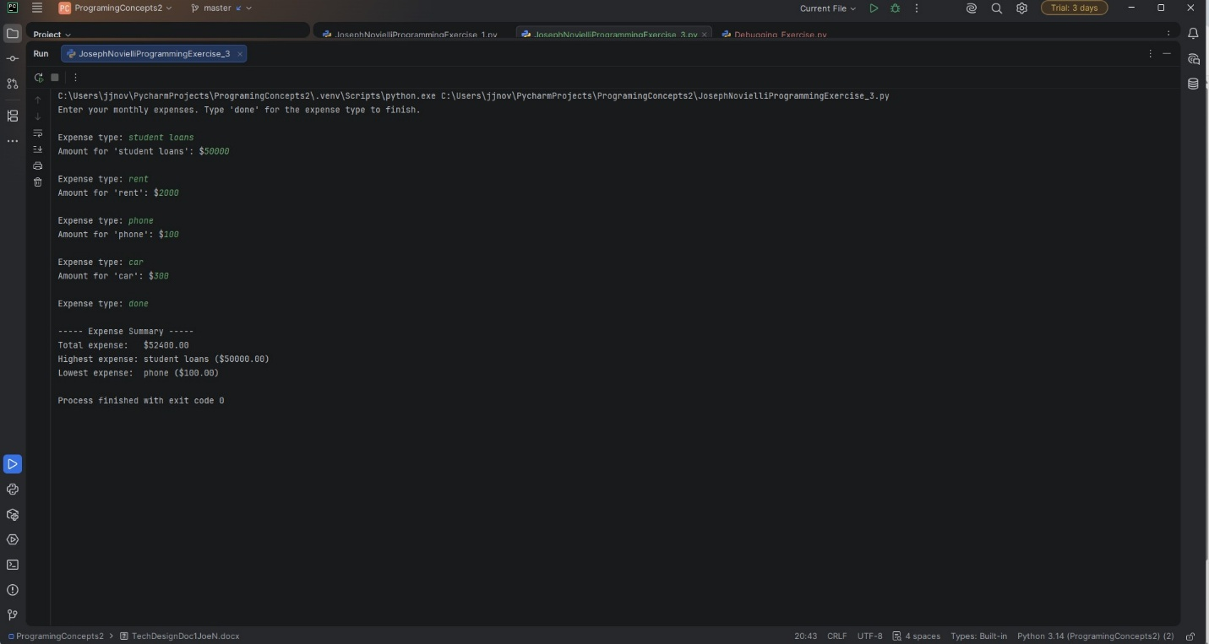

GitHubRepository

