TECHNICAL DESIGN DOCUMENT
Input Validator: Phone Numbers, SSNs, and ZIP Codes
June 27, 2026
Project Name | Input Validator
Language | Python
File | Programming Exercise 6 r.py
Date | June 27, 2026
Purpose | Validate US phone numbers, Social Security Numbers, and ZIP codes using regular expressions

1. Problem Statement
Many applications collect sensitive user data such as phone numbers, Social Security Numbers (SSNs), and ZIP codes. Accepting malformed input can cause downstream processing errors, data integrity problems, or security vulnerabilities. This program addresses that problem by implementing dedicated validation functions using Python regular expressions, and an interactive main function that tests user-supplied values against those validators.

2. Functional Requirements
- Validate US phone numbers in multiple common formats
- Validate US Social Security Numbers with SSA format rules
- Validate US ZIP codes (5-digit and ZIP+4)
- Provide a main () function that accepts user input and prints VALID or NOT VALID
- Run an automated test suite with diverse valid and invalid examples

3. Design Overview
The program is organized into four layers:
- Validation functions — one per data type, each encapsulating a compiled regex
- Test suite (run_tests) — automated pass/fail reporting with 36 test cases
- Interactive driver (main) — prompts the user and prints results
- Entry point guard — calls run_tests then main when executed directly

4. Function Specifications

4.1 validate_phone_number(phone: str) → bool
Signature: validate_phone_number(phone: str) -> bool
Accepts a phone number string and returns True if it matches a recognized US phone format, False otherwise. The function strips surrounding whitespace before matching.
Supported formats:
- (123) 456-7890 — parenthesized area code
- 123-456-7890 — dash-separated
- 123.456.7890 — dot-separated
- 1234567890 — plain 10 digits
- +1 123 456 7890 — with country code
Regex pattern summary: optional +1 country code, followed by an optional area-code group (parenthesized or plain), three middle digits, an optional separator, and four trailing digits.

4.2 validate_ssn(ssn: str) → bool
Signature: validate_ssn(ssn: str) -> bool
Validates a Social Security Number against both structural and SSA-defined rules.
Format rules:
- Format: XXX-XX-XXXX (dashes optional)
- Area (first 3 digits) cannot be 000, 666, or 900–999
- Group (middle 2 digits) cannot be 00
- Serial (last 4 digits) cannot be 0000
These rules are enforced using negative lookahead assertions within the regex pattern, keeping the logic self-contained in a single compiled expression.

4.3 validate_zip_code(zip_code: str) → bool
Signature: validate_zip_code(zip_code: str) -> bool
Validates a US ZIP code in standard 5-digit or ZIP+4 extended format.
Supported formats:
- 12345 — 5-digit base ZIP
- 12345-6789 — ZIP+4 with dash
- 12345 6789 — ZIP+4 with space

4.4 run_tests() → None
Executes 36 predefined test cases (13 phone, 12 SSN, 11 ZIP) covering both valid and invalid inputs. Prints PASS or FAIL for each case and a final summary. Called automatically at program start.

4.5 main() → None
Prompts the user to enter a phone number, SSN, and ZIP code sequentially. Calls the corresponding validator for each and prints whether the input is valid or not.

5. Regular Expression Reference

5.1 Phone Number
^(\+1[\s\-]?)?(\(\d{3}\)[\s\-]?|\d{3}[\s\-\.]?)\d{3}[\s\-\.]?\d{4}$

5.2 Social Security Number
^(?!000)(?!666)(?!9\d{2})\d{3}[-]?(?!00)\d{2}[-]?(?!0000)\d{4}$

5.3 ZIP Code
^\d{5}([\s\-]\d{4})?$

6. Test Cases

6.1 Phone Number Test Cases
Input | Expected | Description
(123) 456-7890 | VALID | Standard format with parentheses
123-456-7890 | VALID | Dash-separated
123.456.7890 | VALID | Dot-separated
1234567890 | VALID | 10 digits, no separators
+1 123 456 7890 | VALID | Country code with spaces
+11234567890 | VALID | Country code, no separators
(123)456-7890 | VALID | Parentheses, no space before digits
123 456 7890 | VALID | Space-separated
12345 | INVALID | Too short — only 5 digits
(123) 456-78901 | INVALID | Too many digits
abc-def-ghij | INVALID | Non-numeric characters
(12) 456-7890 | INVALID | Area code too short
(empty) | INVALID | Empty string

6.2 SSN Test Cases
Input | Expected | Description
123-45-6789 | VALID | Standard dashed format
123456789 | VALID | 9 digits, no dashes
001-45-6789 | VALID | Low area number (valid)
000-45-6789 | INVALID | Area = 000 (SSA rule)
666-45-6789 | INVALID | Area = 666 (SSA rule)
900-45-6789 | INVALID | Area 900-999 (SSA rule)
123-00-6789 | INVALID | Group = 00 (SSA rule)
123-45-0000 | INVALID | Serial = 0000 (SSA rule)
12-345-6789 | INVALID | Wrong grouping
123-456-789 | INVALID | Wrong grouping
abc-de-fghi | INVALID | Non-numeric
(empty) | INVALID | Empty string

6.3 ZIP Code Test Cases
Input | Expected | Description
12345 | VALID | Standard 5-digit ZIP
12345-6789 | VALID | ZIP+4 with dash
12345 6789 | VALID | ZIP+4 with space
00501 | VALID | Lowest valid ZIP (Holtsville, NY)
99950 | VALID | High ZIP (Ketchikan, AK)
1234 | INVALID | Only 4 digits
123456 | INVALID | 6 digits, no extension separator
12345-678 | INVALID | Extension too short (3 digits)
12345-67890 | INVALID | Extension too long (5 digits)
ABCDE | INVALID | Letters instead of digits
(empty) | INVALID | Empty string

7. Error Handling
All three validator functions handle edge cases gracefully:
- Empty strings — the regex anchors (^ and $) prevent a match, returning False
- Whitespace — strip() is called before matching to ignore leading/trailing spaces
- None or non-string — callers are expected to pass strings; functions do not raise exceptions for valid string input including empty strings

8. Sample Program Output

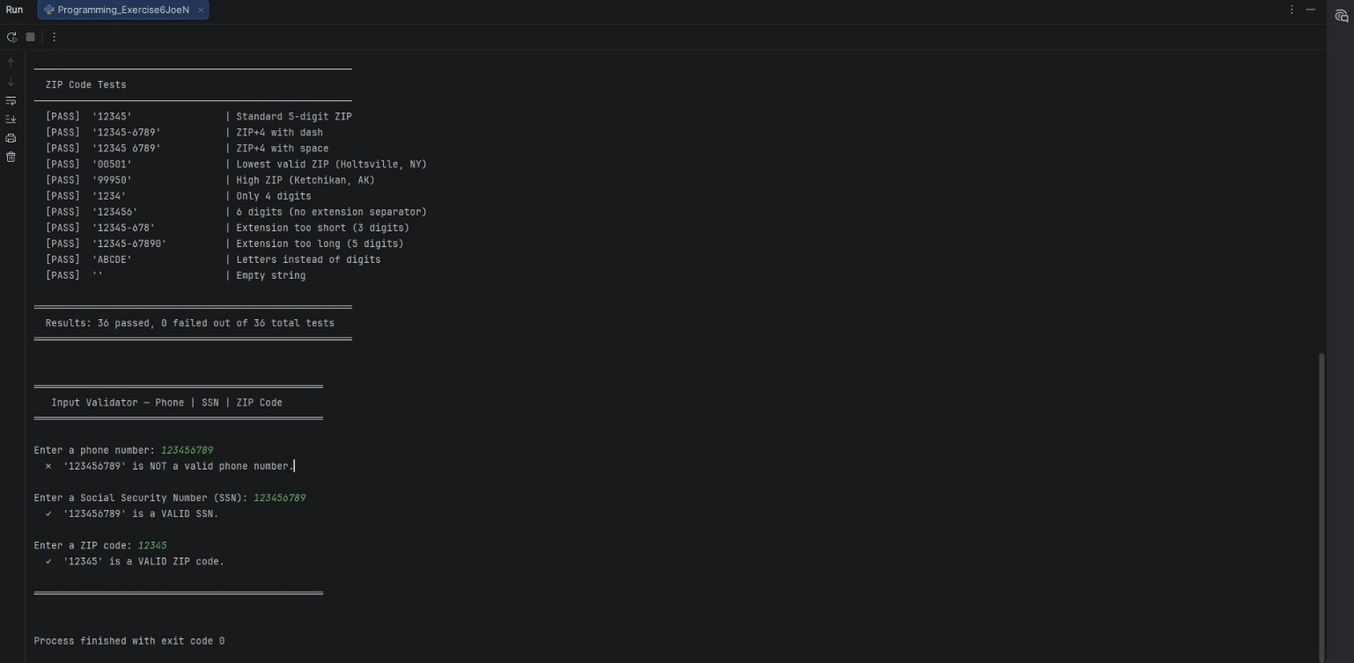

9. Tools and Dependencies
Language | Python 3.x (no third-party packages required)
Module | re (Python standard library — regular expressions)
IDE | Any Python-compatible IDE or text editor
Testing | Inline test suite via run_tests() function

