The Taylor Family Case Study – FIN 540

This case study serves as the basis for the six-week Private Wealth Planning Project in FIN 540. Students will be expected to extract and interpret key financial planning information, including client goals, risk preferences, investment income needs and constraints, and to develop an integrated financial strategy based on their analysis. Students should pay careful attention to behavioral cues and lifestyle commentary when assessing the Taylors’ risk tolerance and investment objectives.

Client Background
Mark and Lisa Taylor, ages 65 and 62, respectively, reside in a suburban neighborhood of Jacksonville, Florida. Mark recently retired from a long and successful career as an optometrist. Lisa, a lifelong educator and art enthusiast, continues to teach part-time at a local university. Although she finds her work fulfilling, she is considering full retirement within the next 1 to 2 years. They have been married for over 35 years, have two financially independent adult children, and three grandchildren (ages 3, 5, and 6)
The Taylors are now focused on transitioning into retirement with a sense of financial security. They hope to enjoy their later years while leaving a meaningful legacy for their family and supporting philanthropic interests that are personally significant to them. The couple is health-conscious, active in their community, and increasingly interested in aligning their financial decisions with their long-term values and lifestyle.
They have no health concerns and have no family history of major medical problems.

Financial Picture
Mark and Lisa maintain liquid reserves of approximately $90,000 in checking and savings accounts for day-to-day expenses and emergencies. Their investable assets are held across several account types, distributed as follows:
- Joint taxable brokerage account: $1,012,051
- Traditional IRAs: $1,197,000 (Mark) and $546,000 (Lisa)
- Roth IRAs: $132,000 (Mark) and $82,000 (Lisa)
An Excel spreadsheet showing holdings and cost basis as of April 20, 2026, is provided.

Mark receives a defined benefit pension, joint and survivor, of $55,000 pre-tax per year (not indexed for inflation). Lisa earns approximately $24,000 pre-tax from part-time teaching. While Mark just turned 65 and is now covered by Medicare, they have chosen to delay claiming Social Security benefits until Mark’s age 70 to maximize the payout. Combined, their future Social Security benefits are projected to be about $76,000 annually at Mark’s age 70. Lisa intends to teach for three more years and then fully retire.

Financial Goals and Lifestyle
The Taylors estimate their annual post-tax spending needs at $180,000, which includes housing, healthcare premiums, charitable donations, and personal lifestyle expenses such as modest vacations and occasional cultural outings. They expect their spending to grow with inflation at approximately 2.5% per year.
The couple has expressed an interest in updating their home, a renovation they estimate will cost $100,000 within the next 12 months. Longer term, they are committed to helping fund their grandchildren’s future college expenses by investing in 539 plans for them—$10,000 per year per grandchild for the next 3 years.
Mark is interested in establishing a donor-advised fund to support charitable giving during their lifetime. Lisa is particularly focused on financial stability and ensuring resources are available to help support future generations. They both agree on the importance of leaving a financial legacy, though their individual preferences suggest different risk attitudes that may need to be balanced in their investment strategy.

Investment Preferences and Attitudes
Historically, the Taylors have favored conservative investments. Their taxable portfolio consists largely of well-known individual stocks and bond funds. Their IRA holdings are diversified across stock, bond, and balanced mutual funds. While neither Taylor has worked with a professional advisor previously, they are both open to receiving structured, objective advice.
They have expressed curiosity about environmental, social, and governance (ESG) investing, but lack clarity on how to effectively incorporate it into their portfolio. Mark describes himself as “comfortable with a little market noise” and emphasizes the need for long-term growth, particularly within tax-advantaged accounts. Lisa, on the other hand, recalls feeling uneasy during periods of market volatility in 2008 and again in 2020, preferring steadier, more predictable outcomes—even if returns are lower.

Tax Considerations
Mark and Lisa file jointly and fall into a combined federal and state marginal bracket of approximately 24% for ordinary income and 15% for qualified dividends and capital gains. They are aware of Roth conversion strategies and the importance of managing required minimum distributions (RMDs) from their Traditional IRAs beginning at age 73. While they have not implemented any specific tax strategy, they are eager to reduce long-term tax liability and enhance portfolio efficiency.

Risk Tolerance Questionnaire
Mark and Lisa Taylor Responses in Red
Risk Tolerance Questionnaire – Understanding Your Comfort with Risk
All investing involves risk. But choosing not to invest also carries a risk - specifically, inflation risk, meaning your purchasing power may decline over time. Historically, investments with higher long-term returns (such as stocks) also experience greater short-term fluctuations. A well-designed investment plan balances these risks with your financial goals, time horizon, and personal comfort level.

This questionnaire helps us understand:
- Your emotional comfort with market ups and downs (risk tolerance)
- Your practical ability to take risk (risk capacity)
- Your preferences regarding portfolio allocation

1. Your Subjective Comfort with Risk
A. Compared with others your age, how comfortable are you with investment risk?
- Much less comfortable
- Slightly less comfortable
- About average
- Slightly more comfortable
- Much more comfortable

B. If you had to rate your comfort level with investment risk on a scale from 0 to 100—
50 = average comfort for someone your age
Higher = more comfortable; lower = less comfortable
Your number: _____65___

2. Understanding Long-Term Investment Behavior
Below is a summary of expected long-term annual returns for major investment types. These ranges illustrate how much returns can vary from year to year—even when long-term averages look attractive.
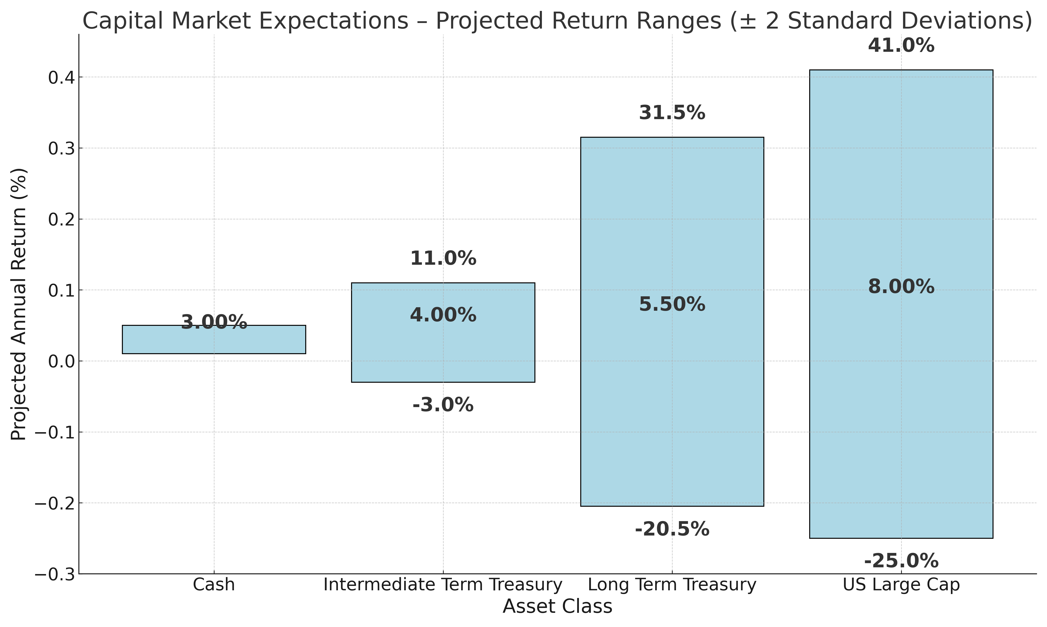
Stocks are expected to provide higher average returns of about 8% compounded annually but can fluctuate widely. Money market funds and short to intermediate term bonds offer lower returns with more stability. Long bonds are expected to provide compounded returns and volatility of less than stocks. Most investors should hold a diversified mix of different investment types.

3. Selecting a Long-Term Asset Allocation
The following five portfolios are examples of including several different investment types in a portfolio in varying proportions
 | A | B | C | D | E
Stocks | 45% | 55% | 65% | 75% | 85%
Bonds | 50% | 40% | 30% | 20% | 10%
Alternatives | 5% | 5% | 5% | 5% | 5%
Total | 100% | 100% | 100% | 100% | 100%
Expected Return | 6.00% | 6.25% | 6.75% | 7.00% | 7.50%
Annualized Volatility | 8.00% | 9.50% | 11.00% | 13.00% | 15.00%

Notice that as the proportion of stocks in a portfolio increases both the expected return and volatility increase. The graphic below shows the potential range of annual returns for these different portfolios. The long-term average expected return is depicted in the middle of the bar while the range of annual returns is depicted by the length of the bar.

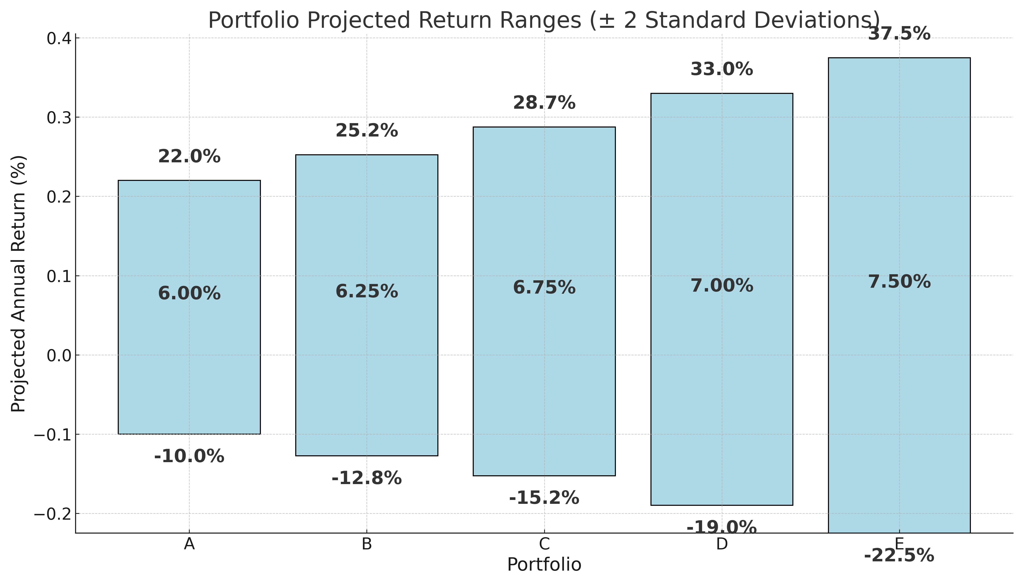
Which of these allocations are the most comfortable to you, A, B, C, D or E? You may select more than one or suggest something in between. ___C/D______

4. Evaluating Your Reaction to Market Declines
Extreme situations have been known to occur such as 2008 when stocks, bonds and other investments all declined at once. Even a diversified portfolio dropped in value by about 25% during 2008. Here is the range of outcomes for different allocations:
Allocation | Loss
20% Stocks/80% Bonds | -3%
30% Stocks/70% Bonds | -8%
40% Stocks/60% Bonds | -12%
50% Stocks/50% Bonds | -16%
60% Stocks/40% Bonds | -20%
70% Stocks/30% Bonds | -24%
80% Stocks/20% Bonds | -29%
90% Stocks/10% Bonds | -33%
100% Stocks/0% Bonds | -37%

What is your maximum comfortable one-year loss (%)?: ___25%_____

5. Additional Factors Affecting Risk Capacity
A. When do you expect to begin withdrawing funds?
- <3 years
- 3–7 years
- 8–15 years
- >15 years

B. How stable is your current income?
- Very stable
- Mostly stable
- Somewhat uncertain
- Highly uncertain

C. Emergency savings?
- >6 months
- 3–6 months
- <3 months
- None

6. Final Thoughts
Additional information you would like us to consider:
__________________________________________________________
__________________________________________________________
__________________________________________________________
__________________________________________________________
__________________________________________________________
__________________________________________________________

