FIN 540 — Portfolio Management and Wealth Planning
Case Study Week 3: Asset Allocation

Course Case Study Overview
Throughout this course, you will be working on a case study for a hypothetical client family, Mark and Lisa Taylor. Each week, for Weeks 1 through 6, you will submit your recommended solution to a portion of the case study.

Weekly Assignment Schedule
Week | Deliverable
Week 1 | Elements of an Investment Policy Statement (IPS) for the Taylor Family
Week 2 | Capital Market Expectations, including historical and projected returns, volatility, and correlations
Week 3 | Recommended asset allocation, including sub-asset classes, for the Taylor Family
Week 4 | Recommended investments within each sub-asset class for the Taylor Family
Week 5 | Client communication of your recommendations to the Taylor Family
Week 6 | Implementation plan for the Taylor Family, including asset location

Week 3 Assignment Overview
This week you will build an efficient frontier from your capital market expectations and develop a recommended asset allocation for the Taylor family. Your recommendation will draw on the Investment Policy Statement from Week 1, the capital market expectations from Week 2, and your reading assignments.

General Guidance
- Copy your Week 2 projected CMEs into the Part A table below. You may refine them based on instructor feedback or further deliberation — but state any changes you made relative to your Week 2 submission.
- For correlations (Part B), use historical correlations already in Portfolio Visualizer which computes these from ETF proxies for each asset class.
- Portfolio Visualizer’s Efficient Frontier tool (https://www.portfoliovisualizer.com/efficient-frontier) uses mean-variance (Markowitz) optimization to plot the set of portfolios that maximize expected return at each level of risk, given your inputs.
- When you select a point on the frontier (Part C), tie your choice explicitly to the return objective and risk tolerance you developed in the IPS (Week 1). The frontier is the menu; the IPS tells you where to order from.
- Part D is your recommended allocation — not necessarily the same as your Part C frontier point. Real-world recommendations often deviate from pure mean-variance optima due to sub-asset-class judgment, client preferences, behavioral considerations, and practical constraints. Where your Part D allocation differs from Part C, explain why.
- You may use this Word file to submit your answers. If you do, please rename the file to include your name.

Part A — Capital Market Expectations (copied from Week 2)
Enter your projected CMEs below. These inputs will drive the efficient frontier in Part C.
Asset Class | Projected Annualized Return | Projected Standard Deviation
Short-Term U.S. Treasuries | 3.3%, | 3.1%
Intermediate-Term U.S. Treasuries | 5.2% | 5.7%
Long-Term U.S. Treasuries | 5.5% | 9.9%
U.S. Corporate Bonds (intermediate to long term) | 6% | 8.5%
International Bonds | 3.8% | 8.5%
Large-Cap U.S. Stocks | 10.3% | 20%
Mid-Cap U.S. Stocks | 10.7% | 17.9%
Small-Cap U.S. Stocks | 12% | 31.6%
International Developed-Market Stocks | 8.5% | 17%
Emerging-Markets Stocks | 8.5% | 23%
Alternatives — Real Estate | 11.4% | 15.5%
Alternatives — Commodities | 5.8% | 20%

Part B — Correlations Review
Using the provided Portfolio Visualizer correlation file provided (which computes correlations from monthly returns of ETFs representing each asset class), choose one equity ETF, one bond ETF, and one alternative ETF from the table. Discuss the pairwise correlations Portfolio Visualizer reports among these three ETFs. Comment on whether you believe the reported correlations are reasonable, or whether any should be adjusted based on your forward-looking expectations from Week 2.
ETFs selected (equity / bond / alternative) and pairwise correlations observed
Hey! I am going to go with IVV / AGG / VNQ, since it keeps me consistent with the proxies I used in week 2. So IVV goes with equity/stocks, while AGG goes with Bonds, and VNQ goes with alternatives/Real estate. Over the monthly 2008–2026 window, the excel spreadsheet reports IVV–AGG at 0.26, IVV–VNQ at 0.75, and AGG–VNQ at 0.44. The stocks–bonds figure is low, which is what makes bonds the diversifier in the portfolio. Stocks–REITs is high at 0.75 because VNQ holds publicly traded REITs that trade on equity exchanges and react to the same risk-on/risk-off moves as stocks.

Assessment of reasonableness — do you accept these correlations as inputs to the optimization, or would you adjust them? Justify.
I accept these as my optimizer inputs. They're computed consistently from monthly ETF returns over a long window and adjusting them by hand would just add my own subjective/bias error on top. (plus, I trust the professors excel) They also make sense- REITs trade like stocks, so a high 0.75 makes sense, and real estate rate sensitivity supports a moderate bond-REIT link. The one I'd flag is stocks-bonds: 0.26 blends two very different regimes, and forward-looking I think there's a real chance we stay in an inflation regime where stocks and bonds stay positively correlated, which would shrink the diversification benefit bonds are supposed to provide. So I accept 0.26 as the base case but would stress-test the allocation against a higher figure (~0.35-0.40). Bonds are still great but I want to be consistent with my Week 2 view that historical correlations are useful reference points but shouldn't be treated as permanent.

Part C — Efficient Frontier and Point Selection
Using your CMEs from Part A, create a forecast efficient frontier in the free version of Portfolio Visualizer. Consider whether to apply any allocation constraints (e.g., minimum or maximum weights on specific asset classes). Paste a screenshot of your frontier in the placeholder below. Then select a point on the frontier that is consistent with the Taylors’ return objective and risk tolerance from their IPS, and describe the allocation at that point.
Constraints applied to the optimization, and rationale (if no constraints were applied, state this and justify)
I did some constraints on this because of diversification. My caps: short-term Treasuries ≤10% and long-term Treasuries ≤10%, emerging markets ≤8% and commodities ≤5% real estate ≤10% (it behaves like equity per my Part B correlations, so I avoid double-counting equity risk), and per-sleeve equity caps (large ≤40%, mid ≤25%, small ≤15%, international ≤25%) to force some diversification. Also, I didn’t use historical returns and volatility, I put those in myself from Week 2 numbers.

Efficient Frontier (screenshot from Portfolio Visualizer)
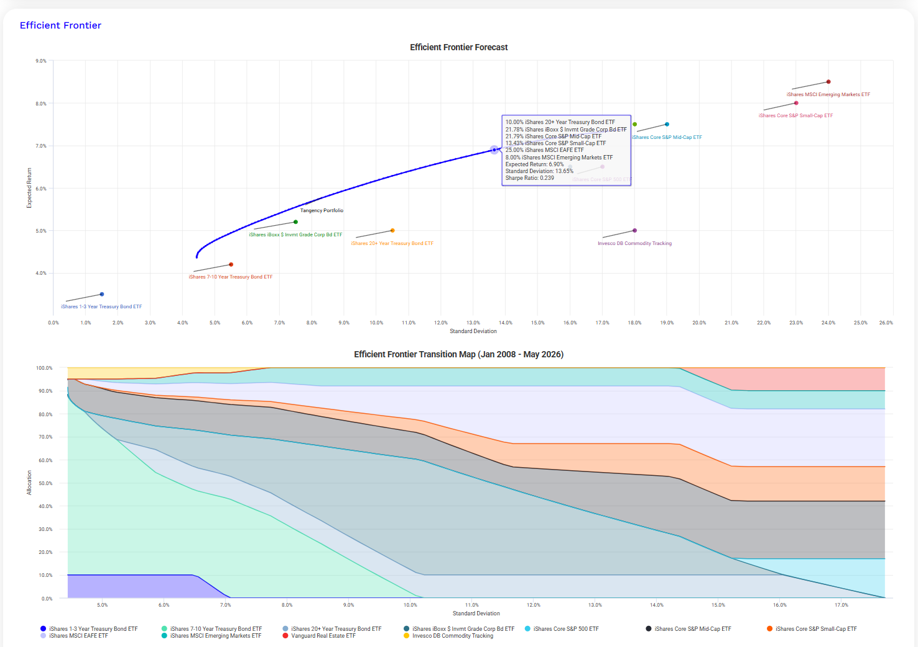

I will also paste it at the bottom of this assignment because that’s really small.

— Insert efficient frontier screenshot here —

Commentary on the frontier — does it look appropriate to use for the Taylors? Are there features that concern you or give you confidence?
This does look appropriate to use in the Taylor family case. This concerns me a little bit just because the graph doesn’t show very high returns, which is to be expected if bonds and safer assets are mixed in, with lower volatility. I uncapped the small cap and the medium cap stock ETFs, and it had a lot more range on the return investment- but it carried a lot more deviation and risk, so I capped them at the caps I defined above.

Selected point on the frontier for the Taylors — cite the expected return, standard deviation, and brief allocation summary. Explain why this point matches their IPS return objective and risk tolerance.
I selected the 6.9% return point on the graph. 6.9% was their IPS return objective. This is around ~66% equity / ~32% fixed income. The Family’s ability to bear risk is high ($2.97M against a ~2.6% steady-state withdrawal, a ~33-year horizon, and a ~$131k pension + Social Security income floor), so they can absorb a 13.65% vol portfolio (which is the volatility with 6.9% average return). Also, they have stated that the max they can lose in one year is 25%, and this stays within that.

Part D — Recommended Allocation for the Taylors
Translate your Part C frontier point into a recommended asset allocation using your professional judgment. You are not limited to the exact mix produced by the optimizer — you may adjust for sub-asset-class reasoning, client preferences (including any ESG considerations), behavioral factors, or practical constraints. You do not need to include every asset class; enter 0% for any asset class you choose to exclude. Where your recommendation differs from your Part C frontier point, explain why.
Asset Class | Recommended Allocation (%)
Short-Term U.S. Treasuries | 2%
Intermediate-Term U.S. Treasuries | 10%
Long-Term U.S. Treasuries | 5%
U.S. Corporate Bonds (intermediate to long term) | 12%
International Bonds | 0%
Large-Cap U.S. Stocks | 25%
Mid-Cap U.S. Stocks | 12%
Small-Cap U.S. Stocks | 8%
International Developed-Market Stocks | 15%
Emerging-Markets Stocks | 6%
Alternatives — Real Estate | 5%
Alternatives — Commodities | 0%
TOTAL (must equal 100%) | 100%

Subtotals and Expected Return
Metric | Value
Fixed Income Subtotal | 29%
Equities Subtotal | 66%
Alternatives Subtotal | 5%
Total (must equal 100%)
Expected Portfolio Return (from Part A CMEs) | 6.5%

Justification of the recommended allocation — address (a) how it meets the Taylors’ return objective, (b) how it fits their risk tolerance, and (c) why and how it differs from the Part C frontier point, if it does.
This portfolio has an expected return of about 6.5% from my Part A CMEs. This sits just below the 6.9% required return I got in Week 1, but that figure carried a deliberate conservatism buffer. This is what I am thinking: at ~6.5% nominal, and 2.5% inflation, the portfolio earns roughly 4% real against a steady-state withdrawal of only ~2.6%, so once Social Security begins, it grows while funding the $180k lifestyle, the renovation, the 529s, and the legacy. The plan is funded with margin.

For Risk tolerance- At 66% equity, the allocation falls inside the 65–75% (C/D) band the Taylors flagged as comfortable, and the 66/29/5 split maps almost exactly to model portfolio C. Its volatility (~12.9%) is actually slightly lower than my Part C frontier point, and a roughly 1-in-100 bad year is about 23.5%, well inside their stated 25% maximum-loss limit. The 29% bond sleeve, weighted toward intermediate Treasuries, gives Lisa downside protection and covers near-term spending, balancing her stability preference against Mark's appetite for growth.

For differences from the Part C frontier point, I made five changes: I added a 25% large-cap U.S. core (the optimizer zeroed it only because my CMEs assigned large-cap the lowest equity return, but I think it’s essential to include); I trimmed the optimizer's constraint-driven overweight’s in international developed fund from 25% to 15%, and mid-cap stocks from 22% to 12%; I decreased emerging markets (8%→6%) for Lisa's comfort; (since its pretty risky). I added a 5% real-estate position for income and inflation protection given Mark's non-indexed pension; and I laddered the bond position for liquidity and lower duration risk. The net effect is a slightly lower expected return (6.5% vs. 6.9%) in exchange for slightly lower volatility, better diversification, and a portfolio that is actually implementable and behaviorally appropriate for these clients. With large cap added in, the portfolio might perform better than the 6.5% figure, but overall this portfolio is better than the 6.9% one just because of the lower risk level.



