How to emulate/send Notifications to a user

Notifications must be posted to the UrbanAirship API, which is the hub for messages and other things.

To send a notification to a device, you must get the Channel ID, which can be found under the Settings page in the deployed Mobile App. This can only be done on a device, not through Ionic Serve. See the accompanying documentation in the docs folder to be able to build and deploy an API to a locally connected mobile device (via USB) or via the Emulator.

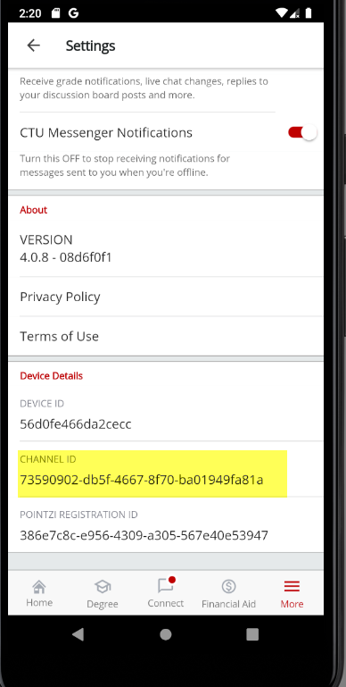

Once you have obtained the Channel ID, you can use the below API Calls to register a push notification that will be forwarded to the Channel ID owned by a particular device (Real or emulated).