Step 10: Customer Churn Deployment Architecture
Machine Learning Engineering Bootcamp Capstone
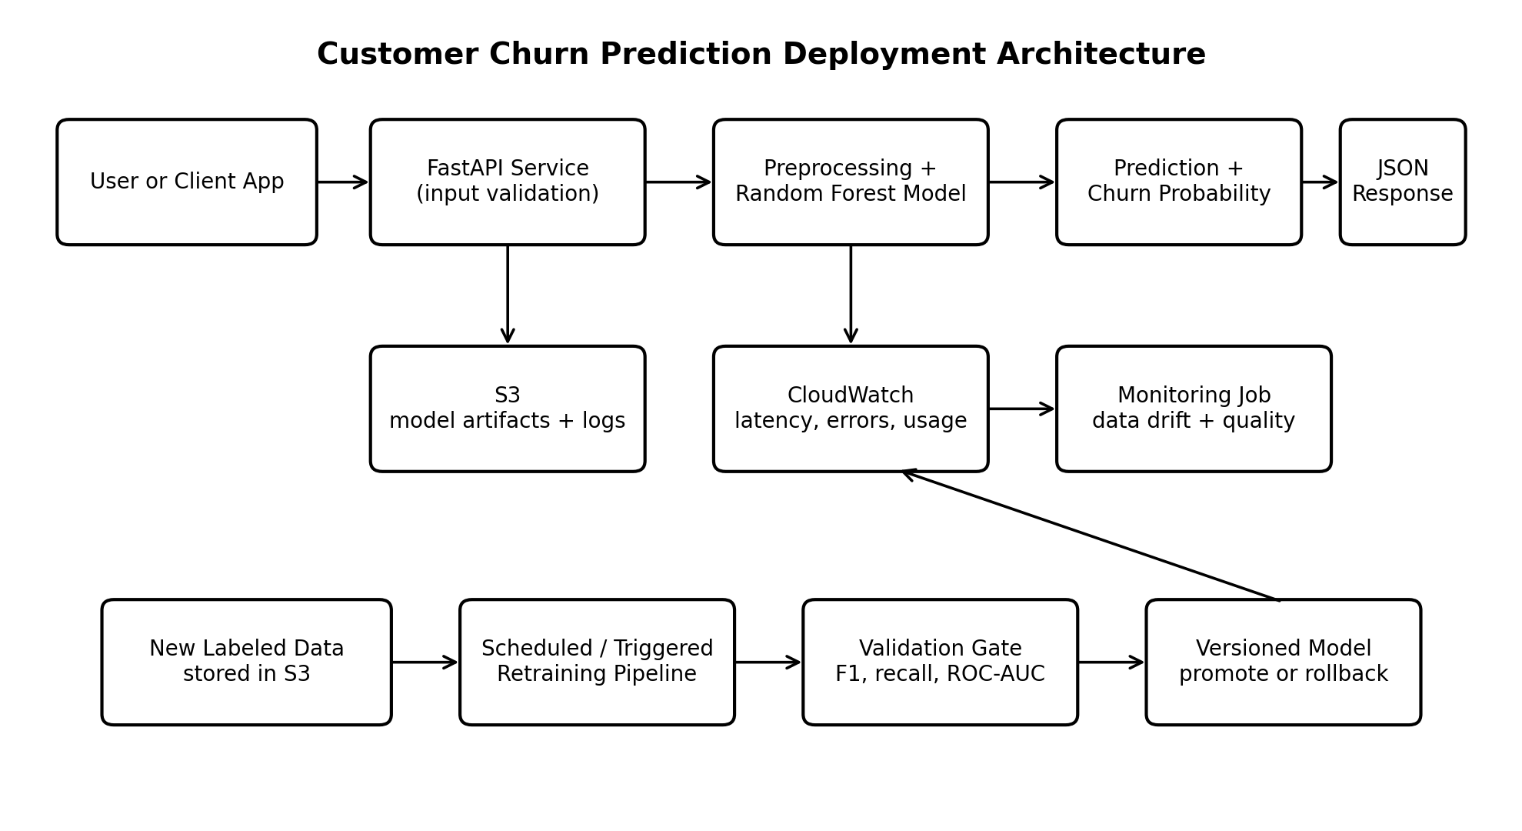
Design overview. The trained Random Forest is exposed through a FastAPI REST API packaged in Docker and hosted on AWS App Runner. A JSON request contains the eight training features. FastAPI validates the request, applies the expected feature order, loads the versioned model, and returns the predicted class, churn probability, model version, and timestamp.

Major Components, Storage, and Data Flow
Client and API: A user interface or another application sends JSON to FastAPI. Pydantic rejects missing, invalid, or out-of-range values.
Inference service: The container loads the joblib model at startup. A health endpoint confirms that the service and model are available.
Storage: Versioned model artifacts, metadata, monitoring baselines, and future labeled records are stored in S3. Logs and system metrics are sent to CloudWatch.
Monitoring: CloudWatch tracks request volume, latency, HTTP errors, container health, and prediction distributions. A scheduled job compares recent data with the training baseline.

Model Lifecycle and Redeployment
- Retrain quarterly, or earlier when drift, lower F1/recall, or enough new labeled data triggers review.
- Use the same feature schema plus confirmed outcomes, stored as dated and partitioned S3 files.
- Evaluate candidates on F1, recall, ROC-AUC, calibration, and basic fairness checks.
- Deploy approved models to staging, run smoke tests, then promote them. Keep the prior artifact for rollback.
- Store the model version, metrics, parameters, training date, dataset version, and feature list with every artifact.

Technology, Time, and Cost
Tools: FastAPI, Pydantic, joblib, Docker, AWS App Runner, S3, CloudWatch, GitHub, and GitHub Actions. Effort: 8-12 focused hours for the first deployment. Cost: $5-$25 per month for a low-traffic demo, depending on uptime and use.

Scaling, Reliability, and Edge Cases
- Traffic spikes: App Runner adds instances automatically; sustained high traffic can move to ECS/Fargate or Kubernetes.
- Large batch scoring: read records from S3 in chunks and write partitioned output files instead of sending millions of requests to the API.
- Artifact failure: startup fails the health check, the container restarts, and the previous version remains available.
- Unexpected input or outages: return structured 4xx/5xx responses, attach request IDs, and use retries with exponential backoff.
- Drift and privacy: alert on changed feature or prediction distributions, and keep direct customer identifiers out of logs.

Architecture Options by Usage
Scenario | Architecture | Trade-off
Low-traffic demo | FastAPI + Docker + App Runner | Fastest and simplest.
Large scheduled scoring | S3 + AWS Batch/ECS task | Efficient for millions of records; not interactive.
High-volume service | API Gateway + ECS/EKS | More resilient, but more costly and complex.

Pre-Deployment Checklist
☐ Model and metadata load in a clean environment. | ☐ Secrets are stored outside the repository.
☐ Feature names, order, and types match training. | ☐ Logs exclude sensitive identifiers.
☐ Validation covers missing, invalid, and extreme values. | ☐ Alarms cover errors, latency, and container health.
☐ Unit tests and a known prediction smoke test pass. | ☐ Model version and rollback artifact are recorded.
☐ Docker image builds and runs locally. | ☐ Staging predictions match notebook outputs.
☐ Health and readiness endpoints work. | ☐ Retraining and promotion thresholds are documented.

Implementation Sequence
1. Package model inference with FastAPI. 2. Add validation, health checks, logs, and tests. 3. Build and test Docker locally. 4. Deploy to App Runner and connect S3 and CloudWatch. 5. Run staging tests and publish the endpoint. 6. Add scheduled monitoring and retraining.

