Title

N1. Surname11, N2. Surname22, N3. Surname31, …

*1Adress 1  
2Adress 2*

*E-mail: paquillo@email.com*

The body of your abstract, the first paragraph starts wi/thout indent. Please use citations like this [1] or this [2,3,4] or this [2–4]. An inline equation can be added like $\vec{F}=-\vec{∇}V$, while a figure can be added like

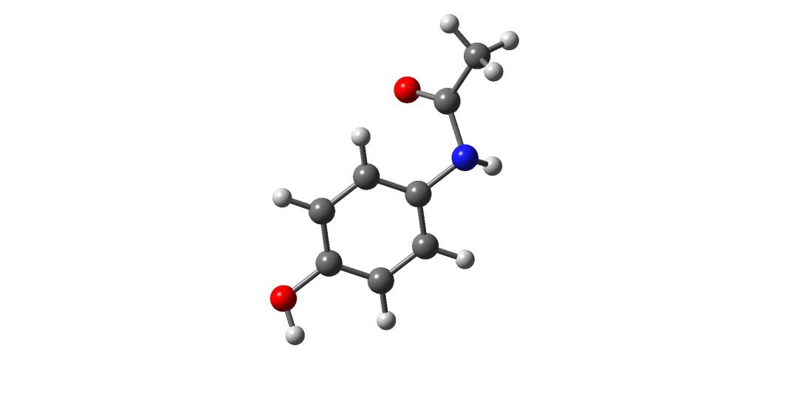  
**Figure 1:** Molecular structure of paracethamol.

For each new paragraph please use 1 cm indent for the first line. Overall abstract (including references) should not exceed one page.

[1] N1., Surname1, N2., Surname2, …., *Journal Abbreviation* **Volume** (Year) Page0–PageN.

[2] N1., Surname1, N2., Surname2, …., *Journal Abbreviation* **Volume** (Year) Page0–PageN.

[3] N1., Surname1, N2., Surname2, …., *Journal Abbreviation* **Volume** (Year) Page0–PageN.

[4] N1., Surname1, N2., Surname2, …., *Journal Abbreviation* **Volume** (Year) Page0–PageN.