Towards near-unity OLEDs: Synergetic photon management

Junho Kim¹˒², Seongjeong Lee², Seunghyup Yoo², Malte C. Gather¹˒³

¹ Humboldt Centre for Nano- and Biophotonics, Department of Chemistry and Biochemistry, University of Cologne, Köln, Germany. ² School of Electrical Engineering, Korea Advanced Institute of Science and Technology (KAIST), Daejeon, Republic of Korea. ³ School of Physics and Astronomy, University of St Andrews, North Haugh, St Andrews, UK.

Correspondence: Seunghyup Yoo (syoo.ee@kaist.edu), Malte C. Gather (malte.gather@uni-koeln.de)

Abstract

Organic light-emitting diodes (OLEDs) have reached internal emission efficiencies close to 100% through advances in materials and device operation, yet their outcoupling efficiency remains at 20–30%, which leaves them less efficient than inorganic light-emitting diodes. Even devices that combine an external outcoupling structure with a high-index substrate have stalled at an external quantum efficiency (EQE) of about 60%, and neither the cause nor the attainable limit has been quantified. Here we describe light extraction in an OLED with an external outcoupling structure as a multi-pass extraction process, in which light shuttles repeatedly between the outcoupling structure and the device and is extracted in successive passes, and we show that the extraction efficiency of the light delivered to the substrate is set by the round-trip loss of the device, that is, by the parasitic absorption inside the device: the Joule dissipation loss at the reflective electrode and the absorption in the transparent electrode. This parasitic absorption, a secondary loss in conventional devices, becomes the dominant loss channel the moment an outcoupling structure is attached, so the optical design rules of the device have to be rewritten around minimising the round-trip loss rather than around resonance and emitter orientation. Following these rules, we show experimentally that 91.6% of the light delivered to the substrate can be extracted even on a substrate of ordinary refractive index (maximum EQE 55.8%, model prediction 55.9%), and that on a high-index substrate carrying a microlens array an auxiliary reflector placed outside the current path alone raises the EQE from 61% to 77%. The proposed design is free of the conventional constraints of highly oriented emitters, microcavities and precisely optimised outcoupling structures, yet it opens a route to EQEs in the high 80s with isotropic emitters and 90% when combined with a lower-absorption transparent electrode, and it applies not only to OLEDs for lighting and displays but also to tandem OLEDs, QLEDs, PeLEDs and other thin-film light-emitting devices.

Introduction

OLEDs lead today's display market on the strength of their high colour purity, surface emission and large-area processing. Their reach has recently extended to mobile XR markets such as AR/VR devices and to high-end electronics, and, exploiting surface emission and low operating temperature, to wearable and implantable light sources. Despite this versatility, OLEDs are less efficient than inorganic light-emitting diodes, and in applications that demand high brightness and long lifetime they are still considered unable to replace them.

The external quantum efficiency (EQE), the number of emitted photons per injected electron, is written for a conventional OLED as the product of the internal emission efficiency and the outcoupling efficiency, equation (1).

η_EQE = η_int · η_out = (γ · η_PLQY · χ) · η_out (1)

The internal emission efficiency η_int is the product of the charge-balance factor γ, the effective photoluminescence quantum yield (PLQY) and the exciton-utilisation factor χ, and decades of work have brought all three close to 100% [1,2]. The outcoupling efficiency η_out, by contrast, is still limited to about 20–30% by the ray-optics constraint imposed by the refractive-index contrast between the organic layers and air [3–5], and most efforts to raise OLED efficiency have therefore targeted this factor: external outcoupling structures [6–9], emitters with a high horizontal dipole ratio [10,11] and microcavities [12]. Among these, external outcoupling structures extract the substrate modes without interfering with the electrical operation of the device and, combined with a high-index substrate, recover the waveguided modes as well, reaching EQEs close to 60% [13,14]. That very different optical designs have all stopped near 60% points to a common limiting mechanism rather than to a defect of any particular structure; yet the loss channels have not been quantified, no guideline exists for going beyond this value and the attainable limit is unknown. Outcoupling structures of many kinds keep being reported, but the reports go no further than an improvement over a reference device, and which change improves the extraction, and by how much, has not been established.

Here we derive a closed-form law that describes light extraction in an OLED with an external outcoupling structure as a multi-pass extraction process and verify it with an integrated optical simulation that couples wave optics and ray optics. The analysis identifies the parasitic absorption inside the device, the Joule dissipation loss at the electrode that acts as the reflector and the absorption in the transparent electrode, as the main loss channel, and it yields concrete design rules that minimise this loss. Devices built to these rules extract 91.6% of the light delivered to the substrate, as confirmed by measurement; adding an auxiliary reflector to a device on a high-index microlens-array substrate gives an EQE of 77%; and the same rules chart a route to EQEs in the high 80s with an isotropic emitter and 90% with a low-absorption transparent electrode in an electrode-integrated device. The rules leave a wide design space, since they rely neither on microcavities nor on oriented emitters nor on an optimised outcoupling structure, and they extend beyond bottom-emitting OLEDs to top-emitting OLEDs, tandem devices, QLEDs and PeLEDs.

Results

Multi-pass extraction and the definition of the extraction efficiency

Figure 1a compares a conventional OLED and an OLED designed by the rules of this work, both with an external outcoupling structure attached. In an OLED with an external outcoupling structure only part of the light leaves at the interface between the outcoupling structure and air; the rest is returned towards the substrate, is reflected by the layer stack of the device and travels back to the outcoupling structure. Because the light is extracted in successive passes of this kind, a loss that is small in a single round trip, such as the Joule dissipation loss at the metal electrode or the absorption in the transparent conductive oxide (TCO) electrode, has a large effect on the final efficiency. Conversely, in a device whose internal optical losses are suppressed by our design rules the returned light travels back to the outcoupling structure almost without loss, and most of the light delivered to the substrate is eventually extracted.

With this process in mind, the EQE of an OLED with an external outcoupling structure separates into two factors, equation (2) (Supplementary Note 1).

η_EQE = η_sub · η_ext (2)

Here η_sub is the fraction of the power generated in the emitting layer that is delivered to the substrate, that is, the power that remains after the losses to waveguided modes, surface plasmon polariton (SPP) modes and absorption inside the device. Most external outcoupling structures are index-matched to the substrate to avoid the additional loss that an index step would cause, so η_sub is then also the power delivered to the outcoupling structure. η_ext is the fraction of the power delivered to the substrate that the external outcoupling structure finally sends into air; we call it the substrate-to-air extraction efficiency (sub-to-air extraction efficiency hereafter). In an OLED without an outcoupling structure the escape cone is fixed by the ray-optics limit and, for light distributed isotropically inside the substrate, this fraction scales as 1/n_sub². The frequently quoted 1/(2n²) is an estimate of the total outcoupling efficiency from the emitting dipole to air and must be distinguished from the sub-to-air extraction efficiency defined here.

Once an external outcoupling structure is attached, the light delivered to the substrate makes many round trips through the layer stack and is extracted pass by pass, so the loss per round trip determines the final extraction efficiency. Let p be the probability that light leaves into air in one encounter with the outcoupling structure, R_LED the reflectance of the device for light incident from the substrate, and A′ = 1 − R_LED the fraction lost in one round trip (absorption, plus the transmission through the rear when the reflector is partly transparent). If the outcoupling structure randomises the angle of the light on every round trip and does not absorb, the amount extracted in each round trip forms a geometric series with ratio (1 − p)(1 − A′), whose sum is the closed form of equation (3) (the derivation and the angle- and wavelength-resolved matrix form are given in Methods and Supplementary Note 1).

η_ext = p / [p + (1 − p) A′] (3)

One electrode of the OLED is assumed to be reflective, so T_LED = 0. The relation has the same structure as the statistical-optics result known for light extraction from thin-film inorganic LEDs with a rear reflector [15,16]; here we apply it to an OLED with an external outcoupling structure and quantify A′ as the parasitic absorption of the multilayer stack. The organic charge-transport layers of a conventional OLED are transparent across the visible, so A′ is determined mainly by the Joule dissipation loss at the electrode that serves as the reflector and by the absorption in the transparent electrode. For light whose angles are randomised inside the substrate, p is of order 1/n_sub² [15], about 0.4 for an ordinary glass substrate (n_sub = 1.5).

Figure 1b shows, for p = 0.4, the fraction extracted in each round trip and the cumulative extracted fraction as a function of the number of round trips for A′ = 0.02, 0.10 and 0.25. In a device with a large round-trip loss the remaining light decays rapidly and most of it is absorbed within a few round trips, whereas in a device with a small round-trip loss the curve decays gently until the light delivered to the substrate has all escaped; the cumulative fractions converge to 0.73, 0.87 and 0.97, the values given by equation (3). Figure 1c sums this process: the extraction efficiency of equation (3) as a function of the round-trip reflectance R_LED = 1 − A′ for p = 0.25, 0.4 and 0.6. Once the parasitic absorption inside the device is held to a few per cent, the curves enter their steeply rising region and near-unity extraction becomes possible; for the same round-trip loss the curve moves down as p decreases, because the loss is then accumulated over more round trips.

Equation (3) rests on the assumption that the angle of the returned light is randomised on every round trip. A close-packed hemispherical microlens array sends more than half of the returned light back at steep angles above 60°, and light at these angles has a low probability of escaping on the next pass, so the assumption breaks down and the η_ext obtained from the matrix series is lower than equation (3). The difference also depends on the angular distribution of the light that the device delivers to the substrate and reaches 10 percentage points near the values of n_sub at which a waveguided mode enters the substrate at near-grazing angles (Supplementary Fig. 1). We therefore use equation (3) for the design trends and upper bounds of Figs 1 and 2, and the matrix series for the quantitative values of specific devices (Fig. 3a, Figs 4 and 5, Table 1).

Of the two factors in equation (2), η_sub is dominated by the waveguided-mode and SPP losses, and the means of reducing them, a high-index substrate or a thick electron-transport layer (ETL) of low extraordinary refractive index (n_e), are comparatively well established, so a near-unity substrate-delivery efficiency is within reach. Far less is known about η_ext. Equation (3) states that raising η_ext to near unity amounts to reducing the round-trip loss A′ to a few per cent or less, so we first examine where in the device this loss arises and how large it is.

Quantifying the parasitic absorption

In an OLED with an external outcoupling structure, then, the absorption channels inside the device weigh heavily on the final efficiency. In conventional OLEDs with a transparent oxide electrode such as ITO this absorption amounts to a loss of about 5% and has been treated as a secondary channel, but once an outcoupling structure is attached it not only reduces the amount of light delivered to the substrate but also, as equation (3) shows, acts directly on the extraction efficiency. ITO thicknesses of 70 nm or 150 nm have been preferred for green OLEDs, for example, because the gain in outcoupling efficiency from satisfying the λ/4 or λ/2 cavity condition at the emission wavelength outweighed the absorption loss of the thicker ITO. Figure 2a–c compares, for Al and Ag reflectors, the loss that light returned to the substrate suffers in one round trip in a device with an external outcoupling structure, split into the Joule dissipation loss of the metal reflector and the TCO absorption as a function of ITO thickness, together with the resulting sub-to-air extraction efficiency. Without an outcoupling structure the ITO absorption is incurred in a single pass; here the light crosses the ITO twice in every round trip, so the loss for the same thickness is far larger. The TCO absorption grows in proportion to the ITO thickness whereas the Joule dissipation loss of the metal reflector is constant, so the share of the two losses depends strongly on the reflector. With a conventional Al reflector the reflector alone loses 13% per round trip and even 150 nm of ITO contributes only about 15% of the round-trip loss, whereas with a low-loss Ag reflector, whose loss falls to 1.8%, the same ITO accounts for more than half of the round-trip loss and becomes the main loss channel. As a result the sub-to-air extraction efficiency of Ag exceeds that of Al by 11–13 percentage points at every thickness (Fig. 2c), and as the ITO thickens from 30 nm to 200 nm it falls from 97% to 93% for Ag and from 84% to 82% for Al. The same increase in thickness weighs more heavily on Ag because in the Ag device the TCO absorption is the major part of the round-trip loss.

These trends become stronger when a high-index substrate and outcoupling structure are used to raise η_sub and the EQE (Fig. 2d,e). A high-index outcoupling structure enlarges the index contrast to air, narrows the critical angle and lowers p, and, as equation (3) shows, the lower p is, the more light is lost inside the device before it escapes into air for the same round-trip loss (Supplementary Fig. 2: BTDF and BRDF versus the refractive index of the outcoupling structure). As the substrate index rises from 1.3 to 2.0, p falls 2.5-fold from 0.58 to 0.23 while the round-trip loss itself hardly changes (Fig. 2d), so the decline in extraction efficiency stems entirely from the fall of p rather than from a poorer reflector, and the gap in extraction efficiency between Al and Ag widens from 7 percentage points at n_sub = 1.3 to 12 at 1.5 and 22 at 2.0 (Fig. 2e). Consequently, a high-index outcoupling structure delivers more light to the substrate but extracts a smaller fraction of it; in an Al device with its large parasitic absorption this decline cancels the gain in substrate-delivery efficiency, and the EQE peaks at 61% at n_sub = 1.8 and then drifts down to 59–61% at higher indices (Fig. 2f). This is why previous work has stalled near 60%. In an Ag device, whose round-trip loss is only a few per cent, the EQE keeps rising with the substrate index, reaches 89% at n_sub = 1.8 and stays at 88% at 2.0, and the trade-off between substrate index and final EQE disappears.

Minimising the parasitic absorption requires quantifying and tracking the optical losses incurred while the light makes its round trips. Most organic materials in an OLED have their energy gap in the ultraviolet and absorb little in the visible, so this parasitic absorption is the Joule dissipation loss in the TCO and in the metal [17]. As Fig. 2g–j shows, the angle- and wavelength-resolved round-trip loss for light incident from the substrate onto the device differs greatly between reflector structures. With the transparent electrode fixed at 150 nm of ITO and only the reflector changed, the round-trip loss weighted by the emission spectrum and by the angular distribution (cos θ sin θ) is 15.6% for the widely used Al cathode but 4.5% for an Ag reflector, more than three times lower. As the shading in Fig. 2j indicates, not only the reflectance but also the angular distribution of the light delivered to the substrate and of the light returned to it matter, so even for a given electrode the design should be steered towards minimum parasitic absorption. Tracking where the loss occurs layer by layer with the Poynting vector confirms that there is no loss in the organic layers, which are transparent in the visible, that the loss in the TCO scales with its thickness and that the loss on reflection at the metal electrode is far larger for Al (Supplementary Fig. 3). An OLED with an external outcoupling structure therefore calls for minimising the Joule dissipation loss of the electrode that acts as the reflector and for a TCO that is as thin, and of as low an extinction coefficient, as the sheet resistance allows.

An alternative that avoids the Joule dissipation loss inevitable in a metal electrode is a dielectric reflector (a distributed Bragg reflector, DBR) combined with a TCO. For a reflector of ten thermally evaporable ZnS/LiF pairs placed behind a transparent cathode (ITO 50 nm), with the thickness of every layer optimised over all angles inside the substrate and over the emission spectrum (Fig. 2i,j; design details in Supplementary Note 2), the absorption is 4.1%, lower than for Ag, but 1.0% of transmission through the rear at wavelengths and angles outside the stopband adds to it, so the total round-trip loss of 5.1% is on a par with Ag. Whether the reflector is metallic or dielectric, equation (3) demands one thing only: a round-trip loss within a few per cent. In an electrode-integrated structure a thick Ag reflector, which does not send the light through the transparent electrode twice, is simpler and loses less. A dielectric reflector, on the other hand, is non-conductive and can be added on top of a finished device independently of the electrodes, which makes it well suited as an auxiliary reflector that lowers the round-trip loss of an existing device after the fact; the experiments below use this configuration.

Design rules for the transparent electrode

When the charge-transport layers are transparent in the visible and the Joule dissipation loss of the metal electrode is minimised with a thick Ag electrode, the absorption in the transparent electrode is the only major parasitic absorption channel left in the device, and design rules different from those of a conventional OLED apply. The λ/4 and λ/2 ITO thicknesses mentioned above, and the thin-metal electrodes used in top-emitting OLEDs (TEOLEDs) to raise the transmittance in concert with the optical properties of a capping layer, were all choices made for resonance and transmission; here, to minimise the absorption channel, we assume the minimum thickness that still guarantees electrical conductivity, 50 nm of ITO or 10 nm of Ag. Since the absorption of the transparent electrode cannot be removed entirely if the sheet resistance required for stable operation is to be maintained, the key is to come as close as possible to an ideal transparent electrode. The dissipation in a transparent electrode is proportional to the imaginary part of the permittivity, ε₂ = 2nk. For a TCO such as ITO, n varies little but k varies strongly with the process conditions; for Ag, the least absorbing of the thin metals, k varies little but n varies strongly with process conditions such as the seed layer or co-deposition with another metal.

Figure 3a quantifies the influence of these two parameters in the proposed structure with a high-index substrate (n_sub = 1.8) and a hemispherical microlens array. On an ordinary glass substrate the waveguided-mode loss dominates η_sub and masks the influence of the transparent electrode, but on a high-index substrate, where the waveguided modes are removed, the absorption in the transparent electrode makes up most of the remaining loss and its sensitivity is laid bare. The amount of light delivered to the substrate decreases by what is absorbed on crossing the transparent electrode and therefore falls almost linearly with the k of the TCO or the n of the thin Ag, whereas the sub-to-air extraction efficiency falls hyperbolically with the parasitic absorption, as equation (3) shows. A change of the k of ITO from 0 to only 0.01 lowers the extraction efficiency from 95% to 81% and the attainable EQE from 91% to 75%, and at k = 0.08 the EQE drops to 45%; this sensitivity makes reducing the absorption of the transparent electrode a new design rule. For thin Ag, a continuous film with n of about 0.04 would promise a very high efficiency in theory, but a real Ag film of about 10 nm tends to grow in the Volmer–Weber mode, has a higher n and shows n and k that depend strongly on the seed-layer conditions. In TEOLEDs and transparent OLEDs, metals such as Yb or Mg have been added to obtain thinner continuous films with higher transmittance, but although this works in terms of transmittance, even a small amount of alloying raises the ε₂ of the metal film considerably and lifts n above 0.2, at which point the EQE is limited to 55% or less. TEOLEDs therefore require either thermally evaporated thin Ag in continuous-film form, achieved through the process conditions and seed-layer processing, or a transparent oxide electrode deposited by low-damage sputtering.

Design of the substrate-delivered modes

The other factor of equation (2), η_sub, must be raised as well for the EQE to approach unity. Unlike η_ext, this can draw directly on the established methodology of OLED optical design. Waveguided modes arise from total internal reflection because the organic layers and the transparent electrode (n ≈ 1.8–2.0) have a higher index than the substrate (n ≈ 1.5); raising the substrate index to that of the emitting layer (n_sub ≈ n_EML) brings the critical angle of the substrate to the cut-off angle of the waveguided modes, and light that was trapped in the organic layers joins the substrate modes. The refractive index of the transparent electrode must then not exceed that of the substrate either, since for n_TCO > n_sub the transparent electrode itself becomes a waveguide and the waveguided modes remain. Figure 3b shows the power fraction of each mode as a function of the total organic thickness and the substrate index: as the substrate index approaches that of the EML, the power of the waveguided modes is transferred entirely to the substrate modes.

The evanescent component in Fig. 3b comprises all near-field components whose in-plane wavevector exceeds the light line of the organic layers and which therefore cannot propagate inside them; most of it is the SPP mode formed by the coupling of the near field of the emitting dipole to the metal electrode, the rest is a lossy surface wave absorbed directly by the metal. Both components decay exponentially with the distance between the emitting layer and the metal, so a thick electron-transport layer between them suppresses them. Figure 3b also shows the evanescent component shrinking as the organic layers thicken; without an index contrast between the organic layers, reducing this loss below 10% takes about 320 nm and reducing it to the 1% level takes close to 500 nm of organic material. Such thickness lengthens the charge-transport distance and raises the driving voltage, which compromises stable operation. Doping allows thick transport layers, but the polaron absorption it introduces in the visible adds to the parasitic absorption inside the device and calls for a more careful analysis.

An electron-transport layer with a low extraordinary refractive index (n_e), the index seen by TM polarisation, suppresses the SPP mode of the evanescent component at a smaller thickness. Figure 3c compares ETLs with the ordinary index fixed at 1.8 and n_e lowered from 1.8 (isotropic) to 1.5; in the TM power dissipation density on the left, the sharp peak beyond the light line is the SPP mode. As n_e decreases the SPP dispersion changes, the peak moves towards the light line of the substrate and weakens, and the ETL thickness needed to bring the evanescent loss below 20% falls to 110, 104, 90 and 59 nm for n_e = 1.8, 1.7, 1.6 and 1.5. The exact thickness depends on the indices of the EML and HTL and on the wavelength, but the trend is the same, and since a low-n_e ETL achieves the same SPP suppression in a thinner layer it also helps the driving voltage.

In summary, the design rules of this work are four: (i) a low-loss rear reflector with a round-trip loss within a few per cent (thick Ag or an optimised DBR); (ii) a transparent electrode of the minimum thickness and minimum absorption compatible with conductivity (50 nm ITO or 10 nm continuous Ag); (iii) an index ladder with n_sub ≈ n_EML and n_TCO ≤ n_sub; and (iv) SPP suppression by a thick or low-n_e electron-transport layer. Rules (iii) and (iv) bring η_sub, and rules (i) and (ii) bring η_ext, to near unity.

Experimental verification

Figure 4 presents the experiments that test the core of the proposed optical design, the validity of equation (3), namely that reducing the round-trip loss extracts almost all of the light delivered to the substrate. In both devices the low-loss reflector is not an electrode but an auxiliary reflector covering the rear of the finished device, outside the current path. These experiments therefore test the underlying multi-pass extraction law rather than the electrode-integrated design itself, and for the sake of stable electrical operation and effective charge injection the electrical requirements were given priority over the design rules of the preceding sections in the choice of the transparent-electrode thickness of the green device (150 nm ITO) and in the addition of an n-type dopant.

The first device is a green phosphorescent OLED on a glass substrate of ordinary index with a microlens-array film (Fig. 4a). The thin-film encapsulation and the Parylene-C layer on top of the device electrically isolate the upper Ag film from the bottom electrode, so that it acts as a reflector only. The maximum EQE rises 2.8-fold from 20% to 55.8%; with a simulated substrate-delivery efficiency η_sub of 60.9%, this corresponds to extraction of 91.6% of the light delivered to the substrate (emitted power measured, η_sub from the model; Methods). This value was obtained with a commercial microlens film of ordinary refractive index, and it agrees with the maximum EQE of 55.9% predicted by the integrated model to within 0.1 percentage points.

The second device is an orange phosphorescent OLED on a high-index substrate (n = 1.77) patterned with a microlens array, which tests ultra-high efficiency through a high-index substrate and the use of a dielectric reflector (Fig. 4b). With the Al cathode as the only reflector the EQE stops at 61% because of the Joule dissipation loss, whereas with a ZnS/LiF DBR added to the rear of the finished device as an auxiliary reflector the EQE reaches 77%. Here the substrate-delivery efficiency is 88%, so a sub-to-air extraction efficiency of about 87.5% has been achieved. This DBR consists of only 4.5 thermally evaporated ZnS/LiF pairs; unlike conventional DBRs with ten or more pairs it can be formed on the organic layers without damage, and it demonstrates that a highly efficient OLED does not require a conductive reflector such as Ag. In both experiments the gain was obtained solely by adding a reflector while leaving the stack of each device untouched, which supports the conclusion that the improvement stems entirely from the reduction of the round-trip loss.

Design freedom

The advantage of the proposed optical structure is not limited to ultra-high efficiency. Until now only the light collected within the escape cone fixed by the device structure could be extracted, so a design that gathers light towards the normal with a microcavity or concentrates as much light as possible inside the escape cone with a highly oriented emitter was indispensable. As Fig. 3a shows, however, within our design rules minimising the parasitic absorption inside the device matters far more than forming a two-beam interference or a Fabry–Pérot resonance. Without an external outcoupling structure (Fig. 5a), the ETL and HTL thicknesses are forced to the cavity orders of a quarter or three quarters of the wavelength to form a microcavity, and the EQE map shows pronounced interference fringes. In our structure these fringes vanish, and simply making the ETL thicker than 150 nm produces a broad high-efficiency region above 90% of the maximum (87.4%) (Fig. 5b). Given that second-order cavity thicknesses are preferred for yield against particles and for lower leakage current, this greatly widens the design freedom of the device structure.

The same holds for the emitter. In a conventional Al-cathode device on glass the EQE rises almost linearly with the horizontal dipole ratio Θ of the emitter even with a microlens array attached (from 31% to 55% as Θ goes from 0.5 to 1.0, Fig. 5c), which is why so much emitter research still aims at a high degree of orientation. In our structure with a low-loss reflector and an index-matched high-index substrate the EQE hardly changes over the same range, from 83% to 85%, and reaches 84% even with a nearly isotropic emitter (Θ = 0.67); the difference between the two curves comes entirely from the round-trip loss of the device, not from the emitter orientation. The same calculation for a real material stack with anisotropic, lower-index electron- and hole-transport layers (B3PyMPM ETL 200–300 nm, TCTA:B3PyMPM EML, TAPC HTL, ITO 50 nm, Ag 100 nm) gives 87–89% with an isotropic emitter (ETL 200–300 nm; 3–5 percentage points above the generic stack), essentially the same 87–89% with the emitters of Θ ≈ 0.8–0.9 that are now widely reported [25,26], and 89–91% when the k of the ITO is lowered from 0.0032 to 0.002 (Table 1; values over the full emission spectrum and at 550 nm). This not only changes the design paradigm of concentrating light inside a limited escape cone but also sets a new direction for emitter development.

Freedom is gained in the design of the outcoupling structure as well. A typical microlens array consists of hemispherical lenses with an aspect ratio of 1, but with electrohydrodynamic printing or inkjet printing the aspect ratio is often difficult to control. Figure 5d shows the EQE as a function of the aspect ratio of hexagonally close-packed lenses: in a device with a low-loss reflector the EQE stays above 95% of its maximum (86.6%) over the whole range from 0.25 to 1.5. An OLED with an Al electrode is not only less efficient because of the Joule dissipation loss but also falls off more steeply at low aspect ratios, so its tolerance is narrower: the shallower the lens, the smaller the escape probability p per encounter and the larger the number of round trips, so the loss accumulates more in a device with a large round-trip loss. External outcoupling with a scattering layer also reaches high efficiency with our approach; the EQE stays at 80–90% over a wide range of the scatterance S and the asymmetry parameter g and is practically independent of both (Fig. 5e), which relieves practical problems such as the optimisation of the scattering-layer process and sample-to-sample variation.

Discussion

We have described light extraction in OLEDs with an external outcoupling structure by a multi-pass extraction law and tracked the loss channels quantitatively, showing that the parasitic absorption inside the device, which sets the round-trip loss, governs the final efficiency, and we have proposed new design rules that minimise it. We confirmed experimentally that an Ag auxiliary reflector extracts 91.6% of the light delivered to the substrate on a substrate of ordinary refractive index, achieved an EQE of 77% with a dielectric auxiliary reflector on a high-index outcoupling substrate, and charted a route to EQEs in the high 80s with an isotropic emitter and 90% with a lower-absorption transparent electrode in an electrode-integrated structure, a route that is almost independent of the emitter orientation (Θ = 0.67–0.9). Because the law asks only that the round-trip loss be within a few per cent, the type of reflector is a design variable rather than a premise; the design rules are free of the constraints represented by emitter orientation and microcavities, tolerate a wide range of shapes and scattering properties of the outcoupling structure, and can be applied to many outcoupling structures and processes. The auxiliary reflectors of our experiments require additional space outside the device, so display pixels will need a structure that integrates the low-loss reflector into the electrode. This reduces to lowering the absorption of the thin-Ag or low-damage-oxide transparent electrode of a TEOLED, and the same principle carries over to QLEDs, PeLEDs and other thin-film light-emitting devices, where it may serve as a new platform for the optical design of thin-film LEDs.

Methods

Optical simulation

The optical simulations combine ray optics, wave optics and an integrated model that couples the two. The bidirectional scattering distribution function (BSDF) of the external outcoupling structure was computed by Monte Carlo ray tracing (LightTools) with at least 5,000,000 rays per combination of wavelength and angle of incidence. For the aspect-ratio calculation of Fig. 5d we used our own ray-tracing code for hexagonally close-packed lenses with periodic boundary conditions and lens-to-lens re-entry, assuming a spherical cap for aspect ratios up to 1 and a half-ellipsoid that does not overlap its neighbours above 1 (the two shapes coincide in the hemisphere at aspect ratio 1). At aspect ratio 1 this code reproduces B_T(θ), p and η_ext of the hemispherical BSDF computed with LightTools to three decimal places. For the wave-optical part, the parasitic absorption, reflectance and transmittance inside the OLED were computed with custom MATLAB code implementing the transfer-matrix formalism, an OLED emission model based on the classical dipole model and a Poynting-vector model for the thin films, following refs [18,19]. The refractive indices of every layer (including anisotropy), the PLQY of the emitting dipoles, the horizontal dipole ratio and the Purcell factor were all included, and the emission zone was placed at the centre of the EML. The integrated simulation follows refs [13,20]: the emission profile delivered to the substrate is computed for a semi-infinite substrate and the reflectance of the device for light incident from the substrate is taken into account. When the substrate index exceeds that of the emitting layer (n_e for TM polarisation in an anisotropic EML), the near-field components that are evanescent in the EML but propagate in the substrate (1 < u < n_sub/n_EML) tunnel through the layers below the dipole into the substrate, and this contribution is included in η_sub and in P_sub(θ).

The angle- and wavelength-resolved form of equations (1)–(3) is as follows. Writing the power P₀ delivered by the OLED to the substrate and its angular distribution as the row vector P_sub(θ), the transmitted component of the outcoupling structure as the row vector B_T(θ), its reflected component as the matrix B_R(θ_i, θ_r) and the reflectance of the device as the diagonal matrix R(θ), the extracted power summed over all orders of round trips is P_out = P₀ · P_sub · (I − B_R R)⁻¹ · B_Tᵀ. This was evaluated at each wavelength and weighted by the emission spectrum to obtain the EQE and the angular distribution. Replacing the angle-dependent quantities by their averages over the recirculating light, p and A′ ≡ 1 − ⟨R⟩, and using B_R ≈ 1 − B_T sums the series to equation (3) (Supplementary Note 1). Throughout the main text p is the transmitted component B_T(θ) of the BSDF of the outcoupling structure averaged with the angular weight cos θ sin θ, a property of the outcoupling structure alone, independent of the device. The η_ext and EQE of Fig. 1 and Fig. 2c–f were computed with equation (3), those of Fig. 3a, Figs 4 and 5 and Table 1 with the matrix series. The BSDFs used in the series are ray-tracing results for hexagonally close-packed hemispheres (n_MLA = 1.30–2.00 in steps of 0.05); each device uses the BSDF with n_MLA equal to its substrate index (the average of 1.75 and 1.80 for the n = 1.77 substrate of Fig. 4b). Equation (3) assumes that the angle of the returned light is randomised on every round trip, whereas a close-packed hemispherical microlens array tends to return the light at steep angles, so the η_ext of the series is lower than equation (3). Because the series uses the angular distribution P_sub(θ) of the light delivered to the substrate as it is, a calculation in which n_sub is varied continuously, as in Fig. 2d–f, shows a step in η_ext of up to 10 percentage points, followed by recovery, just after each index at which a waveguided mode enters the substrate at a near-grazing angle (n_eff = 1.35, 1.52, 1.66 and 1.73 at 550 nm, and n_sub = n_org = 1.8) (Supplementary Fig. 1). These steps reflect the mode structure of a single-wavelength, fixed-thickness calculation, so for Fig. 2c–f, which shows design trends independent of the materials and structure, we use equation (3) and present the difference from the series in Supplementary Fig. 1. Equation (3) is an upper bound.

The design-rule calculations (Figs 2 and 3, Fig. 5c,d, Table 1) were performed at a single wavelength of 550 nm with PLQY = 1 and isotropic orientation (horizontal dipole ratio Θ = 2/3; Θ is varied only in Fig. 5c). In Fig. 2, Fig. 3a,b and Fig. 5c,d the charge-transport layers and the emitting layer are isotropic, non-absorbing media with n = 1.8; in Fig. 3c only the ETL is anisotropic (n_o = 1.8, n_e varied). Figure 5a,b was computed for the real material stack reflector 100 nm/B3PyMPM d_ETL/TCTA:B3PyMPM 25 nm (emission zone at the centre)/TAPC d_HTL/ITO 50 nm/substrate with the ETL and HTL thicknesses varied from 10 to 300 nm; (a) is an Al reflector on a planar substrate with n_sub = 1.5, (b) an Ag reflector with a hemispherical microlens array (n_MLA = 1.8, 20 terms of the series) on a substrate with n_sub = 1.8. The wavelengths span 400–700 nm in 1-nm steps, weighted by the emission spectrum of Ir(ppy)₂acac on a photon-number basis, with PLQY = 1, Θ = 2/3 and an in-plane wavevector grid of 1,000 points per unit of u = k_∥/(n_EML k₀) up to u = 3. For the scattering layer of Fig. 5e, an index-matched, non-absorbing layer, the BSDF was generated by Monte Carlo ray tracing (5×10⁴–10⁵ photons per incidence-angle bin) with a Henyey–Greenstein phase function (asymmetry parameter g = 0.5–1.0) and a scattering optical thickness S = μ_s d = 1–15. The device is reflector (Ag or Al) 100 nm/B3PyMPM 500 nm/TCTA 25 nm (emission zone at the centre)/TCTA:B3PyMPM 10 nm/(TAPC 500 nm/HATCN 3 nm)×3/ITO 50 nm/substrate (n = 1.8), and the EQE was obtained by summing the series over 20 round trips with the emission spectrum of Ir(ppy)₂acac over 400–800 nm (1-nm steps), PLQY = 0.98 and Θ = 0.76. The optical constants of ITO are, in every calculation, the values reported by König et al. [21] (refractiveindex.info; n = 1.864 and k = 0.0032 at 550 nm, n = 1.79–2.08 over 400–700 nm); those of Al, IZO, the organic materials, ZnS and LiF were measured by spectroscopic ellipsometry, and those of Ag are taken from McPeak et al. [24]. The device simulations of Fig. 4 also use the measured optical constants of each layer. The real-stack calculation of Table 1 obtains P_sub and R_LED from the measured, dispersive optical constants of each layer (including the anisotropy of B3PyMPM, TCTA:B3PyMPM and TAPC) and sums the series with the BSDF of the same hemispherical microlens array (n_MLA = 1.8) as in Fig. 5; both the single-wavelength value at 550 nm and the value weighted over the 400–700 nm emission spectrum on a photon-number basis are given. The Python implementation used for Figs 2 and 3, Fig. 5c,d and Table 1 and the MATLAB implementation used for Fig. 4 and Fig. 5a,b,e agree for the stack of Table 1 to within 0.2 percentage points in η_sub and 1 percentage point in η_ext.

Definition of the extraction efficiency

η_ext is the emitted power divided by the power delivered by the OLED stack to the substrate. For the devices of Fig. 4 the emitted power is the measured EQE and the substrate-delivered power is the model value (0.609 for the green device, 0.88 for the orange device), so the η_ext quoted is a mixed measured/model figure. The validity of the model inputs is supported by the agreement between the measured and simulated EQE (55.8% versus 55.9% for the green device).

OLED fabrication and characterisation

The green OLED has the structure ITO (150 nm)/HATCN (5 nm)/TAPC (55 nm)/HATCN (5 nm)/TAPC (55 nm)/HATCN (5 nm)/TAPC (55 nm)/TCTA (10 nm)/TCTA:B3PyMPM:Ir(ppy)₂acac (25 nm, 4 wt%, co-evaporation)/B3PyMPM (50 nm)/B3PyMPM:Cs₂CO₃ (5 nm, 20 wt%)/Ag (100 nm) and was encapsulated with a thin-film nanolaminate of alternating Al₂O₃ and ZrO₂. A 3-µm Parylene-C coating on top served both as an additional thin-film encapsulation and as the insulating layer that electrically separates the upper MoOx/Ag reflector (5/100 nm) from the device below. A microlens-array film (MAF02, Lumtec) was used as the external outcoupling structure, and index-matching oil (Immersion oil type-F, Olympus) removed the air gap to the glass substrate.

The orange OLED was fabricated on a high-index substrate patterned with a microlens array (HNPS01, n = 1.77, Lumtec), on which 50 nm of IZO deposited by RF sputtering (123 W) served as the electrode. On top of it, HATCN (5 nm)/TAPC (95 nm)/HATCN (5 nm)/TAPC (95 nm)/TCTA (10 nm)/TCTA:B3PyMPM:Ir(dmppy-ph)₂tmd (25 nm, 4 wt%, co-evaporation)/B3PyMPM (55 nm)/Liq (1 nm)/Al (100 nm) were deposited, and a DBR of 4.5 alternating ZnS (70 nm)/LiF (115 nm) pairs was deposited on the rear of the finished device. The ZnS and LiF thicknesses were determined with a genetic algorithm that maximises the reflectance over all angles inside the substrate and over the emission spectrum. Reference devices with the same stacks were fabricated on planar glass/ITO substrates. All organic, metal and inorganic layers were deposited by thermal evaporation at a base pressure below 10⁻⁶ Torr, and all organic materials were purchased from Lumtec.

The devices were characterised in a custom-built goniometer set-up consisting of a source meter, a photodiode and a spectrometer, and the EQE was obtained from the angle-resolved measurements by the method of refs [22,23].

Figure captions

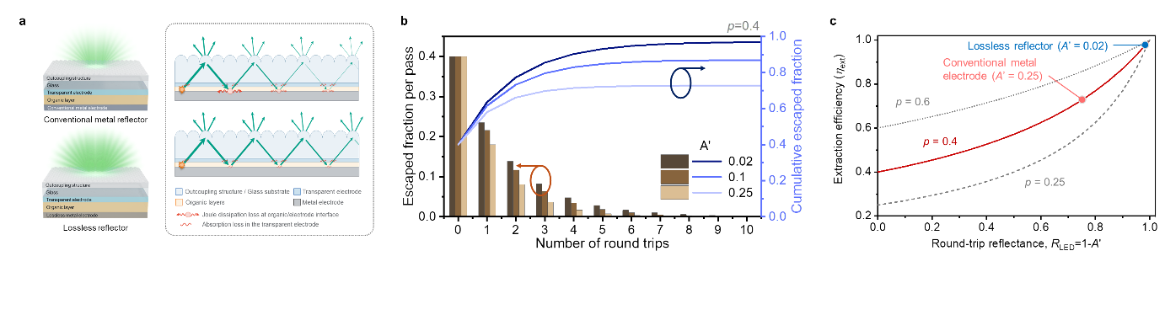
Figure 1. Light extraction as a function of the round-trip loss inside the OLED. (a) Schematic of light extraction with an external outcoupling structure attached to a conventional OLED (top) and to an OLED designed by the proposed rules (bottom). The light delivered to the substrate (P_sub) is partly transmitted by the outcoupling structure (B_T) and partly returned (B_R), reflected by the device stack (R_LED) and sent back to the outcoupling structure; on every round trip a fraction A′ = 1 − R_LED is lost to the Joule dissipation loss of the metal electrode and to the TCO absorption. (b) Fraction extracted in each round trip (bars) and cumulative extracted fraction (lines) versus the number of round trips for an escape probability p = 0.4. For round-trip losses A′ = 0.02, 0.10 and 0.25 the cumulative fractions converge to 0.97, 0.87 and 0.73, the values of equation (3). (c) Extraction efficiency of equation (3) versus the round-trip reflectance R_LED = 1 − A′ for p = 0.25, 0.4 and 0.6 (T_LED = 0).

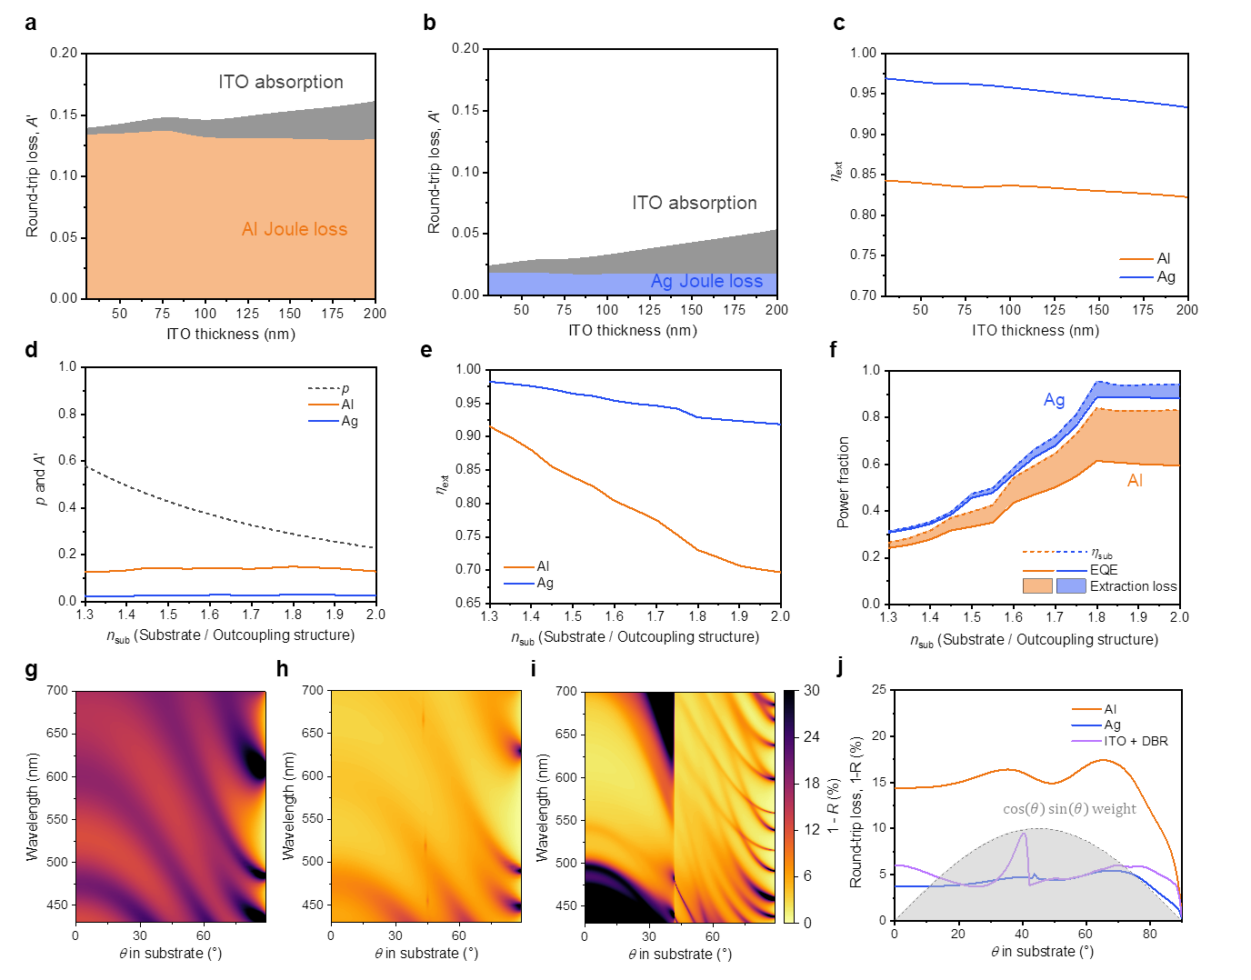
Figure 2. Round-trip loss, substrate-delivery efficiency and EQE for different device structures. (a, b) Loss A′ suffered in one round trip by light returned to the substrate in an OLED with an external outcoupling structure, split into the Joule dissipation loss of the metal reflector (colour) and the TCO absorption (grey) as a function of ITO thickness, for Al (a) and Ag (b) reflectors. (c) Resulting sub-to-air extraction efficiency. (d–f) As a function of the refractive index of the substrate and of the index-matched outcoupling structure: (d) escape probability p and round-trip loss A′; (e) extraction efficiency η_ext; (f) substrate-delivery efficiency η_sub (dashed), EQE (solid) and their difference, the extraction loss (shaded). (g–i) Angle- and wavelength-resolved round-trip loss 1 − R with the transparent electrode fixed at 150 nm ITO and only the reflector changed: Al (g), Ag (h) and a 50-nm ITO cathode with a ten-pair ZnS/LiF DBR (i); the colour scale is shared with (i). (j) Round-trip loss versus angle averaged over the emission spectrum, with the angular weight cos θ sin θ (shaded, a.u.). Weighted over spectrum and angle, the round-trip loss is 15.6% for Al, 4.5% for Ag and 5.1% for the DBR (4.1% absorption + 1.0% rear transmission). Stack: substrate (n = 1.5; varied in (d–f))/ITO (varied in (a–c), 50 nm in (d–f), 150 nm in (g–j))/420 nm of lossless organic layers (n = 1.8)/reflector 100 nm; 550 nm, PLQY = 1, Θ = 2/3. The η_ext and EQE of (c), (e) and (f) are equation (3) evaluated with the p and A′ of (a), (b) and (d); the p of (d) is the single-pass escape probability obtained by averaging the transmitted component of the BSDF of a hemispherical microlens array with the same index as the substrate with the angular weight cos θ sin θ (0.43 at n = 1.5, 0.29 at 1.8). The comparison with the matrix series for the same stack is given in Supplementary Fig. 1. The DBR layer thicknesses were optimised over all angles and over the emission spectrum (Supplementary Note 2).

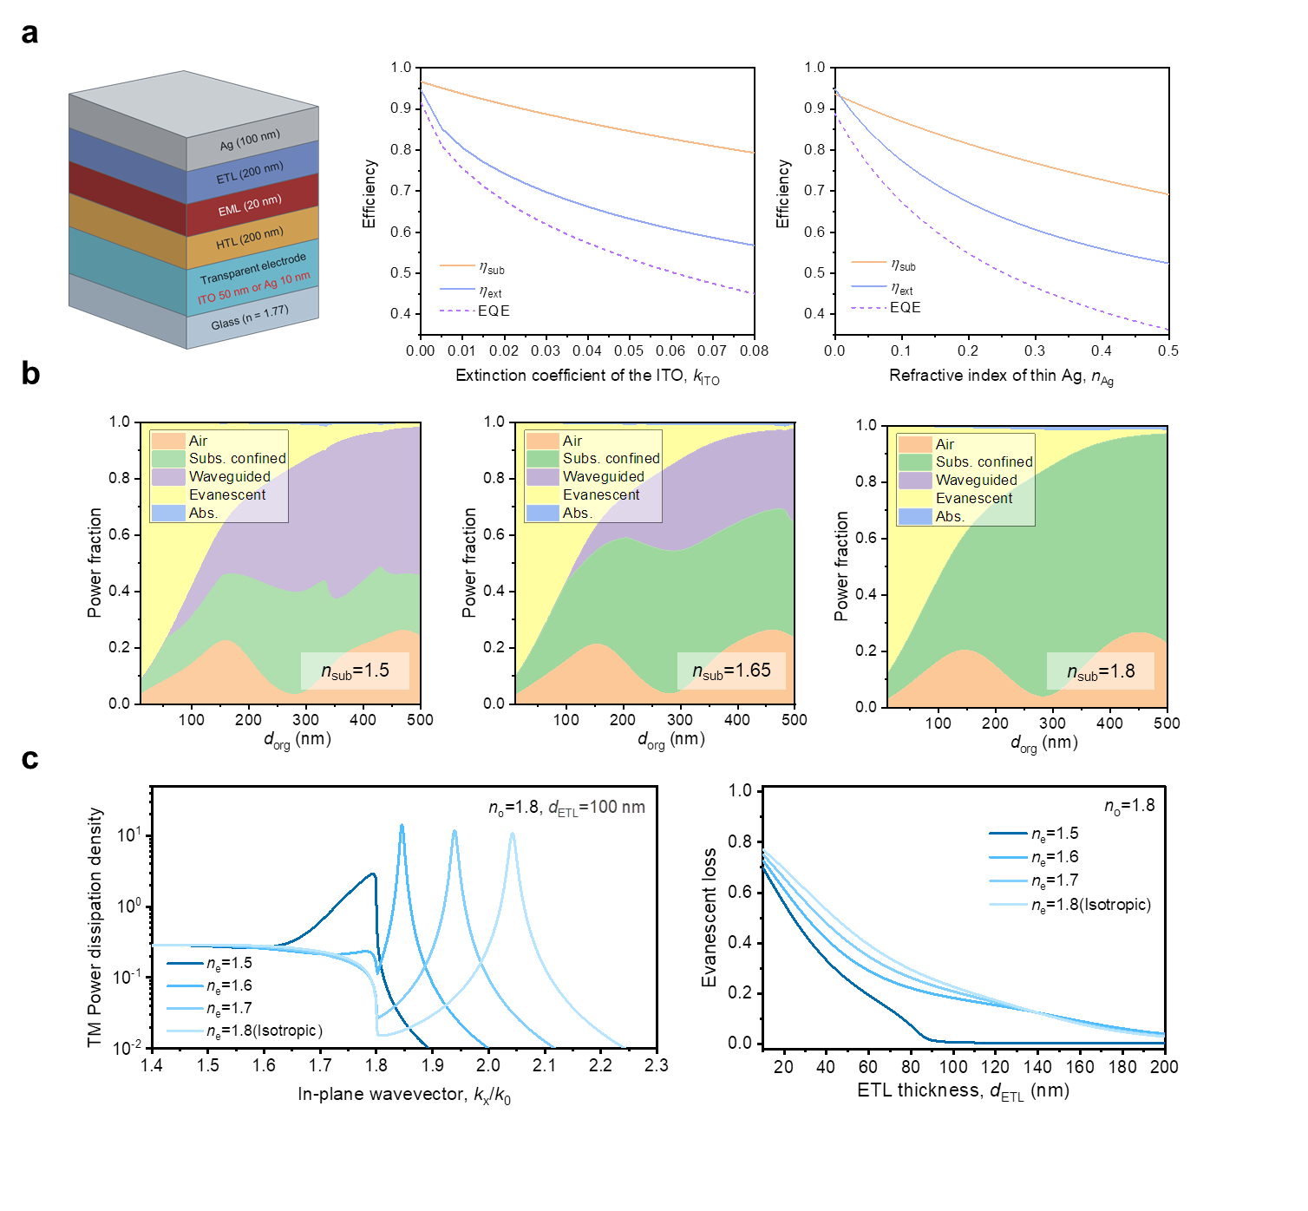
Figure 3. Efficiency trends with the OLED structure. (a) Substrate-delivery efficiency η_sub, sub-to-air extraction efficiency η_ext and EQE versus the absorption of the transparent electrode (extinction coefficient k_ITO of ITO; refractive index n_Ag of 10-nm Ag) for the OLED structure on the left with an ITO transparent electrode (centre) or a thin-Ag transparent electrode (right). The refractive index of ITO is fixed at 1.86 (König et al., 550 nm) and the k of thin Ag at 3.82. The stack is Ag 100 nm/ETL 200 nm/EML 20 nm/HTL 200 nm/transparent electrode/n_sub = 1.8, and η_ext and EQE were computed with the matrix series using the BSDF of a hemispherical microlens array with n_MLA = 1.8. (b) Power fraction of each mode versus the total organic thickness d_org (emitting layer at the centre) for substrate indices n_sub = 1.5, 1.65 and 1.8; Ag reflector, ITO 50 nm, organic layers with n = 1.8. (c) SPP suppression by the extraordinary refractive index n_e of the ETL. Left: TM power dissipation density versus the in-plane wavevector k_x/k₀ at d_ETL = 100 nm. Right: evanescent loss (including the SPP mode, that is, all near-field components beyond the light line of the organic layers) versus ETL thickness. The ordinary index of the ETL is fixed at 1.8; the stack is Ag 100 nm/ETL/EML 20 nm/HTL 50 nm/ITO 50 nm/n_sub = 1.8.

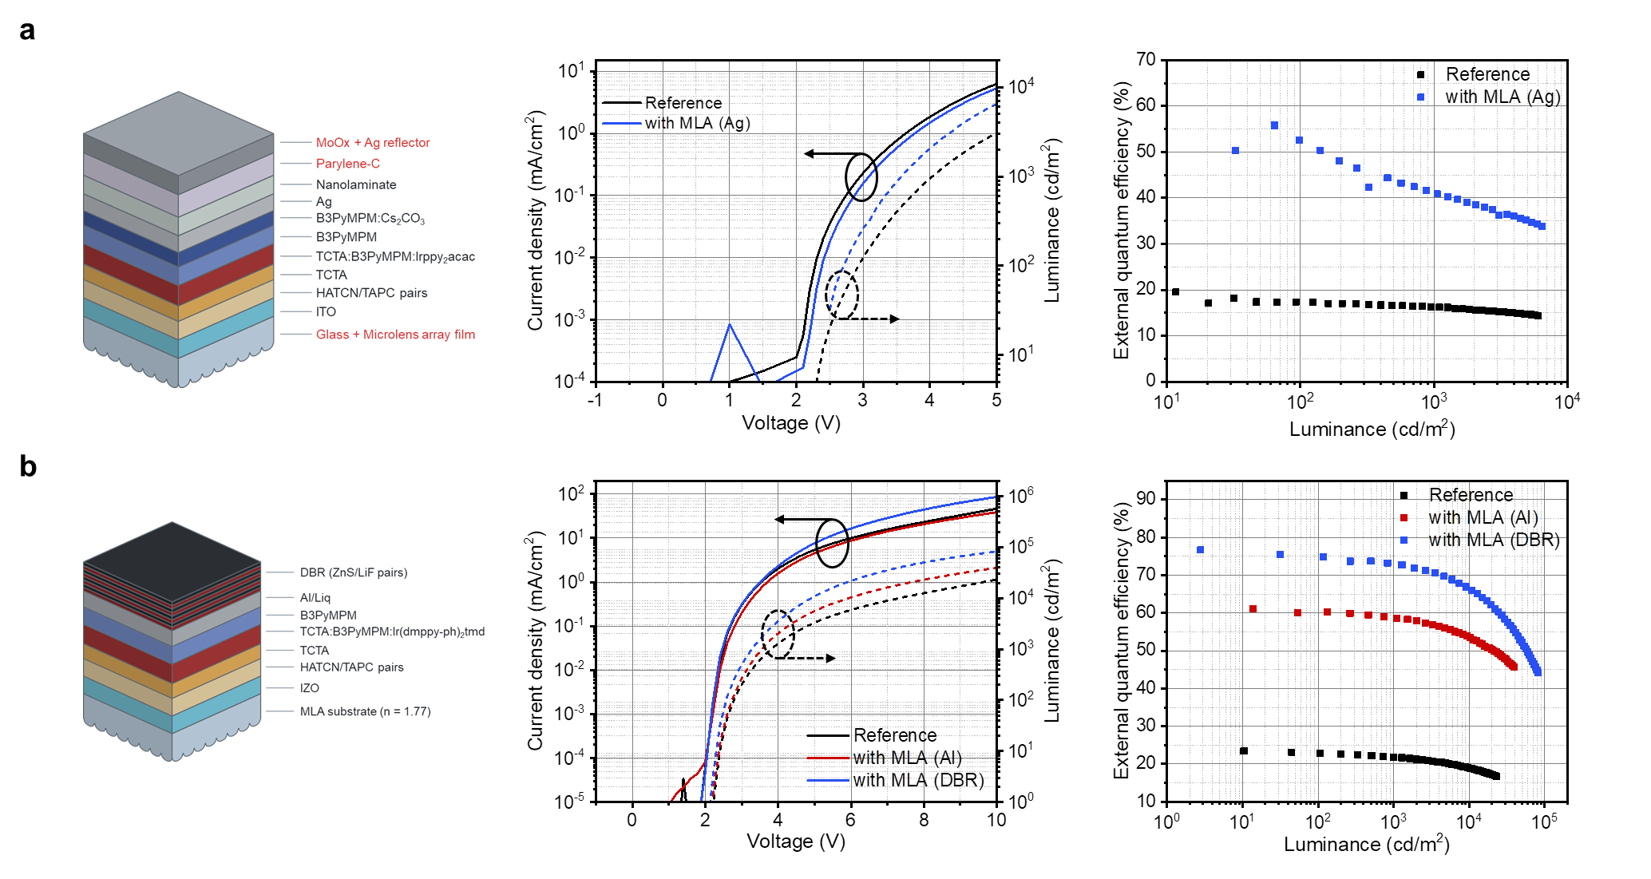
Figure 4. Performance of the OLEDs with microlens arrays. (a) Device structure, J–V–L and L–EQE characteristics of the green phosphorescent OLED fabricated on a glass substrate with a microlens-array film and an Ag auxiliary reflector on the encapsulation (maximum EQE 20% to 55.8%). (b) Device structure, J–V–L and L–EQE characteristics of the orange phosphorescent OLED fabricated on a high-index substrate (n = 1.77) patterned with a microlens array and a ZnS/LiF DBR on the rear (reference device 23%, microlens-array substrate with Al reflector 61%, microlens-array substrate with Al electrode and DBR reflector 77%). The DBR consists of 4.5 alternating ZnS/LiF pairs whose thicknesses were optimised with a genetic algorithm. In both devices the reflector is an auxiliary reflector outside the current path.

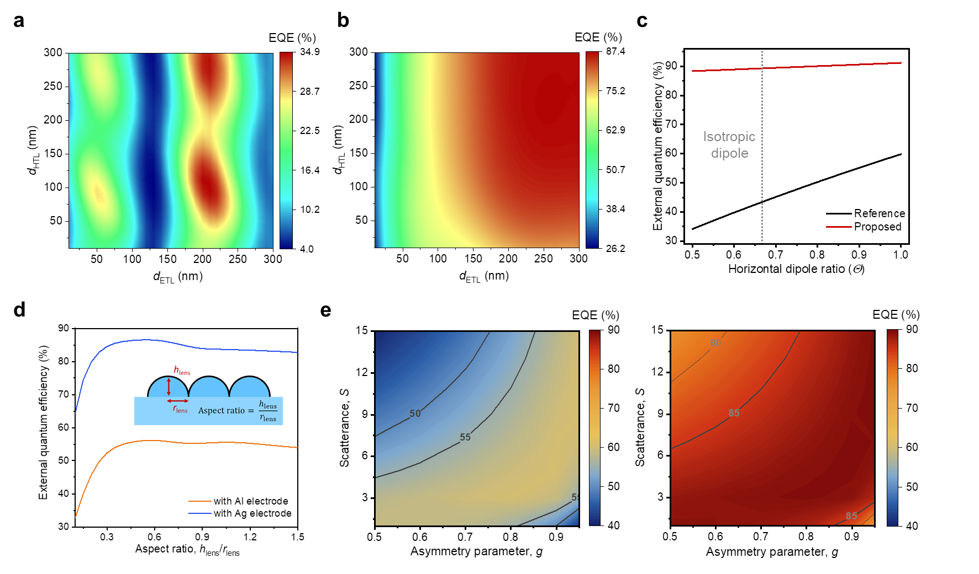
Figure 5. Design freedom afforded by the proposed design rules. EQE versus ETL and HTL thickness for (a) a conventional OLED (Al cathode, n_sub = 1.5, no outcoupling structure) and (b) a device following the proposed rules (Ag reflector, n_sub = n_MLA = 1.8, microlens array). (c) EQE versus the horizontal dipole ratio Θ of the emitter. Reference: Al-cathode device on glass (n = 1.5) with a microlens array and thicknesses tuned to the cavity condition (ETL/HTL 80/230 nm); Proposed: Ag device on an n = 1.8 microlens substrate with unoptimised thicknesses (200/200 nm). The dotted line marks an isotropic emitter (Θ = 0.67). (b)–(e) were all computed with the series of equation (1). (d) EQE versus the aspect ratio (height/base radius) of a single lens in a hexagonally close-packed microlens array (n_sub = n_MLA = 1.8, Al and Ag reflectors). Without lenses, the planar substrate gives an EQE of 21.6% for Al and 25.5% for Ag. (e) EQE versus the scatterance S and the asymmetry parameter g of a scattering layer (left Al, right Ag reflector; substrate n = 1.8). (c) and (d) were computed at a single wavelength of 550 nm with PLQY = 1, Θ = 2/3 (Θ varied in (c)); (a) and (b) with the 400–700 nm emission spectrum, PLQY = 1, Θ = 2/3; (e) with the 400–800 nm emission spectrum, PLQY = 0.98, Θ = 0.76 (Methods).

Table

Table 1. EQE of the near-unity design computed for a real material stack (PLQY = 1). Stack: Ag 100 nm/B3PyMPM d_ETL/TCTA:B3PyMPM 25 nm (emission zone at the centre)/TAPC 180 nm/ITO 50 nm/substrate n = 1.8 with a hemispherical microlens array (n_MLA = 1.8, matrix series). Measured optical constants (B3PyMPM: n_o = 1.821, n_e = 1.609; TCTA:B3PyMPM co-host: n_o = 1.833, n_e = 1.671; TAPC: n_o = 1.691, n_e = 1.664); for ITO, n = 1.864 from König et al. [21] with k = 0.0032 (literature value) or 0.002. Θ = 0.67 is an isotropic emitter. The SPP loss is the whole evanescent component (including the SPP mode). Each entry reads "full emission spectrum (400–700 nm, Ir(ppy)₂acac, photon-number weighting) / single wavelength at 550 nm"; the full-spectrum values are 0.6–0.9 percentage points below the 550-nm values because the ITO and Ag absorb more at shorter wavelengths. A′ is the 550-nm value. Equation (3) gives η_ext = 0.932–0.945 and EQE = 0.898–0.931, 1.4–3.3 percentage points above the series (equation (3) is an upper bound).

d_ETL (nm) | k_ITO | Θ | η_sub (full / 550 nm) | SPP loss | A′ | η_ext | EQE
200 | 0.0032 | 0.67 | 0.962 / 0.963 | 0.023 / 0.023 | 0.029 | 0.904 / 0.912 | 0.870 / 0.878
200 | 0.0032 | 0.80 | 0.970 / 0.971 | 0.015 / 0.015 | 0.029 | 0.900 / 0.908 | 0.873 / 0.882
200 | 0.0032 | 0.90 | 0.975 / 0.976 | 0.010 / 0.010 | 0.029 | 0.897 / 0.906 | 0.875 / 0.884
200 | 0.002 | 0.67 | 0.965 / 0.966 | 0.023 / 0.023 | 0.024 | 0.921 / 0.929 | 0.889 / 0.897
200 | 0.002 | 0.80 | 0.973 / 0.973 | 0.015 / 0.015 | 0.024 | 0.918 / 0.926 | 0.893 / 0.902
200 | 0.002 | 0.90 | 0.978 / 0.979 | 0.010 / 0.010 | 0.024 | 0.916 / 0.924 | 0.896 / 0.905
300 | 0.0032 | 0.67 | 0.979 / 0.981 | 0.004 / 0.003 | 0.029 | 0.901 / 0.907 | 0.883 / 0.890
300 | 0.0032 | 0.80 | 0.980 / 0.981 | 0.003 / 0.002 | 0.029 | 0.896 / 0.903 | 0.879 / 0.886
300 | 0.0032 | 0.90 | 0.981 / 0.982 | 0.002 / 0.001 | 0.029 | 0.893 / 0.900 | 0.876 / 0.883
300 | 0.002 | 0.67 | 0.983 / 0.984 | 0.004 / 0.003 | 0.024 | 0.921 / 0.927 | 0.905 / 0.912
300 | 0.002 | 0.80 | 0.984 / 0.984 | 0.003 / 0.002 | 0.024 | 0.918 / 0.924 | 0.903 / 0.909
300 | 0.002 | 0.90 | 0.984 / 0.985 | 0.002 / 0.001 | 0.024 | 0.915 / 0.921 | 0.901 / 0.907

References (draft, to be checked)

[1] Baldo, M. A. et al. Nature 395, 151 (1998). [2] Uoyama, H. et al. Nature 492, 234 (2012). [3] Brütting, W. et al. Phys. Status Solidi A 210, 44 (2013). [4] Meerheim, R. et al. Appl. Phys. Lett. 97, 253305 (2010). [5] Kim, S.-Y. et al. Adv. Funct. Mater. 23, 3896 (2013). [6] Möller, S. & Forrest, S. R. J. Appl. Phys. 91, 3324 (2002). [7] Sun, Y. & Forrest, S. R. Nat. Photon. 2, 483 (2008). [8] Koo, W. H. et al. Nat. Photon. 4, 222 (2010). [9] Chang, H.-W. et al. J. Appl. Phys. 113, 204502 (2013). [10] Frischeisen, J. et al. Org. Electron. 12, 809 (2011). [11] Kim, K.-H. & Kim, J.-J. Adv. Mater. 30, 1705600 (2018). [12] [[classic microcavity reference: Takada/Tsutsui, Appl. Phys. Lett. 1993, or similar]]. [13] Reineke, S. et al. Nature 459, 234 (2009). [14] Song, J. et al. Nat. Commun. 9, 3207 (2018). [15] Yablonovitch, E. J. Opt. Soc. Am. 72, 899 (1982). [16] Miller, O. D., Yablonovitch, E. & Kurtz, S. R. IEEE J. Photovolt. 2, 303 (2012). [17] [[reference on TCO/metal absorption]]. [18] [[CPS/dipole-model reference: Neyts 1998 / Furno 2012]]. [19] [[Poynting-vector model reference]]. [20] [[integrated (trans-scale) model reference: this group's earlier paper]]. [21] König, T. A. F. et al. ACS Nano 8, 6182 (2014). [22], [23] [[measurement set-up references]]. [24] McPeak, K. M. et al. ACS Photon. 2, 326 (2015). [25] Kim, H. S., Cheon, H. J., Lee, D., Lee, W., Kim, J., Kim, Y.-H. & Yoo, S. Sci. Adv. 9, eadf1388 (2023). [26] Kim, H. S., Cheon, H. J. et al. Sci. Adv. 11, eadr1326 (2025).

