Triphenylene-involved π-Extension Combining with Phenyl-blocking Enhances the Stability of MR-TADF Emitter: Top-Emitting OLED Realizes EQE approaching 60% with BT.2020 Green Gamut and Long Lifetime

Jiahui Liu^{1,2}, Sijie Xian¹, Zhongyan Huang^{1,}*, Jingsheng Miao^{1,}*, Chuluo Yang^{1,}*

[1] Shenzhen Key Laboratory of New Information Display and Storage Materials, College of Materials Science and Engineering, Shenzhen University, Shenzhen 518060, P. R. China
[2] College of Physics and Optoelectronic Engineering, Shenzhen University, Shenzhen 518060, P. R. China

Corresponding Authors
Zhongyan Huang, Email: zyhuang@szu.edu.cn
Jingsheng Miao, Email: jingshengmiao@szu.edu.cn
Chuluo Yang, Email: clyang@szu.edu.cn

Table of contents
I. General Methods 3
II. Device Fabrication and Characterization 4
III. Method of Theoretical Calculations 5
IV. Analysis of Rate Constants. 5
V. Discussion of energy transfer process. 5
VI. Synthesis and Characterization 7
VII. Crystal Data 13
VIII. Additional Spectra and Data 14
IX. Copies of NMR and HRMS Spectra 23
X. References 34

I. General Methods
Unless otherwise noted, all reagents and solvents were obtained from commercial suppliers and used without further purification.
NMR spectra were obtained on a Bruker Advance spectrometer. The ¹H NMR (500 MHz) chemical shifts were measured relative to CDCl₃ or DMSO-d₆ as the internal reference (CDCl₃: δ = 7.26 ppm; DMSO-d₆: δ = 2.50 ppm). The ¹³C NMR (125 MHz) chemical shifts were given using CDCl₃ as the internal standard (CDCl₃: δ = 77.16 ppm). High-resolution mass spectra (HRMS) were obtained with Thermo Scientific LTQ Orbitrap XL. High-performance liquid chromatography (HPLC) analysis was performed on a Shimadzu LC-20AT instrument using the column Daicel Chiralcel OD-H, 5 μm, 4.6 × 250 mm, with hexane and isopropyl ethanol as the mobile phase at a flow rate of 0.7 mL min⁻¹. X-Ray single-crystal diffraction data was collected on a Bruker D8 Venture diffractometer using a graphite-monochromated MoK_{α} (λ = 0.71073 Å) radiation.
UV-visible absorption spectra were conducted on a Shimadzu UV-2700 spectrophotometer (Shimadzu, Japan). Photoluminescence (PL) spectra and phosphorescence spectra (Phos.) were collected on a Hitachi F-7100 fluorescence spectrophotometer (Hitachi, Japan). The photoluminescence quantum yields (Φ_{PL}s) were achieved by a Hamamatsu UV-NIR absolute PL quantum yield spectrometer (C13534, Hamamatsu Photonics) equipped with a calibrated integrating sphere, the integrating sphere was purged with dry argon to maintain an anaerobic atmosphere. The transient PL decay curves were measured by monitoring the decay of the intensity at the PL peak wavelength using the FluoTime 300 (PicoQuant GmbH) with a Picosecond Pulsed UV-LASTER (LASTER375) as the excitation source.
Thermogravimetric analysis (TGA) was carried out using a TGA-Q50 Instrument (TA Instrument, American) at a rate of 10 °C/min under nitrogen atmosphere. The thermal decomposition temperature (T_{d}) was the recorded temperature at 5% weight loss. Differential scanning calorimetry (DSC) thermogram was recorded on TA DSC-Q200 (TA Instrument, American) at a rate of 10 °C/min under nitrogen atmosphere. The glass transition temperature (T_{g}) was determined from the second heating scan.
Cyclic voltammogram (CV) was performed on CHI600 electrochemical analyzer (Chenhua, China), with a solution of tetrabutylammonium hexafluorophosphate (Bu₄NPF₆, 0.1 M) in dry dichloromethane (DCM) as electrolyte and ferrocene/ferrocenium (Fc/Fc⁺) as internal standard. Three-electrode system (Ag/Ag⁺, platinum wire and glassy carbon electrode as reference, counter and work electrode respectively) was used in the CV measurement. The E_{HOMO} energy levels of the compounds were calculated according to the formula: E_{HOMO} (eV) = –[4.8 + (E_{1/2(ox/red)} – E_{1/2(Fc+ /Fc)})] eV. The E_{LUMO} energy levels of the compounds were then deduced from the E_{HOMO} and the onset of UV-Vis absorption wavelength.
Absorption and PL spectra during oxidative electrolysis process were acquired via the chronoamperometry I-t curve method with anodic potential applied. The 10⁻⁴ M sample solutions were applied at the same condition as CV measurement does.

II. Device Fabrication and Characterization
Indium-tin-oxide (ITO) coated glass with a sheet resistance of 15 Ω sq⁻¹ was used as the anode substrate. Prior to film deposition, patterned ITO substrates were cleaned with acetone/ethanol thoroughly in ultrasonic bath, dried with nitrogen gas flow, and finally treated with oxygen plasma in a UV-ozone surface processor (PL16 series, Sen Lights Corporation) for 20 min to enhance the surface work function of ITO anode. Organic layers were deposited with the rate of 0.1 nm·s⁻¹ in a high vacuum chamber below 2.0 × 10⁻⁴ Pa in an inert gas glovebox. The doped and co-doped layers were prepared by co-evaporating dopant and host material from individual sources, and the doping concentrations were modulated by controlling the evaporation rates of dopant. The quartz crystal oscillators controlled the thicknesses of deposited films.
The as-fabricated BE-OLEDs were measured in ambient environment without any encapsulation. Current density-voltage-luminance (J-V-L), EQE-L curves and electroluminescence spectra were collected using a Keithley 2400 source meter and an absolute EQE measurement system (C9920-12, Hamamatsu Photonics, Japan). The capsulated TE-OLEDs were measured in ambient environment using F-Star optical measurement systems (FS-1000GA3-IVL). The device operational lifetime (LT₈₀) was evaluated by measuring the luminance over time at constant current density.

III. Method of Theoretical Calculations
The calculations were carried out using Gaussian 16 serials software. The frontier molecular orbital (FMO) distributions, oscillator strength (f) values and bond dissociation energy (BDE) values were obtained by B3LYP density functional method with basis set def2svp. Time-dependent DFT (TD-DFT) calculations were performed at the B3LYP/def2svp level to obtain the vertical transitions, Huang-Rhys factor (S) and reorganization energy (λ) of the vibrational modes.

IV. Analysis of Rate Constants.
Rate constants of radiative decay (k_{r}) and reverse intersystem crossing (k_{RISC}) are estimated using the following equations: ^{[1]}
$$k_{r}= \frac{Φ_{PL}η_{p}}{τ_{p}}$$
$$k_{RISC}= \frac{η_{d}}{η_{p}τ_{d}(1-Φ_{PL}η_{p})}$$
Where τ_{p} and τ_{d} are the lifetimes calculated from prompt and delayed fluorescence, respectively. η_{p} and η_{d} represent the ratios of prompt and delayed components, respectively.

V. Discussion of energy transfer process.
Achieving efficient FRET requires a good degree of overlap between the emission spectrum of the host and the absorption spectrum of the guest. The calculated results were listed in Table S3:
The FRET radium (R₀) was estimated by the Equation 1 according to the references. ^{[2,3]}
$R_{0}^{6} = \frac{9000(ln10)Φ_{h}k^{2}}{128π^{5}n^{4}N_{A}}\int_{0}^{∞}{F_{h}(λ)ε_{A}(λ)λ^{4}dλ}$ Eq. 1
Where Φ_{h} is the photoluminescence quantum efficiency of the host in the absence of guest, k² is orientation factor, N_{A} is the Avogadro’s number, n is the refractive index, $\int_{0}^{∞}{F_{h}(λ)ε_{A}(λ)λ^{4}dλ}$ is the spectral overlap integral between host photoluminescence (F_{h}(λ)) and the guest absorption (ε_{A}λ) in which F_{h}(λ) is the host’s fluorescence normalized by area, and λ is the wavelength.
The FRET rates (k_{FRET}) in the emitting layer (EML) were estimated using the radiative decay rates as per the following approximation (Equation 2):
$k_{r} = \frac{1}{τ_{r}} ≈ k_{h} + k_{FRET}$ Eq. 2
Where k_{r} represents the radiative decay rate of the corresponding doped films with varying guest concentrations; k_{h} indicates the radiative decay rate of the host in the absence of the guest.
The FRET efficiency (Φ_{FRET}), representing the proportion of excitons decaying radiatively via FRET to the guest, can be expressed by following Equation 3.
$Φ_{FRET} = \frac{k_{FRET}}{k_{FRET} + k_{h}}$ Eq. 3
The distance (R_{hg}) between the host and guest was calculated by the Equation 4. Combined with the low doping concentration and the considerable distances, it is reasonable to rule out Dexter-type energy transfer as a significant contributor to the excited state dynamics.
$k_{FRET} = \frac{1}{τ_{h}}{(\frac{R_{0}}{R_{hg}})}^{6}$ Eq. 4

VI. Synthesis and Characterization
Scheme S1. Synthesis of BN-Phen.
Synthesis of compound 2a. A 50 mL flask with a magnetic stir bar was charged with compound 1a (420.6 mg, 1.0 mmol, 1.0 equiv), 2-bromophenanthrene (565.7 mg, 2.2 mmol, 2.2 equiv), Pd₂(dba)₃ (45.8 mg, 0.05 mmol, 5 mol%), RuPhos (46.7 g, 0.1 mmol, 10 mol%), tBuONa (384.4 mg, 4.0 mmol, 4.0 equiv) and toluene (10.0 mL) under argon atmosphere. The mixture was stirred at 120 °C for 12 h. Afterwards, the reaction mixture was diluted with DCM, filtered through a celite pad and the solvent was removed under reduced pressure. The residue was then purified via column chromatography on silica gel (petroleum ether/ dichloromethane = 4:1, v/v) to provide the product 2a as a white solid (641.6 mg, 83% yield). ¹H NMR (500 MHz, CDCl₃): δ = 2.09 (s, 12H), 2.35 (s, 6H), 6.81 (d, J = 2.0 Hz, 2H), 6.96 (s, 4H), 7.00 (s, 1H), 7.28 (t, J = 7.0 Hz, 1H), 7.32-7.36 (m, 4H), 7.41-7.45 (m, 4H), 7.48-7.51 (m, 4H), 7.58 (t, J = 7.3 Hz, 1H), 7.64 (d, J = 9.0 Hz, 2H), 7.81 (d, J = 7.5 Hz, 2H), 8.46 (d, J = 9.0 Hz, 2 H), 8.49 (d, J = 8.5 Hz, 1 H) ppm. ¹³C NMR (125 MHz, CDCl₃): δ = 18.7, 21.2, 111.3, 112.2, 116.3, 120.1, 122.1, 123.7, 124.6, 125.5, 126.7, 127.20, 127.23, 127.4, 128.6, 128.7, 130.1, 130.6, 131.2, 133.4, 137.0, 137.6, 140.0, 141.4, 143.2, 144.7, 147.2 ppm.
Synthesis of BN-Phen: A 25 mL dried Schlenk tube with a magnetic stir bar was charged with compound 2a (386.5 mg, 0.5 mmol, 1.0 equiv). After being evacuated and backfilled with argon (3 times), dry o-DCB (2.0 mL) and BBr₃ (501.0 g, 2.0 mmol, 4.0 equiv) was added under argon atmosphere. The reaction mixture was stirred at 180 °C for 24 h. Afterwards, the reaction mixture was cooled to 0 ºC and carefully quenched by addition of N,N-diisopropylethylamine (1.1 mL, 6.0 mmol, 12.0 equiv). The aqueous phase was extracted with DCM and the combined organic phases were dried over anhydrous Na₂SO₄. After filtration and evaporation, the crude product was then purified via column chromatography on silica gel (petroleum ether/dichloromethane = 3:1, v/v) to afford BN-Phen as a bright orange powder (351.4 mg, 90% yield). ¹H NMR (500 MHz, CDCl₃): δ = 2.02 (s, 12H), 2.53 (s, 6H), 6.50 (s, 2H), 7.21 (s, 2H),7.15 (s, 4H), 7.30-7.34 (m, 1H), 7.37-7.38 (m, 4H), 7.62-7.65 (m, 4H), 7.75 (d, J = 8.5 Hz, 2H), 7.80 (t, J = 7.8 Hz, 2H), 7.93 (d, J = 8.0 Hz, 2H), 9.16 (d, J = 8.5 Hz, 2H), 10.71 (s, 2H) ppm. ¹³C NMR (125 MHz, CDCl₃): δ = 17.8, 21.5, 103.3, 112.3, 122.3, 124.1, 125.0. 125.9, 127.27, 127.32, 127.6, 128.0, 128.6, 128.7, 129.0, 130.7, 130.9, 131.3, 131.6, 135.2, 136.8, 137.4, 138.5, 142.6, 144.8, 146.3, 147.0 ppm. HRMS (ESI⁺): calcd for C₅₈H₄₆BN₂ [M+H]⁺ 781.3749; found 781.3744.
Scheme S2. Synthesis of BN-Tpl.
Synthesis of compound 2b. A 50 mL flask with a magnetic stir bar was charged with compound 1a (420.6 mg, 1.0 mmol, 1.0 equiv), 2-bromotriphenylene (675.8 mg, 2.2 mmol, 2.2 equiv), Pd₂(dba)₃ (45.8 mg, 0.05 mmol, 5 mol%), RuPhos (46.7 g, 0.1 mmol, 10 mol%), tBuONa (384.4 mg, 4.0 mmol, 4.0 equiv) and toluene (10.0 mL) under argon atmosphere. The mixture was stirred at 120 °C for 12 h. Afterwards, the reaction mixture was diluted with DCM, filtered through a celite pad and the solvent was removed under reduced pressure. The residue was then purified via column chromatography on silica gel (petroleum ether/ dichloromethane = 4:1, v/v) to provide the product 2b as a white solid (654.9 mg, 75% yield). ¹H NMR (500 MHz, CDCl₃): δ = 2.14 (s, 12H), 2.33 (s, 6H), 6.78 (d, J = 2.0 Hz, 2H), 6.96 (s, 4H), 7.19 (s, 1H), 7.27-7.30 (m, 1H), 7.34-7.37 (m, 4H), 7.44 (d, J = 7.0 Hz, 2H), 7.52-7.55 (m, 4H), 7.60 (t, J = 7.0 Hz, 2H), 7.65 (t, J = 7.5 Hz, 2H), 8.18-8.24 (m, 6H), 8.38 (d, J = 8.0 Hz, 2H), 8.56-8.58 (m, 2H), 8.64 (d, J = 7.5 Hz, 2H) ppm. ¹³C NMR (125 MHz, CDCl₃): δ = 18.8, 21.2, 111.2, 112.37, 112.40, 120.2, 122.8, 123.2, 123.4, 123.5, 123.7, 124.5, 126.1, 127.1, 127.22, 127.24, 127.4, 128.7, 128.8, 129.7, 130.1, 130.2, 130.3, 131.0, 137.0, 137.5, 139.8, 141.4, 143.5, 145.4, 147.4 ppm.
Synthesis of BN-Tpl: A 25 mL dried Schlenk tube with a magnetic stir bar was charged with compound 2b (436.6 mg, 0.5 mmol, 1.0 equiv). After being evacuated and backfilled with argon (3 times), dry o-DCB (2.0 mL) and BBr₃ (501.0 g, 2.0 mmol, 4.0 equiv) was added under argon atmosphere. The reaction mixture was stirred at 180 °C for 24 h. Afterwards, the reaction mixture was cooled to 0 ºC and carefully quenched by addition of N,N-diisopropylethylamine (1.1 mL, 6.0 mmol, 12.0 equiv). The aqueous phase was extracted with DCM and the combined organic phases were dried over anhydrous Na₂SO₄. After filtration and evaporation, the crude product was then purified via column chromatography on silica gel (petroleum ether/dichloromethane = 3:1, v/v) to afford BN-Tpl as a bright orange powder (330.4 mg, 75% yield). ¹H NMR (500 MHz, CDCl₃): δ = 2.03 (s, 12H), 2.57 (s, 6H), 6.52 (s, 2H), 7.29 (s, 4H), 7.31-7.34 (m, 1H), 7.37 (s, 2H), 7.38 (s, 2H), 7.57 (t, J = 7.3 Hz, 2H), 7.68 (q, J = 8.0 Hz, 4H), 7.80 (t, J = 7.5 Hz, 2H), 7.99 (s, 2H), 8.13 (d, J = 7.5 Hz, 2H), 8.68 (t, J = 7.0 Hz, 4H), 9.15 (d, J = 8.5 Hz, 2H), 10.65 (s, 2H) ppm. ¹³C NMR (125 MHz, CDCl₃): δ = 17.9, 21.6, 103.5, 108.1, 123.1, 123.2, 123.6, 123.7, 123.8, 126.5, 127.3, 127.6, 127.86, 127.91, 128.0, 128.7, 129.2, 130.0, 130.8, 131.0, 131.2, 133.2, 136.7, 137.4, 138.7, 141.2, 142.6, 145.5, 146.3, 147.0 ppm. HRMS (ESI⁺): calcd for C₆₆H₅₀BN₂ [M+H]⁺ 881.4062; found 881.4055.
Scheme S3. Synthesis of BN-Tpl-Ph.
Synthesis of compound 1b. A 250 mL flask with a magnetic stir bar was charged with 4-bromo-2,6-dimethylaniline (2.0 g, 10.0 mmol, 1.0 equiv), phenylboronic acid (1.83 g, 15.0 mmol, 1.5 equiv), Pd₂(dba)₃ (45.8 mg, 0.05 mmol, 0.5 mol%), BI-DIME (33.0 mg, 0.1 mmol, 1.0 mol%), K₃PO₄ (6.37 g, 30.0 mmol, 3.0 equiv) and toluene (20.0 mL) under argon atmosphere. The mixture was stirred at 100 °C for 24 h. Afterwards, the reaction mixture was diluted with DCM, filtered through a celite pad and evaporated to afford the crude product 3,5-dimethyl-[1,1'-biphenyl]-4-amine as a yellow oil. Then, a 250 mL flask with a magnetic stir bar was charged with 3,5-dibromo-1,1'-biphenyl (1.56 g, 5.0 mmol, 1.0 equiv), the aforesaid amine (2.17 g, 11.0 mmol, 2.2 equiv), Pd₂(dba)₃ (0.23 g, 0.25 mmol, 5 mol%), tBu₃P HBF₄ (0.29 g, 1.0 mmol, 20 mol%), tBuONa (1.92 g, 20.0 mmol, 4.0 equiv) and toluene (20.0 mL) under argon atmosphere. The mixture was stirred at 120 °C for 12 h. Afterwards, the reaction mixture was diluted with DCM, filtered through a celite pad and the solvent was removed under reduced pressure. The residue was then purified via column chromatography on silica gel (petroleum ether/ dichloromethane = 3:1, v/v) to provide the product 1b as a grayish-white solid (2.12 g, 78% yield). ¹H NMR (500 MHz, DMSO-d₆): δ = 2.24 (s, 12H), 5.72 (s, 1H), 6.04 (s, 2H), 7.25-7.27 (m, 3H), 7.31-7.39 (m, 10H), 7.43 (t, J = 7.5 Hz, 4H), 7.63 (d, J = 7.5 Hz) ppm. ¹³C NMR (125 MHz, CDCl₃): δ = 18.8, 98.5, 103.8, 127.1, 127.22, 127.24, 127.3, 128.6, 128.8, 136.1, 137.9, 138.4, 141.0, 142.0, 143.3, 147.7 ppm.
Synthesis of compound 2c. A 50 mL flask with a magnetic stir bar was charged with compound 1b (544.7 mg, 1.0 mmol, 1.0 equiv), 2-bromotriphenylene (675.8 mg, 2.2 mmol, 2.2 equiv), Pd₂(dba)₃ (45.8 mg, 0.05 mmol, 5 mol%), RuPhos (46.7 g, 0.1 mmol, 10 mol%), tBuONa (384.4 mg, 4.0 mmol, 4.0 equiv) and toluene (10.0 mL) under argon atmosphere. The mixture was stirred at 120 °C for 12 h. Afterwards, the reaction mixture was diluted with DCM, filtered through a celite pad and the solvent was removed under reduced pressure. The residue was then purified via column chromatography on silica gel (petroleum ether/dichloromethane = 4:1, v/v) to provide the product 2c as a white solid (757.9 mg, 76% yield). ¹H NMR (500 MHz, CDCl₃): δ = 2.23 (s, 12H), 6.90 (d, J = 2.0Hz, 2H), 7.10 (s, 1H), 7.28 (d, J = 7.0 Hz, 1H), 7.33-7.36 (m, 4H), 7.37 (s, 4H), 7.40-7.43 (m, 6H), 7.46 (d, J = 7.0 Hz, 2H), 7.51-7.55 (m, 4H), 7.56-7.58 (m, 4H), 7.60 (t, J = 7.5 Hz, 2H), 7.64 (t, J = 7.5 Hz, 2H), 8.23-8.25 (m, 6H), 8.38 (d, J = 8.0 Hz, 2H), 8.58 (d, J = 7.0 Hz, 2H), 8.64 (d, J = 7.5 Hz, 2H) ppm. ¹³C NMR (125 MHz, CDCl₃): δ = 19.2, 111.1, 112.3, 112.7, 120.3, 122.8, 123.3, 123.41, 123.44, 124.0, 124.6, 126.2, 127.12, 127.14, 127.2, 127.29, 127.33, 127.6, 128.2, 128.80, 128.83, 128.9, 129.6, 129.7, 130.0, 130.4, 131.0, 138.1, 140.0, 140.7, 141.2, 141.8, 143.6, 145.1, 147.4 ppm.
Synthesis of BN-Tpl-Ph: A 25 mL dried Schlenk tube with a magnetic stir bar was charged with compound 2c (498.6 mg, 0.5 mmol, 1.0 equiv). After being evacuated and backfilled with argon (3 times), dry o-DCB (2.0 mL) and BBr₃ (501.0 g, 2.0 mmol, 4.0 equiv) was added under argon atmosphere. The reaction mixture was stirred at 180 °C for 24 h. Afterwards, the reaction mixture was cooled to 0 ºC and carefully quenched by addition of N,N-diisopropylethylamine (1.1 mL, 6.0 mmol, 12.0 equiv). The aqueous phase was extracted with DCM and the combined organic phases were dried over anhydrous Na₂SO₄. After filtration and evaporation, the crude product was then purified via column chromatography on silica gel (petroleum ether/dichloromethane = 3:1, v/v) to afford BN-Tpl-Ph as a bright orange powder (351.8 mg, 75% yield). ¹H NMR (500 MHz, CDCl₃): δ = 2.16 (s, 12H), 6.60 (s, 2H), 7.28-7.31 (m, 1H), 7.34 (t, J = 7.5 Hz, 2H), 7.38-7.40 (m, 2H), 7.47 (t, J = 7.3 Hz, 2H), 7.54 (t, J = 7.5 Hz, 2H), 7.59 (t, J = 7.5 Hz, 4H), 7.66 (t, J = 7.5 Hz, 2H), 7.70 (t, J = 7.5 Hz, 2H), 7.76 (s, 4H), 7.81 (t, J = 8.0 Hz, 2H), 7.89 (d, J = 1.5 Hz, 4H), 8.04 (s, 2H), 8.13 (d, J = 7.5 Hz, 2H), 8.68 (t, J = 8.5 Hz, 4H), 9.17 (d, J = 8.0 Hz, 2H), 10.68 (s, 2H) ppm. ¹³C NMR (125 MHz, CDCl₃): δ = 18.2, 103.5, 108.1, 123.1, 123.4, 123.6, 123.7, 123.8, 124.9, 126.6, 127.4, 127.8, 127.9, 127.96, 128.01, 128.7, 128.8, 129.1, 129.2, 129.9, 130.9, 131.0, 131.3, 133.3, 138.3, 138.7, 140.6, 141.5, 142.4, 145.3, 146.2, 147.2 ppm. HRMS (ESI⁺): calcd for C₇₆H₅₄BN₂ [M+H]⁺ 1005.4275; found 1005.4295.
Scheme S4. Synthesis of BN-Naph.
Synthesis of compound 2d. A 50 mL flask with a magnetic stir bar was charged with compound 1a (420.6 mg, 1.0 mmol, 1.0 equiv), 2-bromonaphthalene (455.6 mg, 2.2 mmol, 2.2 equiv), Pd₂(dba)₃ (45.8 mg, 0.05 mmol, 5 mol%), RuPhos (46.7 g, 0.1 mmol, 10 mol%), tBuONa (384.4 mg, 4.0 mmol, 4.0 equiv) and toluene (10.0 mL) under argon atmosphere. The mixture was stirred at 120 °C for 12 h. Afterwards, the reaction mixture was diluted with DCM, filtered through a celite pad and the solvent was removed under reduced pressure. The residue was then purified via column chromatography on silica gel (petroleum ether/ dichloromethane = 4:1, v/v) to provide the product 2d as a white solid (571.5 mg, 85% yield). ¹H NMR (500 MHz, CDCl₃): δ = 2.06 (s, 12H), 2.34 (s, 6H), 6.75 (d, J = 2.0 Hz, 2H), 6.90 (t, J = 2.0 Hz, 1H), 6.93 (s, 4H), 7.18 (d, J = 2.0 Hz, 1H), 7.25-7.28 (m, 2H), 7.31-7.39 (m, 9H), 7.54 (d, J = 8.5 Hz, 2H), 7.64 (d, J = 9.0 Hz, 2H), 7.68 (d, J = 8.0 Hz, 2H) ppm. ¹³C NMR (125 MHz, CDCl₃): δ = 18.7, 21.2, 111.3, 112.2, 114.7, 121.0, 123.6, 126.2, 126.8, 127.2, 127.4, 127.6, 128.6, 128.7, 129.1, 130.1, 134.7, 136.9, 137.5, 140.1, 141.4, 143.0, 143.8, 147.2 ppm.
Synthesis of BN-Naph: A 25 mL dried Schlenk tube with a magnetic stir bar was charged with compound 2d (336.2 mg, 0.5 mmol, 1.0 equiv). After being evacuated and backfilled with argon (3 times), dry o-DCB (2.0 mL) and BBr₃ (501.0 g, 2.0 mmol, 4.0 equiv) was added under argon atmosphere. The reaction mixture was stirred at 180 °C for 24 h. Afterwards, the reaction mixture was cooled to 0 ºC and carefully quenched by addition of N,N-diisopropylethylamine (1.1 mL, 6.0 mmol, 12.0 equiv). The aqueous phase was extracted with DCM and the combined organic phases were dried over anhydrous Na₂SO₄. After filtration and evaporation, the crude product was then purified via column chromatography on silica gel (petroleum ether/dichloromethane = 3:1, v/v) to afford BN-Naph as a bright orange powder (299.3 mg, 88% yield). ¹H NMR (500 MHz, CDCl₃): δ = 1.98 (s, 12H), 2.51 (s, 6H), 6.41 (s, 2H), 7.14 (s, 2H), 7.22 (s, 4H), 7.29-7.32 (m, 1H), 7.35-7.36 (m, 4H), 7.44 (t, J = 7.0 Hz, 2H), 7.49 (t, J = 7.0 Hz, 2H), 7.72 (d, J = 8.5 Hz, 2H), 8.21 (d, J = 8.0 Hz, 2H), 9.74 (s, 2H) ppm. ¹³C NMR (125 MHz, CDCl₃): δ = 17.8, 21.5, 103.0, 110.4, 123.3, 127.2, 127.6, 127.9, 128.5, 128.7, 129.1, 130.6, 135.9, 136.9, 137.0, 137.4, 138.4, 142.6, 143.8, 146.6, 147.4 ppm.

VII. Crystal Data
Table S1. Ctystal data of BN-Phen, BN-Tpl and BN-Tpl-Ph.
Identification code | BN-Phen | BN-Tpl | BN-Tpl-Ph
CCDC number | 2526799 | 2526800 | 2526801
Empirical formula | C₅₈H₄₅BN₂ | C₆₆H₄₉BN₂ | C₇₆H₅₃BN₂
Formula weight | 780.77 | 880.88 | 1005.01
Temperature/K | 273.15 | 100.00 | 293.15
Crystal system | triclinic | orthorhombic | triclinic
Space group | P-1 | Pbcn | P-1
a [Å] | 7.8247(2) | 18.7727(4) | 10.8615(6)
b [Å] | 13.2798(4) | 17.9157(4) | 12.8307(8)
c [Å] | 20.6843(5) | 17.3724(4) | 20.5468(12)
α [°] | 84.2140(10) | 90 | 82.642(4)
β [°] | 83.8620(10) | 90 | 85.293(4)
γ [°] | 88.3820(10) | 90 | 76.683(4)
Volume [Å³] | 2125.78(10) | 5842.8(2) | 2759.4(3)
Z | 2 | 4 | 2
ρ_{calc} [g/cm³] | 1.220 | 1.001 | 1.210
μ [mm⁻¹] | 0.070 | 0.435 | 0.526
F(000) | 824.0 | 1856.0 | 1056.0
Crystal size [mm³] | 0.11 × 0.09 × 0.05 | 0.2 × 0.2 × 0.2 | 0.16 × 0.08 × 0.05
Radiation | MoKα (λ = 0.71073) | CuKα (λ = 1.54178) | CuKα (λ = 1.54178)
2θrange [°] | 5.236 to 56.582 | 6.82 to 136.934 | 4.342 to 151.702
Index ranges | ? ≤ h ≤ ?  ? ≤ k ≤ ?  ? ≤ l ≤ ? | -22 ≤ h ≤ 22  -21 ≤ k ≤ 21  -20 ≤ l ≤ 20 | -13 ≤ h ≤ 13  -15 ≤ k ≤ 15  -25 ≤ l ≤ 25
Reflections collected | 10564 | 167083 | 118566
Independent reflections | 10564  R_{int} = ?  R_{sigma} = 0.1219 | 5305  R_{int} = 0.0561  R_{sigma} = 0.0167 | 11103  R_{int} = 0.3809  R_{sigma} = 0.0902
Data/restraints/parameters | 10564/0/556 | 5305/1/320 | 11103/454/609
Goodness-of-fit on F² | 1.211 | 1.058 | 1.472
Final R indexes [I≥2σ (I)] | R₁ = 0.1406, wR₂ = 0.1832 | R₁ = 0.0702, wR₂ = 0.2075 | R₁ = 0.2633  wR₂ = 0.5650
Final R indexes [all data] | R₁ = 0.2611  wR₂ = 0.2215 | R₁ = 0.0744  wR₂ = 0.2109 | R₁ = 0.4452  wR₂ = 0.6507
Largest diff. peak/hole [e Å⁻³] | 0.17/-0.20 | 0.27/-0.24 | 0.49/-0.36

VIII. Additional Spectra and Data
Figure S1. Single crystal structures and packing patterns of (a) BN-Phen, (b) BN-Tpl and (c) BN-Tpl-Ph.
Figure S2. Natural transition orbital (NTO) distributions of S₁ and T₁ states (hole/electron wave functions are shown in purple/cyan) for (a) BN-Naph, (b) BN-Phen, (c) BN-Tpl and (d) BN-Tpl-Ph.
Figure S3. Photophysical properties of BN-Naph. (a) Absorption (Abs.) and fluorescence (Fl.) spectra in toluene solution at 1.0 × 10⁻⁵ M at 298 K. (b) Fluorescence (Fl.) and phosphorescence (Phos.) spectra in toluene solution at 1.0 × 10⁻⁵ M at 77 K. (c) Fluorescence and (d) transient PL spectra measured in DMIC-TRZ film (3 wt%) at 298 K.
Figure S4. Fluorescence (Fl.) and phosphorescence (Phos.) spectra of (a) BN-Phen, (b) BN-Tpl and (c) BN-Tpl-Ph in toluene solution at 1.0 × 10⁻⁵ M (77 K).
Figure S5. Fluorescence spectra measured in different polar solvents (1.0 × 10⁻⁵ M, 298 K) of (a) BN-Phen, (b) BN-Tpl and (c) BN-Tpl-Ph.
Figure S6. PL spectra with logarithmic coordinates after normalization of (a) BN-Phen, (b) BN-Tpl and (c) BN-Tpl-Ph in 10⁻⁵ M toluene solution after UV irradiation for various time intervals.
Figure S7. Fluorescence spectra measured in DMIC-TRZ film (3 wt%) of (a) BN-Phen, (b) BN-Tpl and (c) BN-Tpl-Ph at 298 K.
Figure S8. Cyclic voltammograms of (a) BN-Phen, (b) BN-Tpl and (c) BN-Tpl-Ph measured in dry DCM containing tetrabutylammonium hexafluorophosphate (Bu₄NPF₆, 0.1 M) as electrolyte and ferrocene/ferrocenium (Fc/Fc⁺, 1.0 × 10⁻³ M) as standard.
Figure S9. Electrochemical stability of (a) BN-Phen, (b) BN-Tpl and (c) BN-Tpl-Ph among 100 cycles.
Figure S10. TGA and DSC (inserted) curves of (a) BN-Phen, (b) BN-Tpl and (c) BN-Tpl-Ph.
Figure S11. Chemical structures and full names of materials used in OLEDs.
Figure S12. OLED performances of the binary and ternary EML systems based on BN-Phen, BN-Tpl and BN-Tpl-Ph. (a) PE-luminance and CE-luminance curves and (b) luminance-voltage-current density curves of the binary OLEDs. (c) PE-luminance and CE-luminance curves and (d) luminance-voltage-current density curves of the ternary OLEDs.
Figure S13. Absorption spectra of BN-Phen, BN-Tpl and BN-Tpl-Ph as well as PL spectra of Ir(ppy)₃ in toluene solution at 1.0 × 10⁻⁵ M (298 K).
Figure S14. Photophysical performances of the ternary films composed of the emitter: Ir(ppy)₃: DMIC-TRZ with doping ratio of 3:10:87. PL spectra of (a) BN-Phen, (b) BN-Tpl and (c) BN-Tpl-Ph. Transient PL spectra of (d) BN-Phen, (e) BN-Tpl and (f) BN-Tpl-Ph.
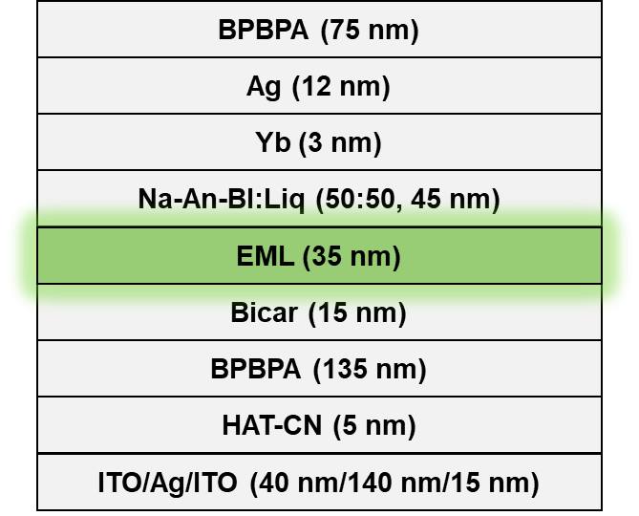
Figure S15. Device structure of the TE-OLED.

Table S2. Summary of photoluminescence spectra data in different polar solvents.
solvent | BN-Phen |  | BN-Tpl |  | BN-Tpl-Ph
 | λ_{em}  [nm] | FWHM  [nm/eV] | λ_{em}  [nm] | FWHM  [nm/eV] | λ_{em}  [nm] | FWHM  [nm/eV]
n-hexane | 512 | 19/0.089 | 508 | 18/0.084 | 507 | 17/0.084
Toluene | 519 | 22/0.101 | 514 | 20/0.094 | 515 | 20/0.092
THF | 523 | 25/0.114 | 518 | 23/0.107 | 518 | 22/0.102
DCM | 528 | 31/0.137 | 524 | 29/0.129 | 524 | 28/0.127

Table S3. Summary of photophysical properties of BN-Naph, BN-Phen, BN-Tpl and BN-Tpl-Ph in DMIC-TRZ film (3 wt%) at 298 K.
Compound | λ_{em}  (nm) | FWHM  (nm) | Φ_{PL}  (%) | τ_{p}  (ns) | τ_{d}  (μs) | η_{p}  (%) | η_{d}  (%) | k_{r}  (× 10⁷ s⁻¹) | k_{ISC}  (× 10⁸ s⁻¹) | k_{RISC}  (× 10⁵ s⁻¹)
BN-Naph | 539 | 29 | 89 | 4.0 | 582.5 | 24.5 | 75.5 | 5.5 | 1.9 | 0.066
BN-Phen | 524 | 25 | 95 | 18.5 | 33.4 | 21.7 | 78.3 | 3.0 | 1.1 | 1.4
BN-Tpl | 521 | 23 | 93 | 12.0 | 32.0 | 18.6 | 81.4 | 3.0 | 1.4 | 1.7
BN-Tpl-Ph | 519 | 22 | 94 | 14.2 | 35.6 | 16.5 | 83.5 | 3.1 | 1.7 | 1.7

Table S4. Summary of electrochemical and thermal properties of BN-Phen, BN-Tpl, and BN-Tpl-Ph.
Emitter | HOMO  (eV) | LUMO  (eV) | T_{d}  (°C) | T_{g}  (°C)
BN-Phen | -5.18 | -2.80 | 448 | 178
BN-Tpl | -5.18 | -2.80 | 472 | 179
BN-Tpl-Ph | -5.21 | -2.81 | 497 | n.d.

Table S5. Summary of energy transfer parameters of the ternary-emitting systems.
Compound | k_{FRET} (10⁶ s⁻¹) | Φ_{FRET} (%) | R₀ (nm) | R_{hg} (nm)
BN-Phen | 8.60 | 93.2 | 6.31 | 4.28
BN-Tpl | 7.10 | 92.0 | 6.34 | 4.44
BN-Tpl-Ph | 8.24 | 93.0 | 6.58 | 4.49

IX. Copies of NMR and HRMS Spectra
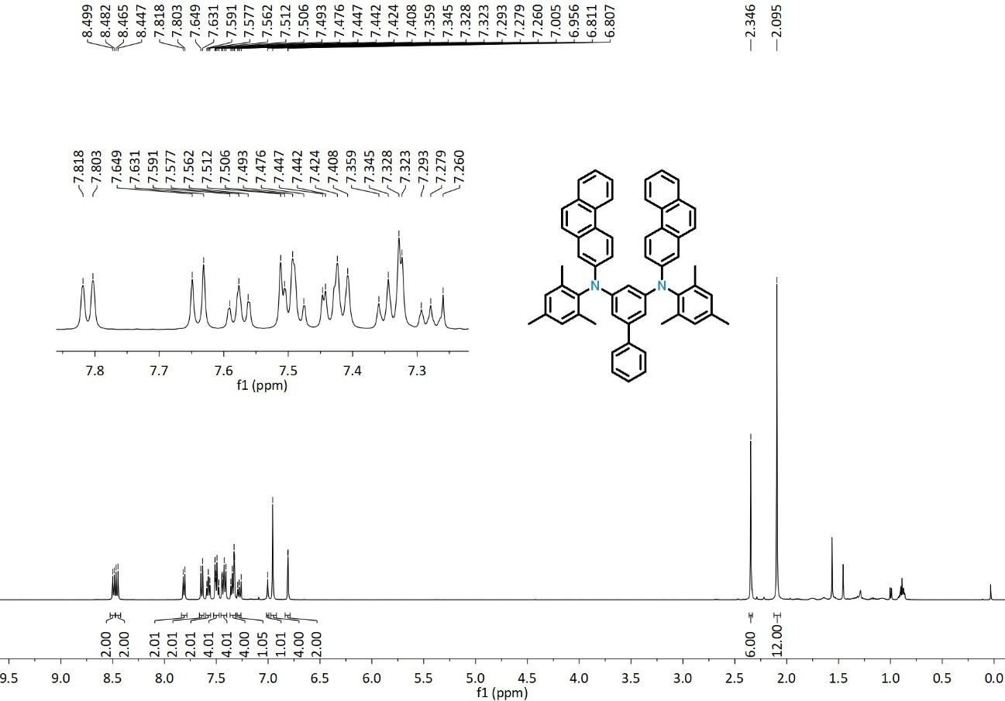
Figure S16. ¹H NMR spectrum of 2a (CDCl₃).
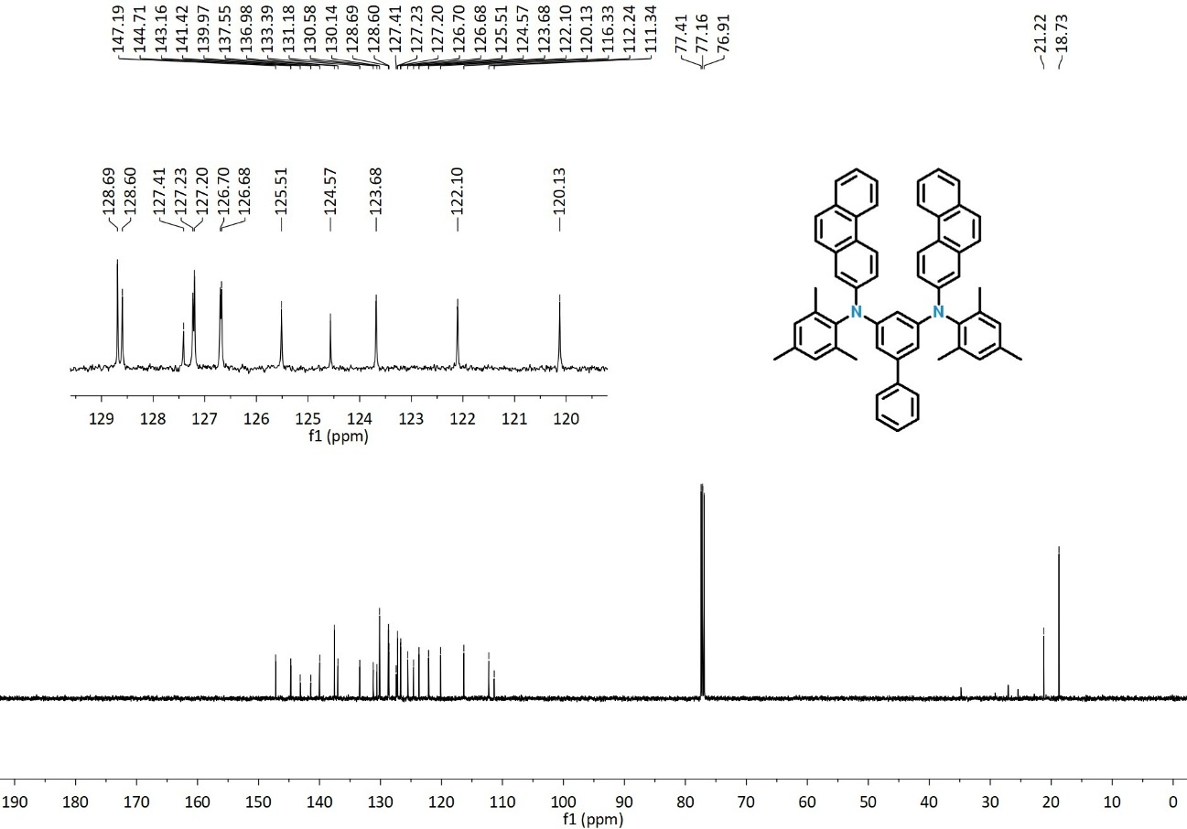
Figure S17. ¹³C NMR spectrum of 2a (CDCl₃).
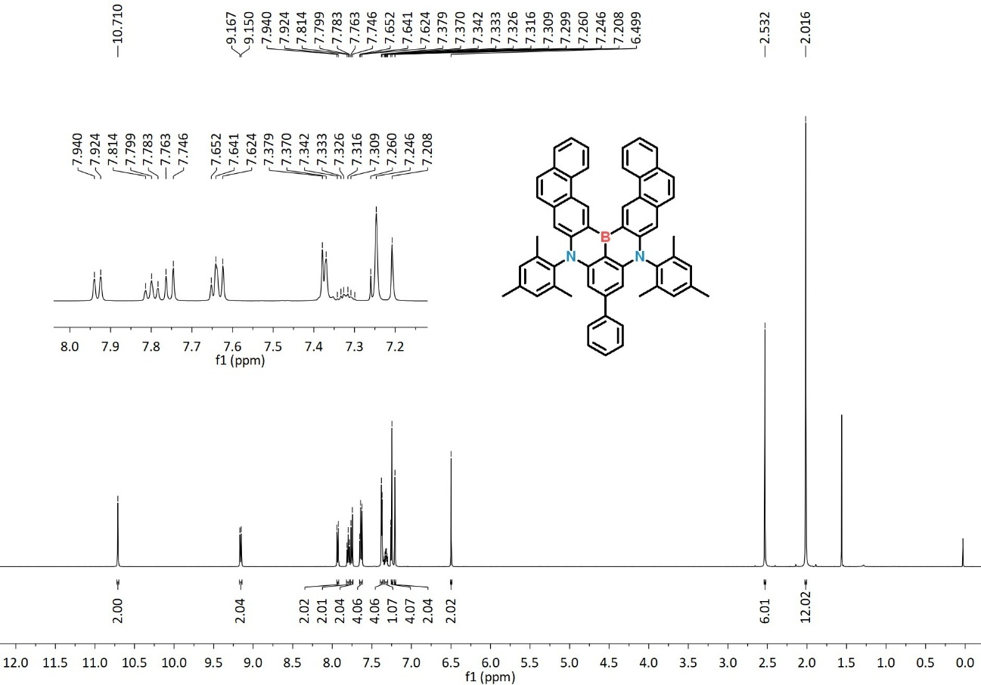
Figure S18. ¹H NMR spectrum of BN-Phen (CDCl₃).
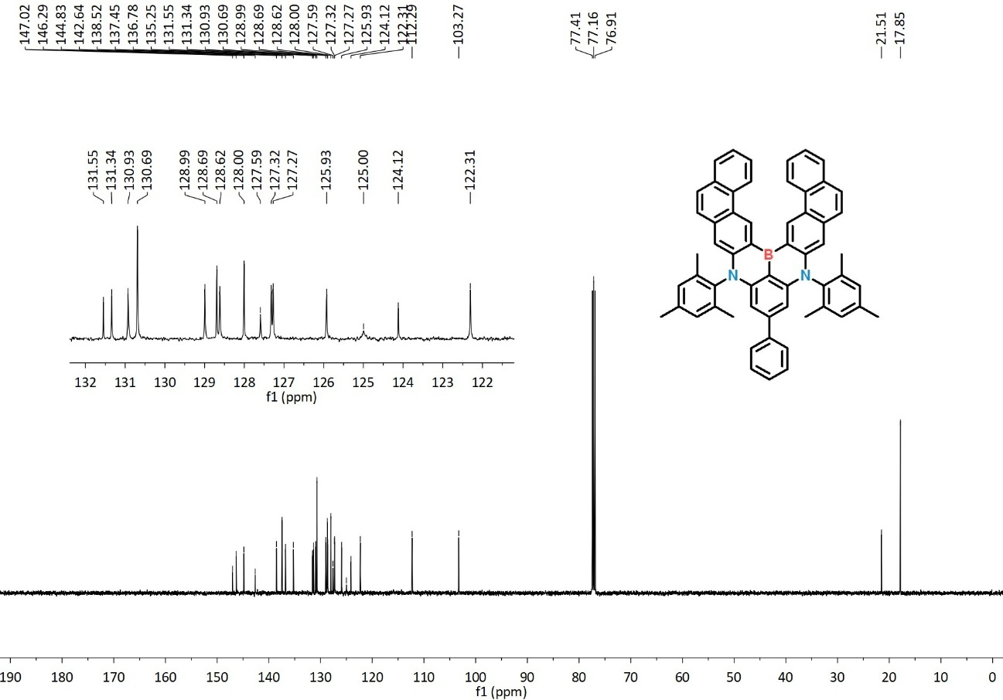
Figure S19. ¹³C NMR spectrum of BN-Phen (CDCl₃).
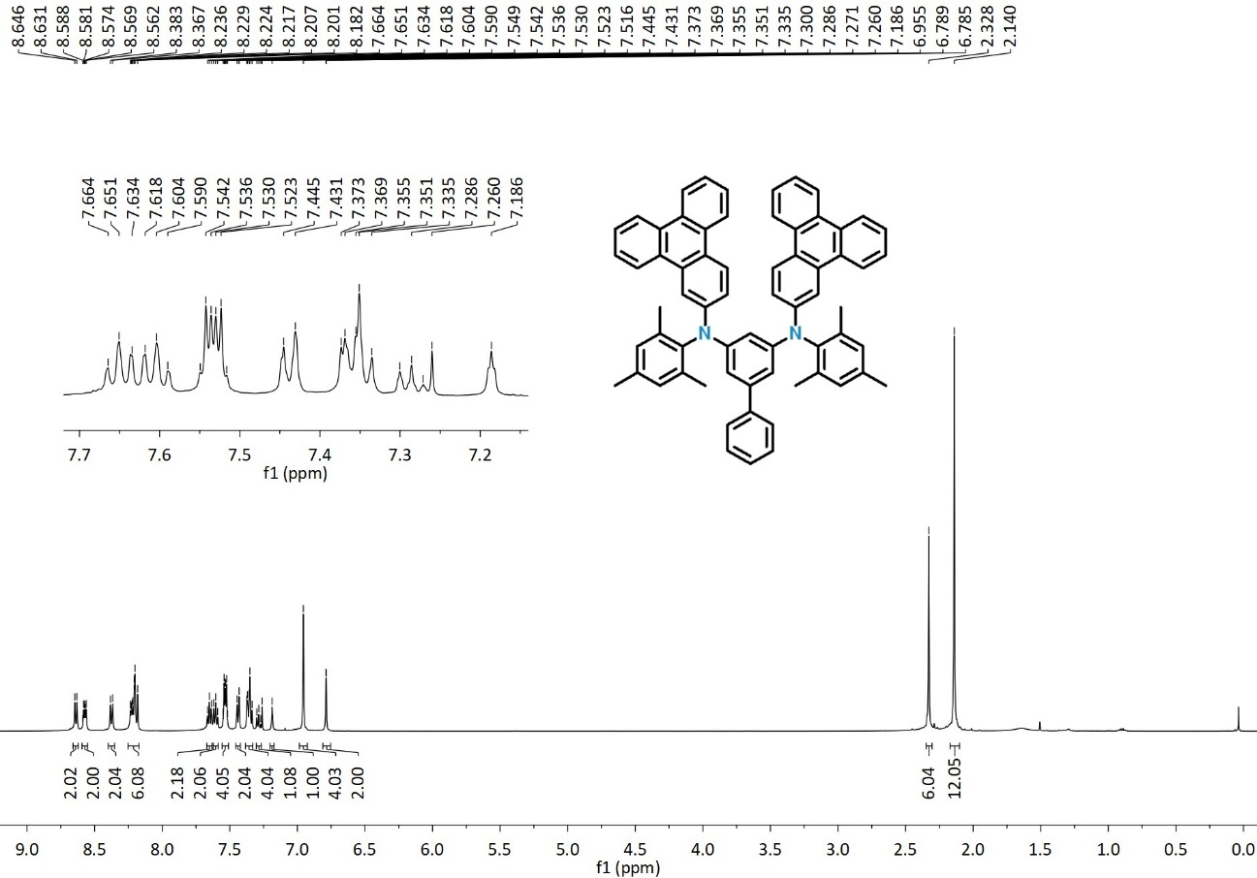
Figure S20. ¹H NMR spectrum of 2b (CDCl₃).
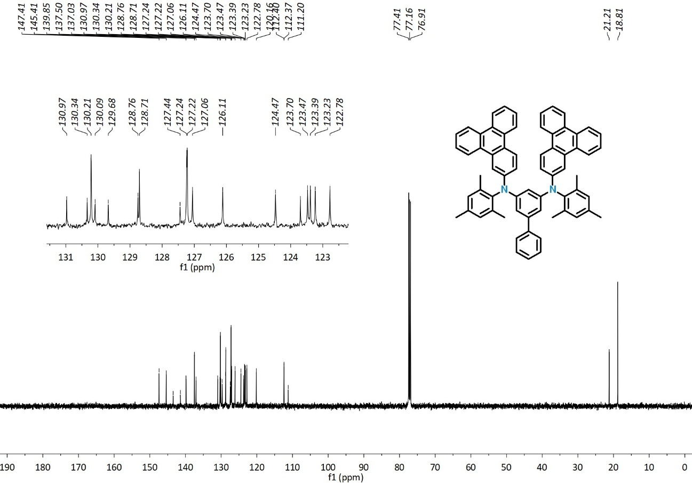
Figure S21. ¹³C NMR spectrum of 2b (CDCl₃).
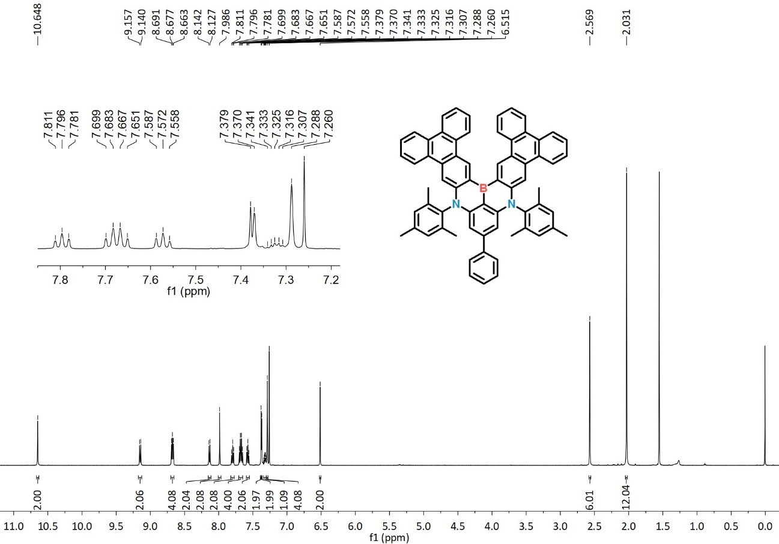
Figure S22. ¹H NMR spectrum of BN-Tpl (CDCl₃).
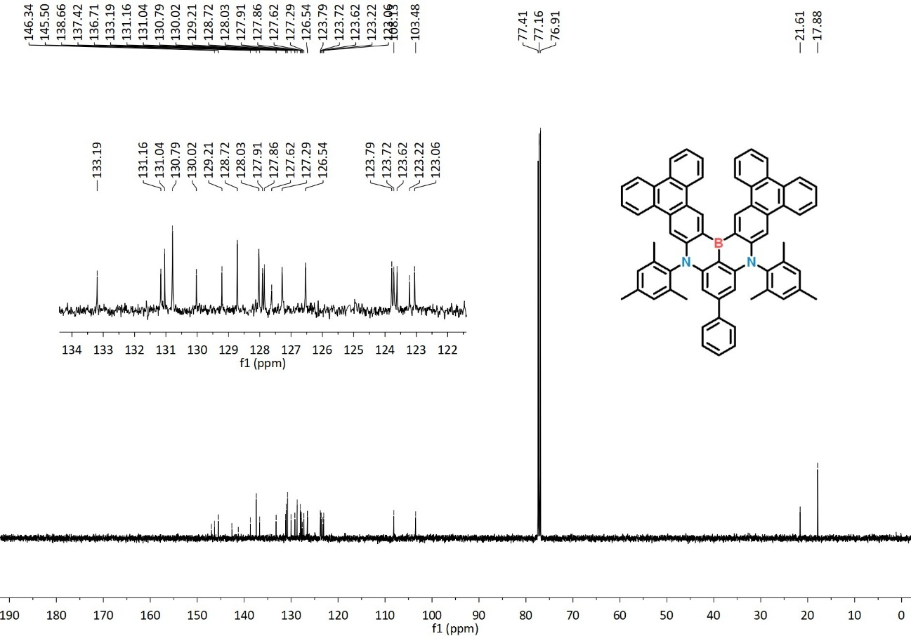
Figure S23. ¹³C NMR spectrum of BN-Tpl (CDCl₃).
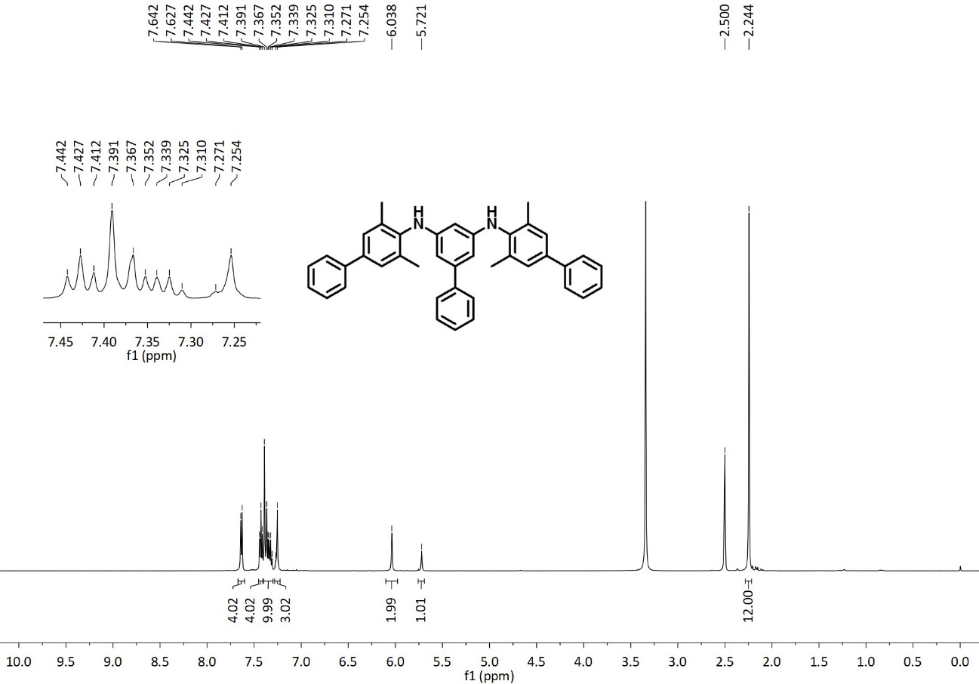
Figure S24. ¹H NMR spectrum of 1b (DMSO-d₆).
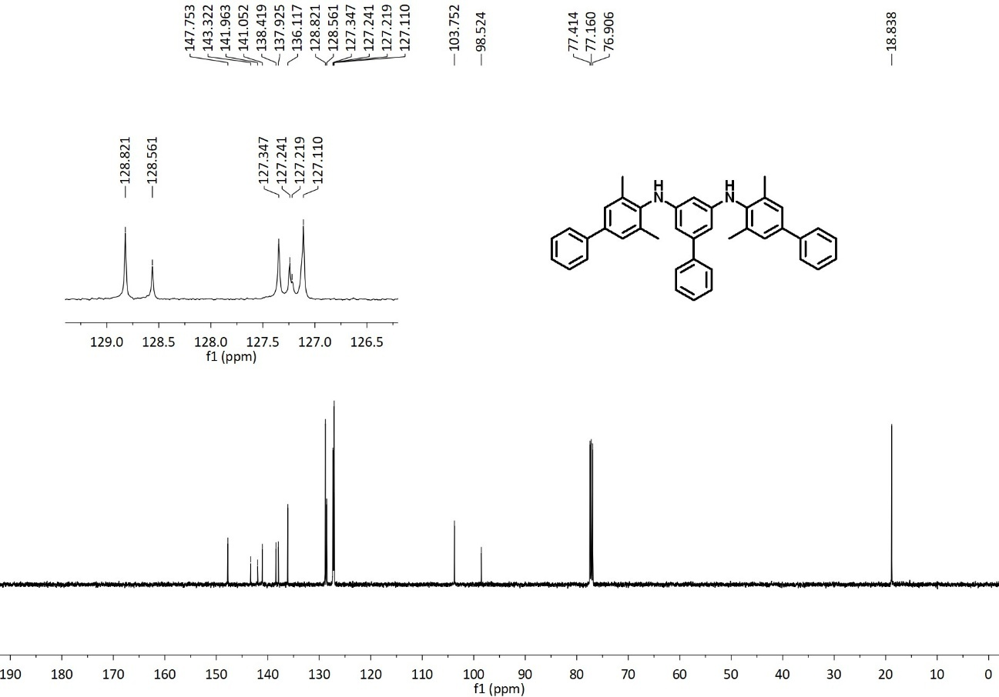
Figure S25. ¹³C NMR spectrum of 1b (DMSO-d₆).
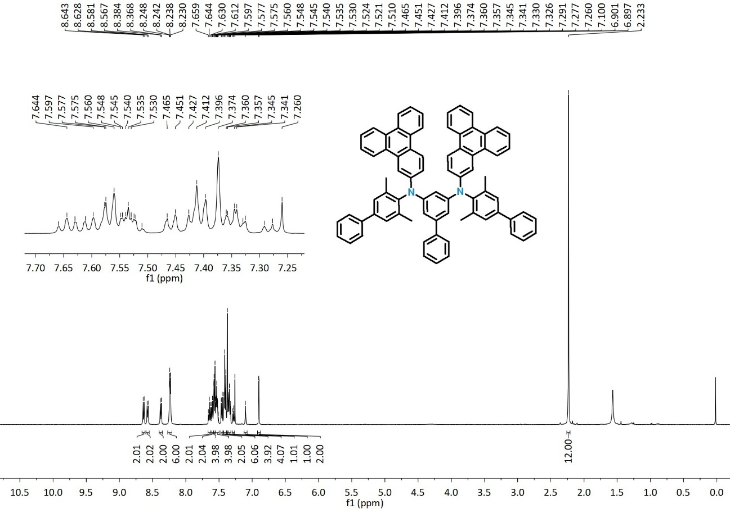
Figure S26. ¹H NMR spectrum of 2c (CDCl₃).
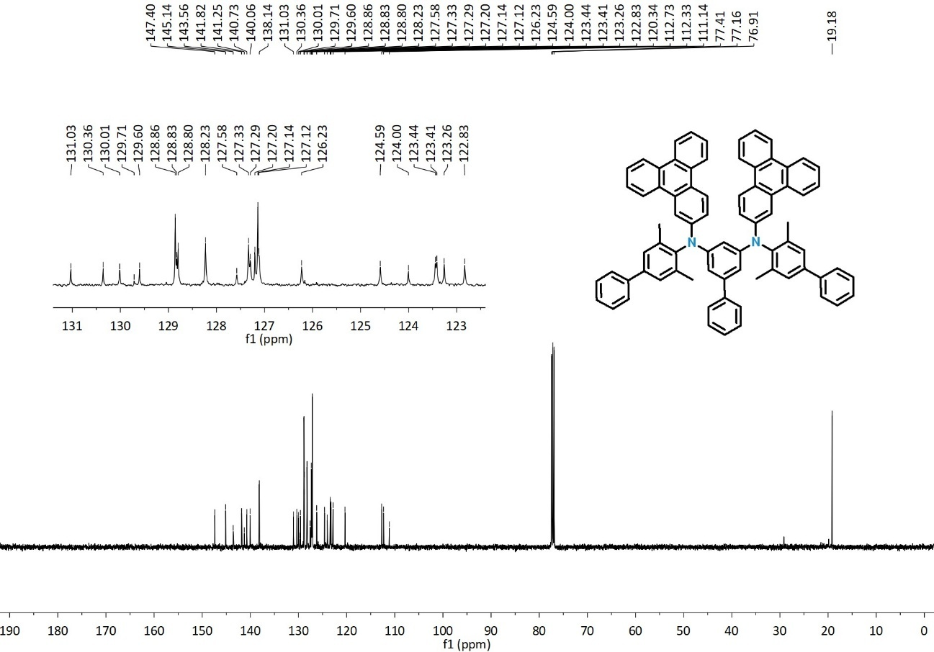
Figure S27. ¹³C NMR spectrum of 2c (CDCl₃).
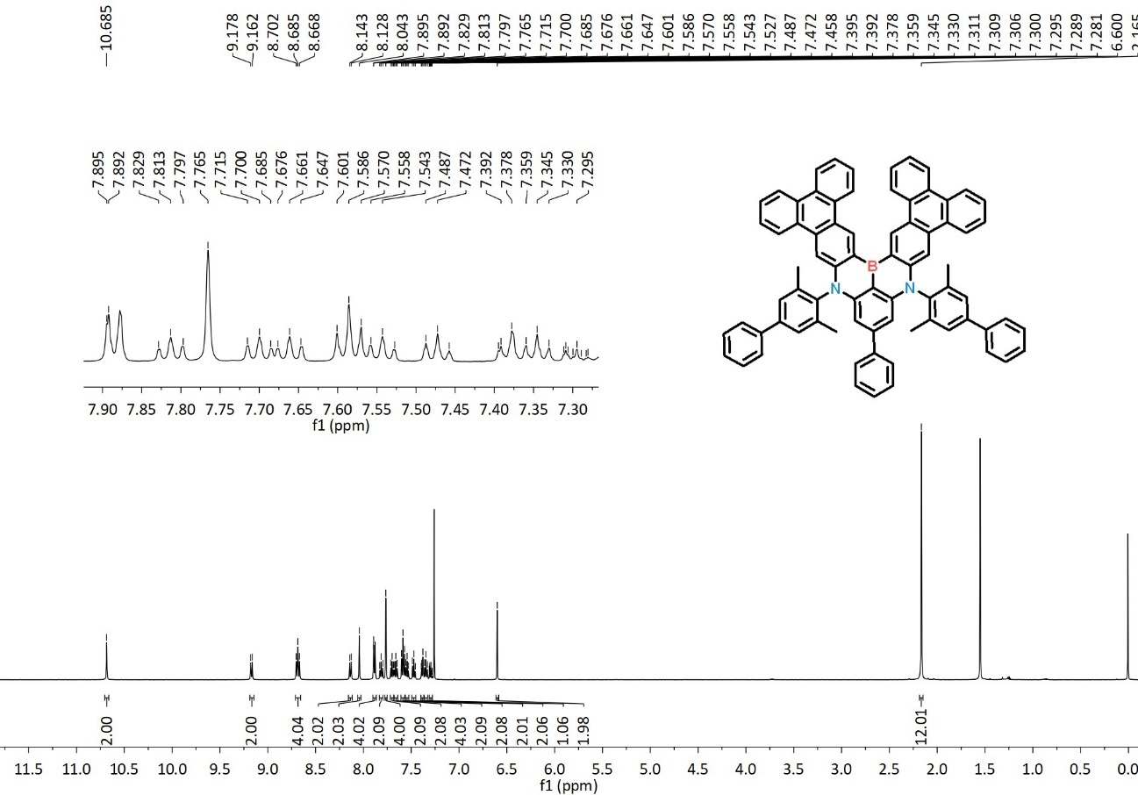
Figure S28. ¹H NMR spectrum of BN-Tpl-Ph (CDCl₃).
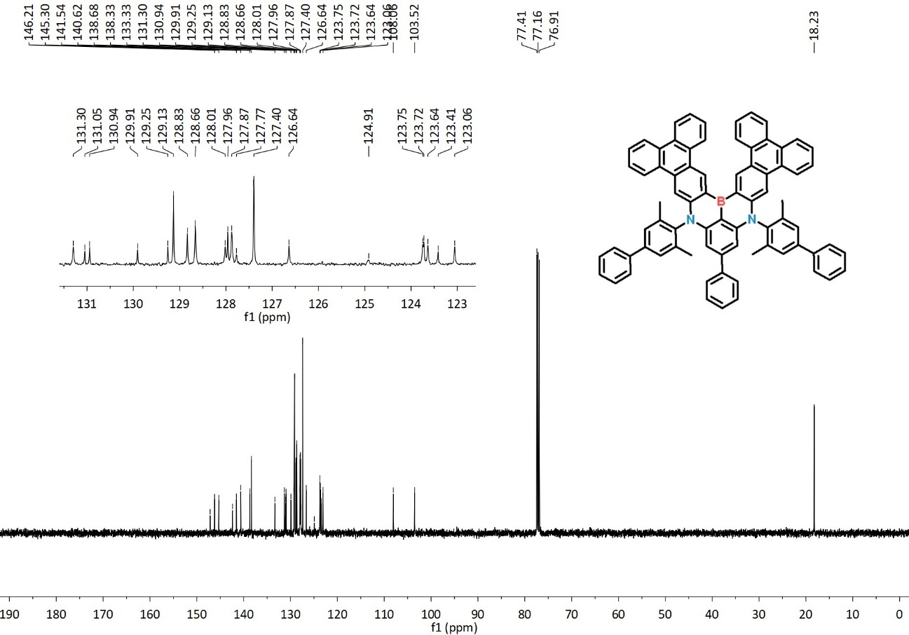
Figure S29. ¹³C NMR spectrum of BN-Tpl-Ph (CDCl₃).
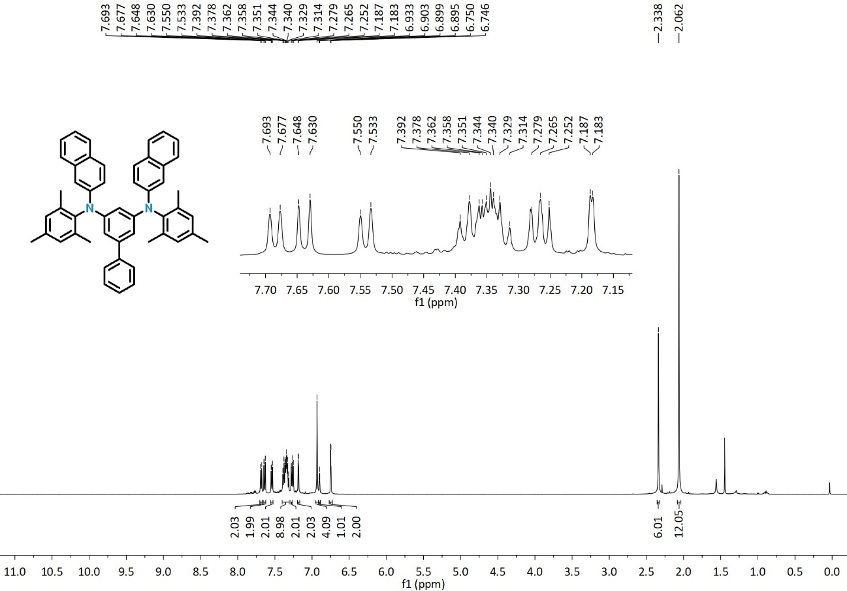
Figure S30. ¹H NMR spectrum of 2b (CDCl₃).
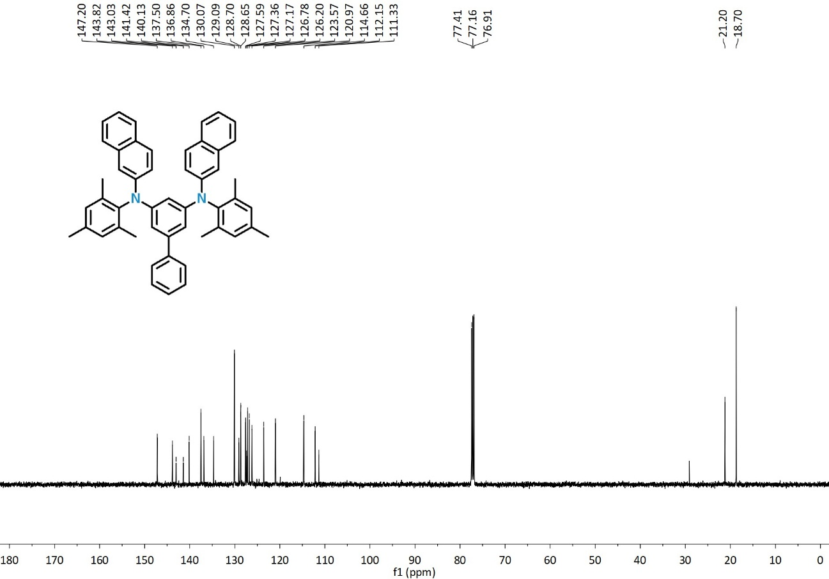
Figure S31. ¹³C NMR spectrum of 2b (CDCl₃).
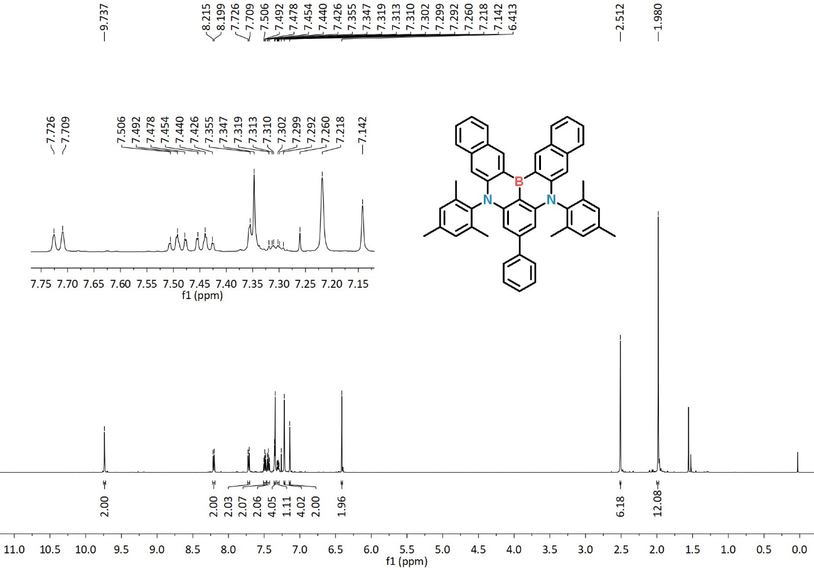
Figure S32. ¹H NMR spectrum of BN-Tpl (CDCl₃).
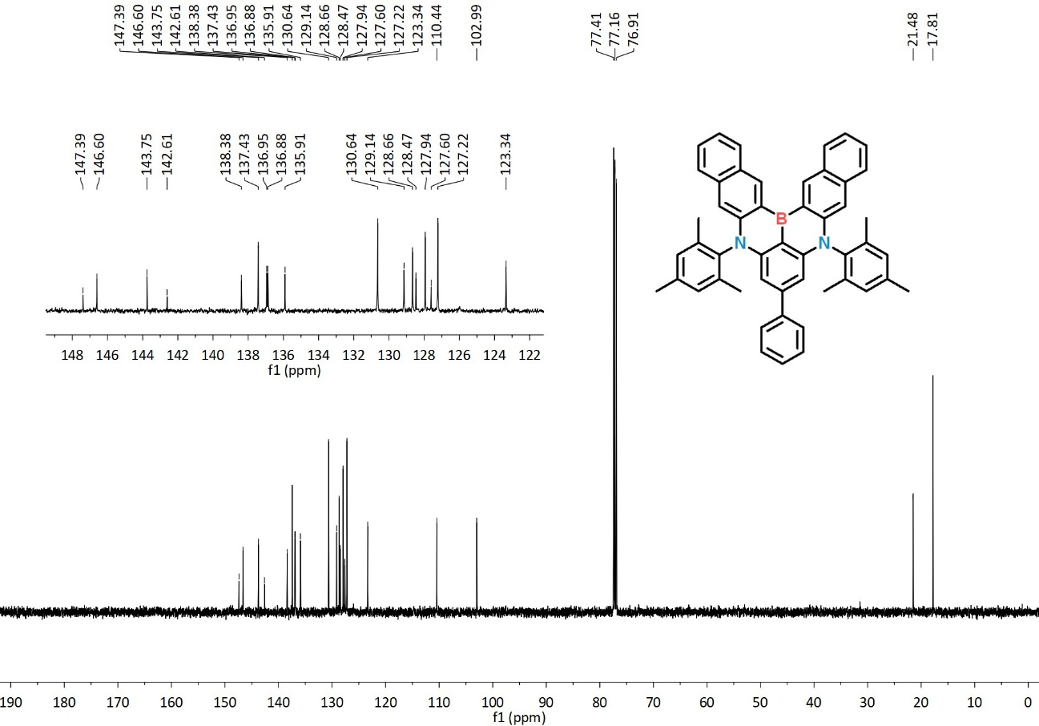
Figure S33. ¹³C NMR spectrum of BN-Tpl (CDCl₃).
Figure S34. HRMS spectrum of BN-Phen.
Figure S35. HRMS spectrum of BN-Tpl.
Figure S36. HRMS spectrum of BN-Tpl-Ph.
Figure S37. HPLC chromatogram of BN-Phen.
Figure S38. HPLC chromatogram of BN-Tpl.
Figure S39. HPLC chromatogram of BN-Tpl-Ph.

X. References
- K. Masui, H. Nakanotani, C. Adachi, Org. Electron. 2013, 14, 2721.
- Y. Kawamura, J. Brooks, J. J. Brown, H. Sasabe, C. Adachi, Phys. Rev. Lett. 2006, 96, 017404.
- Y.-Y. Jing, N. Li, X. Cao, H. Wu, J. Miao, Z. Chen, M. Huang, X. Wang, Y. Hu, Y. Zou, C. Yang, Sci. Adv. 2023, 9, eadh8296.

