Supplement 1: Reciprocal Angular Transport Explains the Limited Benefit of Mixing in OLED Light Extraction
Supporting information for the main manuscript

Notes S1–S4 support the spectral metrics: model details, the devices and the 38 structures, accuracy and convergence, and the separation of mixing from escape. Notes S5–S8 support the freeform-versus-hemisphere case study, Note S9 reports direct ray tracing and an out-of-sample test, Note S10 gives the estimators and numerical diagnostics, and Note S11 compares mixing at the escape surface with mixing at the device side. Main-text references are cited as "main ref. n".

Note S1 | Model details and numerical checks
Polarization and azimuth. The transport model is scalar. R(θ) is the polarization average (|r_{s}|²+|r_{p}|²)/2 of the stack reflectance, v⁽⁰⁾ is the sum of the s- and p-polarized power launched into the substrate, and the tracers apply the unpolarized Fresnel coefficients at every encounter. Textures that are not axisymmetric (hexagonal arrays, supercells, wavy fields) are reduced to a polar-angle kernel by launching rays at the centre angle of each 1° bin, uniformly over the cell and in azimuth, and binning the exit directions by polar angle only; B_{R} is the position- and azimuth-averaged return operator.
Full series. η_{sta} is obtained by a direct linear solve on the full 0–90° grid. Over all cases the spectral radius of diag R B_{R} stays below 0.9991, the residual below 10⁻¹⁶, and a pass-by-pass sum agrees with the solve to 10⁻¹⁴.
Angular cutoff. Bins near 90° carry almost no étendue but can return light at their own angle, and a few such states can dominate λ₂ without affecting extraction. The spectral metrics are therefore evaluated on θ < 85°, which excludes 0.76% of the étendue and less than 0.1% of v⁽⁰⁾: B_{R} is restricted to these bins, M is formed by renormalizing the columns of the sub-block, and ρ is taken from the sub-block. η_{sta}, in the full series and in the reduced model, always uses 0–90°. On the full domain detailed balance gives the stationary distribution of M as π ∝ w(1−p). The renormalized sub-block has stationary distribution π^{(S)}_{i} ∝ w_{i} s_{i} instead, with s_{i} = Σ_{j<85°} B_{R}(i→ j) the fraction returned into the retained bins, because Σ_{i} [B_{R}(i→ j)/s_{i}] w_{i} s_{i} = Σ_{i} w_{j} B_{R}(j→ i) = w_{j} s_{j}; s_{i} differs from 1−p_{i} by the light returned beyond the cutoff (up to 0.25 in the bins next to 85° for the hemispherical MLA). The reduced model and the closed-form reference use q ∝ w(1−p) on the full domain; only the spectral metrics use the truncated chain. For every structure λ₂ is real and positive (0.09–0.88), so |λ₂| = λ₂. N_{mix} is the relaxation time, not the e-folding pass number −1/lnλ₂ (2 against 1.44 at λ₂ = 0.5).
Table S1 | Sensitivity of |λ₂| to the angular range.
Structure | 0–90° | 0–85° | 0–80° | 0–70° | weight of second eigenvector above 80°
hemispherical MLA (total-EQE height) | 0.876 | 0.859 | 0.846 | 0.840 | 0.23
freeform MLA (40–60° optimum) | 0.941 | 0.867 | 0.689 | 0.532 | 0.49
random lenslet shapes, s = 0.2 | 0.679 | 0.628 | 0.514 | 0.419 | 0.30
random lenslet heights, spread 0.2 | 0.935 | 0.859 | 0.826 | 0.787 | 0.46

For the freeform 40–60° lens and height-randomized hemispheres the full-range value is set by grazing states (N_{mix} of the 40–60° freeform MLA: 7.5 at 85°, 17 at 90°). The reduced-model error depends little on the cutoff between 80° and 85° and grows above it, when grazing states start to dominate λ₂:
Cutoff | mean error (pp) | max error (pp) | hemispherical MLA | freeform MLA | random MLA | wavy | scattering
80° | 0.32 | 3.02 | 0.21 | 0.64 | 0.20 | 0.66 | 0.29
85° | 0.30 | 2.99 | 0.26 | 0.60 | 0.16 | 0.67 | 0.29
88° | 0.40 | 3.55 | 0.38 | 0.95 | 0.25 | 0.67 | 0.30
90° | 0.55 | 4.72 | 0.45 | 1.16 | 0.52 | 0.68 | 0.30

(class columns: mean error in pp over three devices and three wavelengths). The cutoff therefore controls the influence of physically minor states (0.76% of the étendue, less than 0.1% of v⁽⁰⁾) rather than tuning the accuracy, which is within 0.02 pp of its best value anywhere between 80° and 85°. The absolute values of N_{mix} and ξ depend on the cutoff (ξ of the hemispherical MLA is 0.65, 0.47, and 0.31 at 80°, 85°, and 90°), whereas the relative ranking is largely preserved: the rank correlation with the 85° values is 0.96–0.99 for N_{mix} and 0.90–0.98 for ξ at 80°, 88°, and 90° (Table S6).
Detailed balance of the traced matrices. The relative asymmetry Σ|F-F^{T}|/Σ|F| of F_{ji} = w_{i} B_{R}(i→ j) is 0.05–0.13 on 1° bins, 0.009–0.024 on 5° bins, and 0.002–0.007 on 15° bins, falling as expected for Monte Carlo noise; the planar matrix is exactly symmetric. Symmetrizing F while keeping each column sum changes N_{mix} by at most 0.20 (2.7%), ξ by 0.005, η_{sta} by 0.04 pp, and the reduced-model error by 0.04 pp over all 37 non-planar structures and three devices.
Reciprocal redistribution. For B_{R}(i→ r) = (1−p_{i})[(1−m)δ_{ir} + m q_{r}], detailed balance of the mixing term requires w_{i}(1−p_{i})q_{r} = w_{r}(1−p_{r})q_{i}, i.e. q ∝ w(1−p). The normalized kernel (1−m)I + m q1^{T} has eigenvalues 1 and 1−m, so m = 1−λ₂ for any q.
Complete reciprocal mixing. With q_{r} = w_{r}(1−p_{r})/Σ_{k} w_{k}(1−p_{k}), p_{mix} = Σ_{r} q_{r} p_{r} = (p − ⟨ p²⟩)/(1−p) = p − σ_{p}²/(1−p), where ⟨·⟩ is the étendue-weighted mean; p_{mix} ≤ p is the Cauchy–Schwarz inequality p² ≤ ⟨ p²⟩. The rank-one kernel B_{R} = q(1−p)^{T} with diag R gives (I-uv^{T})⁻¹ = I + uv^{T}/(1−v^{T}u) with u_{k} = R_{k} q_{k}, v = 1−p, hence the closed form of main-text Sec. 2.4; it agrees with the numerical series to 10⁻⁹ for all 342 cases. Values for every structure are in selectivity/data/reciprocal_limit.json; p_{mix}/p is 0.87–0.91 for hemispherical MLAs, 0.81–0.87 for freeform MLAs, 0.84–0.93 for random MLAs, 0.37–0.90 for wavy surfaces, 0.59–0.99 for scattering layers, and 0.14 for the planar interface.
Reciprocity alone does not bound the efficiency. The complete-mixing kernel is the only reciprocal rank-one kernel with given p(θ), but other reciprocal kernels exist. Two states with w = (1, 1), p = (0.4, 0), R = 0.8, and all light launched into the second state give, for the rank-one kernel B = [[0.225, 0.375], [0.375, 0.625]], η = 0.375; the kernel [[0, 0.6], [0.6, 0.4]] has the same column sums and is also reciprocal, yet sends all light returned from the trapped state into the escaping one and gives η = 0.427. η_{mix} is therefore a reference, not a bound; among the structures studied, only two wavy surfaces exceed it, by at most 0.4 pp.
Bounds on p∞. With D = diag(w), D^{−1/2}B_{R} D^{1/2} is symmetric, so ρ(B_{R}) is the maximum of its Rayleigh quotient. With x = D^{1/2}1 the quotient is Σ_{i,r} w_{i} B_{R}(i→ r)/Σ_{i} w_{i} = 1−p̃, both sums running over the bins below the cutoff; hence p∞ ≤ p̃. p̃ is the probability that uniform-radiance light leaves the truncated chain in one encounter, by escape or by return beyond the cutoff, and exceeds p by less than 0.008. The column sums are 1−p(θ_{i}), so p∞ ≥ min_{θ} p(θ). All 37 non-planar structures satisfy both bounds, with smallest margins of 0.0014 (upper) and 0.106 (lower); the planar interface meets the lower bound with equality. With p in place of p̃ the upper bound would fail for the thick scattering layer (τ* = 4) by 0.005. ξ is a structure-only descriptor; the device-aware variant 1−ρ(diag R B_{R}) ranks the structures like p∞ (Spearman 0.956, Al, 550 nm). A two-parameter reciprocal kernel fitted to both λ₂ and ρ, and a two-rate scalar formula, were not more accurate overall than the one-parameter model (0.32 pp mean) and are not used.
Band-resolved bound. The substrate bins are sorted by radiance v⁽⁰⁾_{k}/w_{k}; the étendue of an air band, mapped into the substrate by Snell's law, is (sin²θ_{hi}−sin²θ_{lo})/n² in units of w, and it is filled with the brightest bins first, the last one fractionally. The bound is lossless, polarization-independent, and integrated over azimuth. Each band's bound is a separate maximum, so the per-band bounds (sum 0.676) do not add up to the bound for the whole hemisphere (0.540), which fills the étendue 1/n² once; the uniform-radiance bound is additive (0.439, of which 0.014 lies above 80°).

Note S2 | Devices and the 38 structures
Devices. The emitters form a single dipole sheet at the centre of the 25 nm birefringent EML (measured ordinary and extraordinary indices), with a horizontal dipole ratio of 0.865 (Table S2, Fig. S1).
Table S2 | Device stacks (from the cathode to the substrate).
Device | Cathode | ETL | EML | HTL-side layers | Anode | Substrate | A' at 550 nm
Al | Al 100 nm | B3PyMPM 61.3 nm | TCTA:B3PyMPM:Ir(dmppy-ph)₂tmd 25 nm | TCTA 10 nm / TAPC 97.5 nm | ITO 150 nm | glass, n = 1.51 | 0.167
Ag | Ag 100 nm | B3PyMPM 61.3 nm | as Al | TCTA 10 nm / TAPC 97.5 nm | ITO 150 nm | glass, n = 1.51 | 0.044
Low loss | Ag 100 nm | B3PyMPM 200 nm | as Al | TAPC 180 nm | ITO 50 nm | glass, n = 1.51 | 0.026

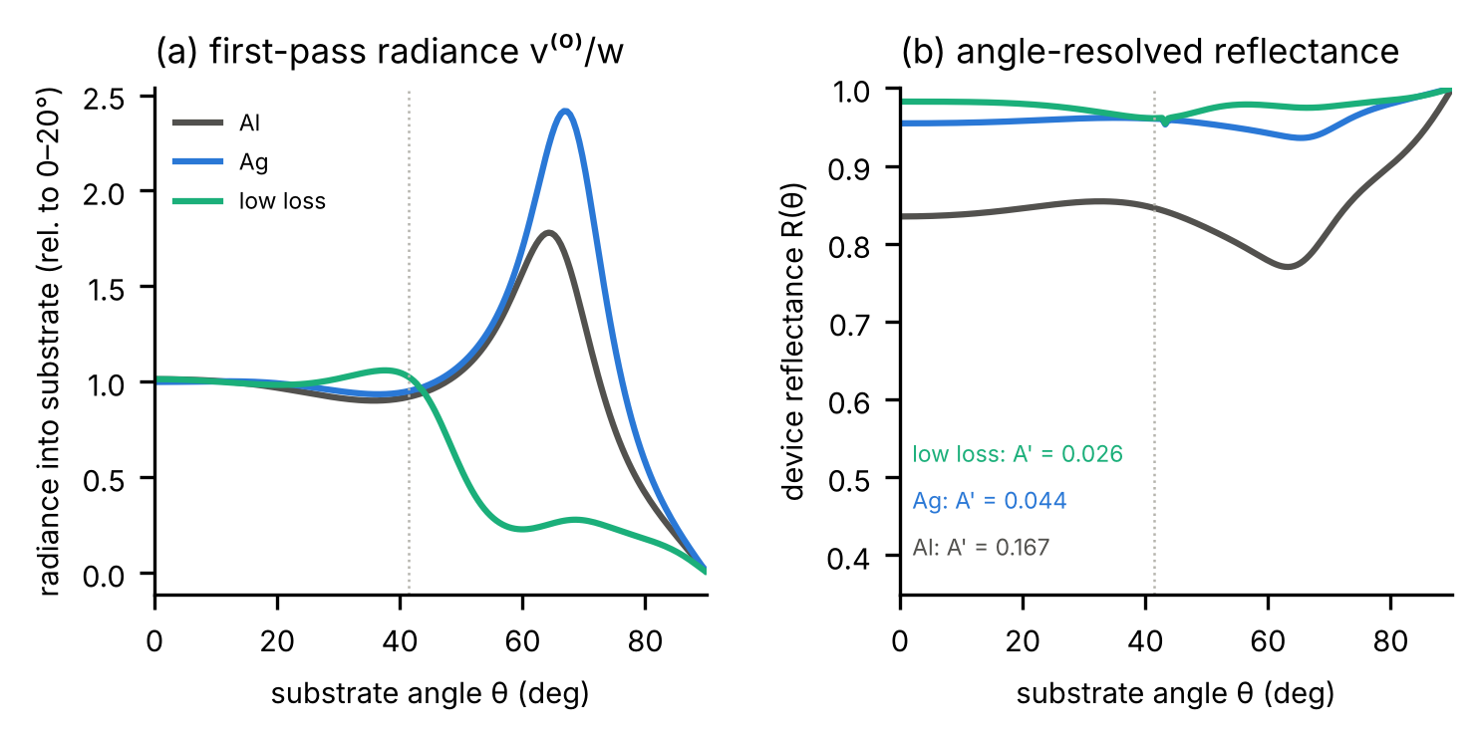
Fig. S1 | Device inputs at 550 nm. (a) Radiance launched into the substrate on the first pass, v⁽⁰⁾_{k}/w_{k}, relative to its mean over 0–20°. (b) Angle-resolved reflectance R(θ) seen from the substrate, with the uniform-radiance round-trip loss A'. Dotted line, critical angle of the glass/air interface.
Height-field tracer. The surface z = h(x, y) separates the index-matched medium (n = 1.51) from air; rays are marched with a Lipschitz-safe step, refined by bisection, and reflected or refracted with the unpolarized Fresnel coefficients. 20,000 rays per 1° incidence bin are used (10,000 for wavy surfaces). For a hemispherical lenslet the tracer reproduces the LightTools return matrix of main ref. 14: escape probability 0.4275 against 0.4274, transmittance within 0.008 at every angle, and fewer than 0.1% of rays undetermined. The freeform profiles are rebuilt from the optimized control points with a PCHIP spline.
Random lens arrays tile a 6 × 6 supercell periodically. Shape spread s perturbs the five control points of the quarter circle by Gaussian noise of standard deviation 0.25s (radial) and 0.4s (height), so that s = 1 approaches independent profiles; height spread scales each lenslet by 1± s; position jitter displaces each centre by up to a fraction of the pitch, optionally with ±20% radius spread. Where lenslets overlap the higher surface is taken; profiles with near-vertical walls are rejected. Wavy surfaces are periodic Gaussian-correlated height fields on a 12 × 12 box (correlation length one), scaled to a prescribed rms slope; only the slope statistics matter in ray optics. Scattering layers are non-absorbing, index-matched Henyey–Greenstein slabs (20,000 rays per 0.5° bin) combined with the flat exit face by the adding method.
Table S3 | The 38 structures at 550 nm. p: escape probability for uniform radiance; N_{mix} and p∞ on θ < 85°; ξ = p∞/p̃; η: full series for the Al, Ag, and low-loss (LL) devices; S_{40–60}: 40–60° share of the multi-pass output (Al); last two columns: reciprocal and isotropic (q ∝ w) reduced model minus full series (Al). A, lenslet shape spread s; B, height spread ±s; C, position jitter (fraction of the pitch); C2, as C with ±20% radius spread; W, wavy surface of the given rms slope. Scattering layers are labelled by g and τ*, MLAs by the benchmark objective of the optimum they reproduce.
Structure | p | N_mix | p∞ | ξ | η Al | η Ag | η LL | S40–60 (Al) | err. recip. Al (pp) | err. q∝w Al (pp)
planar | 0.398 | ∞ | 0.000 | 0.00 | 0.384 | 0.356 | 0.664 | 0.334 | -0.00 | -0.00
scatter g0.0_t0.25 | 0.381 | 2.2 | 0.212 | 0.54 | 0.675 | 0.874 | 0.945 | 0.349 | -2.07 | +4.21
scatter g0.0_t1.0 | 0.324 | 1.1 | 0.309 | 0.93 | 0.725 | 0.907 | 0.949 | 0.353 | -0.10 | +1.24
scatter g0.8_t0.25 | 0.386 | 1.2 | 0.320 | 0.81 | 0.749 | 0.914 | 0.959 | 0.359 | -0.19 | +3.04
scatter g0.8_t1.0 | 0.326 | 1.2 | 0.326 | 0.98 | 0.737 | 0.913 | 0.951 | 0.354 | -0.08 | +0.34
scatter g0.9_t1.0 | 0.326 | 1.2 | 0.326 | 0.98 | 0.738 | 0.913 | 0.951 | 0.354 | -0.10 | +0.29
scatter g0.8_t4.0 | 0.188 | 1.2 | 0.194 | 0.99 | 0.579 | 0.838 | 0.901 | 0.353 | -0.06 | +0.14
MLA free_20-40 | 0.429 | 3.8 | 0.251 | 0.58 | 0.788 | 0.925 | 0.967 | 0.352 | -0.69 | +0.32
MLA free_40-60 | 0.425 | 7.5 | 0.167 | 0.39 | 0.789 | 0.929 | 0.961 | 0.360 | -1.11 | -0.44
MLA free_60-80 | 0.417 | 3.0 | 0.337 | 0.79 | 0.785 | 0.929 | 0.966 | 0.349 | -1.46 | -0.21
MLA free_total | 0.424 | 4.6 | 0.199 | 0.46 | 0.771 | 0.914 | 0.961 | 0.341 | -0.89 | +0.44
MLA hemi_0-20 | 0.423 | 7.3 | 0.190 | 0.44 | 0.790 | 0.924 | 0.964 | 0.328 | -0.38 | +0.13
MLA hemi_20-40 | 0.422 | 7.0 | 0.203 | 0.47 | 0.793 | 0.926 | 0.964 | 0.327 | -0.21 | +0.23
MLA hemi_40-60 | 0.425 | 8.0 | 0.181 | 0.42 | 0.783 | 0.920 | 0.965 | 0.339 | -0.64 | -0.03
MLA hemi_60-80 | 0.420 | 6.2 | 0.214 | 0.50 | 0.792 | 0.926 | 0.965 | 0.331 | -0.24 | +0.20
MLA hemi_total | 0.422 | 7.1 | 0.199 | 0.47 | 0.792 | 0.925 | 0.964 | 0.327 | -0.27 | +0.19
A_shape0.0 | 0.422 | 7.0 | 0.214 | 0.50 | 0.794 | 0.927 | 0.965 | 0.328 | -0.15 | +0.24
A_shape0.1 | 0.421 | 3.8 | 0.279 | 0.65 | 0.797 | 0.931 | 0.966 | 0.336 | -0.30 | +0.27
A_shape0.2 | 0.421 | 2.7 | 0.334 | 0.78 | 0.799 | 0.934 | 0.966 | 0.349 | -0.28 | +0.39
A_shape0.4 | 0.422 | 2.5 | 0.343 | 0.80 | 0.794 | 0.932 | 0.966 | 0.358 | -0.40 | +0.57
A_shape0.7 | 0.426 | 1.9 | 0.344 | 0.79 | 0.788 | 0.929 | 0.966 | 0.358 | -0.27 | +1.31
A_shape1.0 | 0.428 | 1.9 | 0.335 | 0.77 | 0.785 | 0.927 | 0.966 | 0.354 | -0.23 | +1.47
B_aspect0.2 | 0.422 | 7.1 | 0.184 | 0.43 | 0.795 | 0.928 | 0.965 | 0.328 | -0.20 | +0.18
B_aspect0.4 | 0.422 | 6.0 | 0.215 | 0.50 | 0.797 | 0.930 | 0.966 | 0.332 | -0.18 | +0.20
B_aspect0.6 | 0.423 | 4.1 | 0.294 | 0.69 | 0.799 | 0.933 | 0.968 | 0.341 | -0.19 | +0.24
C2_jitter0.05_r20 | 0.421 | 4.2 | 0.281 | 0.66 | 0.798 | 0.931 | 0.966 | 0.331 | -0.12 | +0.34
C2_jitter0.1_r20 | 0.421 | 3.5 | 0.300 | 0.70 | 0.796 | 0.930 | 0.966 | 0.329 | -0.15 | +0.45
C2_jitter0.2_r20 | 0.420 | 3.7 | 0.294 | 0.69 | 0.799 | 0.932 | 0.966 | 0.335 | -0.13 | +0.35
C2_jitter0.3_r20 | 0.420 | 3.2 | 0.314 | 0.74 | 0.796 | 0.932 | 0.966 | 0.341 | -0.21 | +0.40
C_jitter0.05 | 0.421 | 6.2 | 0.215 | 0.50 | 0.796 | 0.928 | 0.965 | 0.328 | -0.15 | +0.25
C_jitter0.1 | 0.421 | 5.0 | 0.245 | 0.57 | 0.797 | 0.930 | 0.966 | 0.331 | -0.15 | +0.29
C_jitter0.2 | 0.421 | 3.9 | 0.281 | 0.66 | 0.798 | 0.932 | 0.966 | 0.336 | -0.18 | +0.32
C_jitter0.3 | 0.420 | 3.5 | 0.298 | 0.70 | 0.798 | 0.932 | 0.966 | 0.340 | -0.20 | +0.34
W_slope0.2 | 0.402 | 2.2 | 0.142 | 0.35 | 0.608 | 0.815 | 0.933 | 0.334 | -2.71 | +9.57
W_slope0.4 | 0.410 | 1.2 | 0.264 | 0.63 | 0.719 | 0.896 | 0.957 | 0.348 | -1.27 | +6.47
W_slope0.7 | 0.417 | 1.2 | 0.348 | 0.81 | 0.773 | 0.923 | 0.965 | 0.335 | -0.37 | +2.78
W_slope1.0 | 0.422 | 1.1 | 0.377 | 0.87 | 0.792 | 0.932 | 0.968 | 0.329 | -0.07 | +1.70
W_slope1.5 | 0.427 | 1.2 | 0.387 | 0.88 | 0.801 | 0.935 | 0.968 | 0.337 | -0.09 | +1.21

Note S3 | Accuracy and convergence
Table S4 | Error of the reduced and fully randomized models by structure class (pp; 342 cases, three devices, 500/550/600 nm).
Class | cases | reciprocal mean | reciprocal max | q ∝ w mean | q ∝ w max | fully randomized mean | fully randomized max
Planar | 9 | 0.00 | 0.00 | 0.00 | 0.00 | 44.05 | 59.89
Scattering layers | 54 | 0.29 | 2.49 | 0.96 | 4.67 | 1.83 | 11.14
Hemispherical and freeform MLAs | 81 | 0.41 | 2.09 | 0.38 | 2.22 | 3.45 | 12.33
Random lens arrays (A, B, C) | 153 | 0.16 | 0.51 | 0.44 | 1.93 | 2.41 | 10.89
Wavy, rms slope ≥ 0.7 | 27 | 0.19 | 1.06 | 1.11 | 3.07 | 1.61 | 5.57
Wavy, rms slope ≤ 0.4 | 18 | 1.40 | 2.99 | 5.40 | 10.51 | 8.66 | 21.73
All | 342 | 0.30 | 2.99 | 0.81 | 10.51 | 3.93 | 59.89

By device, the mean (maximum) reciprocal-model error is 0.41 (2.7) pp for Al, 0.33 (3.0) pp for Ag, and 0.16 (1.8) pp for the low-loss stack; by wavelength 0.38 (2.5), 0.29 (3.0), and 0.23 (2.6) pp at 500, 550, and 600 nm. The model tends to slightly underestimate η_{sta}.
Monte Carlo uncertainty. Ray noise was estimated by re-tracing with two further ray seeds, and realization spread by drawing two further geometries with the same statistics (Table S5). Ray noise is negligible; realization spread is at most 0.24 in N_{mix}, 0.021 in ξ, and 0.23 pp in η_{sta}, and changes the reduced-model error by at most 0.03 pp.
Table S5 | Monte Carlo uncertainty (550 nm). ±: standard deviation over three ray seeds; in parentheses: over three geometric realizations. Last column: reciprocal reduced model minus full series (Al).
Structure | N_mix | ξ | η Al | err. Al (pp)
A_shape0.0 | 7.05 ± 0.01 (0.00) | 0.499 ± 0.003 (0.000) | 0.7944 ± 0.0001 (0.0000) | -0.15 ± 0.01 (0.00)
A_shape1.0 | 1.95 ± 0.00 (0.12) | 0.769 ± 0.000 (0.009) | 0.7853 ± 0.0003 (0.0023) | -0.23 ± 0.00 (0.03)
B_aspect0.6 | 4.08 ± 0.00 (0.24) | 0.686 ± 0.002 (0.021) | 0.7994 ± 0.0002 (0.0001) | -0.19 ± 0.01 (0.01)
C_jitter0.3 | 3.50 ± 0.01 (0.10) | 0.699 ± 0.001 (0.006) | 0.7979 ± 0.0001 (0.0005) | -0.20 ± 0.00 (0.01)
W_slope0.2 | 2.17 ± 0.01 (0.01) | 0.345 ± 0.001 (0.001) | 0.6084 ± 0.0006 (0.0008) | -2.71 ± 0.01 (0.02)
W_slope1.0 | 1.13 ± 0.00 (0.01) | 0.871 ± 0.001 (0.007) | 0.7924 ± 0.0002 (0.0023) | -0.07 ± 0.02 (0.01)
scatter g0.8_t1.0 | 1.17 ± 0.00 | 0.977 ± 0.000 | 0.7374 ± 0.0000 | -0.08 ± 0.00
scatter g0.0_t0.25 | 2.25 ± 0.01 | 0.545 ± 0.000 | 0.6754 ± 0.0001 | -2.07 ± 0.01

Table S6 | Convergence with bin width, cutoff, ray count, and domain size (Al, 550 nm). Wider bins are obtained by étendue-weighted merging.
Structure | Variant | N_{mix} | ξ | η_{sta} | reduced − full (pp)
planar | 1° bins, cutoff 85° (reference) | ∞ | 0.000 | 0.3841 | +0.00
planar | 3° bins, cutoff 85° | ∞ | 0.000 | 0.3864 | +0.00
hemispherical MLA | 1° bins, cutoff 85° (reference) | 7.10 | 0.468 | 0.7918 | -0.27
hemispherical MLA | 3° bins, cutoff 85° | 6.81 | 0.519 | 0.7920 | -0.25
hemispherical MLA | 1° bins, cutoff 80° | 6.49 | 0.651 | 0.7918 | -0.22
hemispherical MLA | 1° bins, no cutoff | 8.08 | 0.306 | 0.7918 | -0.35
scattering layer (g 0.8, τ* 1) | 0.5° bins (native), cutoff 85° | 1.17 | 0.995 | 0.7374 | -0.08
scattering layer (g 0.8, τ* 1) | 1° bins, cutoff 85° (reference) | 1.17 | 0.995 | 0.7374 | -0.08
scattering layer (g 0.8, τ* 1) | 1° bins, no cutoff | 1.23 | 0.971 | 0.7374 | -0.11
random lenslet shapes, s = 1 | 1° bins, cutoff 85° (reference) | 1.95 | 0.777 | 0.7853 | -0.23
random lenslet shapes, s = 1 | 3° bins, cutoff 85° | 1.89 | 0.795 | 0.7854 | -0.19
random lenslet shapes, s = 1 | 1° bins, no cutoff | 2.13 | 0.720 | 0.7853 | -0.34
wavy, rms slope 0.2 | 1° bins, cutoff 85° (reference) | 2.17 | 0.351 | 0.6084 | -2.71
wavy, rms slope 0.2 | 3° bins, cutoff 85° | 2.16 | 0.369 | 0.6090 | -2.67
wavy, rms slope 0.2 | 1° bins, no cutoff | 2.18 | 0.307 | 0.6084 | -2.75
wavy, rms slope 1.0 | 1° bins, cutoff 85° (reference) | 1.13 | 0.886 | 0.7924 | -0.07
wavy, rms slope 1.0 | 1° bins, no cutoff | 1.14 | 0.868 | 0.7924 | -0.08
hemispherical array (s = 0) | 5,000 rays per bin | 7.08 | 0.502 | 0.7944 | -0.17
hemispherical array (s = 0) | 20,000 rays per bin (main set) | 7.05 | 0.499 | 0.7944 | -0.15
hemispherical array (s = 0) | 40,000 rays per bin | 7.02 | 0.497 | 0.7943 | -0.14
wavy, rms slope 0.2 | 2,500 rays per bin | 2.17 | 0.345 | 0.6094 | -2.76
wavy, rms slope 0.2 | 10,000 rays per bin (main set) | 2.17 | 0.345 | 0.6084 | -2.71
random lenslet shapes, s = 1 | 6 × 6 supercell (main set) | 1.95 | 0.769 | 0.7853 | -0.23
random lenslet shapes, s = 1 | 10 × 10 supercell, new realization | 1.89 | 0.794 | 0.7887 | -0.17
position jitter 0.3 | 6 × 6 supercell (main set) | 3.50 | 0.699 | 0.7979 | -0.20
position jitter 0.3 | 10 × 10 supercell, new realization | 3.46 | 0.703 | 0.7962 | -0.21
wavy, rms slope 0.2 | 12 × 12 box (main set) | 2.17 | 0.345 | 0.6084 | -2.71
wavy, rms slope 0.2 | 24 × 24 box, new realization | 2.17 | 0.347 | 0.6098 | -2.76
wavy, rms slope 1.0 | 12 × 12 box (main set) | 1.13 | 0.871 | 0.7924 | -0.07
wavy, rms slope 1.0 | 24 × 24 box, new realization | 1.13 | 0.867 | 0.7912 | -0.04

η_{sta} changes by at most 0.3 pp (planar, 3° bins) and 0.06 pp for all other structures. The planar interface is the one structure whose returned light never changes angle, so its η_{sta} depends on how the Fresnel edge at the critical angle (41.47°) is resolved within a bin: with 1° bins and uniform radiance within each bin it is 0.384 (Al, 550 nm), whereas an exact per-angle sum at 0.01° gives 0.380 (0.380 with s and p separate). The 0.4 pp difference comes from the bin containing the critical angle (41.47°) and does not affect any statement about the planar interface; for all other structures, which redistribute angle, bin effects are at most 0.06 pp; a 10 × 10 supercell or 24 × 24 wavy box changes N_{mix} by at most 0.06, ξ by 0.025, and η_{sta} by 0.34 pp, comparable to the realization spread.
Polarization. The scalar model averages R over s and p and sums v⁽⁰⁾, and the tracers use unpolarized Fresnel coefficients. The opposite limit treats s and p as separate channels that keep their label at every encounter: η = Σ_{s,p} p_{σ}^{T}(I-diag R_{σ}B_{R,σ})⁻¹v⁽⁰⁾_{σ}, with return matrices traced with |r_{s}|² or |r_{p}|² only and polarization-resolved v⁽⁰⁾_{σ} and R_{σ} (s carries 65–70% of v⁽⁰⁾). The limit is exact for a planar interface; for curved surfaces, which rotate the local plane of incidence, the true value lies between the two (Table S18). The polarization treatment shifts the absolute η_{sta} of the hemispherical MLA and the wavy surface by 0.6–1.5 pp, but the complete-mixing gain by at most 0.4 pp and the reduced-model error by at most 0.1 pp, so the comparisons in the main text are unaffected. For the planar interface the separate-channel result is exact and agrees with the scalar model within 0.11 pp; only its hypothetical complete-mixing reference is 2.6–3.1 pp higher when each polarization is mixed separately, which does not change any conclusion.
Table S18 | Scalar model versus polarization-resolved limit without s/p conversion (Al). Last two columns: scalar / polarization-resolved, pp. Planar matrices are integrated within each 1° bin (0.384 at 550 nm, as in Table S3; 0.380 for an exact per-angle sum, Note S3).
Structure | λ (nm) | η_{sta}, scalar | η_{sta}, s and p separate | difference (pp) | complete-mixing gain | reduced − full
planar interface | 500 | 0.3658 | 0.3649 | -0.09 | 10.09 / 12.72 | +0.00 / +0.00
planar interface | 550 | 0.3837 | 0.3834 | -0.03 | 10.37 / 13.16 | +0.00 / +0.00
planar interface | 600 | 0.4165 | 0.4154 | -0.11 | 8.27 / 11.42 | +0.00 / +0.00
hemispherical MLA | 500 | 0.7019 | 0.7081 | +0.62 | 5.86 / 5.99 | -0.61 / -0.60
hemispherical MLA | 550 | 0.7913 | 0.8038 | +1.25 | 1.41 / 1.05 | -0.28 / -0.30
hemispherical MLA | 600 | 0.8032 | 0.8156 | +1.25 | 0.13 / -0.02 | -0.04 / -0.04
wavy, rms slope 1.0 | 500 | 0.7546 | 0.7637 | +0.91 | 0.12 / 0.04 | -0.31 / -0.42
wavy, rms slope 1.0 | 550 | 0.7916 | 0.8015 | +0.99 | 0.12 / 0.06 | -0.07 / -0.10
wavy, rms slope 1.0 | 600 | 0.7906 | 0.8052 | +1.46 | 0.08 / 0.03 | +0.01 / -0.03

Note S4 | Mixing versus escape and the angular composition of the output
Contour templates. Fig. 4a of the main text scales the p(θ) shape of the hemispherical MLA. Table S7 repeats the calculation with the shapes of a scattering layer and a wavy surface: at fixed p, the whole range of N_{mix} is worth 1.2–3.2 pp, whereas 0.01 in p is worth about 0.6 pp for every template.
Table S7 | Sensitivity of η_{sta} to mixing and escape (Al, 550 nm). Span: change of η_{sta} for N_{mix} from 1 to 16 at fixed p. Slope: change per 0.01 in p at N_{mix} = 4.
Template | span at p = 0.30 (pp) | at 0.38 | at 0.42 | slope per 0.01 in p (pp)
hemispherical MLA | 2.05 | 2.10 | 2.09 | 0.61
scattering layer (g 0.8, τ* 1) | 1.40 | 1.30 | 1.23 | 0.62
wavy surface, rms slope 1.0 | 3.22 | 3.23 | 3.17 | 0.59

Decomposition. Along the shape sweep, the change of η_{sta} relative to the hemispherical array (s = 0) is split in the reciprocal reduced model into a mixing part (m of the randomized array, p(θ) of the hemisphere), an escape part (the reverse), and their interaction (Table S8). On Al the escape part dominates at large spread (−2.20 against +0.91 pp at s = 1), on Ag the two cancel, and on the low-loss stack both stay below 0.15 pp.
Table S8 | Decomposition of the change in η_{sta} along the shape sweep (550 nm, pp).
s | Device | mixing only | p(θ) only | interaction | total (reduced) | total (full series)
0.2 | Al | +0.65 | -0.22 | -0.08 | +0.35 | +0.48
0.2 | Ag | +0.68 | +0.15 | -0.15 | +0.68 | +0.71
0.2 | low loss | +0.09 | +0.13 | -0.02 | +0.20 | +0.15
0.4 | Al | +0.72 | -0.99 | -0.07 | -0.34 | -0.09
0.4 | Ag | +0.74 | -0.11 | -0.19 | +0.44 | +0.52
0.4 | low loss | +0.09 | +0.05 | -0.02 | +0.13 | +0.10
1.0 | Al | +0.91 | -2.20 | +0.30 | -0.98 | -0.91
1.0 | Ag | +0.91 | -0.94 | +0.13 | +0.10 | +0.07
1.0 | low loss | +0.11 | +0.07 | -0.01 | +0.18 | +0.13

Mixing gain by device and wavelength. The complete-mixing reference depends on how the first-pass distribution v⁽⁰⁾ overlaps p(θ) (Table S19). When the cavity launches light into angles that the hemispherical MLA transmits poorly (first-pass escape probability 0.33–0.38 against p = 0.42: Al and Ag at 500 nm, low loss at 600 nm), complete mixing would add 3–9 pp, and random lenses and wavy surfaces realize most of it. Elsewhere the reference is below about 2 pp. Weighted with the emission spectrum of the emitter (Ir(dmppy-ph)₂tmd, peak 572 nm; relative weight 0.01 at 500 nm, 0.52 at 550 nm, 0.71 at 600 nm) and with η_{sub}(λ), the reference is at most 1.2, 1.5, and 2.2 pp for the Al, Ag, and low-loss devices.
Table S19 | Complete-mixing gain and realized randomization gain (pp). First pass: first-pass escape probability p^{T}v⁽⁰⁾ of the hemispherical MLA (p = 0.422). Random − hemisphere: best random MLA minus the hemispherical array; wavy − hemisphere: wavy surface of slope 1.5 minus the hemispherical MLA.
Device, wavelength | first pass | gain, hemispherical MLAs | gain, all non-planar | best random − hemisphere | wavy (1.5) − hemisphere
Al, 500 nm | 0.363 | 5.7 to 6.4 | -0.6 to 6.4 | +3.6 | +5.8
Al, 550 nm | 0.433 | 1.3 to 1.7 | -0.4 to 1.8 | +0.5 | +0.9
Al, 600 nm | 0.462 | 0.1 to 0.3 | -0.2 to 1.2 | +0.0 | -0.3
Al, spectrally weighted | — | 0.4 to 0.6 | -0.2 to 1.1 | +0.2 (best random or wavy) | —
Ag, 500 nm | 0.326 | 8.4 to 9.4 | -0.4 to 9.4 | +5.7 | +8.4
Ag, 550 nm | 0.413 | 1.1 to 1.5 | -0.3 to 2.0 | +0.7 | +1.0
Ag, 600 nm | 0.462 | 0.3 to 0.4 | -0.1 to 1.2 | +0.0 | +0.1
Ag, spectrally weighted | — | 0.6 to 0.9 | -0.2 to 1.4 | +0.5 (best random or wavy) | —
low loss, 500 nm | 0.467 | 0.2 to 0.3 | -0.1 to 0.8 | +0.1 | +0.1
low loss, 550 nm | 0.458 | 0.1 to 0.1 | -0.0 to 0.4 | +0.3 | +0.4
low loss, 600 nm | 0.382 | 3.2 to 4.0 | -0.1 to 4.3 | +3.0 | +4.0
low loss, spectrally weighted | — | 1.8 to 2.2 | -0.1 to 2.2 | +2.0 (best random or wavy) | —

Angular composition of the output. Fig. S3 shows the band-resolved radiance bound and the composition of the output for the Al device at 550 nm. S_{40–60} = P_{air}(40–60°)/P_{air}(0–90°), both powers in air including Fresnel losses, over all 38 structures (Table S9). In the low-loss device the lower end (0.274–0.293) belongs to the hemispherical MLAs; all other structures stay within 0.31–0.37.
Table S9 | Range of S_{40–60} over all structures.
Device, wavelength | min | max
Al, 500 nm | 0.320 | 0.364
Al, 550 nm | 0.327 | 0.360
Al, 600 nm | 0.339 | 0.361
Ag, 550 nm | 0.322 | 0.361
low loss, 550 nm | 0.274 | 0.366

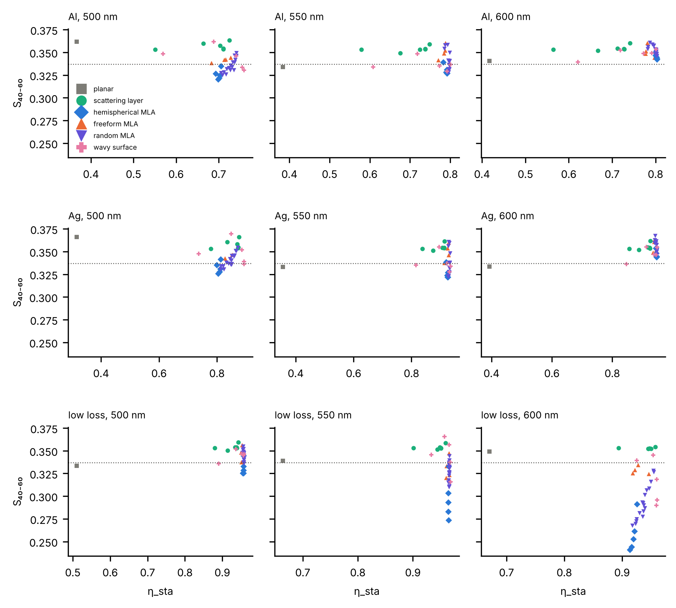
Fig. S2 | Angular composition of the output for all devices and wavelengths. S_{40–60} of the multi-pass output against η_{sta} for all 38 structures; rows, Al, Ag, and low-loss devices; columns, 500, 550, and 600 nm; dotted line, Lambertian partition (0.337). Monte Carlo uncertainty of S_{40–60} is at most 0.003 (ray seeds and realizations, six random and wavy structures).
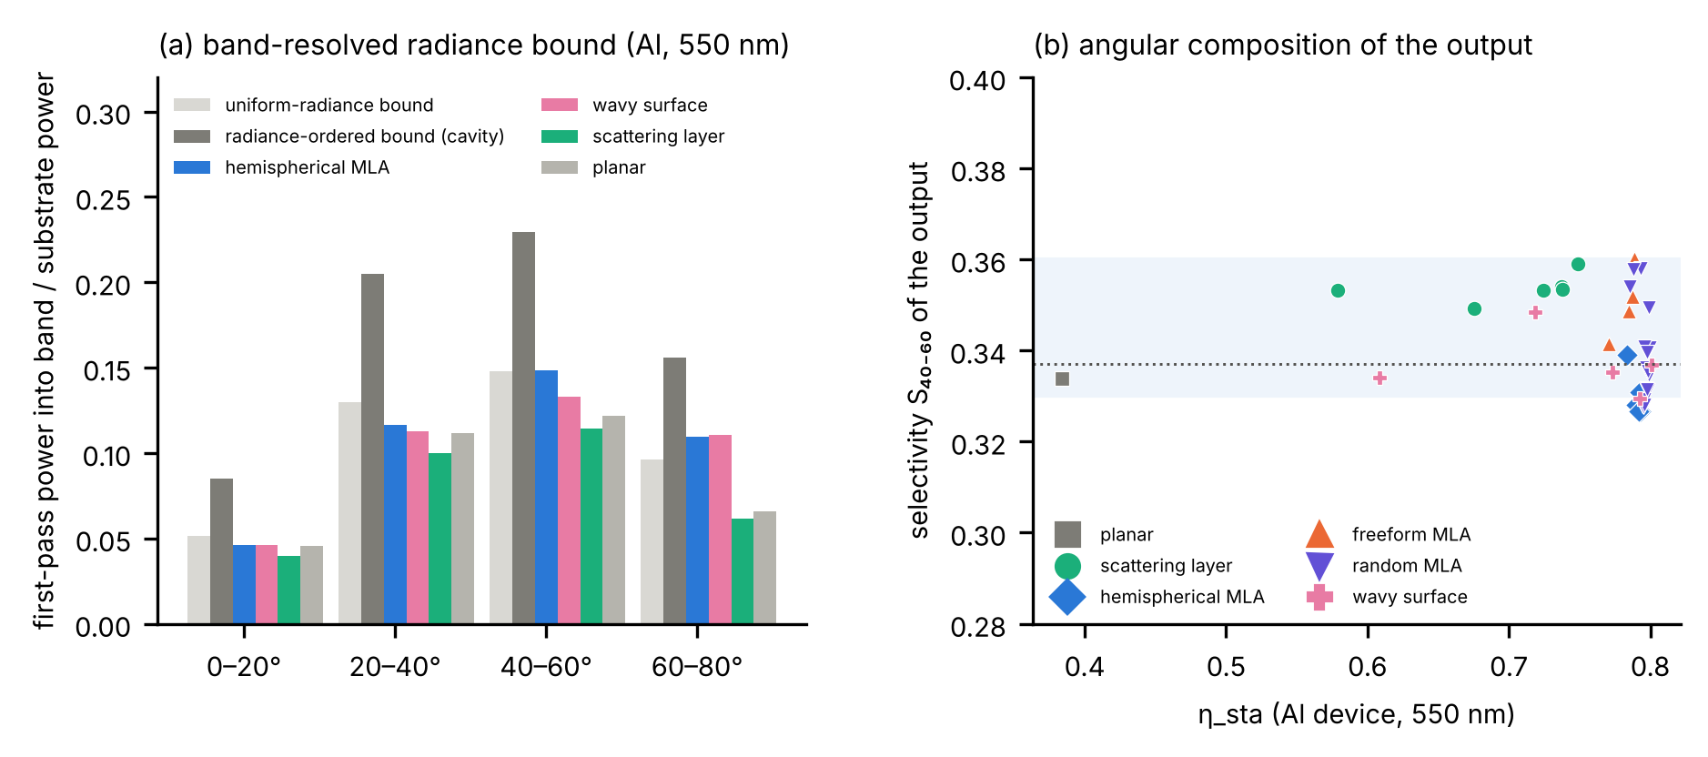
Fig. S3 | Radiance bound and angular composition of the output (main text, Sec. 4.5). (a) First-pass power into each polar band (Al, 550 nm) for the uniform-radiance bound, the radiance-ordered bound, and four structures. (b) S_{40–60} of the multi-pass output versus η_{sta} for all structures. The shaded band marks 0.33–0.36, and the dotted line marks the Lambertian value.

Note S5 | Benchmark platform and design space
All campaigns share the platform of Table S10; the hemisphere is a point of the freeform design space. Bands are polar bins of the far field over the full azimuth, with the Lambertian partition 0.117 / 0.296 / 0.337 / 0.220.
Table S10 | Common platform and design variables.
Quantity | Freeform | Hemispherical reference
Source | disc, radius 1 mm, CPS dipole distribution, η_{rad} = 0.98, emission 453–753 nm | same
Substrate, textured patch | glass, 1.295 mm, n = 1.51; 25 × 25 mm | same
Lenslets | hexagonal, ~10 µm radius, N-BK7 index-matched | same
Profile | 7-point spline, end points (0, 1) and (1, 0); x₂–x₆ in 0–1, ascending; y₂–y₆ in 0–1.5 | quarter circle
Height scale (stretch_{Z}) | 0.1–3 | 0.1–3
ETL and HTL thickness | 10–150 nm each | 10–150 nm each
Feasibility | no self-intersection or collinear triples; point spacing 0.05–1.0; turning angle ≤ 120° | always satisfied
Free variables | 13 | 3

Searches and fidelity. Each arm is optimized by MATLAB surrogateopt (radial-basis surrogate) followed by patternsearch at 10,000 rays and 31 wavelengths; every optimum is re-evaluated three times at 50,000 rays and 151 wavelengths. EQE is the radiative efficiency times the spectrally weighted fraction of generated photons reaching air, over the hemisphere or a band; it includes the cavity's coupling into the substrate and is not directly comparable with η_{sta}. Infeasible candidates are returned to the optimizer as constraint violations and not traced. The 25 mm patch underestimates the total of an infinite film by about 4%, but no band share changes by more than 0.24 pp between 15 and 100 mm, and all comparisons are made at equal patch.
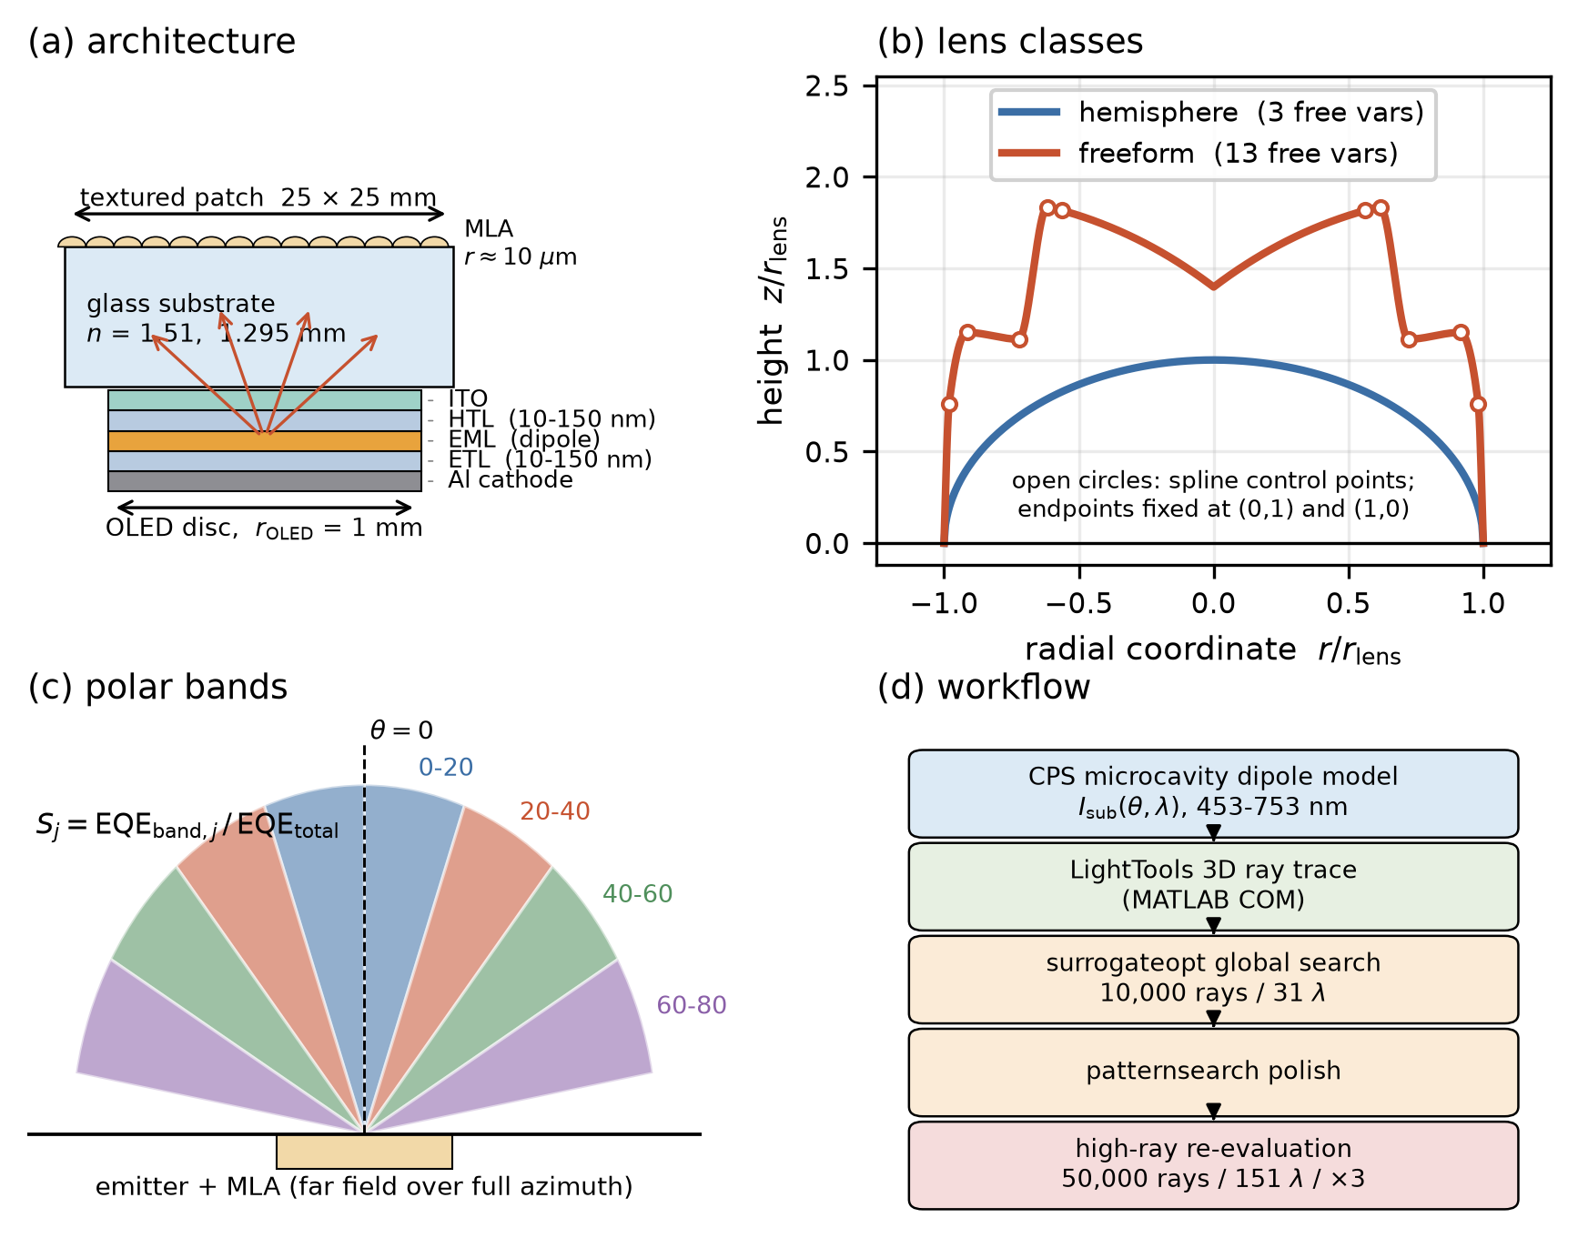
Fig. S4 | Platform and benchmark design. (a) OLED–substrate–MLA architecture. (b) The hemispherical reference and an axisymmetric freeform profile (40–60° optimum; open circles, free control points) in units of the lens radius. (c) The four polar bands. (d) Optimization workflow.

Note S6 | Restart control and statistics
In the original per-band campaign (random seeds plus the best designs of a separate weighted-sum campaign) the 0–20° and 20–40° gains were below unity (0.946, 0.966). Because the hemisphere lies in the freeform design space, this was a search failure. The restart control repeats every search from that arm's hemispherical optimum: the hemisphere and eight perturbations within 8% of each range seed surrogateopt, and patternsearch runs both from the surrogate winner and directly from the hemisphere. The hemisphere is re-measured in the same session.
Table S11 | Restart control. Mean ± standard deviation over three re-evaluations.
Arm | hemisphere (archived) | hemisphere (re-measured) | dev. | restarted | gain | t | winning branch
0–20° | 0.06682 | 0.06677 ± 0.00017 | 0.07% | 0.06699 ± 0.00013 | +0.32% | 1.7 | polish from hemisphere
20–40° | 0.16591 | 0.16595 ± 0.00017 | 0.02% | 0.16628 ± 0.00020 | +0.20% ‡ | 2.1 ‡ | surrogateopt
40–60° | 0.18503 | 0.18486 ± 0.00008 | 0.09% | 0.19355 ± 0.00010 | +4.70% | 114.6 | polish from surrogate
60–80° | 0.13589 | 0.13581 ± 0.00014 | 0.06% | 0.14075 ± 0.00025 | +3.64% | 29.6 | surrogateopt
total EQE | 0.54679 | 0.54679 ± 0.00013 | 0.00% | 0.55231 ± 0.00004 | +1.01% | 68.7 | polish from surrogate

‡ Settled by re-measuring both stored designs five times each: 0.16583 ± 0.00015 against 0.16631 ± 0.00021, +0.29% at t = 4.1 (threshold 1.86). In Table 2 of the main text, the 40–60° entry is the per-band optimum (0.19802), which the restart did not surpass, and the total is the best of three dedicated starts (0.5539).
Independent searches. Freeform/hemisphere ratios: 0–20° 0.946 (original campaign, 60 + 15 evaluations) and 1.003 (restart, about 47); 20–40° 0.966 and 1.002; 40–60° 1.070 and 1.046; 60–80° 1.020 and 1.036; total EQE 1.005, 1.011, and 1.013 (three random starts, 140 evaluations each) and 1.010 (restart). The hemisphere used about 45 evaluations for 3 variables (15 per variable), the freeform searches 47–140 for 13 (4–11 per variable), so the comparison favours the hemisphere. Inverted (concave) and randomly assembled MLA families optimized on the same platform reached total EQEs of 0.517 and 0.522, below the hemisphere.
What the t values test. t = Δ/(s_{p}2/n) with n = 3 and pooled standard deviation s_{p} compares two fixed designs against the Monte Carlo noise of one evaluation (about 10⁻⁴ in EQE); with a Holm correction over five objectives [S. Holm, Scand. J. Stat. 6, 65 (1979)] the thresholds are 3.75, 3.50, 3.19, 2.78, and 2.13. The large values (t = 30–115) reflect this small noise. They show that a reported difference is not an evaluation artefact but say nothing about the uncertainty of the optimizer, which only the spread over independent searches above measures. The restart winner is also the best of about seventy noisy evaluations, so its +0.3% residues at 0–40° are upper limits.
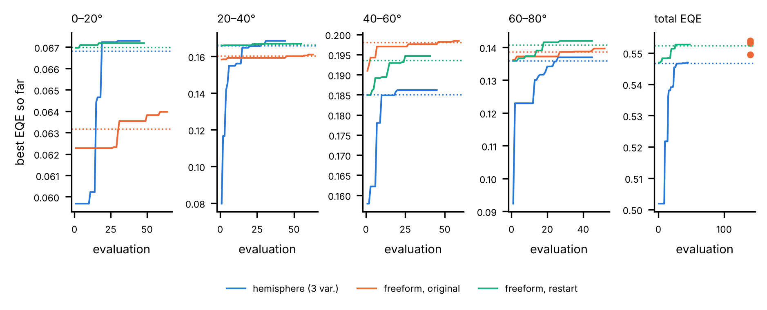
Fig. S5 | Best-so-far search curves. Best objective found so far against the evaluation count, at search fidelity (10,000 rays, 31 wavelengths), for the hemispherical campaign (3 variables), the original freeform per-band campaign, and the restart control; dotted lines, final re-evaluated values (50,000 rays, 151 wavelengths); dots in the total-EQE panel, final values of three independent random starts (140 evaluations each). Search-fidelity maxima are biased upward by noise and can exceed the re-evaluated values.
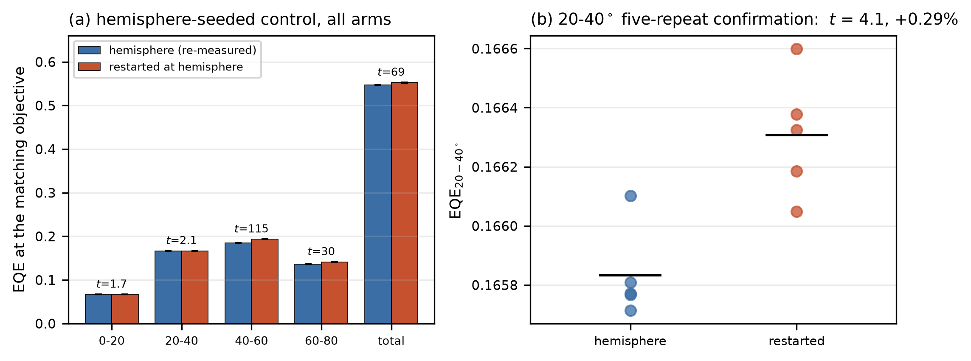
Fig. S6 | Restart control. (a) Re-measured hemisphere and restarted optimum for every arm, with standard deviations and t. (b) Five-repeat confirmation of the 20–40° arm.

Note S7 | Total efficiency fixes the angular composition
Over the 606 usable evaluations of a weighted-sum campaign (114 random feasible designs, 492 optimizer-visited), each band EQE is nearly proportional to the total (Table S12, Fig. S7); random designs alone reproduce the collapse. S_{40–60} spans only 0.336–0.375 (5–95%), and the 40–60° band carries the largest share in every design with total EQE ≥ 0.40. Band-dedicated optima raise their band's share by 1–27% but lose 1–11% of total EQE, for net band-power gains of 1.00–1.22 against the natural composition of the twenty most efficient designs.
Table S12 | Band EQE against total EQE (least squares, 95% intervals).
Band | slope | intercept | R² (all 606) | R² (114 random only)
0–20° | 0.125 ± 0.004 | −0.014 ± 0.002 | 0.848 | 0.828
20–40° | 0.318 ± 0.007 | −0.020 ± 0.004 | 0.931 | 0.925
40–60° | 0.348 ± 0.005 | 0.003 ± 0.003 | 0.968 | 0.967
60–80° | 0.189 ± 0.008 | 0.026 ± 0.004 | 0.769 | 0.724

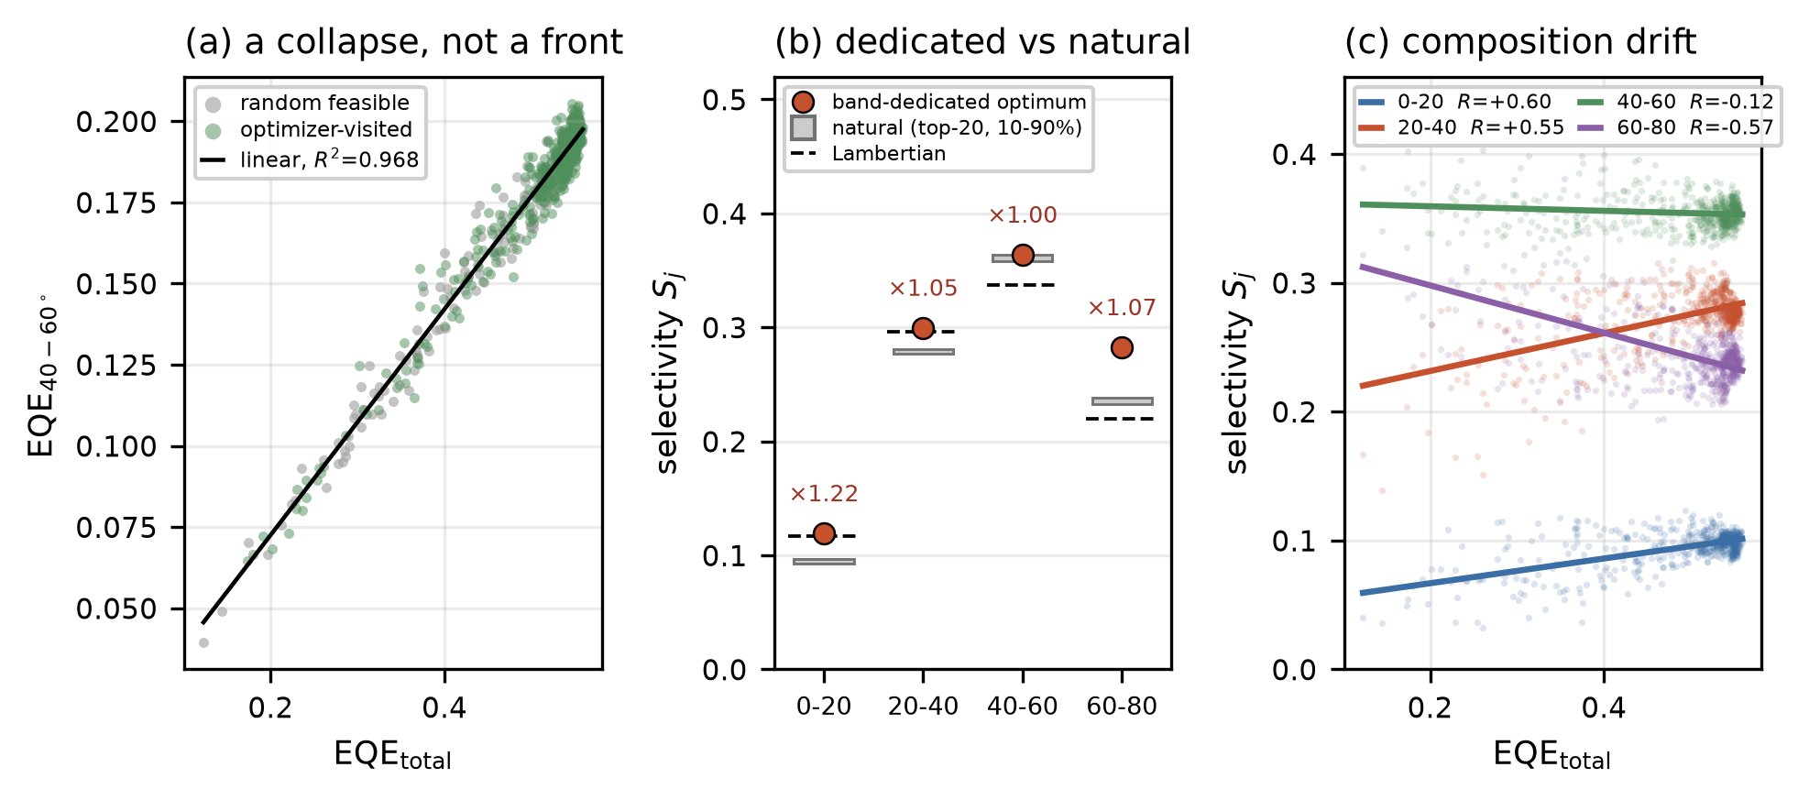
Fig. S7 | Total efficiency fixes the angular composition. (a) Total EQE against 40–60° EQE for random (grey) and optimizer-visited (green) designs; line, R² = 0.968. (b) Selectivity of the band-dedicated optima (red) against the natural composition (grey, 10–90% range) and the Lambertian partition (dashed), labelled with the net band-power gain. (c) Selectivity against total EQE for all bands.

Note S8 | Lens versus cavity
Full device model. The benchmark optimizes the cavity together with the lens. To separate the two, the eight optimized lenses of main-text Table 2 were evaluated in the full device model of the main text (birefringent CPS + TMM, dispersive constants), weighted with the emission spectrum (400–700 nm, 10 nm steps), with η_{rad} = 0.98 and the polar bands of the benchmark (Table S13). "Lens only" places both lenses at the hemisphere's cavity; "cavity only" places the hemisphere at the freeform's cavity.
Table S13 | Freeform/hemisphere EQE ratio: LightTools and the multi-pass model.
Objective | cavity ETL/HTL (nm), hemisphere / freeform | LightTools | model, own cavities | model, lens only | model, cavity only
20–40° | 54.9/52.1 / 61.2/75.8 | 0.966 | 0.959 | 0.946 | 0.974
40–60° | 74.6/81.7 / 68.5/114.4 | 1.070 | 1.026 | 1.004 | 0.986
60–80° | 99.8/71.1 / 90.5/76.3 | 1.020 | 0.972 | 0.964 | 0.996
total EQE | 61.3/97.5 / 67.5/120.6 | 1.013 | 0.974 | 0.971 | 1.003

The freeform entries are the designs of the original per-band campaign and of the total-EQE campaign (for 60–80° the restart optimum, ratio 1.036, has no traced return matrix). For the hemispheres the model reproduces the LightTools EQE within +0.7% (total) to +3.8% (60–80°); for the freeform optima it lies between −3.2% (total) and +0.5% (20–40°). The two tools therefore agree on the size of the differences (a few percent) but not on their sign below about 5%; the main reason is the profile: the freeform curves are rebuilt with a PCHIP spline, whereas LightTools uses its own spline, and the total-EQE optimum has a non-monotonic profile with an annular trough (control-point heights 1.05, 0.15, 0.19, 0.53, 0.50), for which the reconstruction is least certain. Lens and cavity interact (Table S14): the freeform 40–60° lens gains 0.4%, 1.8%, and 4.1% over the hemispherical one at the hemisphere's band cavity, the total-EQE cavity, and its own cavity when spectrally weighted, and 5.6–9.2% at 550 nm alone, because the cavity resonance moves with wavelength and the spectral average smears the angular distribution that the lens acts on.
Table S14 | 40–60° band EQE, freeform/hemisphere (40–60° designs of the benchmark), at three cavities.
Cavity ETL/HTL (nm) | 550 nm | spectrally weighted
74.6/81.7 (hemisphere, 40–60° optimum) | 1.056 | 1.004
61.3/97.5 (hemisphere, total-EQE optimum) | 1.070 | 1.018
68.5/114.4 (freeform, 40–60° optimum) | 1.092 | 1.041 | This also explains main-text Table 2, where the total-EQE freeform lens, at the hemisphere's cavity and 550 nm, has η_{sta} = 0.771 against 0.792.

Lens-only optimization at a fixed stack. With the stack fixed (Al, ETL 61.3 / HTL 97.5 nm, 550 nm), the hemisphere's height and an 11-variable freeform profile (5 radial and 5 height control points, height scale; same bounds and feasibility rules as the benchmark) were optimized for the same objective in the multi-pass model with the same tracer: a grid search for the hemisphere and a (1+8) evolution strategy with step-size adaptation, started at the hemispherical optimum, for the freeform (80 evaluations at 4,000 rays per bin; winners re-evaluated at 20,000). Results (Table S15): the freeform gains 1.25% in η_{sta} and 9.0% in the 40–60° band. The total-objective winner keeps p (0.422 against 0.421) but lowers N_{mix} from 7.1 to 2.1 and raises p_{mix}/p from 0.91 to 0.93, i.e. it recovers 1.0 of the 1.4 pp that complete reciprocal mixing would add to the hemisphere. The LightTools freeform optima, evaluated at the same stack, reach 0.771 (η_{sta}) and 0.284 (40–60°).
Table S15 | Lens-only optimization at a fixed stack (multi-pass model, Al, 550 nm).
Objective | lens | η_{sta} | 40–60° power | p | N_{mix} | ξ
η_{sta} | hemisphere (height 0.93) | 0.7936 | 0.2609 | 0.421 | 7.1 | 0.47
η_{sta} | freeform, optimized at fixed stack | 0.8035 | 0.2728 | 0.422 | 2.1 | 0.85
40–60° power | hemisphere (height 1.73) | 0.7773 | 0.2692 | 0.427 | 8.8 | 0.38
40–60° power | freeform, optimized at fixed stack | 0.7946 | 0.2935 | 0.428 | 2.7 | 0.79

LightTools control. opt_fixedcavity_freeform.m repeats the per-band freeform optimization of opt_4band_freeform.m with ETL and HTL fixed at each arm's hemispherical optimum and the hemisphere as the first seed, so that G_{j} ≥ 1 holds by construction and any gain is due to the lens shape; it requires the LightTools pipeline and has not been run here.

Note S9 | Direct ray tracing and out-of-sample test
Direct ray tracing. Rays are launched with the first-pass distribution v⁽⁰⁾ (Al, 550 nm; polar angle drawn uniformly in sin²θ within each 1° bin, azimuth and position uniform), traced through the height field, and, when returned, absorbed with probability 1−R(θ) or reflected specularly, keeping their azimuth, and sent to a new uniformly drawn position (the substrate is thick compared with the lattice). 10⁶ rays per case; the standard error is 0.04–0.05 pp. A second run re-randomizes the azimuth at every pass, which is what the chain on polar angle assumes.
Out-of-sample structures. Nine structures were chosen after the reduced model and its reciprocal redistribution were fixed and were not used to adjust anything: hexagonal arrays of spherical caps (contact angle 60° and 35°), paraboloids h = 1−ρ², cones of 45° and 60° side angle, truncated Gaussian bumps (peak height 1.5), a 6 × 6 supercell randomly filled with hemispheres and 60° cones (radius spread ±20%, position jitter 15% of the pitch), and quasi-periodic wavy surfaces whose spectrum is concentrated on a ring |k| = 2 (rms slope 0.6 and 1.2). Return matrices: 20,000 rays per bin (10,000 for wavy surfaces); errors over three devices and three wavelengths.
Table S16 | Direct ray tracing and out-of-sample test (Al, 550 nm; reduced and fully randomized models minus full series).
Structure | p | N_{mix} | ξ | η_{sta} full series | direct, (θ,φ) | direct, φ re-randomized | reduced − full (pp) | fully randomized − full (pp)
hemispherical MLA (main set) | 0.422 | 7.1 | 0.47 | 0.7918 | 0.7878 ± 0.0004 | 0.7913 | -0.27 | +2.24
freeform MLA, 40–60° (main set) | 0.425 | 7.5 | 0.39 | 0.7887 | 0.7882 ± 0.0004 | 0.7886 | -1.11 | +2.69
wavy, rms slope 0.2 (main set) | 0.402 | 2.2 | 0.35 | 0.6084 | 0.6087 ± 0.0005 | 0.6093 | -2.71 | +19.29
wavy, rms slope 1.0 (main set) | 0.422 | 1.1 | 0.87 | 0.7924 | 0.7916 ± 0.0004 | 0.7917 | -0.07 | +2.15
spherical caps, 60° contact | 0.418 | 2.0 | 0.74 | 0.7761 | — | — | -0.24 | +3.51
spherical caps, 35° contact | 0.410 | 1.4 | 0.66 | 0.7273 | 0.7258 ± 0.0004 | 0.7260 | -1.82 | +7.90
paraboloids | 0.425 | 2.7 | 0.71 | 0.8010 | — | — | -0.27 | +1.50
cones, 45° side | 0.423 | ∞ | 0.23 | 0.7838 | — | — | -3.53 | +3.06
cones, 60° side | 0.431 | 68.2 | 0.68 | 0.7866 | 0.7808 ± 0.0004 | 0.7865 | -2.55 | +3.26
Gaussian bumps | 0.424 | 1.6 | 0.70 | 0.7573 | — | — | -0.34 | +5.76
random mix of cones and hemispheres | 0.427 | 2.7 | 0.76 | 0.7951 | 0.7937 ± 0.0004 | 0.7947 | -0.11 | +2.17
ring-spectrum wavy, slope 0.6 | 0.413 | 1.3 | 0.76 | 0.7565 | 0.7551 ± 0.0004 | 0.7567 | -0.72 | +5.18
ring-spectrum wavy, slope 1.2 | 0.424 | 1.2 | 0.86 | 0.7934 | — | — | -0.11 | +2.18

Over all 81 out-of-sample cases the reciprocal reduced model has a mean error of 1.50 pp; without the two cone arrays (63 cases) 0.48 pp and at most 3.3 pp (35° caps), against 2.62 and 8.8 pp for the fully randomized model and 1.30 and 5.2 pp for isotropic redistribution. The cone arrays fail (mean 6.0 and 4.2 pp, maximum 20 and 14 pp, low-loss device). The 45° cones retroreflect light within 0–4° (0.5% of the étendue) into itself, giving λ₂ = 1 like the planar interface; the 60° cones have a ladder of slow modes (λ₂–λ₄ = 0.985, 0.91, 0.85) spread over most angles. In both cases 1−λ₂ underestimates how fast the light that escapes is redistributed. The direct traces confirm the full series for the 60° cones within 0.6 pp, so the failure is that of the one-rate reduction, not of the angle-resolved model.
Mode occupancy (post hoc). Because the truncated M is self-adjoint in the inner product weighted by its stationary distribution π^{(S)} ∝ w s (Note S1), the light returned after the first pass, u₀ ∝ B_{R}v⁽⁰⁾, can be expanded in its orthogonal eigenmodes. Table S17 lists the share of the deviation u₀/π^{(S)} − 1 carried by slow modes (λ > 0.8) and the relaxation rate weighted by the actual returned light, λ_{eff} = Σ _{≥ 2} a^2 λ/Σ _{≥ 2} a^2 (defined in selectivity/mixing.py before the out-of-sample test, but examined only after it). For the 60° cones the slow modes carry 0.4% of the deviation, λ_{eff} = 0.43 against λ₂ = 0.985, and the reduced model with m = 1−λ_{eff} is accurate; for the 45° cones the closed retroreflecting set carries 98% of it, and no single rate works. Over the 38 structures λ_{eff} is less accurate than λ₂ (mean 0.48 against 0.31 pp, maximum 3.7 against 3.0 pp), mainly for hemispherical MLAs, so λ₂ is kept and a large λ₂ with a negligible slow-mode share serves as a warning that one rate misstates the mixing.
Table S17 | Slow-mode occupancy of the returned light and reduced-model error (mean / max over three devices and three wavelengths, pp).
Structure | λ₂ | λ_{eff} | slow-mode share | error with λ₂ | error with λ_{eff}
hemispherical MLA | 0.859 | 0.734 | 0.243 | 0.24 / 0.62 | 0.67 / 2.93
freeform MLA, 40–60° | 0.867 | 0.723 | 0.572 | 0.87 / 2.09 | 0.83 / 2.47
wavy, rms slope 0.2 | 0.540 | 0.195 | 0.000 | 1.98 / 2.99 | 0.72 / 2.33
random lenslet shapes, s = 1 | 0.487 | 0.376 | 0.000 | 0.12 / 0.23 | 0.19 / 0.82
spherical caps, 35° (out-of-sample) | 0.296 | 0.237 | 0.000 | 1.42 / 3.30 | 1.18 / 2.83
paraboloids (out-of-sample) | 0.636 | 0.379 | 0.000 | 0.33 / 0.83 | 0.37 / 1.51
cone–hemisphere mix (out-of-sample) | 0.634 | 0.397 | 0.000 | 0.27 / 0.82 | 0.38 / 1.27
cones, 60° (out-of-sample) | 0.985 | 0.430 | 0.004 | 4.15 / 14.36 | 0.23 / 0.77
cones, 45° (out-of-sample) | 1.000 | 0.988 | 0.978 | 5.99 / 20.15 | 5.50 / 18.61

Note S10 | Estimators and numerical diagnostics
Estimators. The traced matrices are built as follows (height-field tracer; the scattering layers use the slab Monte Carlo of selectivity/slab.py plus the adding method with the flat Fresnel face).
for each incidence bin i = 0..89 (1 deg):
for each of N rays (N = 20,000; 10,000 for wavy surfaces):
theta = bin centre i + 0.5 deg; phi ~ U(0, 2 pi); (x, y) ~ U(unit cell or supercell)
start just below the base plane, moving up into the structure
repeat up to 60-80 interface events:
march to the next crossing of z = h(x, y) (Lipschitz-safe step, bisection)
reflect with probability (R_s + R_p)/2 at the local normal, else refract
if the ray is in air moving up above max h: escape; record air polar angle
if the ray is in glass moving down below z=0: return; record substrate polar angle
rays that reach the event limit are counted as lost (not renormalized)
BT[i, j_air] = escaped count / N; BR[i, j_sub] = returned count / N
p_i = sum_j BT[i, j]; M[:, i] = BR[i, :]^T / sum_j BR[i, j] (full domain)
spectral metrics: principal sub-block of BR^T below 85 deg; M_S[:, i] = B_S[:, i] / s_i, s_i = sum over retained bins

An encounter starts when a ray leaves the substrate upwards and ends when it escapes into air or re-enters the substrate below the base plane; Fresnel reflection inside the escape cone is part of the return. The lost fraction is at most 0.3% in any bin and is not renormalized, so p_{i} + Σ_{j} B_{R}(i→ j) = 1 - lost. λ₂ is the eigenvalue of second-largest modulus of M_{S} from numpy.linalg.eigvals (LAPACK geev, double precision) on the non-symmetrized matrix; p∞ = 1−ρ(B_{S}) uses the un-renormalized sub-block, so return beyond the cutoff counts as leaving the chain, consistent with p̃. η_{sta} uses numpy.linalg.solve (LAPACK gesv) on 0–90°, with ρ(diag R B_{R}) ≤ 0.9991 verified for every case; η_{mix} uses the closed form on the same grid, and the first pass is p^{T}v⁽⁰⁾ for every structure, since the slab matrices already contain the multiple scattering inside the layer and at its face. Spectral weighting: η = Σ_{λ} s(λ) η_{sub}(λ) η(λ)/Σ_{λ} s(λ) η_{sub}(λ), 400–700 nm in 10 nm steps, with the device recomputed at each wavelength and the structure matrices fixed.
Detailed balance. With F_{ji} = w_{i} B_{R}(i→ j) below 85°, the relative residual F-F^{T}/ F is 0.013–0.154 (median 0.047) over the 37 non-planar structures; entry-wise, |F_{ji}−F_{ij}|/(F_{ji}+F_{ij}) has a median of 0.06 and a 90th percentile of 0.25, dominated by weak entries. Projecting onto the nearest reciprocal matrix with the same column sums changes N_{mix} by at most 2.7%, ξ by 0.005, and η_{sta} by 0.04 pp (Note S1), so the physical conclusions do not depend on Monte Carlo asymmetry.
Adding method versus direct slab Monte Carlo. A single trace through the HG slab with the Fresnel face (Lambertian within each 1° input bin) reproduces the adding-method matrices (Table S20; adding / direct). S_{40–60} differs by up to 0.006 because the main calculation maps substrate bins to air bins after the slab, whereas the direct trace bins the air angle exactly.
Table S20 | Scattering layers: adding method / direct Monte Carlo (Al, 550 nm). Last column: largest difference in p(θ) below 85°.
Slab | p | N_{mix} | ξ | η_{sta} | S_{40–60} | max $ | \Delta p(\theta) | $
g 0.8, τ* 1 | 0.3258 / 0.3257 | 1.172 / 1.170 | 0.977 / 0.977 | 0.7374 / 0.7373 | 0.354 / 0.348 | 0.011
g 0, τ* 0.25 | 0.3812 / 0.3814 | 2.246 / 2.255 | 0.545 / 0.546 | 0.6754 / 0.6759 | 0.349 / 0.343 | 0.009

Bands in the hemispherical return matrix. The share of returned light that lands more than 10° from its incident angle (incidence 45–80°) is 0.130 for the single-lenslet unit cell, 0.127 for a 6 × 6 supercell of identical hemispheres traced with the other tracer, and 0.127 with twice the rays; the supercell matrices at 20,000 and 40,000 rays differ by 2.4% (relative Frobenius norm). The bands are deterministic pathways of rays totally reflected at the lens flank, e.g. from 70° to about 34° and from 50° to about 39°.
Signed errors of the reduced model. The reciprocal reduced model underestimates on average (Table S21); the largest error is −2.99 pp for the wavy surface of rms slope 0.2 on Ag at 550 nm, the structure with the lowest ξ among fast mixers.
Table S21 | Reciprocal reduced model minus full series (pp).
Subset | mean signed | mean absolute | max absolute
all 342 cases | -0.24 | 0.30 | 2.99
scattering layers | -0.28 | 0.29 | 2.49
hemispherical MLAs | -0.24 | 0.26 | 1.12
freeform MLAs | -0.40 | 0.60 | 2.09
random MLAs | -0.08 | 0.16 | 0.51
wavy surfaces | -0.67 | 0.67 | 2.99
Al | -0.41 | 0.41 | 2.71
Ag | -0.28 | 0.33 | 2.99
low loss | -0.04 | 0.16 | 1.78
500 nm | -0.32 | 0.38 | 2.49
550 nm | -0.29 | 0.29 | 2.99
600 nm | -0.11 | 0.23 | 2.58

Cutoff dependence of ξ. Table S22 gives ξ for representative structures. Hemispherical and random lenses, whose second eigenvector reaches into near-grazing states, change most; thick scattering layers barely change. The shallow wavy surface and the thin isotropic scatterer stay below random lenses of similar N_{mix} at every cutoff.
Table S22 | ξ versus cutoff.
Structure | 80° | 85° | 88° | 90°
planar | 0.000 | 0.000 | 0.000 | 0.000
hemispherical MLA | 0.639 | 0.465 | 0.381 | 0.306
random lenslet shapes, s = 1 | 0.828 | 0.769 | 0.730 | 0.720
wavy, rms slope 0.2 | 0.426 | 0.345 | 0.313 | 0.307
wavy, rms slope 1.0 | 0.890 | 0.871 | 0.868 | 0.868
scattering layer, g 0, τ* 0.25 | 0.563 | 0.545 | 0.538 | 0.537
scattering layer, g 0.8, τ* 4 | 0.996 | 0.993 | 0.990 | 0.989

Exceeding the complete-mixing reference. For the chain started in its stationary distribution q, the one-step autocorrelation of the escape probability, C = Σ_{i} q_{i} f_{i} Σ_{j} M_{ji} f_{j} / Σ_{i} q_{i} f_{i}² with f = p − p_{mix}, is zero for complete mixing and positive for angle retention. Table S23 lists the three structures with the lowest C and three typical ones; C and η_{sta}−η_{mix} (Al, 550 nm) are correlated with coefficient -0.76 over the 37 non-planar structures.
Table S23 | Escape autocorrelation and the gap to the reference (Al, 550 nm).
Structure | C | η_{sta}−η_{mix} (pp)
W_slope0.4 | -0.094 | +0.42
W_slope0.7 | -0.084 | +0.01
scatter g0.0_t1.0 | +0.026 | -0.02
scatter g0.8_t1.0 | +0.145 | -0.03
A_shape1.0 | +0.430 | -0.67
MLA hemi_total | +0.814 | -1.40

LightTools settings of the benchmark. Disc source (radius 1 mm) with the angular distribution of the CPS substrate radiance (1° polar mesh, uniform in azimuth), monochromatic runs weighted by the CPS power per wavelength; search at 10 nm steps (31 wavelengths, 453–753 nm) and 10,000 rays, final evaluation at 2 nm steps (151 wavelengths) and 50,000 rays, three repeats; device reflectance as a polarization-averaged angle- and wavelength-resolved user coating on the bottom face; textured patch 25 × 25 mm on a 1.295 mm substrate; far-field intensity mesh in 1° polar bins integrated over azimuth, bands summed with sinθ weighting. Freeform profiles are passed to LightTools as spline control points, and each constructed geometry is checked by a control-point round trip with tolerance 10⁻⁴ (lens radius units); geometries failing it are rejected. Evaluated through the freeform pipeline with quarter-circle control points, the hemisphere reproduces its own campaign within 0.00–0.09% (Table S11).

Note S11 | Mixing at the escape surface versus the device side
Device-side kernel. Let the device reflect returned light with a kernel D(i→ j) instead of the specular reflectance diag R. Energy conservation at each incidence angle fixes the column sums, Σ_{j} D(i→ j) = R_{i}. Reciprocity of the device requires w_{i} D(i→ j) = w_{j} D(j→ i). A rank-one kernel D(i→ j) = a_{i} b_{j} satisfies the second condition only if b_{j} ∝ w_{j} a_{j}, and the first condition then gives a_{i} ∝ R_{i}. The result is D(i→ j) = R_{i} R_{j} w_{j}/Σ_{k} w_{k} R_{k} (main text, Sec. 2.5). The multi-pass efficiency is η = p^{T}(I − D B_{R})⁻¹v⁽⁰⁾, where B_{R} is the return matrix of the structure itself. Light that has been reflected by D is distributed in proportion to w_{j} R_{j}, independently of its incidence angle. Its escape probability at the next encounter is therefore p_{D} = Σ_{k} w_{k} R_{k} p_{k}/Σ_{k} w_{k} R_{k}.
Comparison with mixing at the escape surface. At the escape surface, the same construction with column sums 1−p_{i} gives the kernel (1−p_{i}) w_{r}(1−p_{r})/Σ_{k} w_{k}(1−p_{k}) of Sec. 2.4. The redistribution weight 1−p is then perfectly anticorrelated with the escape probability, which produces the term −σ_{p}²/(1−p). At the device, the weight is R, and the correction is Cov_{w}(R,p)/⟨ R⟩_{w}. For the three bottom-emitting stacks of this work, |p_{D} − p| < 0.008 for all structures at 500, 550, and 600 nm.
Strong microcavities. For a top-emitting microcavity with a 20 nm Ag cathode, an optical clear resin (n = 1.59) as the exit medium, and a planar exit face, the modelled device reflectance seen from the resin is 0.63 inside the escape cone and 0.92 outside it. The device absorbs most strongly at the angles at which it emits. The covariance is then negative, and p_{D} = 0.316 compared with p = 0.355. Device-side mixing is therefore also reduced in strong microcavities, although less than mixing at the escape surface. This example uses the stack model of selectivity/advsci_model.py and is illustrative only.
Table S24 | Gain over the actual η_{sta} for complete reciprocal mixing at the escape surface and at the device (37 non-planar structures). The last column gives the difference between device-side mixing and the fully randomized model.
Device | λ (nm) | Mixing at the escape surface (pp) | Mixing at the device (pp) | Device-side − fully randomized (pp)
Al | 500 | −0.6 to +6.4 (median 3.5) | +0.3 to +18.8 (median 4.5) | −3.3 to −0.7
Al | 550 | −0.4 to +1.8 (median 0.8) | +0.2 to +17.1 (median 2.0) | −2.1 to +0.3
Al | 600 | −0.2 to +1.2 (median 0.1) | +0.2 to +15.7 (median 1.3) | −1.4 to +1.5
Ag | 500 | −0.4 to +9.4 (median 4.7) | +0.3 to +15.8 (median 5.0) | −2.7 to −0.7
Ag | 550 | −0.3 to +2.0 (median 0.6) | +0.1 to +11.2 (median 1.2) | −1.1 to −0.1
Ag | 600 | −0.1 to +1.2 (median 0.2) | +0.1 to +9.2 (median 0.6) | −0.7 to +0.5
low loss | 500 | −0.1 to +0.8 (median 0.1) | +0.1 to +6.7 (median 0.4) | −0.1 to +0.4
low loss | 550 | 0.0 to +0.4 (median 0.0) | +0.1 to +4.1 (median 0.3) | +0.2 to +1.1
low loss | 600 | −0.1 to +4.3 (median 2.1) | +0.1 to +4.8 (median 2.1) | −0.9 to +1.2

Slab model. The slab has refractive index n, an internal isotropic source (v⁽⁰⁾ ∝ w), a planar exit face with unpolarized Fresnel transmission integrated within each 0.25° bin, and an angle-independent back reflectance R. No mixing means specular reflection at both faces. Mixing at the exit face uses the kernel of Sec. 2.4 with the Fresnel p(θ). Mixing at the back reflector uses D with constant R, which gives the fully randomized result p/[p+(1−p)(1−R)].
Table S25 | Slab with a planar exit face and a back reflector.
n | R | p | p_{mix} | No mixing | Mixing at exit face | Mixing at back reflector
1.5 | 0.90 | 0.404 | 0.054 | 0.440 | 0.599 | 0.871
1.5 | 0.98 | 0.404 | 0.054 | 0.445 | 0.837 | 0.971
2.0 | 0.90 | 0.210 | 0.040 | 0.245 | 0.419 | 0.726
2.0 | 0.98 | 0.210 | 0.040 | 0.249 | 0.733 | 0.930
2.4 | 0.90 | 0.137 | 0.032 | 0.170 | 0.331 | 0.614
2.4 | 0.98 | 0.137 | 0.032 | 0.174 | 0.665 | 0.888
3.0 | 0.90 | 0.080 | 0.024 | 0.107 | 0.243 | 0.467
3.0 | 0.98 | 0.080 | 0.024 | 0.111 | 0.576 | 0.814
3.5 | 0.90 | 0.055 | 0.019 | 0.079 | 0.192 | 0.369
3.5 | 0.98 | 0.055 | 0.019 | 0.082 | 0.509 | 0.745

Reproducing the figures and data
Main-text Figs. 1–4 and Fig. S3 are produced by selectivity/oe_figs.py; panels (c) and (d) of Fig. 2 and Tables S24–S25 use selectivity/placement.py. oe_figs.py evaluates the 38 structures with the full and reduced models, takes the return matrices from multipass_reset/run_random_sweep.py, and writes PNG, PDF, and an Excel workbook of the plotted arrays to figures_oe/. Main-text Fig. 5 and Figs. S4, S6, and S7 come from the campaign archives through make_figures.py and make_supp_figures_and_data.py; Fig. S1 and Table S2 from selectivity/fig_devices.py; Tables S5–S9 from selectivity/unc_analysis.py, selectivity/review_checks.py, selectivity/review_traces_analysis.py, and selectivity/make_note_s12.py; the complete-mixing reference (Fig. 2, Note S1) from selectivity/reciprocal_limit.py; Tables S1 and S17 from selectivity/cutoff_modes.py; Tables S13–S14 from selectivity/cavity_decomp.py and selectivity/cav_lens_cross.py; Table S15 from multipass_reset/fixedcav_opt.py; Table S16 from multipass_reset/direct_blind.py and blind_table.py; Fig. S2 and Tables S21–S23 from selectivity/review2_diag.py; Table S20 from selectivity/slab_direct_check.py; Fig. S5 from make_optimizer_convergence.py; Table S18 from multipass_reset/polcheck.py; Table S19 from selectivity/data/mixing_gain_by_condition.json and mixing_gain_spectral.json.
cd multipass_reset && python3 run_random_sweep.py && cd ..
cd selectivity && python3 extract_inputs.py && python3 run_devices.py && python3 oe_figs.py && cd ..
python3 make_figures.py && python3 make_supp_figures_and_data.py

