Lab 5 Report

1. SOF file is located in [James_Park_70315379_Lab_5/rtl/lab5/dds_and_nios_lab_time_limited.sof]
2. Code compiles and runs on the De1. Functions correctly. Everything done.
3. Simulations
   1. LFSR

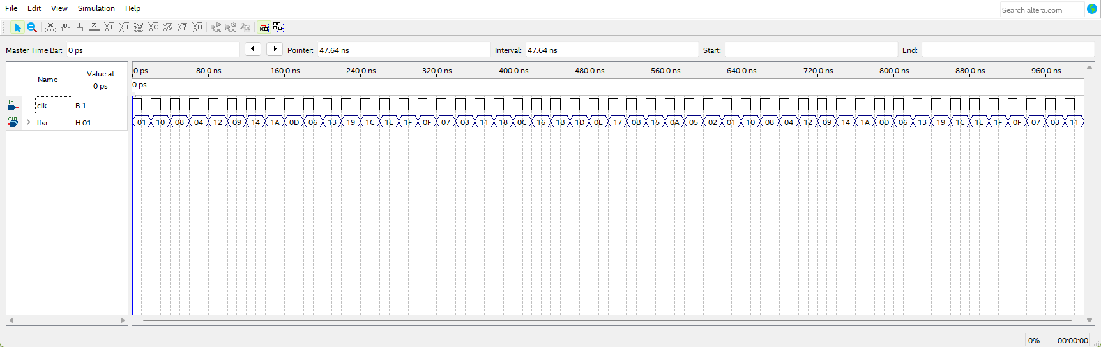Value of lfsr changes every rising edge of clk. Sequence repeats here.

* 1. clk_down

outclk is slower clock of outdata.

inclk is faster clock of indata.

After a rising edge of inclk and a rising edge of inclk while en is high, indata is stored to reg3. Enough delay to resolve metastability issues.

en is the value of outclk captured every two falling edges of inclk.

On the rising edge of outclk, the value in reg3 is moved to outdata.

* 1. clk_up

outclk is faster clock of outdata.

inclk is slower clock of indata.

en is the value of inclk captured every two falling edges of outclk.

After a rising edge of inclk the indata and a rising edge of outclk while en is high, indata is stored to reg3.

On the rising edge of outclk, the value in reg3 is moved to outdata.

* 1. dds

DDS simulations use tuning word 0x10000000, so it is easier to see changes to signal.

Sine wave

With a tuning word of 0x1000000. Values of actual_sig_out repeat producing a sine wave with a period of 16 clk cycles.

sig_sel chooses which type of wave to display. 00 is sine wave.

actual_sig_out is value output at frequency of outclk. This value changes every rising edge of outclk.

reg_sig_out is signal output from waveform_gen. New value generated every rising edge of clk.

Cosine wave

Values of actual_sig_out repeat producing a cosine wave.

sig_sel chooses which type of wave to display. 01 is cosine wave.

Saw Wave

sig_sel chooses which type of wave to display. 10 is saw wave.

Values of actual_sig_out repeat producing a saw wave.

Square Wave

Values of actual_sig_out repeat high and low values producing a square wave.

sig_sel chooses which type of wave to display. 11 is square wave.

1. Signal Tap

dds_increment is 0x056 on interrupt when lfsr[0] is 0. This creates a 1Hz signal.

dds_increment is 0x1AE on interrupt when lfsr[0] is 1. This creates a 5Hz signal.

1. Simulations were run using the built in waveform simulation in Quartus. Simulation files are located in [James_Park_70315379_Lab_5/rtl/sim/]. There is a project file for each component simulated. The dds simulation requires to change the sig_sel value to get a specific wave.