Lab 1 Report
- SOF file is located in [James_Park_70315379_Lab_1/rtl/lab1_de1soc/Basic_Organ_Solution.sof]
- Code compiles and runs on the De1. Simulation testbench of Tone Organ has issues. Not sure why. Signal Tap shows no issues.

- Simulation screenshot
  - Frequency Divider
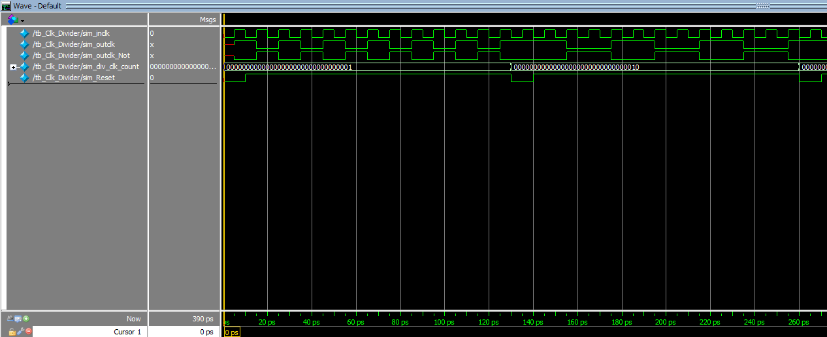
Outclk is high for div_clk_count number of inclk cycles.
Frequency of outclk = Frequency of inclk / (2*div_clk_count)
Because div_clk_count is 1,
12 inclk cycles create 6 outclk cycles.
Because div_clk_count is 2,
12 inclk cycles create 3 outclk cycles.
Not used in this lab but outclk_not is the negation of outclk.

  - Tone organ
Could not get testbench simulation to work. Audio output has no signal. Not sure why, it works on the De1 itself and through the Signal Tap.
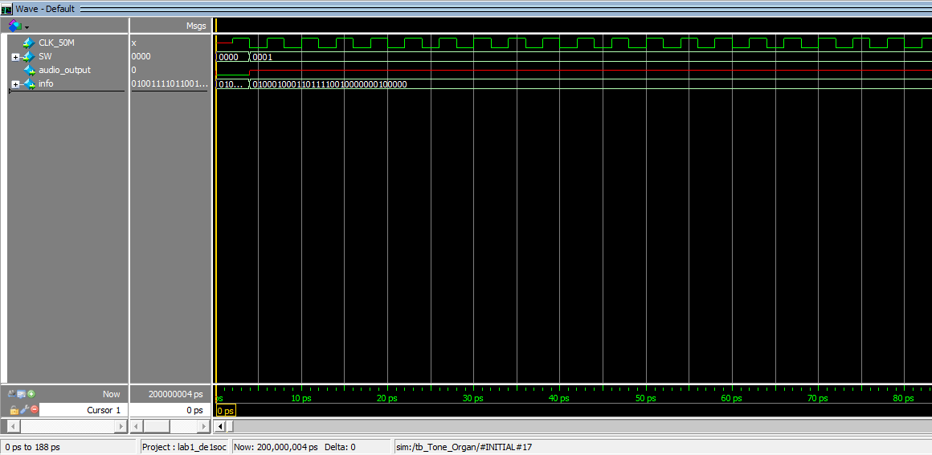

  - LED going side to side
Default behaviour if unknown values is to reset LED array to 0 and led_dir to 1.
If LED array is 0, start by turning on left most LED represented by 00000001 and set direction to go left, represented by led_dir 1.

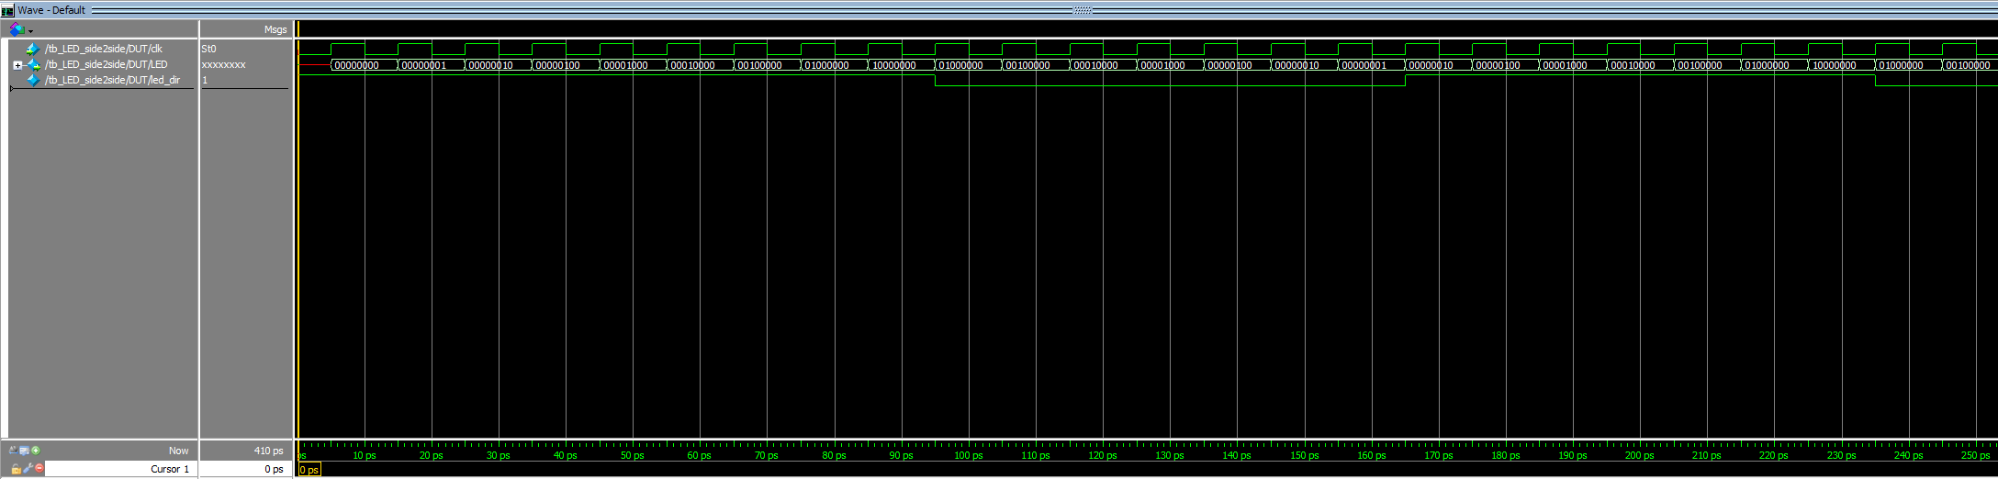
Every posedge of clk, LED is shifted left because led_dir is 1.
If LED is 10000000, shift right instead and change led_dir to 0 to indicate shift right.
Continue shift right until 00000001.
Shift left instead, and change led_dir to 1. Behaviour repeats

- Signal Tap
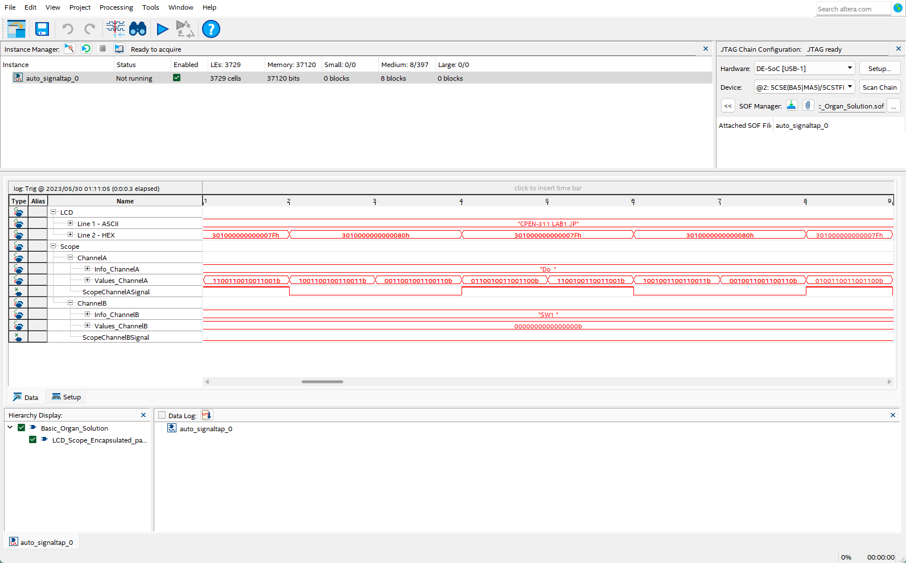
Playing “Do” mapped to switch combination SW[3:1] = 3’b000.
Audio enabled, so SW[3] = 1’b1.
Scope is enabled and is updating, so SW[9:8] = 2’b11.
SW[9:0] represented by left most hex of LCD Line2, 3’h301.
Audio data is shown on right side switching between highest 8 bit signed value 2’h7F and lowest 8 bit signed value 2’h80.

- Simulations were run using ModelSim. The three files for simulations are [tb_Tone_Organ.sv], [tb_Clk_Divider.sv], and [tb_LED_side2side.sv]. They are in the /sim/ folder. The System Verilog files for the modules they test, [Tone_Organ.sv], [Clk_Divider.sv], and [LED_side2side.sv], are also necessary, so they are copied in the /sim/ folder as well.
Images of the simulations are in the /doc/ folder.

