Lab 4 Report
- SOF file is located in [James_Park_70315379_Lab_4/rtl/lab4/output_files/rc4.sof]
- Code compiles and runs on the De1. Functions correctly if not too many nodes added to signal tap. All three loops run correctly, and able to find secret key. LED[0] is on if no key can be found. LED[1] is on if key is found. Timing requirements fail if Signal Tap has a bunch of nodes and functionality breaks down. Only managed to get signal tap for loop 1. Trying to simulate also causes errors. Not sure why. Quite positive I accounted for glitches in design. Did not do challenge.

- Simulations

- Signal Tap
  - Loop 1
reset_n low causes state to reset to 5’b00000 and address to reset to 8’h00.
For loop 1, data is equal to address.
state[1] is assigned to reg incr. If this is high on posedge of clock, address will increment by 1.
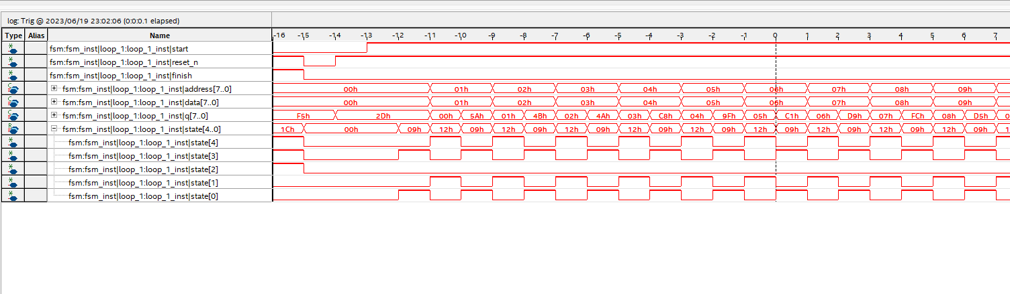
state[0] is assigned to wren, so when state[0] is high write data at address of s_memory. q will display written output on next clock.
state[2] is assigned finish signal. Asserted high when q output is 8’hFF, when state[1] is high.

