0860803

何哲佑

Empirical distribution

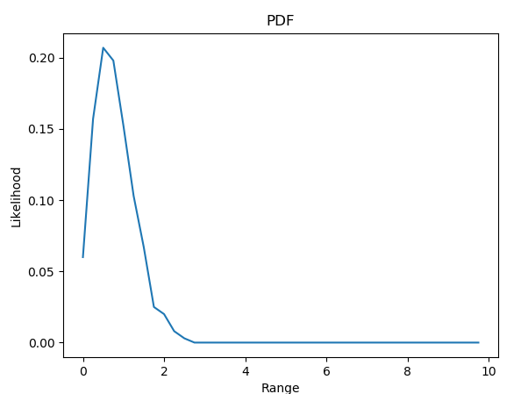

Cumulative distribution

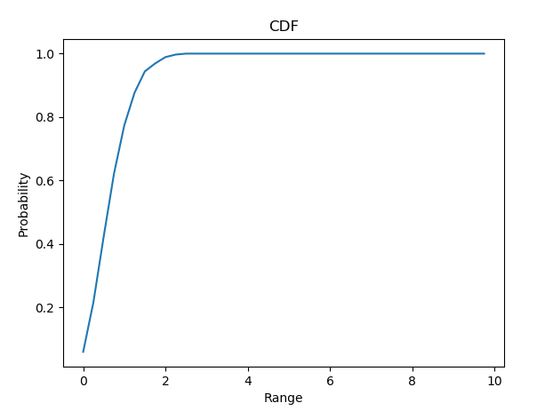

From the pictures we can see that it resembles to a Rayleigh Distribution.

Some extra examples

N = 100, delta = 0.25

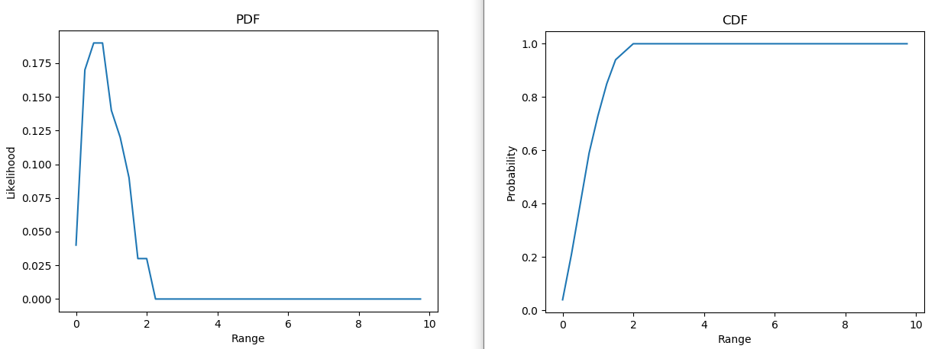

N = 10000, delta = 0.25

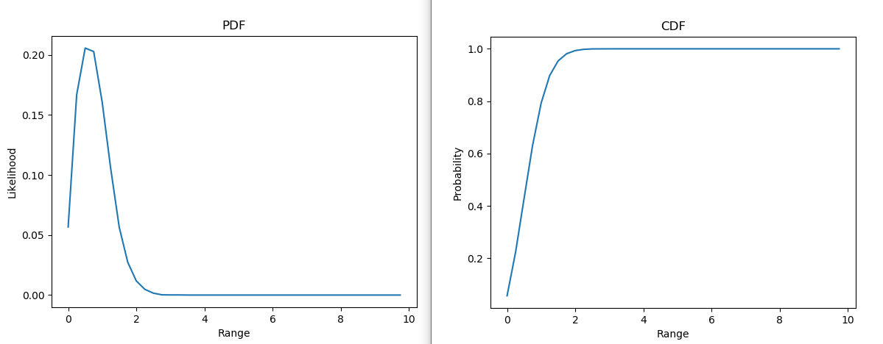

N = 1000, delta = 0.05

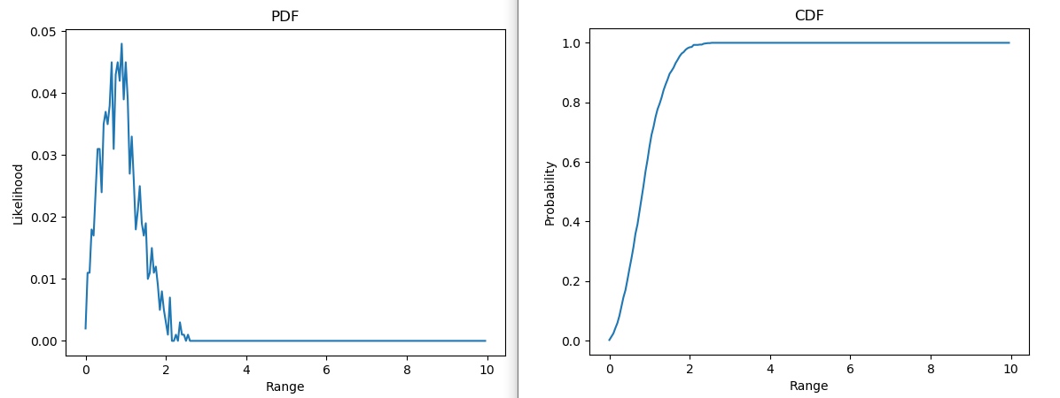

N = 1000, delta = 0.75

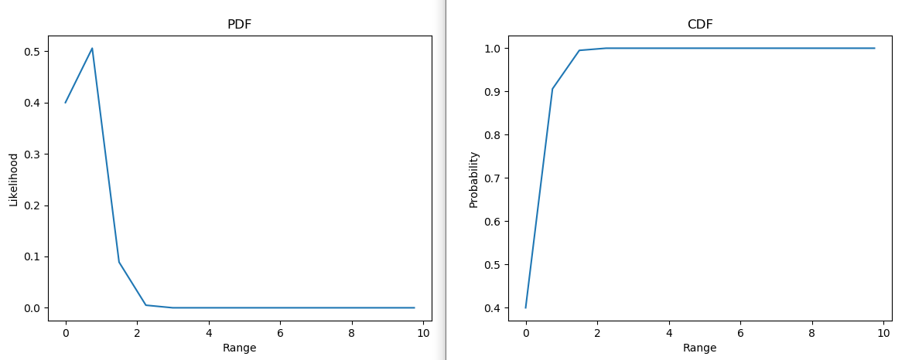

N = 10000, delta = 0.05

