0860803

何哲佑

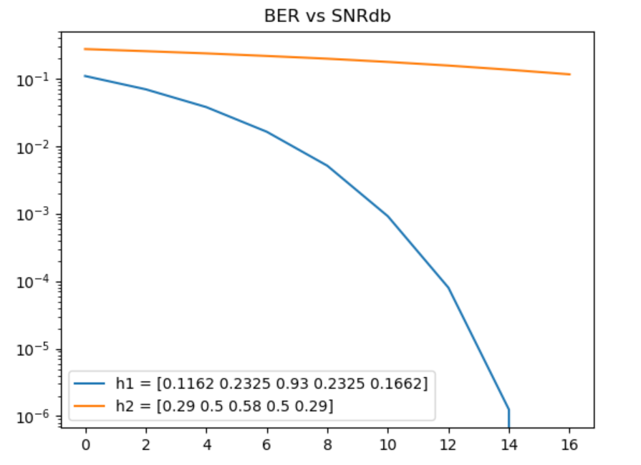

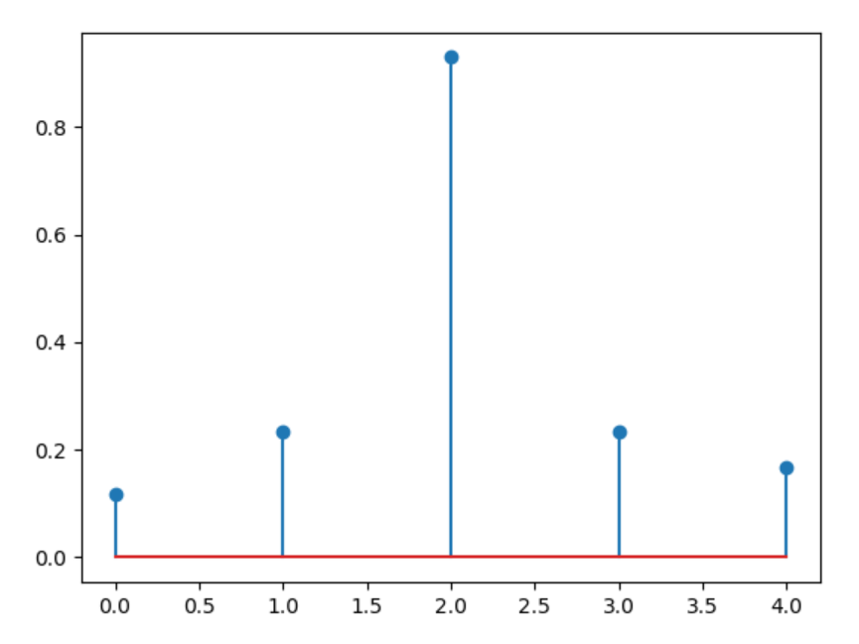 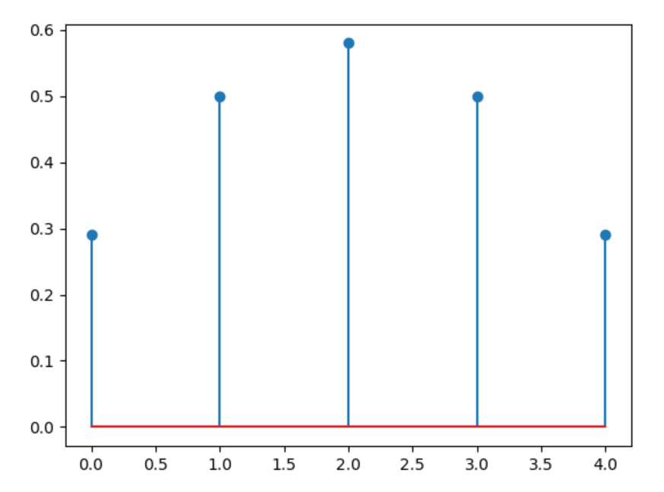

H2

H1

Why is one channel better than the other ?

As we can see the side peaks in the channel 2 are not that small in comparison to the central peak, therefore one symbol receives a lot of influence from the neighbor symbols. On the other hand, channel 1 is closer to what we like, the bigger peak in the middle highlights the symbol to be decoded with respect to the neighbors. In general, as the side peaks become smaller and smaller, we approach more to an standard AWGN model where we just add white gaussian noise.