0860803

何哲佑

Capacity vs SNR

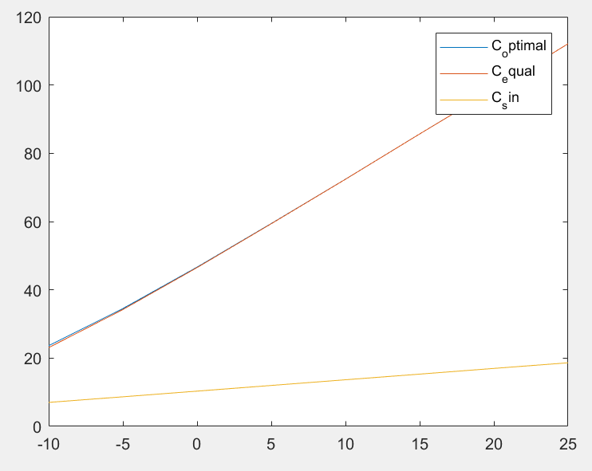

As we see in the low SNR regimes our optimal solution performs better than the others. Single channel assigning of power is always outperformed by the other 2. As we move towards high SNR regimes we can better observe how the gap between optimal power assigning (water filling) and equal power assignment closes, and equally assigning power just becomes as good as water filling.