0860803

何哲佑

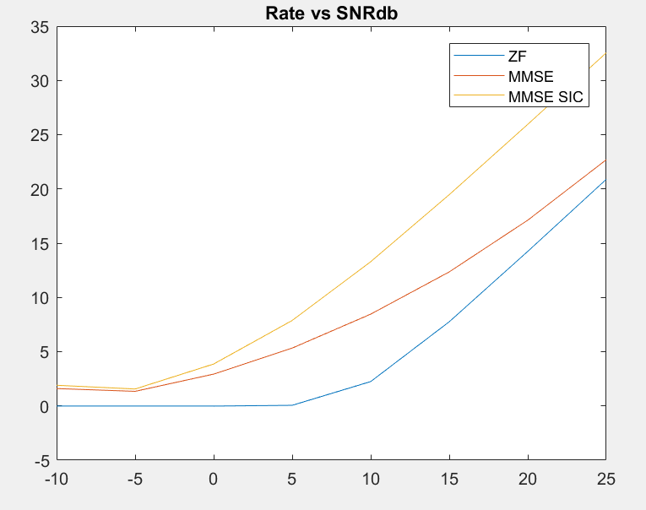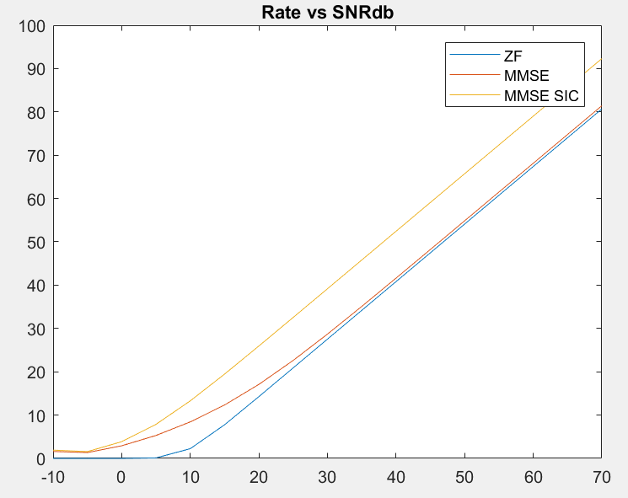

We took 2 pictures to better see the behavior of the capacity along a wider range snr’s. As for the behavior itself, we see that (at any snr) Serial Interference Cancellation outperforms all of the other receiving techniques. The only thing to mention is that in low snr regime MMSE and MMSE SIC are pretty close due to the high interference. As for the Zero Forcing and MMSE in the low snr regime we can see how the MMSE outperforms the ZF in terms of capacity, but as we go to high snr regime the MMSE and ZF receivers start approaching one to each other.