2022-2作业（Hull 英文第十版，见QQ群文件）
第10章：

Problem 10.11、10.12
第11章：

Problem 11.11、11.13、11.14、11.16、11.18
第12章：

Problem 12.8、12.23、12.25、12.26、12.28

√Problem 10.11.
Describe the terminal value of the following portfolio: a newly entered-into long forward contract on an asset and a long position in a European put option on the asset with the same maturity as the forward contract and a strike price that is equal to the forward price of the asset at the time the portfolio is set up. Show that the European put option has the same value as a European call option with the same strike price and maturity.
The terminal value of the long forward contract is:
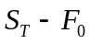
where 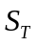 is the price of the asset at maturity and 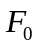 is the forward price of the asset at the time the portfolio is set up. (The delivery price in the forward contract is also .)
The terminal value of the put option is:
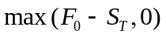

The terminal value of the portfolio is therefore
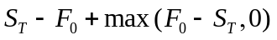
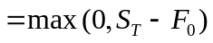
This is the same as the terminal value of a European call option with the same maturity as the forward contract and an exercise price equal to . This result is illustrated in the Figure S10.5.

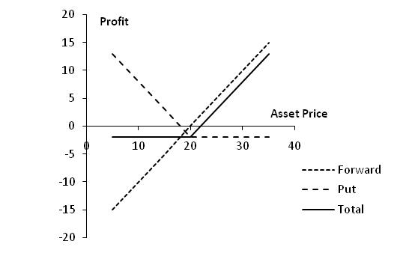

Figure S10.5: Profit from portfolio in Problem 10.11

We have shown that the forward contract plus the put is worth the same as a call with the same strike price and time to maturity as the put. The forward contract is worth zero at the time the portfolio is set up. It follows that the put is worth the same as the call at the time the portfolio is set up.

√Problem 10.12.
A trader buys a call option with a strike price of $45 and a put option with a strike price of $40. Both options have the same maturity. The call costs $3 and the put costs $4. Draw a diagram showing the variation of the trader’s profit with the asset price.
Figure S10.6 shows the variation of the trader’s position with the asset price. We can divide the alternative asset prices into three ranges:
- When the asset price less than $40, the put option provides a payoff of 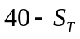 and the call option provides no payoff. The options cost $7 and so the total profit is 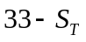.
- When the asset price is between $40 and $45, neither option provides a payoff. There is a net loss of $7.
- When the asset price greater than $45, the call option provides a payoff of 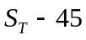 and the put option provides no payoff. Taking into account the $7 cost of the options, the total profit is 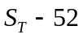.
The trader makes a profit (ignoring the time value of money) if the stock price is less than $33 or greater than $52. This type of trading strategy is known as a strangle and is discussed in Chapter 12.

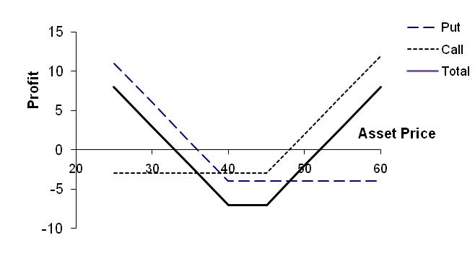

Figure S10.6: Profit from trading strategy in Problem 10.12

√Problem 11.11.
A four-month European call option on a dividend-paying stock is currently selling for $5. The stock price is $64, the strike price is $60, and a dividend of $0.80 is expected in one month. The risk-free interest rate is 12% per annum for all maturities. What opportunities are there for an arbitrageur?
The present value of the strike price is 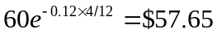. The present value of the dividend is 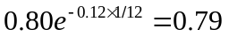. Because
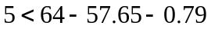
the condition in equation (11.8) is violated. An arbitrageur should buy the option and short the stock. This generates 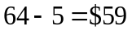. The arbitrageur invests $0.79 of this at 12% for one month to pay the dividend of $0.80 in one month. The remaining $58.21 is invested for four months at 12%. Regardless of what happens a profit will materialize.
If the stock price declines below $60 in four months, the arbitrageur loses the $5 spent on the option but gains on the short position. The arbitrageur shorts when the stock price is $64, has to pay dividends with a present value of $0.79, and closes out the short position when the stock price is $60 or less. Because $57.65 is the present value of $60, the short position generates at least 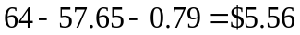 in present value terms. The present value of the arbitrageur’s gain is therefore at least 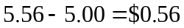.
If the stock price is above $60 at the expiration of the option, the option is exercised. The arbitrageur buys the stock for $60 in four months and closes out the short position. The present value of the $60 paid for the stock is $57.65 and as before the dividend has a present value of $0.79. The gain from the short position and the exercise of the option is therefore exactly . The arbitrageur’s gain in present value terms is exactly .

√Problem 11.13.
Give an intuitive explanation of why the early exercise of an American put becomes more attractive as the risk-free rate increases and volatility decreases.
The early exercise of an American put is attractive when the interest earned on the strike price is greater than the insurance element lost. When interest rates increase, the value of the interest earned on the strike price increases making early exercise more attractive. When volatility decreases, the insurance element is less valuable. Again this makes early exercise more attractive.

√Problem 11.14.
The price of a European call that expires in six months and has a strike price of $30 is $2. The underlying stock price is $29, and a dividend of $0.50 is expected in two months and again in five months. Risk-free interest rates (all maturities) are 10%. What is the price of a European put option that expires in six months and has a strike price of $30?
Using the notation in the chapter, put-call parity [equation (11.10)] gives
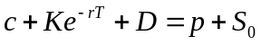
or
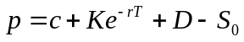

In this case

In other words the put price is $2.51.

√Problem 11.16.
The price of an American call on a non-dividend-paying stock is $4. The stock price is $31, the strike price is $30, and the expiration date is in three months. The risk-free interest rate is 8%. Derive upper and lower bounds for the price of an American put on the same stock with the same strike price and expiration date.
From equation (11.7)
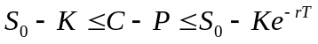

In this case
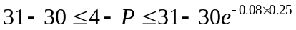
or
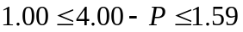
or
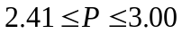

Upper and lower bounds for the price of an American put are therefore $2.41 and $3.00.

√Problem 11.18.
Prove the result in equation (11.7). (Hint: For the first part of the relationship consider (a) a portfolio consisting of a European call plus an amount of cash equal to  and (b) a portfolio consisting of an American put option plus one share.)
As in the text we use and  to denote the European call and put option price, and  and  to denote the American call and put option prices. Because 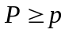, it follows from put–call parity that
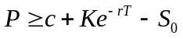
and since 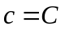,
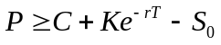
or
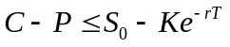

For a further relationship between and , consider
Portfolio I: One European call option plus an amount of cash equal to .
Portfolio J: One American put option plus one share.
Both options have the same exercise price and expiration date. Assume that the cash in portfolio I is invested at the risk-free interest rate. If the put option is not exercised early portfolio J is worth
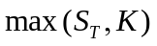
at time . Portfolio I is worth
at this time. Portfolio I is therefore worth more than portfolio J. Suppose next that the put option in portfolio J is exercised early, say, at time . This means that portfolio J is worth at time . However, even if the call option were worthless, portfolio I would be worth 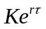 at time . It follows that portfolio I is worth at least as much as portfolio J in all circumstances. Hence
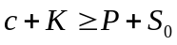
Since ,
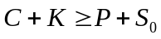
or
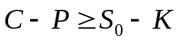

Combining this with the other inequality derived above for 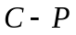, we obtain

√Problem 12.8.
Use put–call parity to relate the initial investment for a bull spread created using calls to the initial investment for a bull spread created using puts.
A bull spread using calls provides a profit pattern with the same general shape as a bull spread using puts (see Figures 12.2 and 12.3 in the text). Define 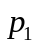 and as the prices of put and call with strike price 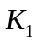 and 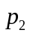 and 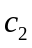 as the prices of a put and call with strike price 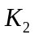. From put-call parity
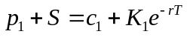

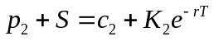
Hence:
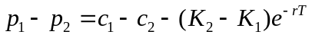
This shows that the initial investment when the spread is created from puts is less than the initial investment when it is created from calls by an amount 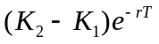. In fact as mentioned in the text the initial investment when the bull spread is created from puts is negative, while the initial investment when it is created from calls is positive.
The profit when calls are used to create the bull spread is higher than when puts are used by 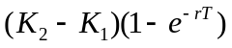. This reflects the fact that the call strategy involves an additional risk-free investment of over the put strategy. This earns interest of .

√Problem 12.23.
Three put options on a stock have the same expiration date and strike prices of $55, $60, and $65. The market prices are $3, $5, and $8, respectively. Explain how a butterfly spread can be created. Construct a table showing the profit from the strategy. For what range of stock prices would the butterfly spread lead to a loss?
A butterfly spread is created by buying the $55 put, buying the $65 put and selling two of the $60 puts. This costs 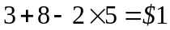 initially. The following table shows the profit/loss from the strategy.
Stock Price | Payoff | Profit
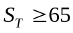 | 0 | 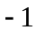
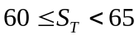 | 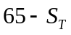 | 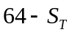
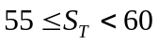 | 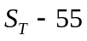 | 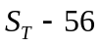
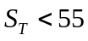 | 0

The butterfly spread leads to a loss when the final stock price is greater than $64 or less than $56.

√Problem 12.25.
Draw a diagram showing the variation of an investor’s profit and loss with the terminal stock price for a portfolio consisting of
- One share and a short position in one call option
- Two shares and a short position in one call option
- One share and a short position in two call options
- One share and a short position in four call options
In each case, assume that the call option has an exercise price equal to the current stock price.
The variation of an investor’s profit/loss with the terminal stock price for each of the four strategies is shown in Figure S12.5. In each case the dotted line shows the profits from the components of the investor’s position and the solid line shows the total net profit.

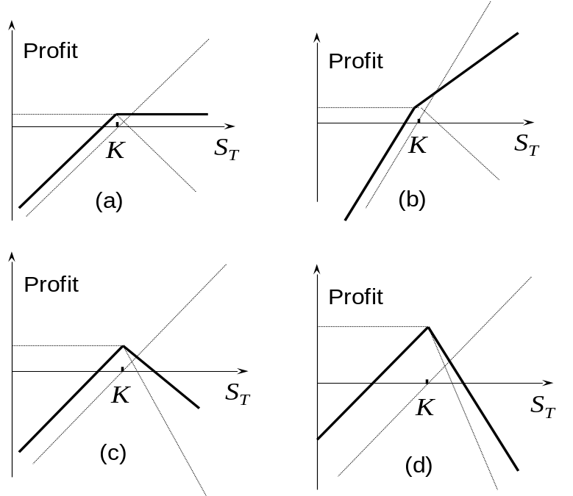

Figure S12.5 Answer to Problem 12.24

√Problem 12.26.
Suppose that the price of a non-dividend-paying stock is $32, its volatility is 30%, and the risk-free rate for all maturities is 5% per annum. Use DerivaGem to calculate the cost of setting up the following positions. In each case provide a table showing the relationship between profit and final stock price. Ignore the impact of discounting.
- A bull spread using European call options with strike prices of $25 and $30 and a maturity of six months.
- A bear spread using European put options with strike prices of $25 and $30 and a maturity of six months
- A butterfly spread using European call options with strike prices of $25, $30, and $35 and a maturity of one year.
- A butterfly spread using European put options with strike prices of $25, $30, and $35 and a maturity of one year.
- A straddle using options with a strike price of $30 and a six-month maturity.
- A strangle using options with strike prices of $25 and $35 and a six-month maturity.
In each case provide a table showing the relationship between profit and final stock price. Ignore the impact of discounting.
- A call option with a strike price of 25 costs 7.90 and a call option with a strike price of 30 costs 4.18. The cost of the bull spread is therefore 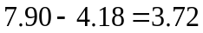. The profits ignoring the impact of discounting are

Stock Price Range | Profit
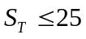 | 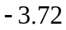
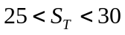 | 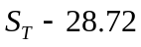
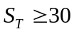 | 1.28

(b) A put option with a strike price of 25 costs 0.28 and a put option with a strike price of 30 costs 1.44. The cost of the bear spread is therefore 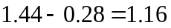. The profits ignoring the impact of discounting are

Stock Price Range | Profit
 | 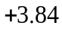
 | 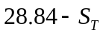
 | 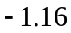

(c) Call options with maturities of one year and strike prices of 25, 30, and 35 cost 8.92, 5.60, and 3.28, respectively. The cost of the butterfly spread is therefore 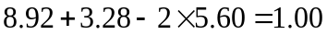. The profits ignoring the impact of discounting are

Stock Price Range | Profit
 | 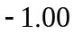
 | 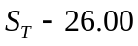
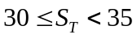 | 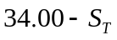

(d) Put options with maturities of one year and strike prices of 25, 30, and 35 cost 0.70, 2.14, 4.57, respectively. The cost of the butterfly spread is therefore 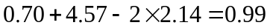. Allowing for rounding errors, this is the same as in (c). The profits are the same as in (c).

(e) A call option with a strike price of 30 costs 4.18. A put option with a strike price of 30 costs 1.44. The cost of the straddle is therefore 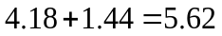. The profits ignoring the impact of discounting are

Stock Price Range | Profit
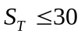 | 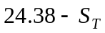
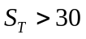 | 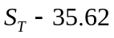

(f) A six-month call option with a strike price of 35 costs 1.85. A six-month put option with a strike price of 25 costs 0.28. The cost of the strangle is therefore 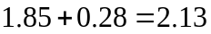. The profits ignoring the impact of discounting are

Stock Price Range | Profit
 | 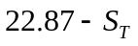
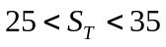 | −2.13
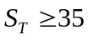 | 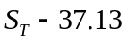

√Problem 12.28. (Excel file)
Describe the trading position created in which a call option is bought with strike price K₁ and a put option is sold with strike price K₂ when both have the same time to maturity and K₂ > K₁. What does the position become when K₁ = K₂?

The position is as shown in the diagram below (for K₁ = 25 and K₂ = 35). It is known as a range forward and is discussed further in Chapter 17. When K₁ =K₂, the position becomes a regular long forward.

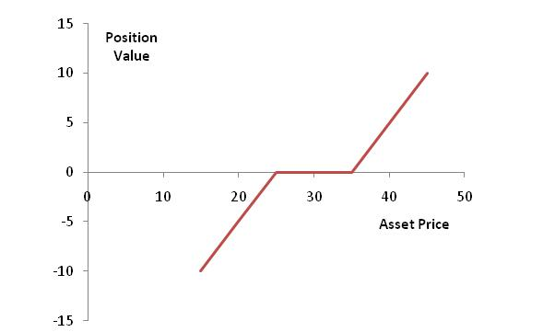

Figure S12.6: Trading position in Problem 12.27

