2022-3作业（Hull 英文第十版，见QQ群文件）
第13章
Problem 13.1、13.4（这两题，每题分别用无套利技术、风险中性定价技术、组合复制技术这三种方法求解）。13.5, 13.6, 13.13

第14章
Problem 14.2，14.4，14.5，14.9，14.10，14.11，14.17

第15章
Problem 15.6，15.7，15.8

√Problem 13.1.
A stock price is currently $40. It is known that at the end of one month it will be either $42 or $38. The risk-free interest rate is 8% per annum with continuous compounding. What is the value of a one-month European call option with a strike price of $39?
Consider a portfolio consisting of
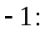 Call option
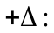 Shares
If the stock price rises to $42, the portfolio is worth 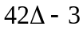. If the stock price falls to $38, it is worth 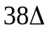. These are the same when
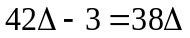
or 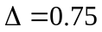. The value of the portfolio in one month is 28.5 for both stock prices. Its value today must be the present value of 28.5, or 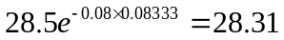. This means that
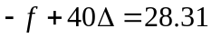
where  is the call price. Because , the call price is 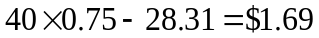. As an alternative approach, we can calculate the probability, , of an up movement in a risk-neutral world. This must satisfy:
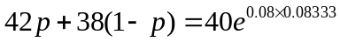
so that
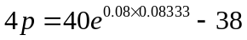
or 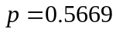. The value of the option is then its expected payoff discounted at the risk-free rate:
or $1.69. This agrees with the previous calculation.

√Problem 13.4.
A stock price is currently $50. It is known that at the end of six months it will be either $45 or $55. The risk-free interest rate is 10% per annum with continuous compounding. What is the value of a six-month European put option with a strike price of $50?
Consider a portfolio consisting of
Put option
Shares
If the stock price rises to $55, this is worth 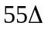. If the stock price falls to $45, the portfolio is worth 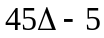. These are the same when
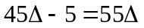
or 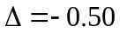. The value of the portfolio in six months is 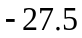 for both stock prices. Its value today must be the present value of , or 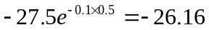. This means that
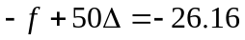
where is the put price. Because , the put price is $1.16. As an alternative approach we can calculate the probability, , of an up movement in a risk-neutral world. This must satisfy:
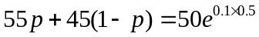
so that
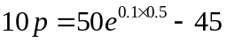
or 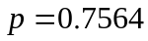. The value of the option is then its expected payoff discounted at the risk-free rate:
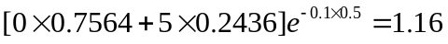
or $1.16. This agrees with the previous calculation.

√Problem 13.5.
A stock price is currently $100. Over each of the next two six-month periods it is expected to go up by 10% or down by 10%. The risk-free interest rate is 8% per annum with continuous compounding. What is the value of a one-year European call option with a strike price of $100?
In this case 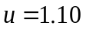, 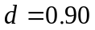, 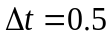, and 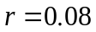, so that
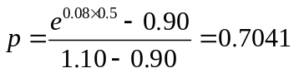
The tree for stock price movements is shown in Figure S13.1. We can work back from the end of the tree to the beginning, as indicated in the diagram, to give the value of the option as $9.61. The option value can also be calculated directly from equation (13.10):
or $9.61.

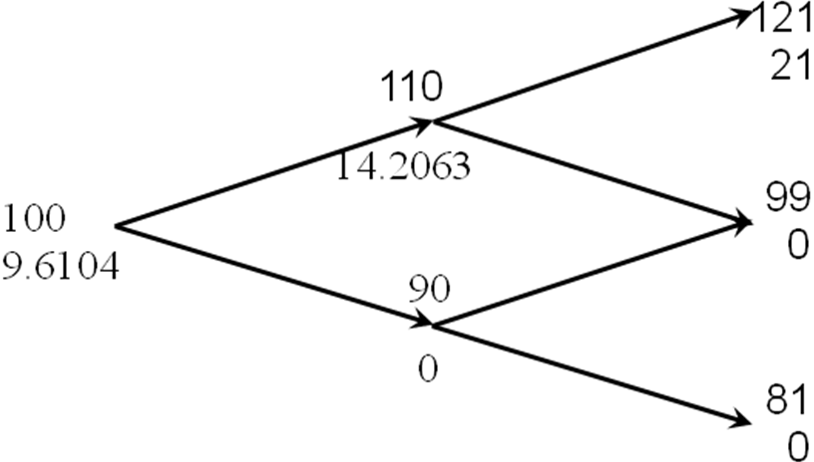

Figure S13.1: Tree for Problem 13.5

√Problem 13.6.
For the situation considered in Problem 13.5, what is the value of a one-year European put option with a strike price of $100? Verify that the European call and European put prices satisfy put–call parity.
Figure S13.2 shows how we can value the put option using the same tree as in Problem 13.5. The value of the option is $1.92. The option value can also be calculated directly from equation (13.10):
or $1.92. The stock price plus the put price is 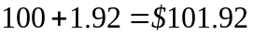. The present value of the strike price plus the call price is 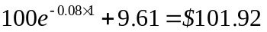. These are the same, verifying that put–call parity holds.
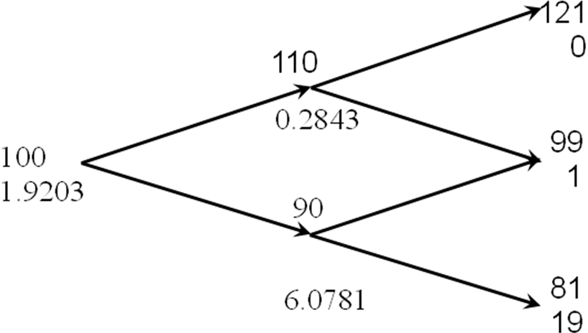

Figure S13.2: Tree for Problem 13.6

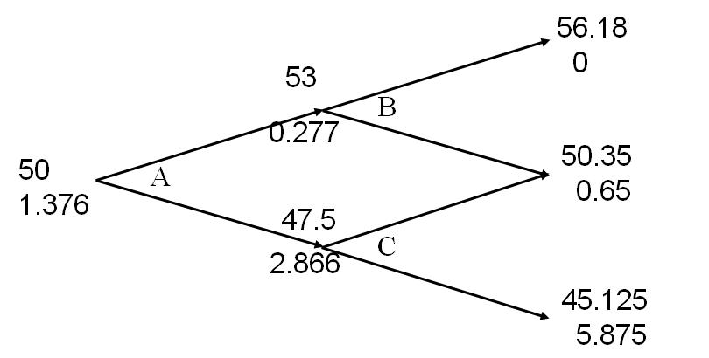

√Problem 13.13.
For the situation considered in Problem 13.12, what is the value of a six-month European put option with a strike price of $51? Verify that the European call and European put prices satisfy put–call parity. If the put option were American, would it ever be optimal to exercise it early at any of the nodes on the tree?
The tree for valuing the put option is shown in Figure S13.4. We get a payoff of 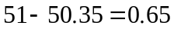 if the middle final node is reached and a payoff of 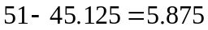 if the lowest final node is reached. The value of the option is therefore
This can also be calculated by working back through the tree as indicated in Figure S13.4.
The value of the put plus the stock price is
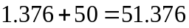

The value of the call plus the present value of the strike price is
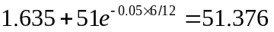

This verifies that put–call parity holds
To test whether it worth exercising the option early we compare the value calculated for the option at each node with the payoff from immediate exercise. At node C the payoff from immediate exercise is 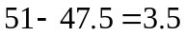. Because this is greater than 2.8664, the option should be exercised at this node. The option should not be exercised at either node A or node B.

Figure S13.4: Tree for Problem 13.13

√Problem 14.2.
Can a trading rule based on the past history of a stock’s price ever produce returns that are consistently above average? Discuss.

The first point to make is that any trading strategy can, just because of good luck, produce above average returns. The key question is whether a trading strategy consistently outperforms the market when adjustments are made for risk. It is certainly possible that a trading strategy could do this. However, when enough investors know about the strategy and trade on the basis of the strategy, the profit will disappear.
As an illustration of this, consider a phenomenon known as the small firm effect. Portfolios of stocks in small firms appear to have outperformed portfolios of stocks in large firms when appropriate adjustments are made for risk. Research was published about this in the early 1980s and mutual funds were set up to take advantage of the phenomenon. There is some evidence that this has resulted in the phenomenon disappearing.

√Problem 14.4.
Variables 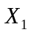 and 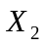 follow generalized Wiener processes with drift rates 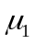 and 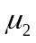 and variances 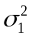 and 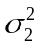. What process does 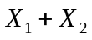 follow if:
- The changes in and in any short interval of time are uncorrelated?
- There is a correlation 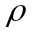 between the changes in and in any short interval of time?
  - Suppose that X₁ and X₂ equal a₁ and a₂ initially. After a time period of length , X₁ has the probability distribution

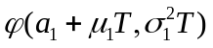
and has a probability distribution

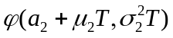

From the property of sums of independent normally distributed variables, has the probability distribution

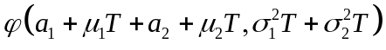

i.e.,
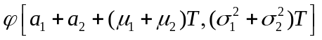
This shows that follows a generalized Wiener process with drift rate 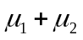 and variance rate 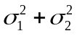.
  - In this case the change in the value of in a short interval of time 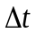 has the probability distribution:
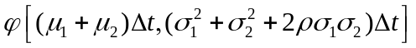
If , , 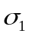, 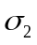 and are all constant, arguments similar to those in Section 14.2 show that the change in a longer period of time is

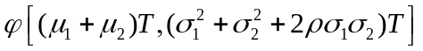

The variable,, therefore follows a generalized Wiener process with drift rate and variance rate 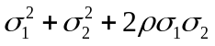.

√Problem 14.5.

Consider a variable,, that follows the process

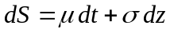

For the first three years, 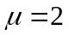 and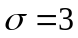; for the next three years, 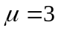 and 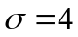. If the initial value of the variable is 5, what is the probability distribution of the value of the variable at the end of year six?

The change in during the first three years has the probability distribution

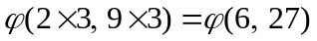

The change during the next three years has the probability distribution

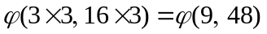

The change during the six years is the sum of a variable with probability distribution 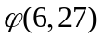 and a variable with probability distribution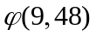. The probability distribution of the change is therefore
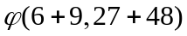

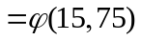

Since the initial value of the variable is 5, the probability distribution of the value of the variable at the end of year six is
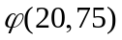

√Problem 14.9.

It has been suggested that the short-term interest rate,, follows the stochastic process

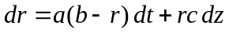

where , , and are positive constants and 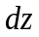 is a Wiener process. Describe the nature of this process.

The drift rate is 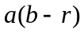. Thus, when the interest rate is above the drift rate is negative and, when the interest rate is below , the drift rate is positive. The interest rate is therefore continually pulled towards the level . The rate at which it is pulled toward this level is . A volatility equal to is superimposed upon the “pull” or the drift.
Suppose 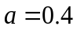, 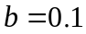 and 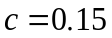 and the current interest rate is 20% per annum. The interest rate is pulled towards the level of 10% per annum. This can be regarded as a long run average. The current drift is 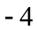% per annum so that the expected rate at the end of one year is about 16% per annum. (In fact it is slightly greater than this, because as the interest rate decreases, the “pull” decreases.) Superimposed upon the drift is a volatility of 15% per annum.

√Problem 14.10.
Suppose that a stock price, , follows geometric Brownian motion with expected return  and volatility :
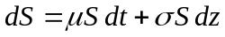

What is the process followed by the variable 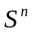? Show that also follows geometric Brownian motion.

If 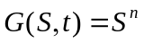 then 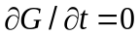, 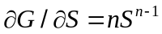, and 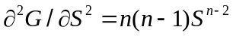. Using Itô’s lemma:
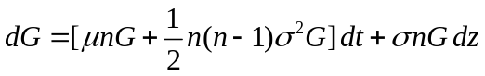

This shows that 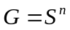 follows geometric Brownian motion where the expected return is
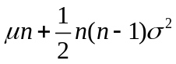
and the volatility is . The stock price has an expected return of and the expected value of 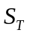 is 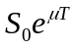. The expected value of 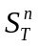 is
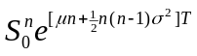

√Problem 14.11.
Suppose that is the yield to maturity with continuous compounding on a zero-coupon bond that pays off $1 at time . Assume that follows the process

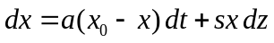

where , 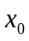, and are positive constants and is a Wiener process. What is the process followed by the bond price?

The process followed by , the bond price, is from Itô’s lemma:
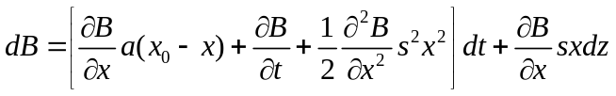

Since:
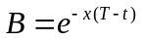

the required partial derivatives are
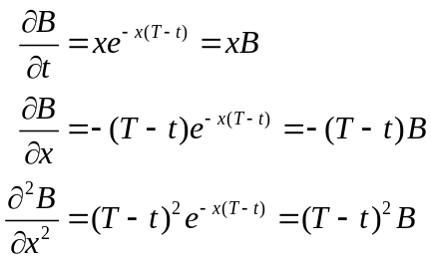
Hence:

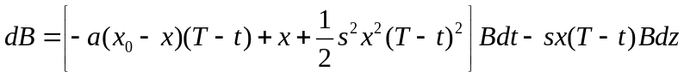

√Problem 14.17.
A stock price is currently 50. Its expected return and volatility are 12% and 30%, respectively. What is the probability that the stock price will be greater than 80 in two years? (Hint 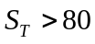 when 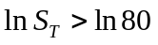.)
The variable 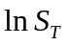 is normally distributed with mean 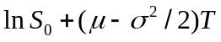 and standard deviation 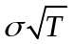. In this case 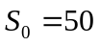, 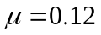, 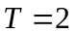, and 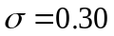 so that the mean and standard deviation of are 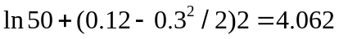 and 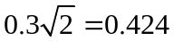, respectively. Also, 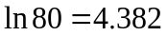. The probability that is the same as the probability that 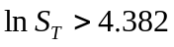. This is
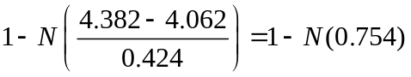
where 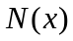 is the probability that a normally distributed variable with mean zero and standard deviation 1 is less than . Because 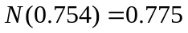, the required probability is 0.225.

√Problem 15.6.
What is implied volatility? How can it be calculated?
The implied volatility is the volatility that makes the Black–Scholes-Merton price of an option equal to its market price. The implied volatility is calculated using an iterative procedure. A simple approach is the following. Suppose we have two volatilities one too high (i.e., giving an option price greater than the market price) and the other too low (i.e., giving an option price lower than the market price). By testing the volatility that is half way between the two, we get a new too-high volatility or a new too-low volatility. If we search initially for two volatilities, one too high and the other too low we can use this procedure repeatedly to bisect the range and converge on the correct implied volatility. Other more sophisticated approaches (e.g., involving the Newton-Raphson procedure) are used in practice.

√Problem 15.7.
A stock price is currently $40. Assume that the expected return from the stock is 15% and its volatility is 25%. What is the probability distribution for the rate of return (with continuous compounding) earned over a two-year period?
In this case 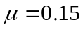 and 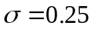. From equation (15.7) the probability distribution for the rate of return over a two-year period with continuous compounding is:
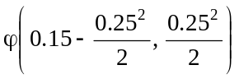

i.e.,

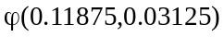

The expected value of the return is 11.875% per annum and the standard deviation is 17.7% per annum.

√Problem 15.8.
A stock price follows geometric Brownian motion with an expected return of 16% and a volatility of 35%. The current price is $38.
- What is the probability that a European call option on the stock with an exercise price of $40 and a maturity date in six months will be exercised?
- What is the probability that a European put option on the stock with the same exercise price and maturity will be exercised?
- The required probability is the probability of the stock price being above $40 in six months time. Suppose that the stock price in six months is
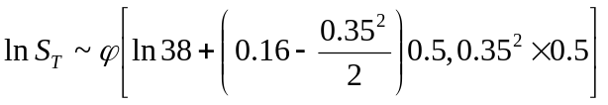

i.e.,
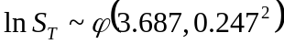

Since 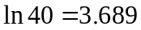, we require the probability of ln(S_{T})>3.689. This is
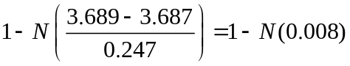
Since N(0.008) = 0.5032, the required probability is 0.4968.
- In this case the required probability is the probability of the stock price being less than $40 in six months time. It is
