2022-4作业（Hull 英文第十版，见QQ群文件）
第17章
Problem: 17.9、17.10、17.17
第18章
Problem: 18.10、18.12
第19章
Problem: 19.24、19.25
第22章
Problem 22.1

√Problem 17.9.
A foreign currency is currently worth $1.50. The domestic and foreign risk-free interest rates are 5% and 9%, respectively. Calculate a lower bound for the value of a six-month call option on the currency with a strike price of $1.40 if it is (a) European and (b) American.
Lower bound for European option is
Lower bound for American option is
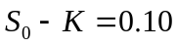

√Problem 17.10.
Consider a stock index currently standing at 250. The dividend yield on the index is 4% per annum, and the risk-free rate is 6% per annum. A three-month European call option on the index with a strike price of 245 is currently worth $10. What is the value of a three-month put option on the index with a strike price of 245?
In this case 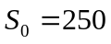, 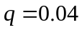, 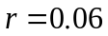, 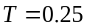, 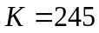, and 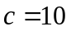. Using put–call parity
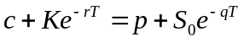
or
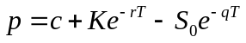
Substituting:
The put price is 3.84.

√Problem 17.17.
Consider again the situation in Problem 17.16. Suppose that the portfolio has a beta of 2.0, the risk-free interest rate is 5% per annum, and the dividend yield on both the portfolio and the index is 3% per annum. What options should be purchased to provide protection against the value of the portfolio falling below $54 million in one year’s time?
When the value of the portfolio falls to $54 million the holder of the portfolio makes a capital loss of 10%. After dividends are taken into account the loss is 7% during the year. This is 12% below the risk-free interest rate. According to the capital asset pricing model, the expected excess return of the portfolio above the risk-free rate equals beta times the expected excess return of the market above the risk-free rate.
Therefore, when the portfolio provides a return 12% below the risk-free interest rate, the market’s expected return is 6% below the risk-free interest rate. As the index can be assumed to have a beta of 1.0, this is also the excess expected return (including dividends) from the index. The expected return from the index is therefore 1% per annum. Since the index provides a 3% per annum dividend yield, the expected movement in the index is 4%. Thus when the portfolio’s value is $54 million the expected value of the index is 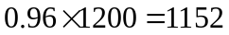. Hence European put options should be purchased with an exercise price of 1152. Their maturity date should be in one year.
The number of options required is twice the number required in Problem 17.16. This is because we wish to protect a portfolio which is twice as sensitive to changes in market conditions as the portfolio in Problem 17.16. Hence options on $100,000 (or 1,000 contracts) should be purchased. To check that the answer is correct consider what happens when the value of the portfolio declines by 20% to $48 million. The return including dividends is 17%. This is 22% less than the risk-free interest rate. The index can be expected to provide a return (including dividends) which is 11% less than the risk-free interest rate, i.e. a return of 6%. The index can therefore be expected to drop by 9% to 1092. The payoff from the put options is 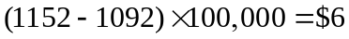 million. This is exactly what is required to restore the value of the portfolio to $54 million.

√Problem 18.10.
Consider a two-month futures call option with a strike price of 40 when the risk-free interest rate is 10% per annum. The current futures price is 47. What is a lower bound for the value of the futures option if it is (a) European and (b) American?

Lower bound if option is European is
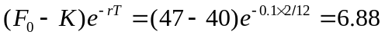
Lower bound if option is American is
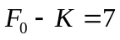

√Problem 18.12.
A futures price is currently 60 and its volatility is 30%. The risk-free interest rate is 8% per annum. Use a two-step binomial tree to calculate the value of a six-month European call option on the futures with a strike price of 60? If the call were American, would it ever be worth exercising it early?
In this case 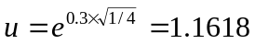; 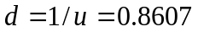; and
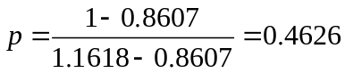
In the tree shown in Figure S18.1 the middle number at each node is the price of the European option and the lower number is the price of the American option. The tree shows that the value of the European option is 4.3155 and the value of the American option is 4.4026. The American option should sometimes be exercised early.
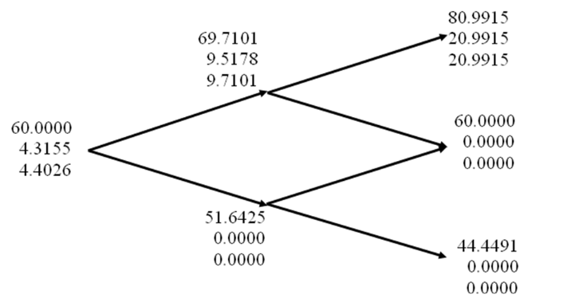

√Problem 19.24.
A financial institution has the following portfolio of over-the-counter options on sterling:

Type | Position | Delta of Option | Gamma of Option | Vega of Option
Call | −1,000 | 0.5 | 2.2 | 1.8
Call | −500 | 0.8 | 0.6 | 0.2
Put | −2,000 | -0.40 | 1.3 | 0.7
Call | −500 | 0.70 | 1.8 | 1.4

A traded option is available with a delta of 0.6, a gamma of 1.5, and a vega of 0.8.
- What position in the traded option and in sterling would make the portfolio both gamma neutral and delta neutral?
- What position in the traded option and in sterling would make the portfolio both vega neutral and delta neutral? Assume that all implied volatilities change by the same amount so that vegas can be aggregated.

The delta of the portfolio is

The gamma of the portfolio is

The vega of the portfolio is

- A long position in 4,000 traded options will give a gamma-neutral portfolio since the long position has a gamma of 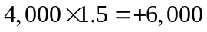. The delta of the whole portfolio (including traded options) is then:
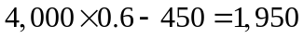
Hence, in addition to the 4,000 traded options, a short position of 1,950 in sterling is necessary so that the portfolio is both gamma and delta neutral.
- A long position in 5,000 traded options will give a vega-neutral portfolio since the long position has a vega of 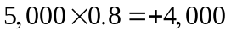. The delta of the whole portfolio (including traded options) is then
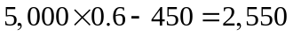
Hence, in addition to the 5,000 traded options, a short position of 2,550 in sterling is necessary so that the portfolio is both vega and delta neutral.

√Problem 19.25.
Consider again the situation in Problem 19.24. Suppose that a second traded option with a delta of 0.1, a gamma of 0.5, and a vega of 0.6 is available. How could the portfolio be made delta, gamma, and vega neutral?
Let 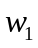 be the position in the first traded option and 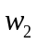 be the position in the second traded option. We require:
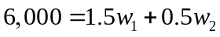

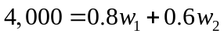
The solution to these equations can easily be seen to be 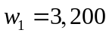, 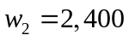. The whole portfolio then has a delta of

Therefore the portfolio can be made delta, gamma and vega neutral by taking a long position in 3,200 of the first traded option, a long position in 2,400 of the second traded option and a short position of 1,710 in sterling.

√Problem 22.1.
Consider a position consisting of a $100,000 investment in asset A and a $100,000 investment in asset B. Assume that the daily volatilities of both assets are 1% and that the coefficient of correlation between their returns is 0.3. Estimate the 5-day 99% VaR and ES for the portfolio assuming normally distributed returns.
The standard deviation of the daily change in the investment in each asset is $1,000. The variance of the portfolio’s daily change is
The standard deviation of the portfolio’s daily change is the square root of this or $1,612.45. The standard deviation of the 5-day change is
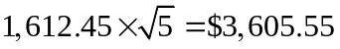
Because N⁻¹(0.01) = 2.326, 1% of a normal distribution lies more than 2.326 standard deviations below the mean. The 5-day 99 percent value at risk is therefore 2.326×3,605.55 = $8,388. The 5-day 99% ES is

