Plans

Based on anonymized, minified repro.

# Ad-hoc 1

Missing index rec noticed

go

declare

@d bigint = 0

,@xx1 int = 40664

,@xx2 int = 41308

,@offset int = 0

,@next int = 100

,@e nvarchar(50) = N'abcdef012';

with cte as (

select

cl.id,

cl.xx

from foo cl

where cl.xx >= @xx1

and cl.xx < @xx2

and cl.d = @d

and cl.e = @e

order by cl.xx desc

offset @offset rows fetch next @next rows only

)

select *

from cte

option (use hint('enable_parallel_plan_preference'));

go

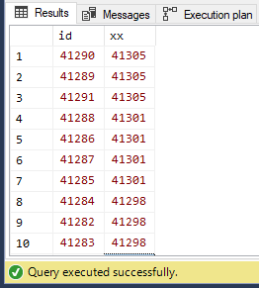

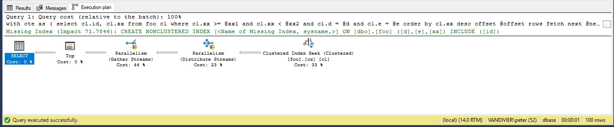

# SProc 1

go

declare

@d bigint = 0

,@xx1 int = 40664

,@xx2 int = 41308

,@offset int = 0

,@next int = 100

,@e nvarchar(50) = N'abcdef012';

exec bar

@d

,@xx1

,@xx2

,@offset

,@next

,@e;

go

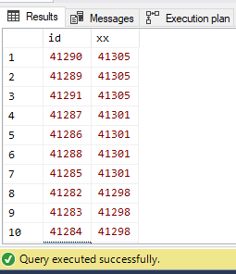

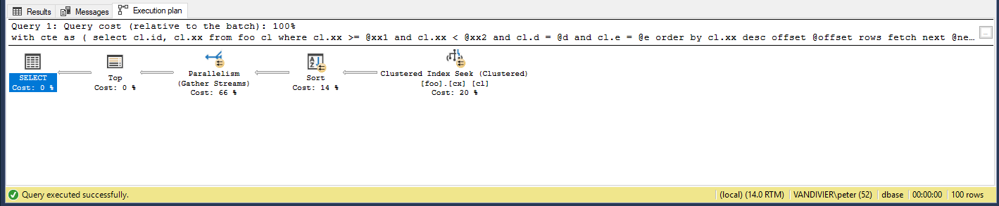

# Sproc 2

go

exec bar

@d = 0

,@xx1 = 40664

,@xx2 = 41308

,@offset = 0

,@next = 100

,@e = N'abcdef012';

go

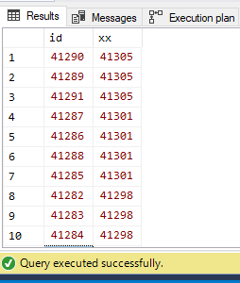

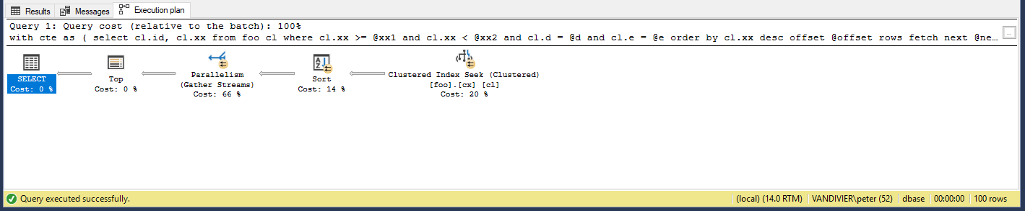

# Ad-hoc 2

with cte as (

select

cl.id,

cl.xx

from foo cl

where cl.xx >= 40664

and cl.xx < 41308

and cl.d = 0

and cl.e = N'abcdef012'

order by cl.xx desc

offset 0 rows fetch next 100 rows only

)

select *

from cte

option (use hint('enable_parallel_plan_preference'));

