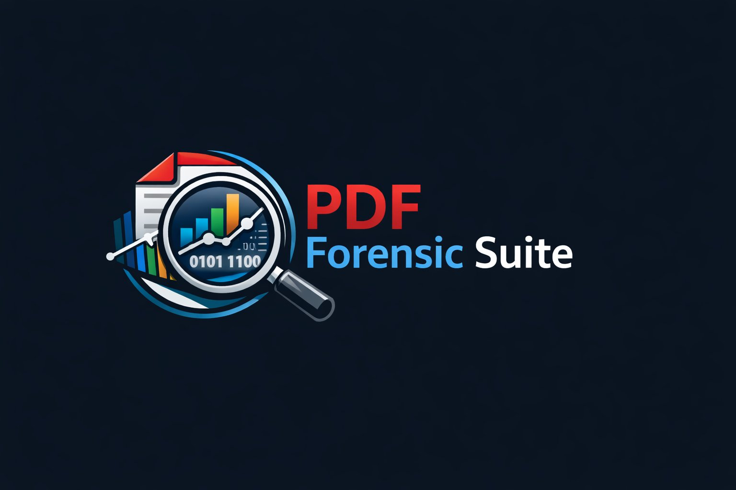
PDF FORENSICS SUITE v1.0.0
Risk Scoring Methodology
Plain-Language Guide
Document Date: April 21, 2026
Released under the MIT License

1. What Is Risk Scoring?
When PDF Forensics Suite analyzes a document, it assigns a numerical risk score to each image it finds. This score summarises how many — and how serious — the structural irregularities are in the way that image has been placed in the document.
Think of it like a checklist that an experienced document examiner would work through. Each item on the checklist that applies adds points to the score. The higher the score, the more items were flagged, and the more urgently the image deserves a closer look.
An important caution: a high risk score is not a conclusion. It is a signal. The tool is identifying patterns that, based on how PDF documents are built, are unusual and warrant investigation. An experienced human examiner must review the image, the document, and its context before drawing any conclusions.

2. How Are PDF Images Different from What You See?
A PDF document does not work like a printed page. When you look at a printed contract, what you see is what exists on the paper. A PDF is different: it separates what is stored in the file from what is displayed to you.
Every image in a PDF is stored as a block of pixel data. That pixel data might contain much more than you ever see — because the document can tell the viewer to show only a portion of it, to cover it with something else, or to display it off the edge of the visible page. The hidden portions still exist in the file, even if they are invisible when you open the document normally.
This architecture has legitimate uses — it allows efficient document design. But it also creates opportunities for concealment. The risk scoring system looks for the specific patterns that are associated with hiding image content.

3. What Does the Score Mean?
Scores run from 0 to 100. They are grouped into three tiers:
Tier | Score Range | What It Means
LOW | 0 – 14 | No significant structural irregularities found. The image placement follows expected patterns. No specific action required, though context always matters.
MID | 15 – 34 | One moderate irregularity was found, or a combination of minor ones. This image warrants review, especially if there are other suspicious elements in the same document.
HIGH | 35 – 100 | One or more serious structural irregularities were detected. Manual examination by an investigator is required. The image should be extracted and the surrounding document structure inspected.
A document may contain images with different scores. A single document with hundreds of LOW images and one HIGH image should focus the examiner's attention on that one HIGH image.

4. What Kinds of Irregularities Are Detected?
The tool checks for eight different types of structural irregularities. Here is what each one means in plain terms:

4.1 Hidden by Boundary Cropping
Score contribution: +30
A PDF can package images inside a container that only shows part of the image — like looking at a photograph through a window. If the tool detects that an image is larger than its container, the extra pixels exist in the file but are invisible to anyone viewing the document normally. This is similar to folding over part of a printed photograph and scanning only the visible portion — except that in a PDF, the "folded" part is still in the file.

4.2 Hidden by Custom Clipping
Score contribution: +30
A PDF can define an arbitrary shape — any polygon or curve — and instruct the viewer to show only the part of the image inside that shape, hiding everything outside it. This is like cutting out an irregular portion of a photograph and only showing that cutout. The rest of the image data still exists in the file.

4.3 One Image Placed Over Another
Score contributions: +35 (if the covered image is completely hidden) to +8 (if partially covered)
Two images can overlap on the same page. If a fully opaque image is placed on top of another, the bottom image is completely invisible to the reader — but it is still in the file and can be extracted. This is the digital equivalent of using correction fluid on a photocopy: you cannot see what was underneath, but a forensic examiner looking at the original file can.
The tool distinguishes four levels of severity depending on whether the concealment is complete or partial.

4.4 Image Placed Off the Visible Page
Score contribution: +25
A PDF viewer shows only the visible area of a page. But a PDF file can contain image placements that are entirely outside this visible area — positioned off to the side or below the bottom of the page. These images are invisible when the document is viewed or printed normally, but they are present in the file. This technique has been used to embed hidden content such as watermarks, tracking information, or original document elements.

4.5 Different Resolution Than Other Images in the Document
Score contribution: +20
Every image has an effective display resolution — how many pixels are packed into each inch of the page. When a document is created consistently (for example, all pages scanned on the same scanner), all images will have similar resolutions. When one image has a very different resolution from the others, it is likely from a different source — a screenshot, a different scanner, a different camera, or a different software application. This does not automatically mean fraud, but it is a meaningful indicator that the document may have been assembled from multiple sources.
The tool also flags images that are stretched differently horizontally versus vertically — an indicator that an image was manually resized disproportionately.

4.6 Minor Indicators (Low Score Contribution)
Score contribution: +5 each
Three additional patterns are recorded but carry minimal weight. They are included because they sometimes accompany the more significant findings above, and their combination can elevate a score. On their own, they are not conclusive:
- Transparency effects applied to an image container
- Transparency applied directly to an image (for example, a PNG logo with a transparent background)
- An image that has been rotated or skewed (which is legitimate in many documents but harder to visually assess)

5. Why These Specific Point Values?
The point values were chosen to reflect the forensic weight of each finding — how strongly it is associated with intentional document manipulation, and how rarely it occurs in legitimately created documents.
A fully concealed image (+35) receives the highest single score because there is virtually no legitimate reason for a document to contain an image that is completely hidden behind another. It reaches the HIGH tier in a single finding.
Boundary cropping and custom clipping (+30 each) receive the next highest scores because they directly hide image content. They are set slightly lower than full concealment because legitimate document designs occasionally use these techniques.
Off-page images (+25) are serious but scored slightly lower because faulty PDF export software can occasionally misplace content off-page without any fraudulent intent.
Resolution anomalies (+20) are meaningful indicators that receive a moderate score because while mixed-source documents do occur legitimately, the combination of one image at a very different resolution than all others is a reliable signal worth investigating.
Partial concealment (+15 or +8) receives lower scores than full concealment because partial overlap has many legitimate explanations (captions over photographs, logos on coloured backgrounds).

6. Can the Score Be Wrong?
Yes. The scoring system is an automated tool, and all automated tools can produce results that require human interpretation. Two types of errors are possible:

6.1 High Scores on Legitimate Documents (False Positives)
Some document creation workflows produce high risk scores even when the document has not been tampered with. Common examples include:
- Archival-format PDFs (called PDF/A) sometimes use image containers with cropping as part of their technical structure — not to hide content.
- Professional publishing templates (magazines, newspapers) routinely use images that extend slightly beyond page margins as a design technique called 'full bleed'.
- Documents exported from Microsoft PowerPoint or similar presentation software often produce complex image structures that the tool may flag.
- A document with a CONFIDENTIAL watermark overlaid on every page will show overlap findings for every watermarked image — but this is a legitimate design choice.
- A document combining a digitally created cover page with scanned body pages will have images at different resolutions — not because of tampering, but because they genuinely come from different sources.
The examiner's role is to evaluate these findings in context. A high score alone is not evidence of fraud; it is evidence that the structure of the document is unusual and warrants explanation.

6.2 Low Scores on Tampered Documents (False Negatives)
Some types of document tampering may not be detected by structural analysis and may result in a low risk score:
- If an image has been edited at the pixel level — for example, changing a number in an image of a cheque — but the image dimensions and format remain the same, the tool will not detect the change. Pixel-level analysis requires separate image forensic examination.
- If all the images in a fraudulent document were assembled from exactly the same source at the same resolution, the resolution anomaly check will not flag them.
- The tool does not analyze text, handwriting, or printed content — only image structure.
A low risk score means the tool found no structural irregularities. It does not mean the document has not been altered.

7. What Should Happen After a High Score Is Found?
A HIGH risk score should trigger a human review of that image and the surrounding document. The following questions guide that review:
- What does the hidden image content show? (If concealed by overlap or cropping, the hidden content can be extracted from the file.)
- When was this image created? (The image may contain metadata — creation date, camera model, GPS location — that is independent of the PDF document's own dates.)
- Is the image's resolution consistent with its claimed origin? (A scanned court document should not contain a screenshot-resolution image.)
- Did the document have prior versions? (Multiple revision markers in the file can reveal what the document looked like before the suspicious image was inserted.)
- Is the same image used in other documents in the case? (Cross-document image comparison may reveal the source or a pattern of reuse.)
The examiner should document their findings and conclusions independently of the tool's output. The tool provides a starting point, not a conclusion.

8. What the Score Does Not Tell You
- The score does not tell you whether the document is fraudulent. That is a conclusion for a human examiner.
- The score does not tell you who made the changes or when.
- The score does not analyze the text content of the document.
- The score does not cover encrypted PDFs — documents that are password-protected cannot be analyzed.
- The score does not analyze images that have been edited at the pixel level without changing their structure.

9. Glossary
Term | Plain-Language Definition
Image XObject | The block of pixel data stored in the PDF file — the actual picture, independent of where or how it is displayed.
Transformation Matrix (CTM) | A set of mathematical values that define exactly how an image is positioned, sized, and rotated on the page.
Form XObject | A reusable container in a PDF that can hold images and other content. Like a named template that can be placed anywhere.
BBox (Bounding Box) | The visible window of a Form XObject. Content outside this rectangle is clipped and invisible.
Clipping Path | A custom shape that masks an image, showing only the portion inside the shape.
Effective DPI | The actual display resolution of an image as it appears on the page — calculated from the image's pixel count divided by its physical size on the page.
Z-order | The painting sequence of objects on a page. Objects with a higher z-order are painted later and appear on top.
Incremental Update | A mechanism for modifying a PDF without rewriting the whole file. Changes are appended to the end. Each update is marked with %%EOF and creates a new revision.
SMask (Soft Mask) | A secondary greyscale image that controls the transparency of each pixel in the main image — used for smooth edges and alpha transparency.

