# 1. Use ”Su_raw_matrix.txt” for the following questions (30 points).

# Preliminary Stuff

install.packages('systemfonts')

install.packages('textshaping')

install.packages(c('googledrive', 'googlesheets4', 'httr', 'ragg', 'rvest', 'xml2'))

install.packages("ggplot2")

install.packages("tidyverse")

library(ggplot2)

# Problem 1

# Load the file

su <- read.delim('/home/jj/Downloads/Su_raw_matrix.txt')

# Mean

msu <- mean(su$Liver_2.CEL)

# Standard deviation

sdsu <- sd(su$Liver_2.CEL)

# Col Means

cmsu <- colMeans(su)

# Col Sums

cssu <- colSums(su)

# Problem 2

# Random 1000 matrices

randNumPoint2 <- rnorm(1000, mean = 0, sd = .2)

randNumPoint5 <- rnorm(1000, mean = 0, sd = .5)

df2 <- data.frame(values = randNumPoint2)

df3 <- data.frame(values = randNumPoint5)

# The .2 Histogram

ggplot(df2, aes(x = values)) +

xlim(c(-5,5)) +

geom_histogram(bins = 50, fill = "skyblue", color = "white") +

labs(title = "Histogram for Mean = 0, SD = 0.2",

x = "Value",

y = "Frequency") +

theme_minimal()

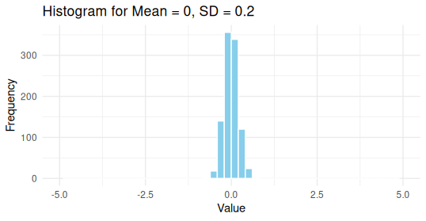

df3 <- data.frame(values = randNumPoint5)

# The .5 Histogram

ggplot(df3, aes(x = values)) +

xlim(c(-5,5)) +

geom_histogram(bins = 50, fill = "skyblue", color = "white") +

labs(title = "Histogram for Mean = 0, SD = 0.5",

x = "Value",

y = "Frequency") +

theme_minimal

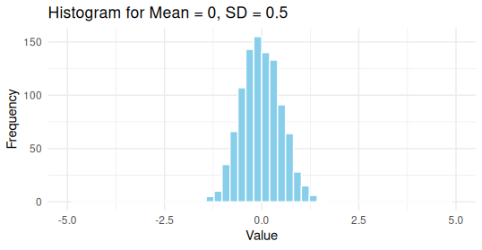

# Then comment on how these histograms are different from each other and state the reason.

# This essentially means a shorter, wider histogram

# The change in standard deviation from 0.2 to 0.5 results in

# a wider distribution over values that deviate more from the mean.

# Problem 3

# a) The setup

dat <- data.frame(cond = factor(rep(c("A","B"), each=200)),

rating = c(rnorm(200),rnorm(200, mean=.8)))

# b) Overlaid histograms

ggplot(dat, aes(x=rating, fill=cond)) +

geom_histogram(binwidth=.5, alpha=.5, position="identity")

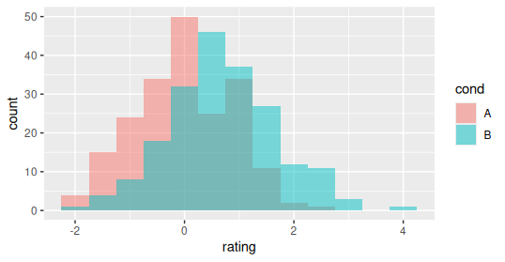

# c) Interleaved histograms

ggplot(dat, aes(x=rating, fill=cond)) + geom_histogram(binwidth=.5, position="dodge")

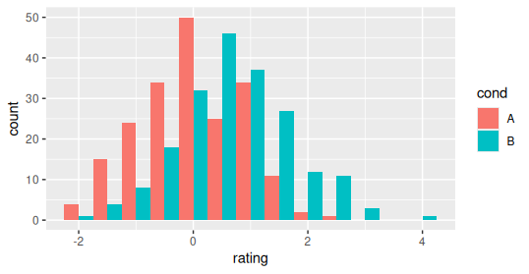

# d) Density plots

ggplot(dat, aes(x=rating, colour=cond)) + geom_density()

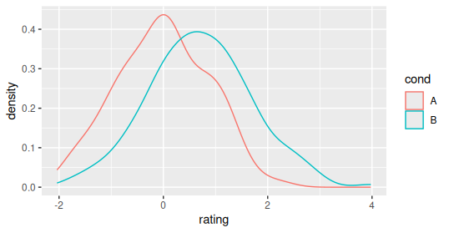

# e)Density plots with semitransparent fill

ggplot(dat, aes(x=rating, fill=cond)) + geom_density(alpha=.3)

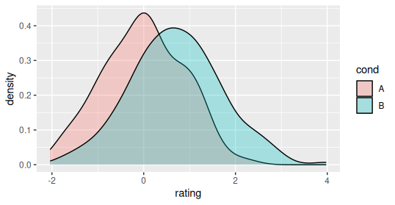

# f-a)

diabetes <- read.csv('/home/jj/Downloads/diabetes_train.csv')

# f-b) Overlaid histograms

ggplot(diabetes, aes(x=mass, fill=class)) +

geom_histogram(binwidth=.5, alpha=.5, position="identity")

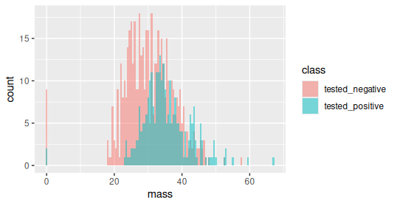

# f-c) Interleaved histograms

ggplot(diabetes, aes(x=mass, fill=class)) + geom_histogram(binwidth=.5, position="dodge")

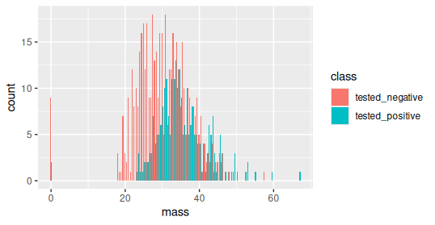

# f-d) Density plots

ggplot(diabetes, aes(x=mass, colour=class)) + geom_density()

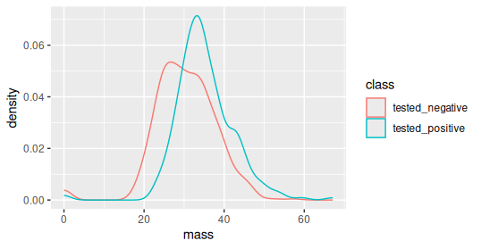

# f-e)Density plots with semitransparent fill

ggplot(diabetes, aes(x=mass, fill=class)) + geom_density(alpha=.3)

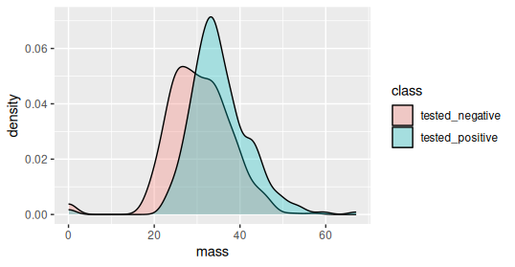

# Problem 4

library(tidyverse)

passengers <- read.csv('/home/jj/Downloads/Data/titanic.csv')

# (a) Drop all non-numerical or null values from the dataset and print a summary

passengers %>% drop_na() %>% summary()

# (b) Return only the rows where the Sex variable='male'

passengers %>% filter(Sex == "male")

# (c) Sort the dataset by the fare column

passengers %>% arrange(desc(Fare))

# (d) Add a column named family size that is the sum of the columns Parch and SibSp

passengers %>% mutate(FamSize = Parch + SibSp)

#(e) Get the average fare and add up number of survivors by sex

passengers %>% group_by(Sex) %>% summarise(meanFare = mean(Fare), numSurv = sum(Survived))

# Problem 5

quantiles <- quantile(diabetes$skin, probs = c(0.10, 0.30, 0.50, 0.60))