**Days before competition**It is important to achieve high muscle glycogen concentrations before the start of an endurance event. To achieve this, you can follow a “supercompensation protocol” by loading carbohydrates in the days before the event. Researchers studied different types of muscle glycogen supercompensation protocols and found that a mixed diet for the first 3 days (50% of total dietary intake was from carbohydrates) followed by 3 days of a very high carbohydrate diet (70%) resulted in very high muscle glycogen stores(1). This would be in the range of consuming approximately 5-7 grams of carbohydrates per kg bodyweight for an athlete, but has to be adjusted based on caloric needs (e.g. athlete is in a caloric deficit or surplus).   
  
After glycogen stores are high, they will stay high for several days if you do not perform much exercise. Carbohydrate loading can increase endurance capacity by about 20% on average and can improve endurance performance by about 2-3% (2). Based on the current scientific literature carbohydrate loading only seems to benefit exercise that lasts at least 90 minutes. Carbohydrate loading seems to have no effect on sprint performance and high intensity exercise with a maximum duration of 30 minutes.   
  
  
  
Glycogen loading **in Figure  
Carbohydrate intake should be high in the days before the event and muscle activity should be limited (tapering)**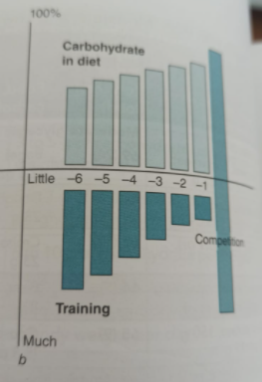

**Main take away:  
6 days before event start increase carbohydrate intake in diet up to 50% of total energy intake and last 3 days before marathon up to 70%   
🡪 with current intake of 2700 kcal this would come to 340 grams and 470 grams of carbohyrdates respectively**

**Hours before the competitions**Athletes should be advised to have a fairly large meal with carbohydrates 3-5 hours before a competition. This will lead to increased carbohydrate availability in muscle and the liver. Achieving this high carbohydrate/glycogen availability is important because it results in more fuel for exercise, thus resulting in higher exercise performance. Ingestion of a carbohydrate-rich meal (aim for 140-330g of carbohydrates) 3-5 hours before exercise improves exercise performance (3). Such a meal could include foods that have fast acting carbohydrates like bread, jam, honey, cereal, bananas and fruit juice.   
 **Main take away:**

**Last fairly large meal 3-5 hours before competition (usually breakfast) of 140-330 g of carbohydrates 🡪 increased carbohydate availability in muscle and the liver.**  
Ingestion of carbohydrate in the hours before exercise has three important effects:  
1. Transient fall in plasma glucose with the onset of exercise  
2. Increase carbohydrate oxidation and accellerated glycogen breakdown  
3. Blunting of fat oxidation (slow)  
  
**No meal in the 30-60 minutes before the marathon!**  
Evidence shows that there are no performance benefits/or disadvantages if your intra-race nutrition (during) is in order (which it it is!)