These are the results of processing the CATSMAT Periodic Segmentation output for the Sanctus and Kyrie test files.

Note that I am currently unable to extract data from R in any format other than an image (dendogram), so the analysis below uses images taken from R.

See Story S-01223 in VersionOne for a description of what’s going on here.

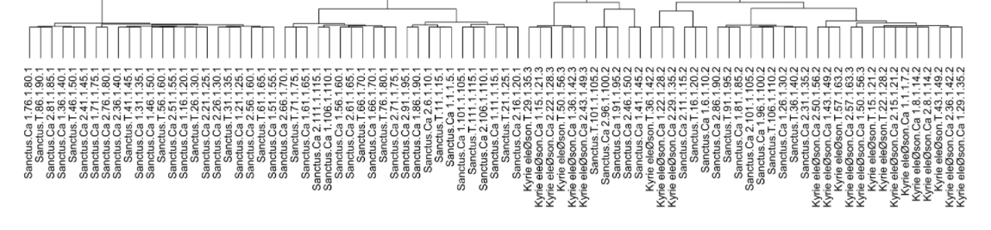

|  |  |
| --- | --- |
|  | Correct |
|  | Correct |
|  | Would expect a segment Sanctus.T.81.1.85.1 however, the C natural in measure 84 is different from the earlier segments where it is C# in measures CA 2.79 and Ca 1.74. Did CATSMAT include Sanctus.T.81.1.85.1 in the result? |
|  | Correct |
|  | Correct |
|  | Correct |
|  | Correct |
|  | Correct |
|  | Correct |
|  | This seems correct, because the Ca 2 segment is at the end of the work – the cannon in part T never occurs. |
|  | Correct |
|  | Correct |
|  | Would expect a segment Sanctus.T.96.1.100.1 however, the C natural in measure 99 is different from the earlier segments where it is C# in measures CA 2.94 and Ca 1.89. Did CATSMAT include Sanctus.T.96.1.100.1 in the result?  Note – There are two sub-segments that are similar. They are   * the second half of the segment starting at CA 1 measure 71 and * the second half of the segment starting at CA 1 measure 86   Note that the cannon between the tree parts swaps the use of the C# and C natural (C# in Ca1 and Ca2 in the first occurrence and C natural in the second, with this pattern inverted in the T part.). |
|  | Correct |
|  | Correct |
|  | Correct |
|  | Correct |
|  | Correct |
|  | Correct |
|  | Would expect a segment Sanctus.T.51.1.55.2 however, the G natural in measure 54 is different from the earlier segments where it is G# in measures CA 2.49 and Ca 1.44. Did CATSMAT include this segment in the result? |
|  | Correct |
|  | Correct |
|  | Correct |
|  | Correct |
|  | Correct |
|  | Correct |
|  | This seems correct, because the Ca 2 segment is at the end of the work – the cannon in part T never occurs. |
|  | Correct |
|  | This group of 6 segments clusters together because they have thesame fist and last notes, and the same number of notes and measures, which is the criteria we are using.  The clusters occur even though the segments are not identical and are not all canonic with each other.  From a strict periodic segmentation point of view, this is clearly a *False Positive.* |
|  | Correct |