- In this network, the switches are externally managed by the opendaylight SDN, where before no such structure was specified by the midterm question. Also the network on the midterm used routers between the hosts instead of switches.
- In this case, the user flow starts closer to when the actual request is made, as no DHCP leases are made, no DNS resolution occurs, and ARP is only minimally involved as there are only two switches and no routers between the two hosts.
- I started getting OF packets when I ran wireshark from s1 on the any interface. Wireshark displayed OF 1.3 as the protocol, where the video showed OFP. I have included the pcap from the capture.
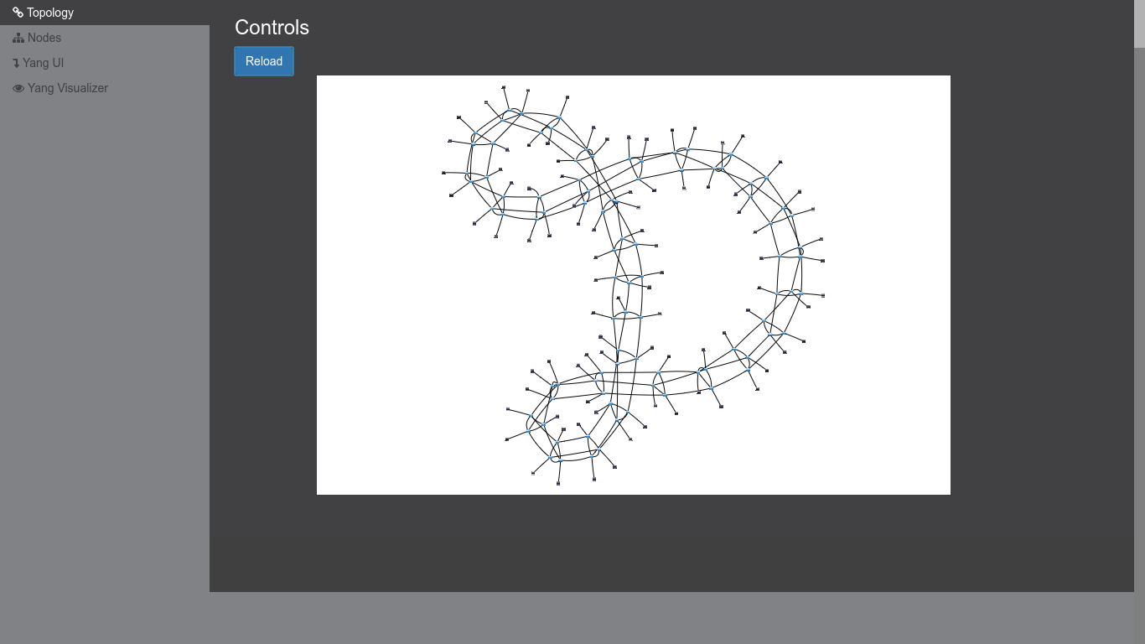
- I was able to get a –torus 30,3 network before it became too difficult to setup
- The reference controller seems to have performance issues when trying to handle slightly complicated SDNs. I wasn’t able to finish pingall on a –torus 3,3 network, where OpenDaylight could, even on a 30,3 network. I assume this is the difference in performance between the CPython interpreter and Java virtual machine.

