Spring 2019 VC++ 实验考试 (Midterm, Final – 25分)

NOTE: There will a question to modify the program after finishing you must answer correctly to receive full points.

(Midterm only)
- Write a program using <cstring>, <string> that will compare strings using both char string and std::string.
- Copy strings using char string – strcpy, std::string (string.replace),
- Insert strings using char string – strcat, std::string(string.insert, string.append, +=)
- Compare strings using char string – strcmp, std::string ==
- String length using char string – strlen, std::string(string.length)
- Print out string array using char *string[], std::string[]
23 points

2. Create a structure named student of 20 students, must have:
char name[20], int age, int ID, char major[20], float grades.
- Add information to some students including name, age, ID, major using a function enterstudent() using cin.
- Printout the information using a function called printstudent() using <iomanip> to order properly.
- Change major of student using a function called changemajor(), changegrade()
- Menu will have 1. add, 2. print, 3. change major, 4 changegrade 5. quit
24 points (22 points final exam)

5. Add write student function to menu.
25 points.(23 points final exam)

(Midterm only)
3. Write a search function for string pointers (char *name[] or int) to search strings of 10 strings or more. Must use a loop for search, must enter the word “exit” to finish the program. Use function strcmp if using <cstring> otherwise when use int, use atoi() .
21 points

(Midterm only)
4. Write a sort function using templates in C++ and show values before and after the swap. You must have 5 types of arrays for the swap including int, float/double, char, char *[], string. Each array must have 10 values or more. Use <iomanip> setw() to arrange the values. 22 points

5. (a) Create a class named Student with name, age, ID, major, gradeAverage ( private: char name [20] , int age, int ID, char major[20], double gradeAvg). Add information to the student including name, age, ID, major, grade and printout the information using a function in the class. Must have 2 constructors and must handle non-parameter, parameter.
Ex Student s1;
Student s2(“Johnny”, 23, 56455, “IT”,78.5); 20 points

Put into 2 files: (.h ) (.cpp) 22 points

NOTE: (For 5 b,c,d) must use 2 files – one a header (.h) file, another (.cpp) main file

5. (b) Use the #include <stack>, #include <queue> STL to add Student objects to the stack, queue, use the stack/queue – push(), pop(), top() objects. Print out students each time. 23 points
Ex: stack<STUDENT>mystu; queue<STUDENT>s2;
Add: mystu.push();
Remove: mystu.pop(); Count: mystu.count();
Inspect: mystu.top()

5. (c) Write an extra derived class from Question 4 Student class, called GradStudent, add a char status[20] (fulltime, parttime) as private variable and add a method “printgrad()” to printout extra information. NOTE: only do if question 5a is finished.
24 points

5. (d) Add 2 friend function to the class Student in Question 4 to change the major and grade of the student. The friend functions must not be part of the class but an outside function. 25 points

5 (b) + (c) = 24 points, 5 (b) + (c) + (d) = 25 points.

6. Write a class template <template> called USEME to add, subtract and multiply, divide two different datatypes. The template must have 2 constructors, one to handle default and one to handle 2 parameters. The add, subtract, multiply must all have separate functions. The constructor with the parameter can be used to add by default. Must show at least 4 examples in main (): 20 points
Ex. USEME<int, float> c1;
c1.printme();c1.add(89,6);
USEME<int, float> c2(5, 8.9);
USEME<char, int>c3(‘r’,3);
USEME<int, char>c4(4,’a’);

7. Create class “Box” and constructor, write a static function getcount() and static int count. Use static to count the number of objects created. The box must have a print function to output color of box printcolor() must also have function to add color called addcolor() also use array of objects to test . Must have 2 constructors including one to handle no parameters and handle 1 parameter. 写一个类 Box 使用静态整数 count和静态函数 getcount() 对象计数, printcolor(), addcolor() 20 points
Ex. Box box1;
Box box2(“green”);
Box box3[5];
box1.printcolor();
box1.addcolor(“orange”);
box1.printcolor();

NOTES:
1. Points will be taken off for taking too much time.
No more than 12 minutes per person will be allowed. -2

2. Cheating including looking at notes or phones or other
people. -5

3. Talking during the test. -5

4. Incomplete program including compile errors and syntax
errors. -5 to -10

5. Failed to answer appropriate question regarding the
program. -2

Final Exam using Visual Dialog:

MFC:

Choice of test2, test3 in exam: (basic)
- (a)Write a SDI application, to add a menu selection named “test” – below must have “test1”, “test2”, “test3” and will open Dialog using a derived class. The dialog must contain a button to popup a messagebox (“this is a button”)
“test1” – open MessageBox
“test2” – open modeless dialog with 2 buttons. One button must have MessageBox, the other button must have button and edit control communications

See picture below:
“test3” – open modeless dialog with 3 radio buttons, 3 checkbox buttons, to do survey – in the end MessageBox must show survey results.

写一个SDI窗口应用程序添加一个菜单选择 “test”, 必须打开一个对话框 派生类, 要加一个Button - MessageBox(“this is a button”).
“test2” - use modeless dialog

“test3” – use modeless dialog

“test2” - example

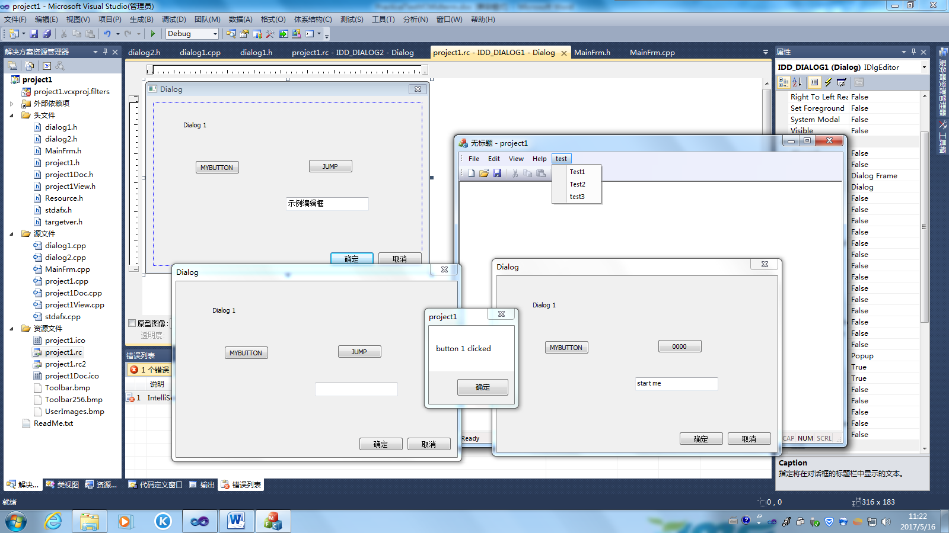

“test3” – example

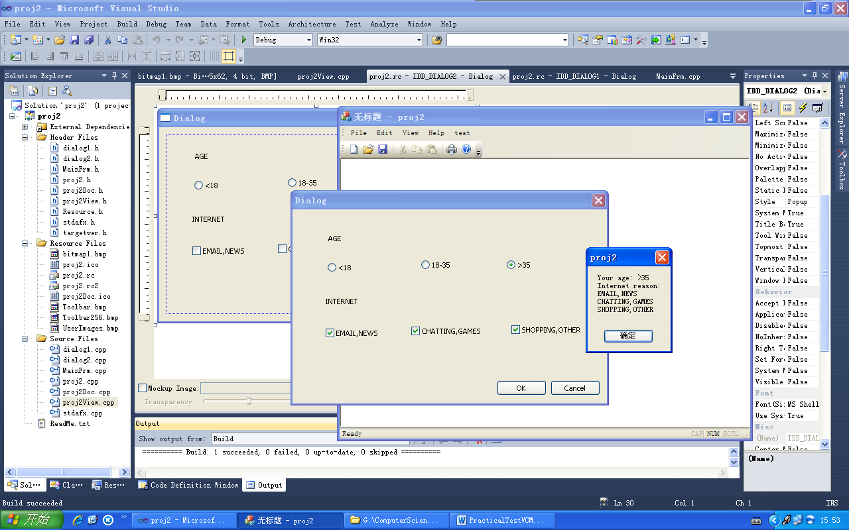

(b) Add BitMap to picture:

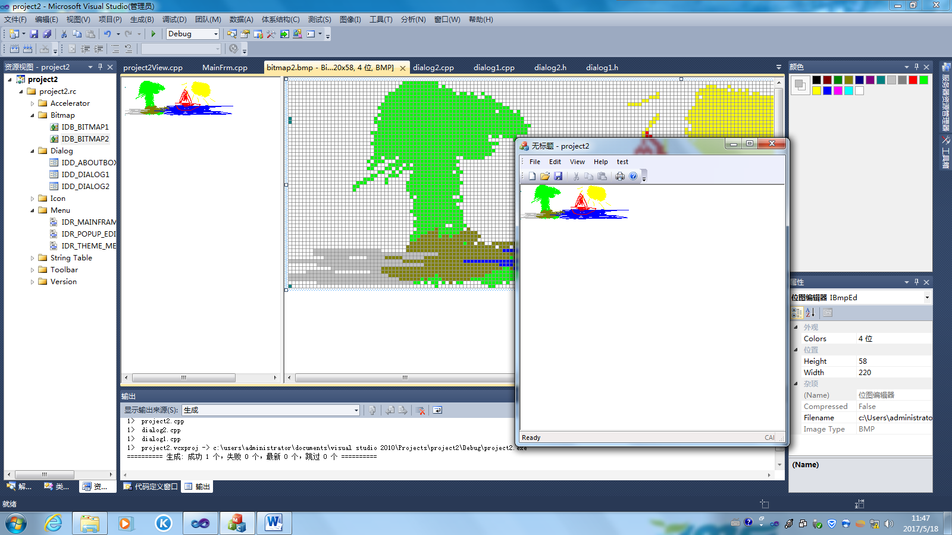

(c) Add Square +Writing to view

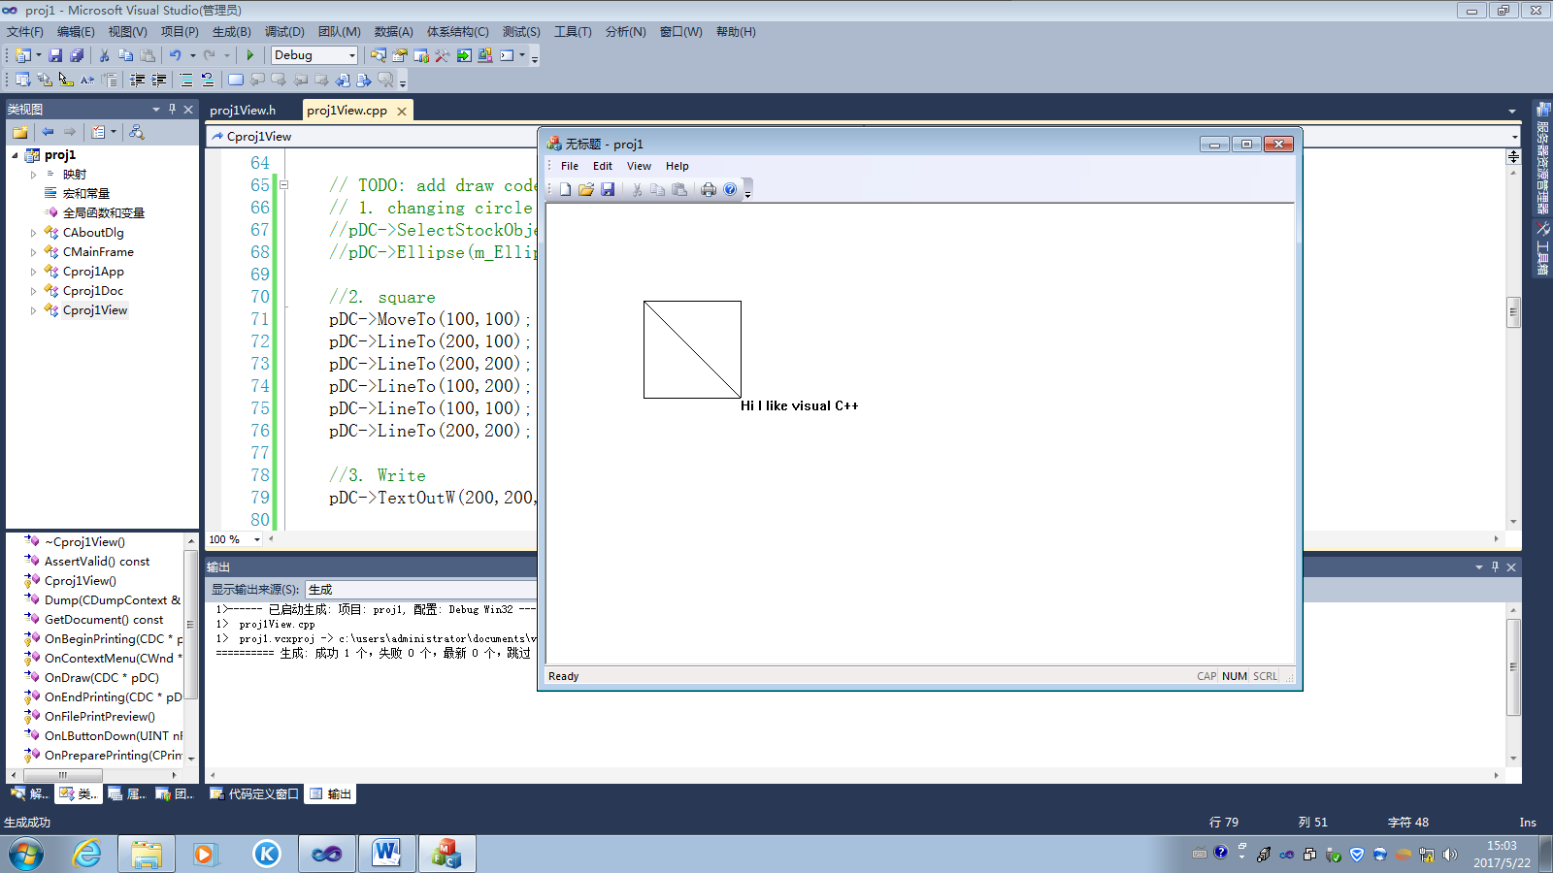

(d) Add changing circle to picture:

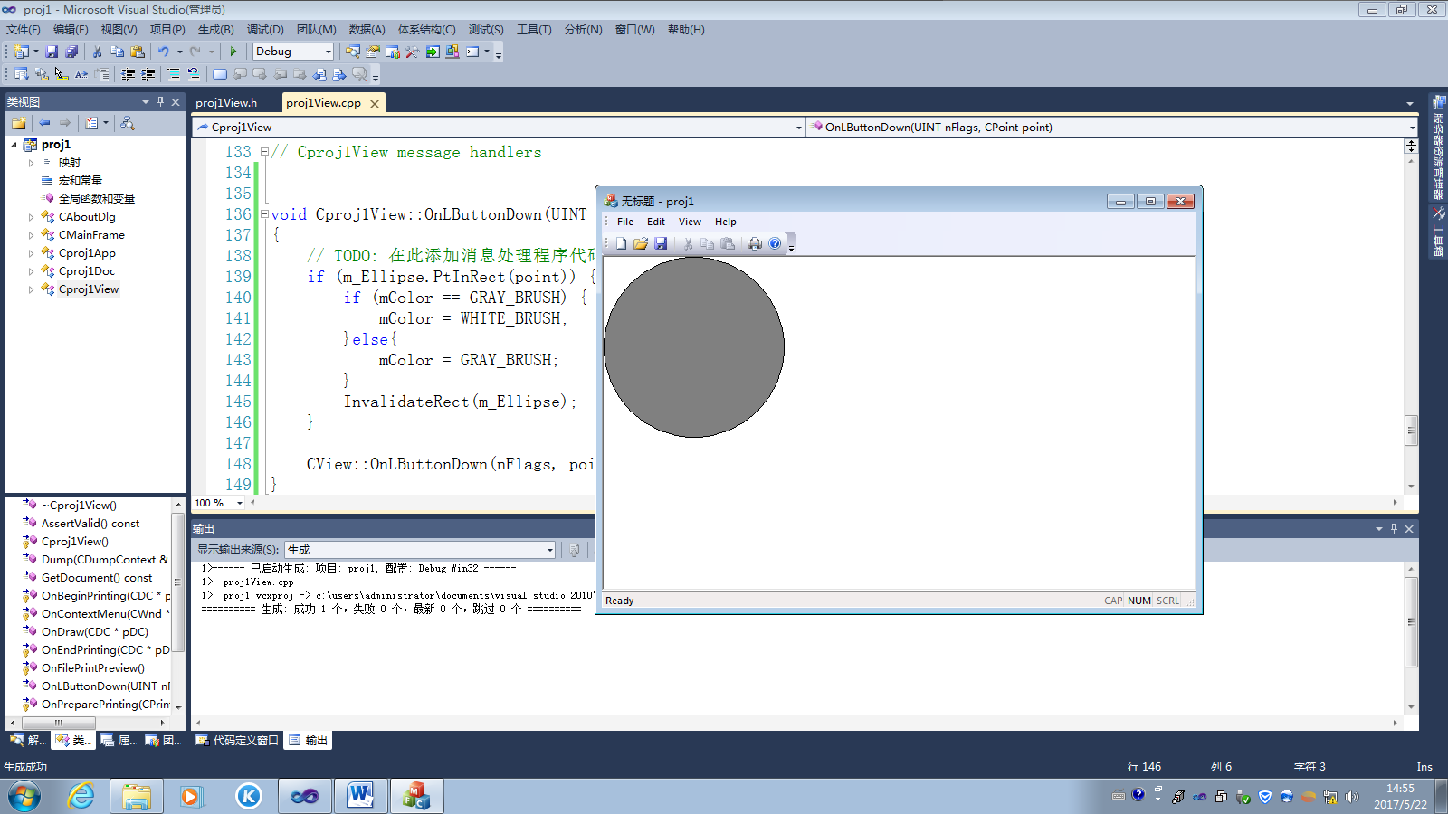

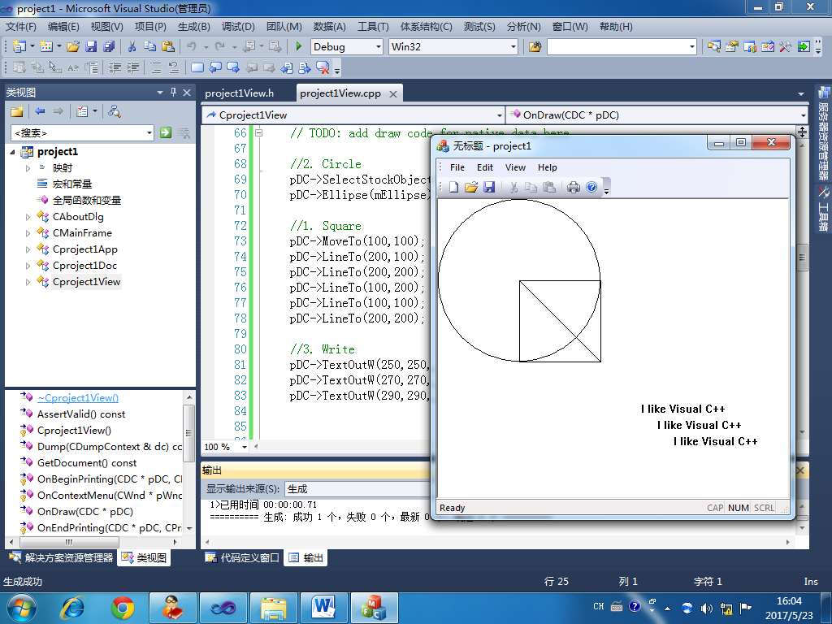

(Written text) (e)

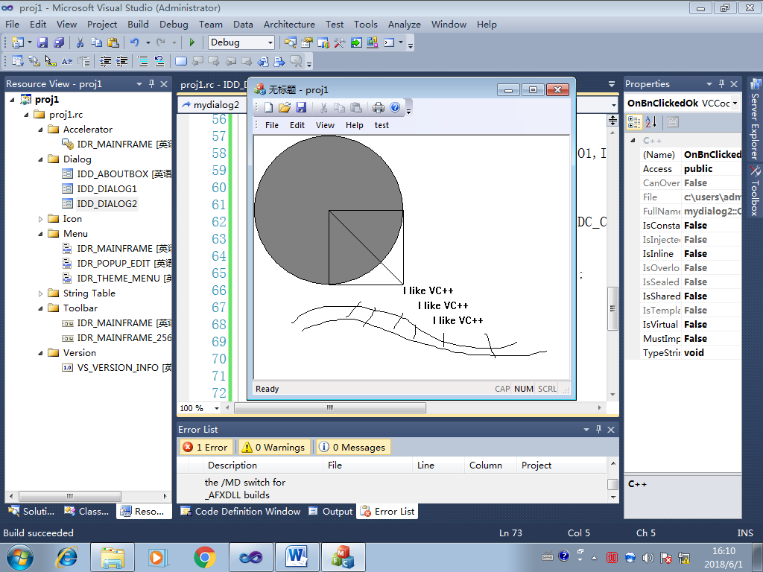

Points: “test2” + (c) = 20
“test2” + (c)(d) = 22
“test2” + (c)(d)(e) = 23
“test2”+”test3”+(c)(d)(e) = 25

