Spring 2017 VC++ 实验考试 (Midterm – 25%)

NOTE: There will a question to modify the program after finishing you must answer correctly to receive full points.

1. Write a search function for string pointers (char *string[]) to search strings of 10 strings or more. Must use a loop for search, must enter the word “exit” to finish the program. Use <string.h> function (strcmp) 22 points

2. Write a sort function using templates in C++ and show values before and after the swap. You must have 3 types of arrays for the swap including int, float/double, char. Each array must have 10 values or more. 23 points

3. Create a struct named STUDENT, must have:
Name, age, ID, major (char name [20], int age, int ID, char *major). Add information to the student including name, age, ID, major and printout the information using a function in the class. There must be a function to input information to the struct. Must have at least 2 students information including a pointer inside main().
Ex. STUDENT s1;
STUDENT s2;
STUDENT *s3;
23 points

4. (a) Create a class named Student with name, age, ID, major, gradeAverage ( private: char name [20] , int age, int ID, char *major, double gradeAvg). Add information to the student including name, age, ID, major, grade and printout the information using a function in the class. Must have 2 constructors and must handle non-parameter, parameter.
Ex Student s1;
Student s2(“Johnny”, 23, 56455, “IT”,78.5); 23 points

4. (b) Write an extra derived class from Question 4 Student class, called GradStudent, add a char status[20] (fulltime, parttime) as private variable and add a method “printgrad()” to printout extra information. NOTE: only do if question 4 is finished.
24 points

4. (c) Add 2 friend function to the class Student in Question 4 to change the major and grade of the student. The friend functions must not be part of the class but an outside function. 24 points

4. (d) Use the #include <vector> STL to add Student objects to the vector, use the vector – push_back to add, pop_back to remove objects. Print out students each time. 24 points
Ex: vector<STUDENT>mystu;
Add: mystu.push_back();
Remove: mystu.pop_back(); Clear: mystu.clear();

5. Write a class template <template> called USEME to add, subtract and multiply two different datatypes. The template must have 2 constructors, one to handle default and one to handle 2 parameters. The add, subtract, multiply must all have separate functions. The constructor with the parameter can be used to add by default. Must show at least 4 examples in main ( ): 23 points
Ex. USEME<int, float> c1;
c1.printme();c1.add(89,6);
USEME<int, float> c2(5, 8.9);
USEME<char, int>c3(‘r’,3);
USEME<int, char>c4(4,’a’);

6. Create class “Box” and constructor, write a static function getcount() and static int count. Use static to count the number of objects created. The box must have a print function to output color of box printcolor() must also have function to add color called addcolor() also use array of objects to test . Must have 2 constructors including one to handle no parameters and handle 1 parameter. 写一个类 Box 使用静态整数 count和静态函数 getcount() 对象计数, printcolor(), addcolor() 23 points
Ex. Box box1;
Box box2(“green”);
Box box3[5];
box1.printcolor();
box1.addcolor(“orange”);
box1.printcolor();

NOTES:
1. Points will be taken off for taking too much time.
No more than 12 minutes per person will be allowed. -2

2. Cheating including looking at notes or phones or other
people. -5

3. Talking during the test. -5

4. Incomplete program including compile errors and syntax
errors. -5 to -10

5. Failed to answer appropriate question regarding the
program. -2

Final Exam 2017:

MFC:

Choice of test2, test3 in exam: (basic)
- (a)Write a SDI application, to add a menu selection named “test” – below must have “test1”, “test2”, “test3” and will open Dialog using a derived class. The dialog must contain a button to popup a messagebox (“this is a button”)
“test1” – open MessageBox
“test2” – open modeless dialog with 2 buttons. One button must have MessageBox, the other button must have button and edit control communications

See picture below:
“test3” – open modeless dialog with 3 radio buttons, 3 checkbox buttons, to do survey – in the end MessageBox must show survey results.

写一个SDI窗口应用程序添加一个菜单选择 “test”, 必须打开一个对话框 派生类, 要加一个Button - MessageBox(“this is a button”).
“test2” - use modeless dialog

“test3” – use modeless dialog

“test2” - example

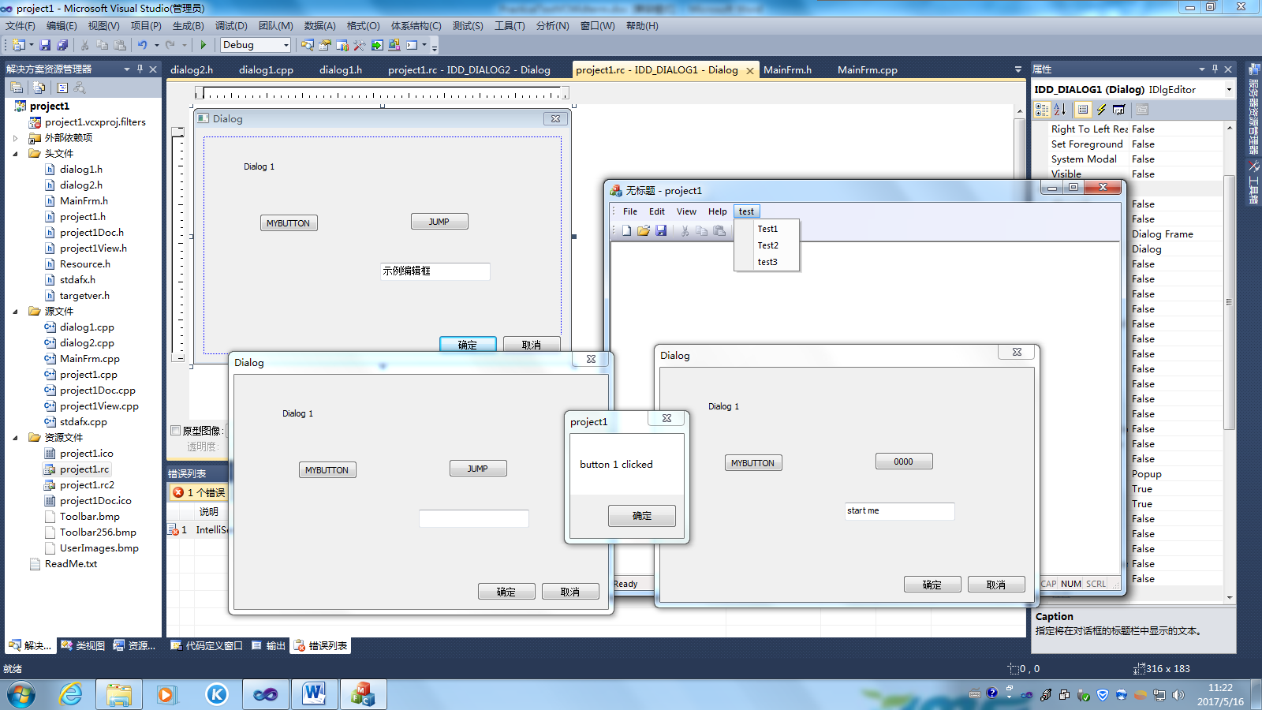

“test3” – example

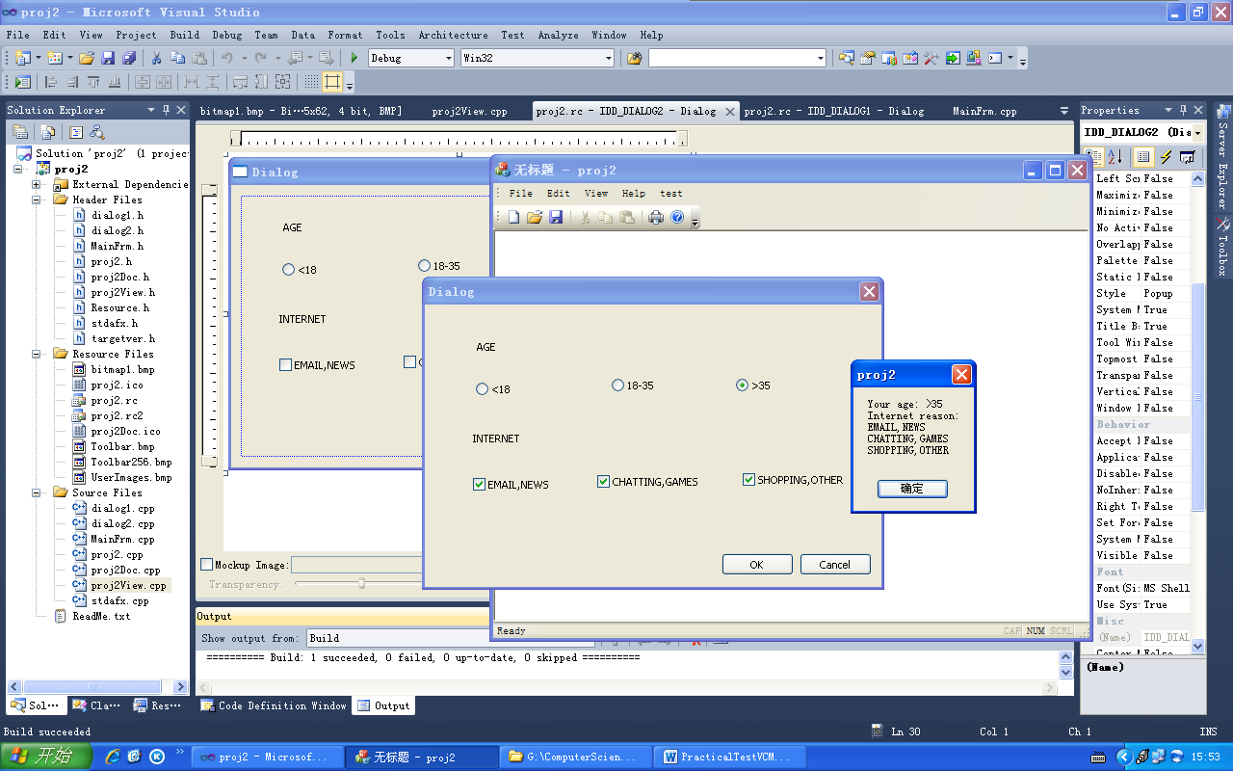

(b) Add BitMap to picture:

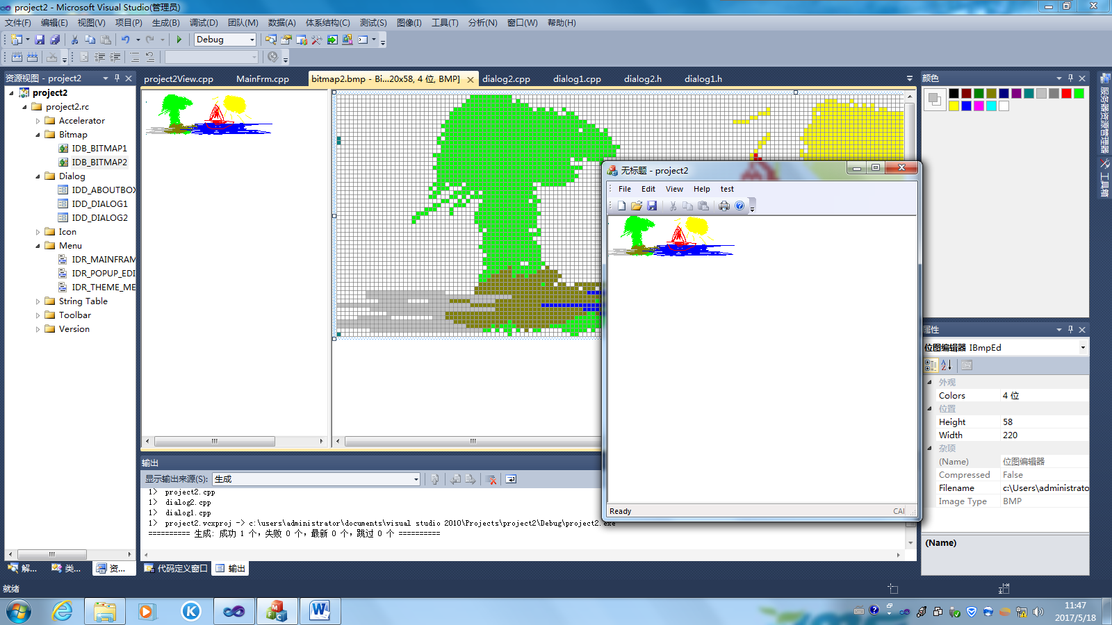

(c) Add Square to view

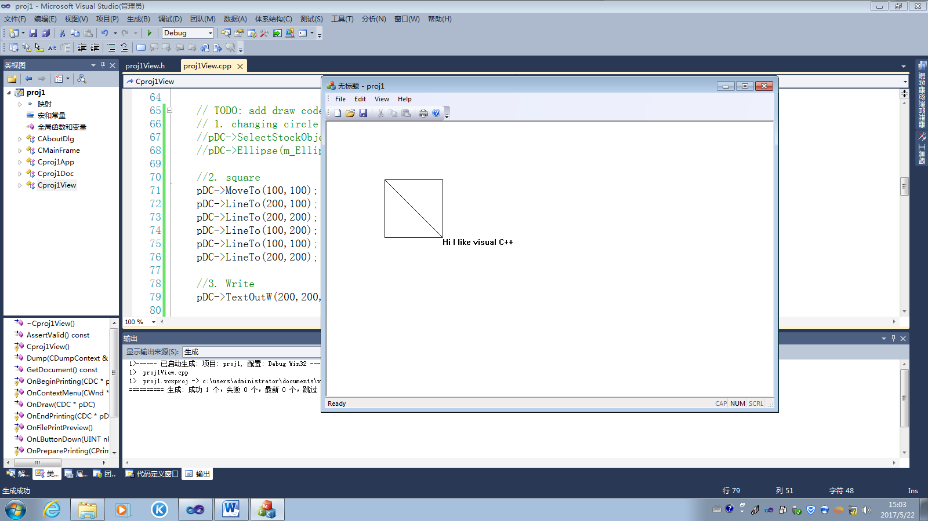

(d) Add changing circle to picture:

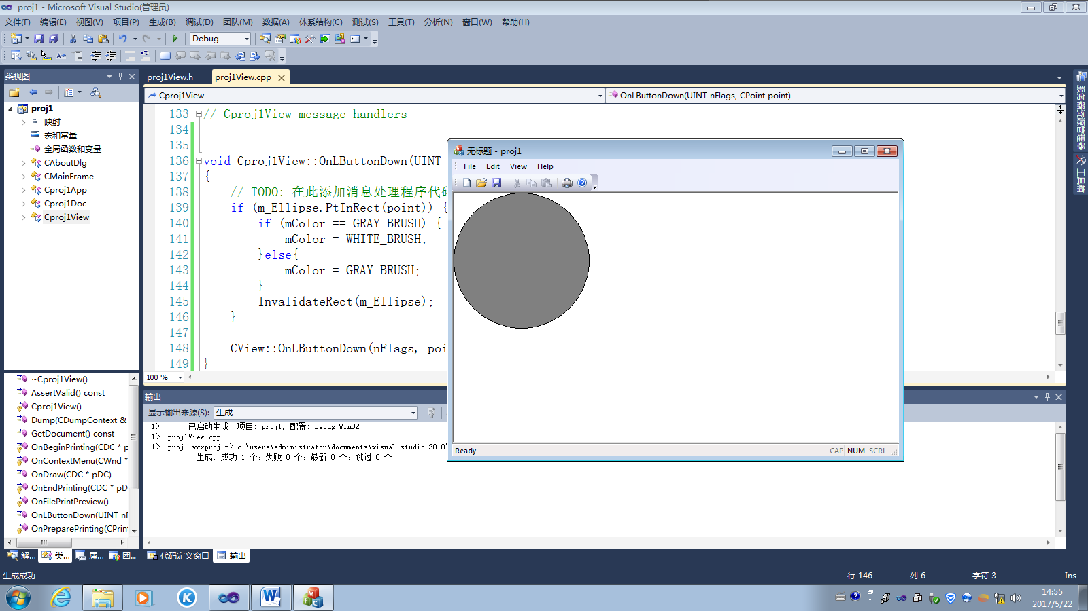

Points: “test2” + (c) = 45
“test2” + (d) = 46
“test3” + (c) = 46
“test3” + (d) = 48

Add 1 point for written text.

