How I fixed this problem in app/globals.css . . .
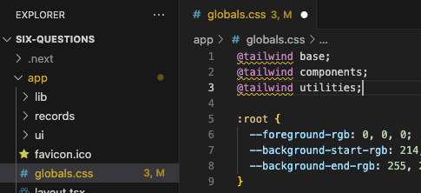
by going to https://byby.dev/at-rule-tailwind . . .
