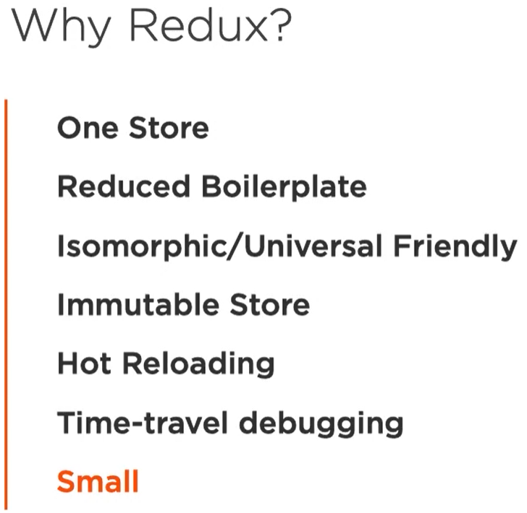

Environment Setup without create-react-app

To understand how **create-react-app** works.

Learn how to customize your dev environment.

