# Final Group Project Group 6

# CST_8288 OOP With Design Pattern

# Judit Johnson Thomas (041117286), Ganga Sajayan(041099560), Kingsten Robert (041131321)

# Samira Quazz

# Algonquin College

# **Table of Contents**

1. Version History
2. Introduction
3. Target Audience
4. Scope

4.1 In-Scope

4.2. Out-of-Scope

1. Application Architecture

5.1 Architecture Overview

5.2 Main Components

1. Business Architecture

6.1 Use case diagram

6.2 Use case descriptions

1. Detailed Design
2. Data Architecture
3. Security Architecture
4. Testing Model
5. References
6. Acronyms/ Abbreviations

# **High level Design**

# **Version History**

**Version**: 1.0

**Authors:**

**Judit Johnson Thomas**

**Ganga Sajayan**

**Kingsten Robert**

**Date: 2024 – November - 09th**

# **Introduction**

This document provides an overview of “The Academic Exchange Platform (AEP) project done by Judit Johnson Thomas (041117286), Ganga Sajayan (041099560), Kingsten Robert (041131321). The Academic Exchange Platform (AEP) connects academic professionals with academic institutions worldwide. This document outlines the high-level design of AEP, detailing its architecture, database, and design components to meet functional requirements.

# **Targeted Audience**

* Academic Institutions
* Academic Professionals
* Students

# **4. Scope**

## 4.1 In Scope

1. Functionalities such as registration, profile management, course listing, searching, and teaching requests.
2. Database design and ERD for managing users, courses, and requests.
3. Security considerations like authentication.

## 4.2 Out of Scope

1. Integration with third-party systems or APIs.
2. Advanced analytics or reporting features.

**5. Application Architecture**

1. Architecture Overview

Frontend: A front-end framework such as React.js (React, 2024) or Vue.js used to enhance the look and feel of the application.

Backend: Servlet-based implementation for handling business logic.

Database: MySQL RDBMS for storing user and course data.

2. Main Components

User Management Module: Handles registration and authentication.

Course Management Module: Manages course creation, updates, and requests.

Search Module: Allows academic professionals to search for courses.

# **6. Business Architecture**

**6.1 Use Case Diagram**

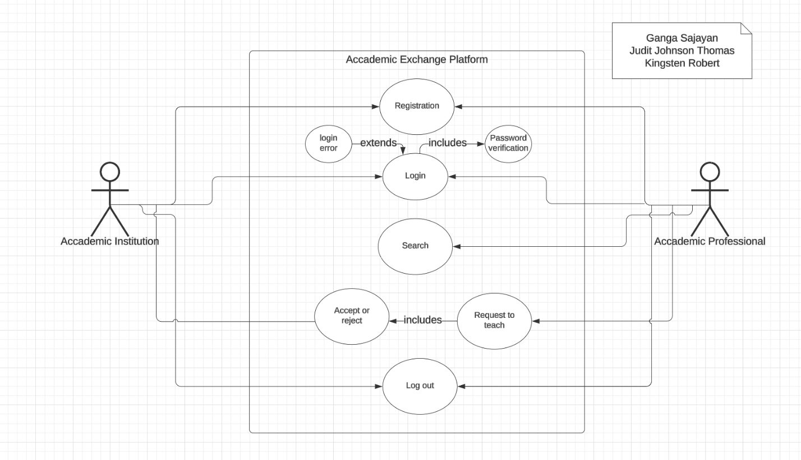

**6.2 Use Case Descriptions**

Actor: Academic Professional  
Description: Registers, logs in, creates a profile, search, requests to teach and logout.

Actor: Academic Institution  
Description: Registers, logs in, creates a profile, accepts or rejects teaching request and logout.

# **7. Detailed Design**

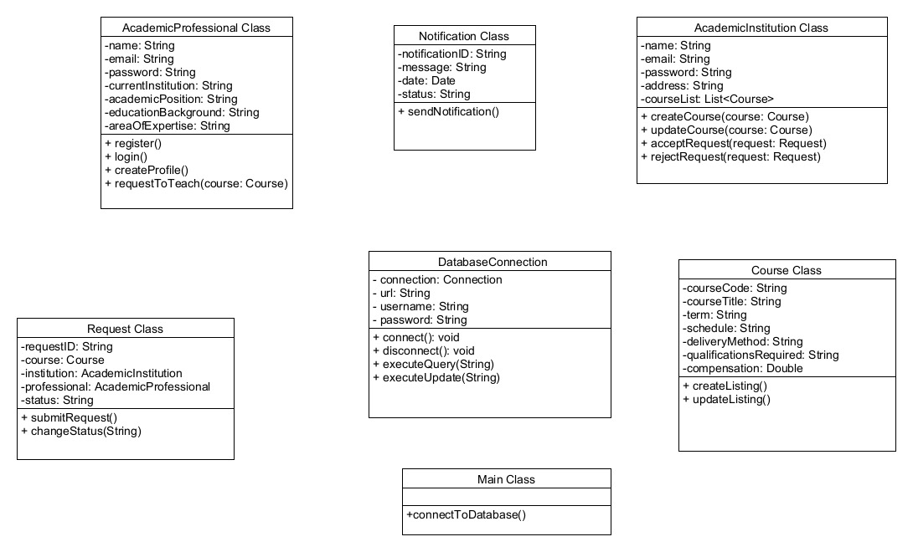

# **8. Data Architecture**

ERD (introduction-of-er-mode, 2024):

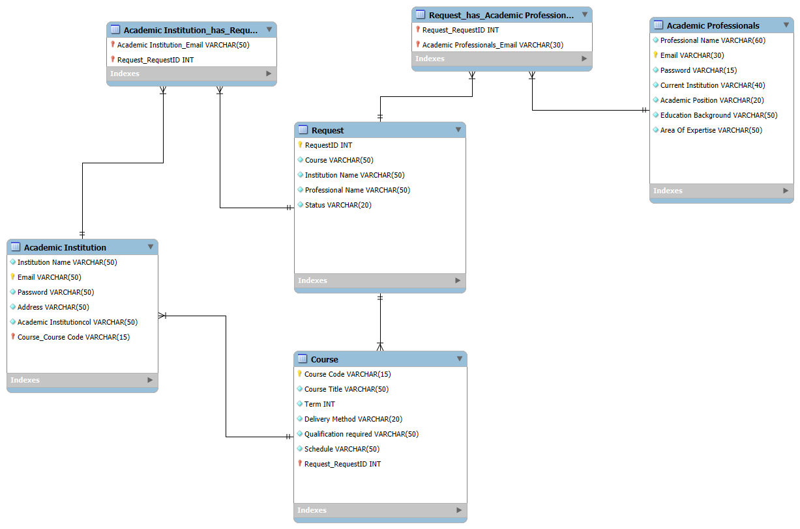

# **9. Security Architecture**

1. Authentication and Authorization

Session-based login/logout functionality using Servlets.

2. Data Protection Mechanisms

Password encryption using hashing (cheatsheets/Password_Storage_Cheat_Sheet.html, 2024).

# **10. Testing Model**

JUnit Testing: Test cases for user registration, course creation, and search functionality.

# 11. **References**

*cheatsheets/Password_Storage_Cheat_Sheet.html*. (2024, November 10). Retrieved from cheatsheetseries: <https://cheatsheetseries.owasp.org/cheatsheets/Password_Storage_Cheat_Sheet.html>

*introduction-of-er-mode*. (2024, November 10). Retrieved from geeksforgeeks: <https://www.geeksforgeeks.org/introduction-of-er-model/>

*React*. (2024, November 10). Retrieved from react.dev: <https://react.dev/>

### **12. Acronyms/Abbreviations**

Acronym Full Form

AEP Academic Exchange Platform

RDBMS Relational Database Management System

ERD Entity-Relationship Diagram

DAO Data Access Object

API Application Programming Interface