**Important Points from Computational #3**

1. Genetic Drift:
   1. What is it?
   2. What happens to genetic variation?

c. What happens when you change the number of individuals in the population?

d. What happens when you change the initial allele frequencies in small populations?

1. Migration:
   1. What is it?

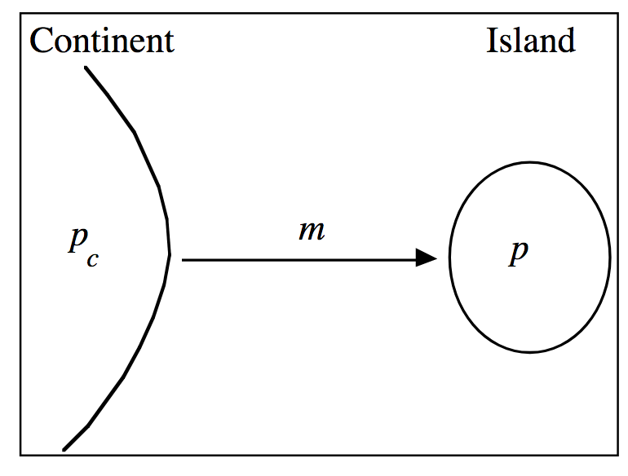

* 1. What happens to genetic variation?
  2. What is the influence of migration rate on allele frequencies of the island population?
  3. What happens when you change allele frequency of the continent?

3. Selection:

a. What is it?

b. What happens to genetic variation?

c. What happens when you change the initial frequency of a?

d. What happens when you modify the relative fitnesses?

e. What happens when the heterozygote has selective advantage (higher selection coefficient?