**Phylogenetics Homework Assignment**

Name:

**Please turn in this assignment via Slack to Jessica by 5:00pm on Tuesday, December 3rd. Note, this is *after* Thanksgiving!**

**Part 1: Concepts of Phylogenetics (12 points)**

*Answer the following questions regarding the interpretation of phylogenetic trees and what relationships they depict.*

1. Explain whether the two trees below show the same or different phylogenetic relationships among the taxa. (2 points)

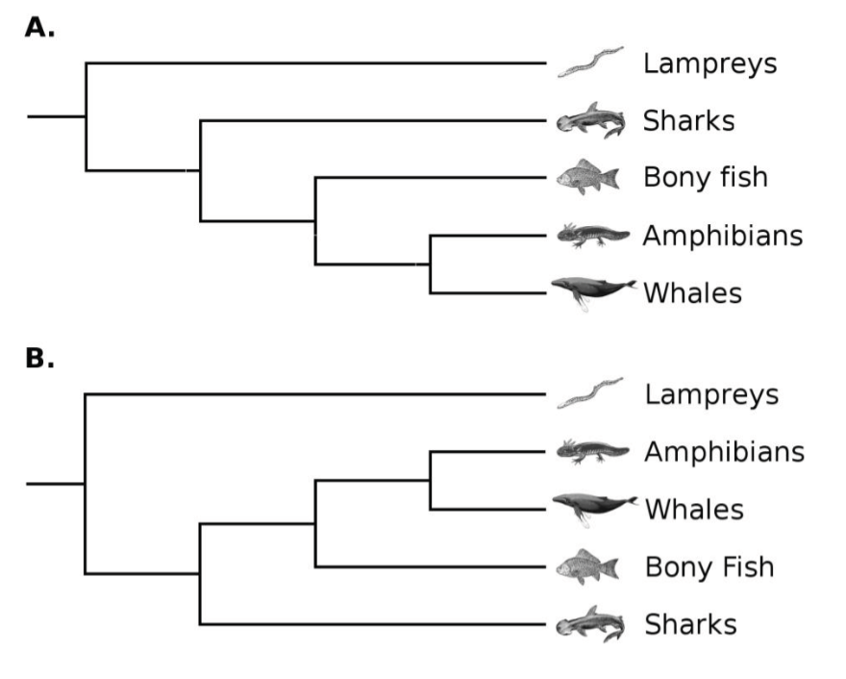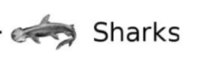

1. The diagram below shows the possible evolutionary relationships among six living species of baobab trees. The drawings show the flowers of the living baobab species. The letters A- E represent ancestral species.

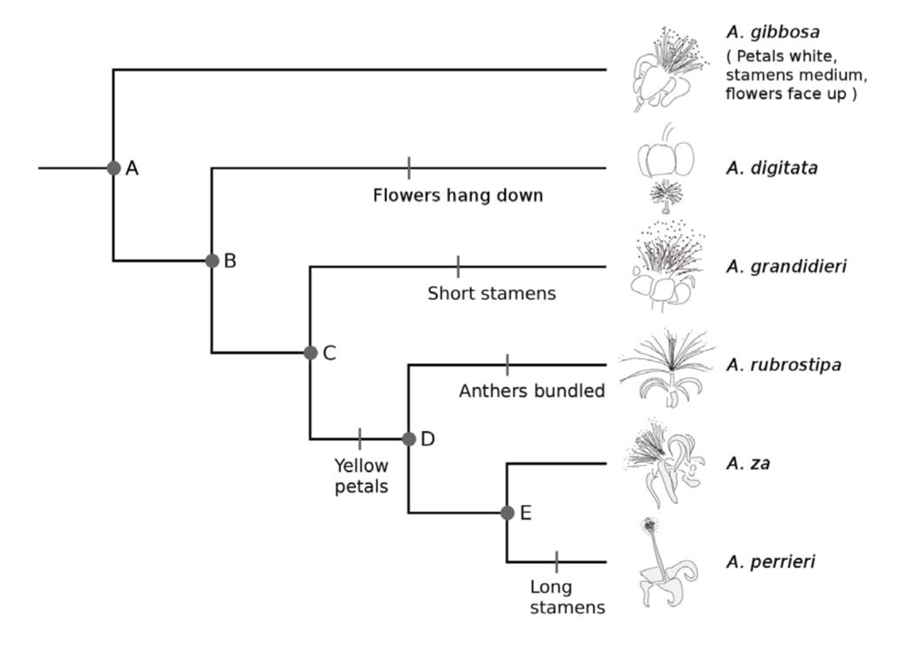

For each of the following three traits (I, II, III), choose the option (a, b, c, or d) which describes what the flowers of species D would have looked like according to this phylogenetic tree (you should have three options circled, one for petals, one for stamens, and one for flowers; 3 points):

1. Petals: a. White b. Yellow c. Can’t tell from diagram
2. Stamens: a. Short b. Medium c. Long d. Can’t tell from diagram
3. Flowers: a. Face down b. Face up c. Can’t tell from diagram
4. The following image depicts an unrooted tree with 6 species represented. How many locations are possible for the root of the tree (see Dr. H’s lecture)? (1 point)

**E**

**F**

**A**

**D**

**B**

**C**

1. Which of these depicts a different relationship from the others? (1 point)

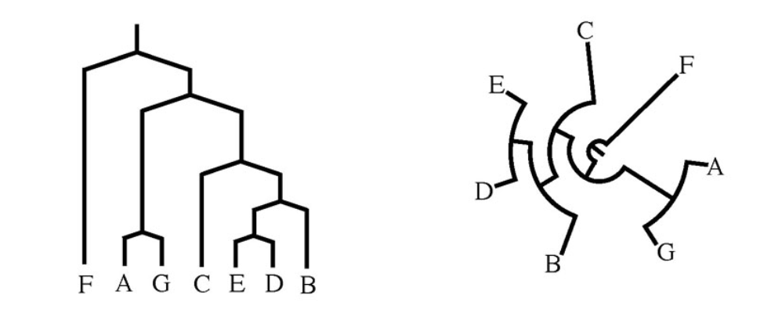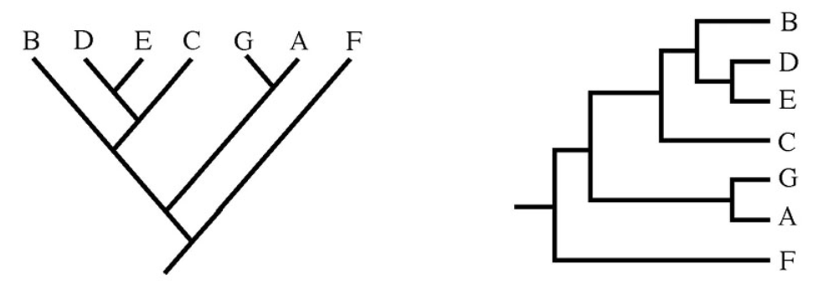

A

B

D

C

1. Based on the tree below, which of the following is an accurate statement of relationships? (1 point)

A

B

C

D

1. Species A is more closely related to species C than species D.
2. Species A is more closely related to species D than species C.
3. Species A is equally related to species C and D.
4. Species A is more closely related to species C than species B.
5. Explain why you chose the answer you did from part 5. (1 point)
6. Does the tree below depict the same relationships as the tree from 5? Why? (2 points)

D

A

B

C

1. Which point marks the most recent common ancestor between a fern and a sponge? (1 point)

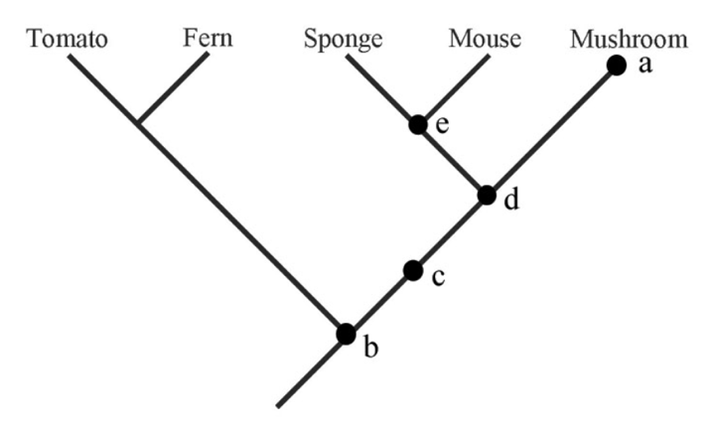

**Part 2: Creating a Tree Using Sequences from GenBank (13 points)**

Using MEGA, search for and include in your alignment the following 9 sequences:

* Canis lupus haplotype GW01 cytochrome b (cytb) gene, partial cds; mitochondrial
* Canis lupus familiaris cytochrome b gene, complete cds; mitochondrial
* Canis rufus cytochrome b (cytb) gene, mitochondrial gene encoding mitochondrial protein, partial cds
* Canis latrans isolate CLA_RKW3591 cytochrome b (CYB) gene, complete cds; mitochondrial
* Canis simensis isolate CSI_RKW2631 cytochrome b (CYB) gene, complete cds; mitochondrial
* Vulpes zerda haplotype ZMo cytochrome b (cytb) gene, partial cds; mitochondrial
* Chrysocyon brachyurus isolate SP104 cytochrome b (cytb) gene, complete cds; mitochondrial
* Urocyon cinereoargenteus cytochrome b (cytb) gene, complete cds; mitochondrial
* Crocuta crocuta cytochrome b (CYTB) gene, complete cds; mitochondrial

1. Form a hypothesis regarding relationships of the species represented in your sequences. Which species do you expect to be the outgroup? Which should be more closely related to each other? *Remember, a hypothesis is a well-educated guess based on your previous knowledge; it is not expected to be perfectly correct, but it should be well-reasoned.* (2 points)

Align the sequences using MEGA, and save and export the alignment in MEGA format.

1. How many variables sites are in the alignment? (1 point)
2. How many sites are parsimony-informative? (1 point)
3. Explain how you could test your hypothesis you wrote above. Be explicit about your method and what you would expect regarding the support for your method (how would you test tree support based on our in-class activity?) (2 points)
4. Test your hypothesis and paste the result below. \*\**Make sure you change the setting for Gaps/Missing Data Treatment to “Use All Sites”\*\** Does your result support your original hypothesis? Explain. (3 points)
5. You should have used a method you are relatively confident in to build your tree for question 13. Now try a method that I recommended NOT be used in class. Paste the tree below, explain how this tree differs from the one in question 13 and why it might differ from your tree in question 13. (3 points)
6. Explain the concept of a molecular clock. (1 point)