## What is this Project?

This project is an implementation of a custom [Visual Studio start page](https://msdn.microsoft.com/en-us/library/aa991992.aspx). Its purpose is to provide an easy way to organize visual studio projects/solutions from your hard drive, allowing quick access and streamlining the development workflow.

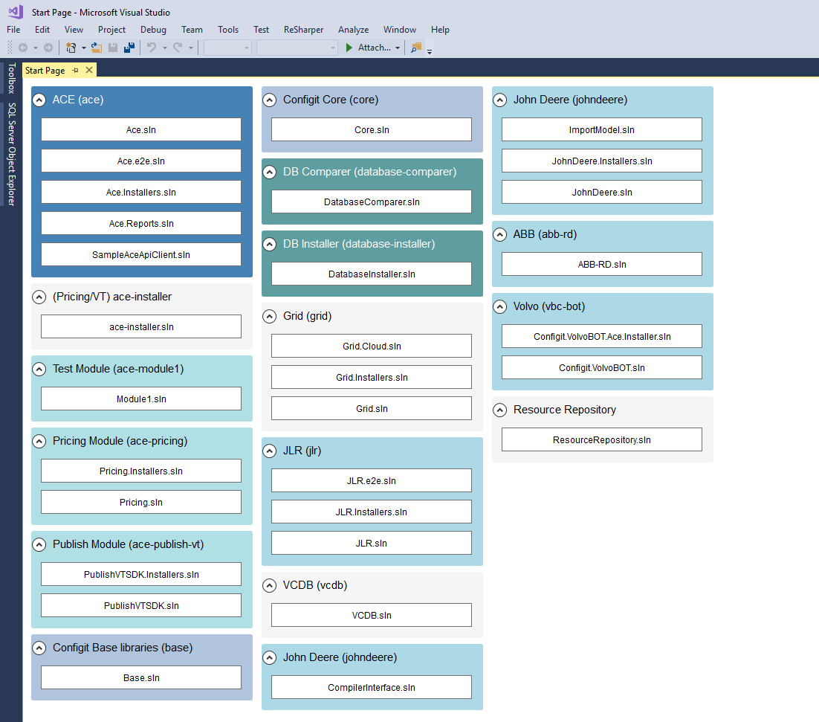

## Installation

1. Run **install.cmd** from elevated command prompt in the setup folder.

This will perform the following actions:

* Determine your Visual Studio installation folder (using vswhere.exe)
* Copies StartPageControl.dll to (vs install folder)\ide\common7\privateassemblies
* Copies start-page.xaml to (Documents)\Visual Studio (version)\StartPages

1. Set the default start page in Visual Studio. Goto Tools/Options/StartUp and set the Customize Start Page to start-page.xaml.

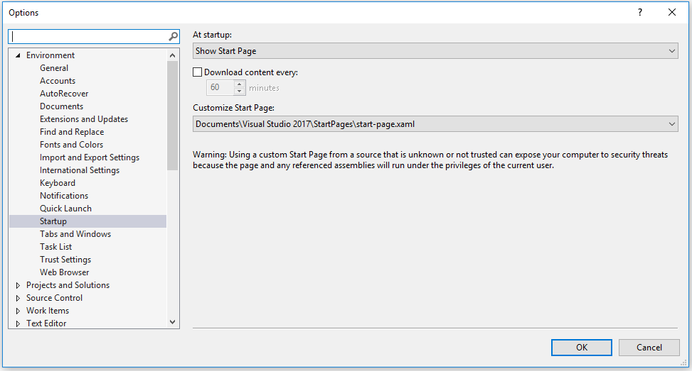

The recommended approach is to run Visual Studio in Safe mode when you perform this step. Please refer to this page:

<https://docs.microsoft.com/en-us/visualstudio/ide/customizing-the-start-page-for-visual-studio>

1. Build the solution and run it to create your first start page.

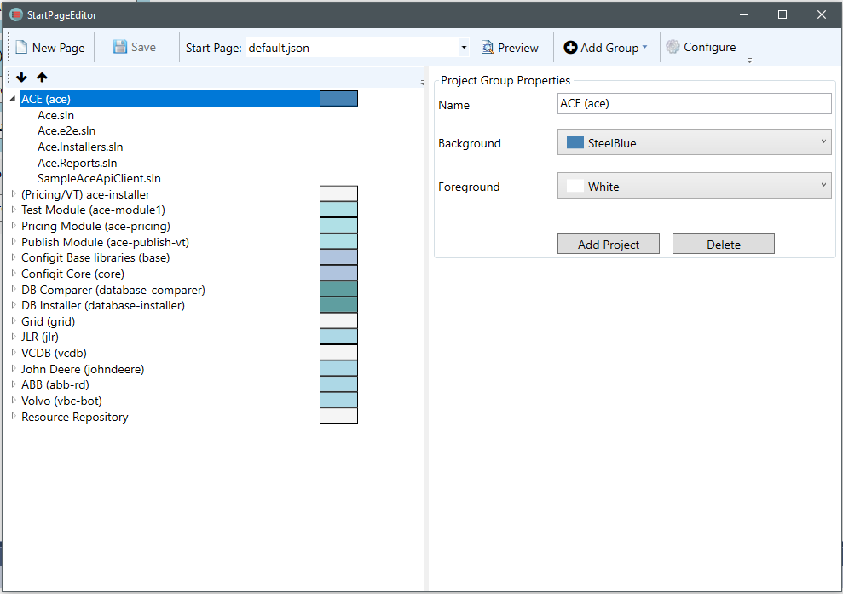

1. Add the Start Page Editor to the Tools menu in Visual Studio
   1. Goto Tools/External Tools/Add
   2. Set the command to {repo folder}\Vs-start-page\StartPageEditor\bin\Release\StartPageEditor.exe

## Configuration

The configuration form allows you to specify start page/group generation options.

The sub-directory level represents how many subdirectories deep the folder the groups will be created at. Example:

If you have the following folders: c:\dev\git\apps, c:\dev\git\framework

Adding the folder c:\dev\git with subdirectory 0 will create a single group Git with all matching files. Setting it to 1 would create 2 groups apps and framework with matches beneath them.

## Setting the Default Page

The default start page is Default.json. To change it navigate to (Documents)\Visual Studio (version)\StartPages and open the file start-page.xaml.

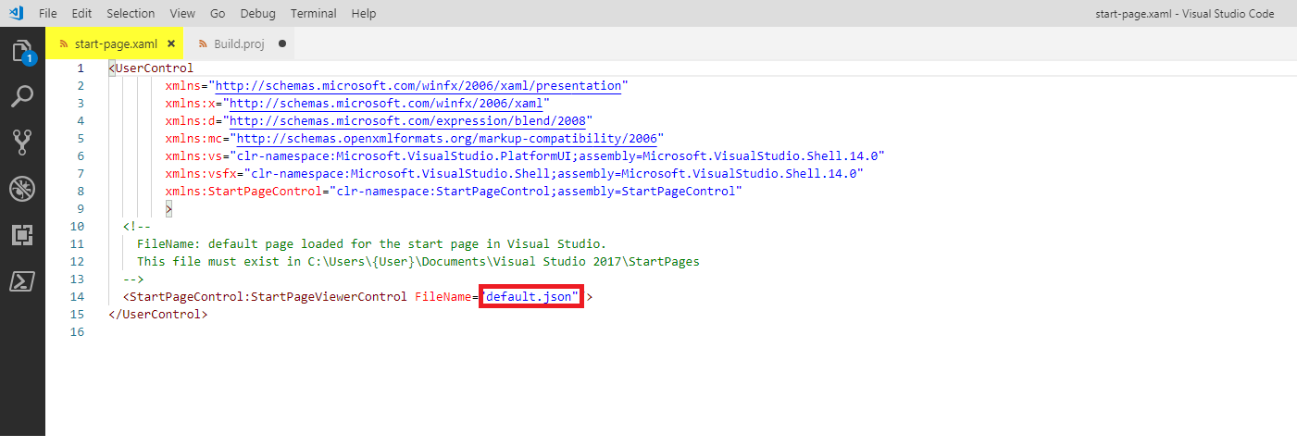

## Oh No! Something has gone wrong

A custom StartPage loads every time that you load Visual Studio. What if for some reason you are getting an error? Now you can’t start Visual Studio!

To remedy such a situation you can rename the file:

(Documents)\Visual Studio (version)\StartPages\start-page.xaml to anything. Now the next time you load Visual Studio it will reload the default start page.

## Development

I developed this application in my spare time as an intro to MVVM and WPF. Great technology! Due to my availability there are very few unit tests. The app could use more however the complexity is low and I have no intentions of continuing to enhance it. Let me know if you like it and your ideas about how to make it better for your development. I consider it a must have for any environment that has more than 25 projects. Enjoy!