**1.2P: Object-Oriented “Hello, World!”**

Jayden Kong, 104547242

Program.cs code (text version on page 3):

Message.cs code (text version on page 4):

Screenshot of output with input “Jayden”:

Screenshot of output with input “Enoch”:

Screenshot of output with input “Joel”:

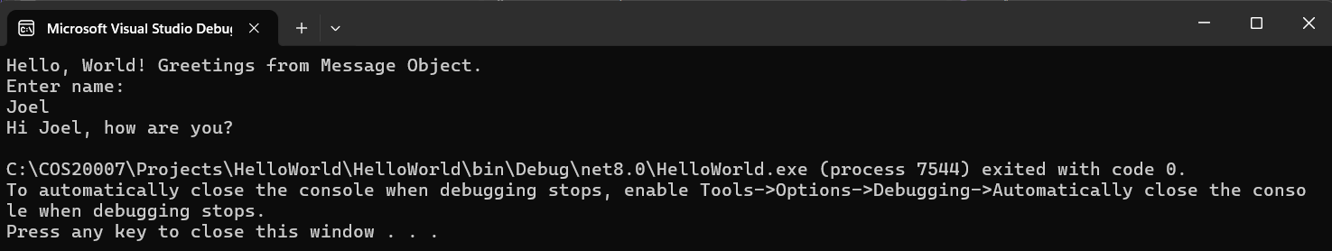

Screenshot of output with input “Eric”:

Screenshot of output with input “test”:

Screenshot showing call stack and code paused within the Print method of the Message class:

