**11.1P - Clock in Another Language**

Jayden Kong, 1045474242

Program was done in python

Screenshot of output (01:01:01):

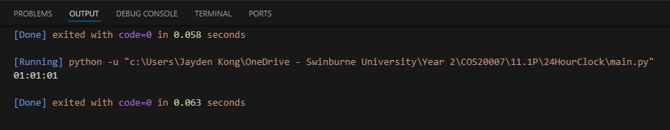

Counter class:

class Counter:

    def __init__(self, name):

        self._name = name

        self._count = 0

    @property

    def name(self):

        return self._name

    @name.setter

    def name(self, value):

        self._name = value

    @property

    def ticks(self):

        return self._count

    def increment(self):

        self._count += 1

    def reset(self):

        self._count = 0

Clock class:

from counter import Counter

class Clock:

    def __init__(self):

        self._seconds = Counter("seconds")

        self._minutes = Counter("minutes")

        self._hours = Counter("hours")

    @property

    def time(self):

        return "{:02d}:{:02d}:{:02d}".format(self._hours.ticks,

self._minutes.ticks, self._seconds.ticks)

    def tick(self):

        self._seconds.increment()

        if self._seconds.ticks == 60:

            self._minutes.increment()

            self._seconds.reset()

            if self._minutes.ticks == 60:

                self._hours.increment()

                self._minutes.reset()

                if self._hours.ticks == 24:

                    self._hours.reset()

    def reset(self):

        self._seconds.reset()

        self._minutes.reset()

        self._hours.reset()

Main:

from clock import Clock

my_clock = Clock()

for i in range(3661):

    my_clock.tick()

print(my_clock.time)      # Prints 01:01:01