**3.1P - Clock Class**

Jayden Kong, 104547242

**Class UML diagram:**

**Example of program output:**

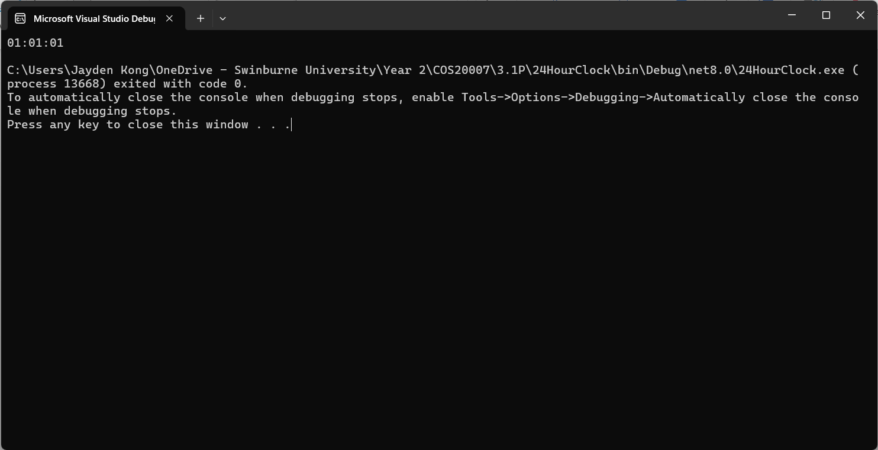

**Unit tests passing:**

