**5.3C - Drawing Program - Saving and Loading**

Jayden Kong, 10454724

Drawing shapes:

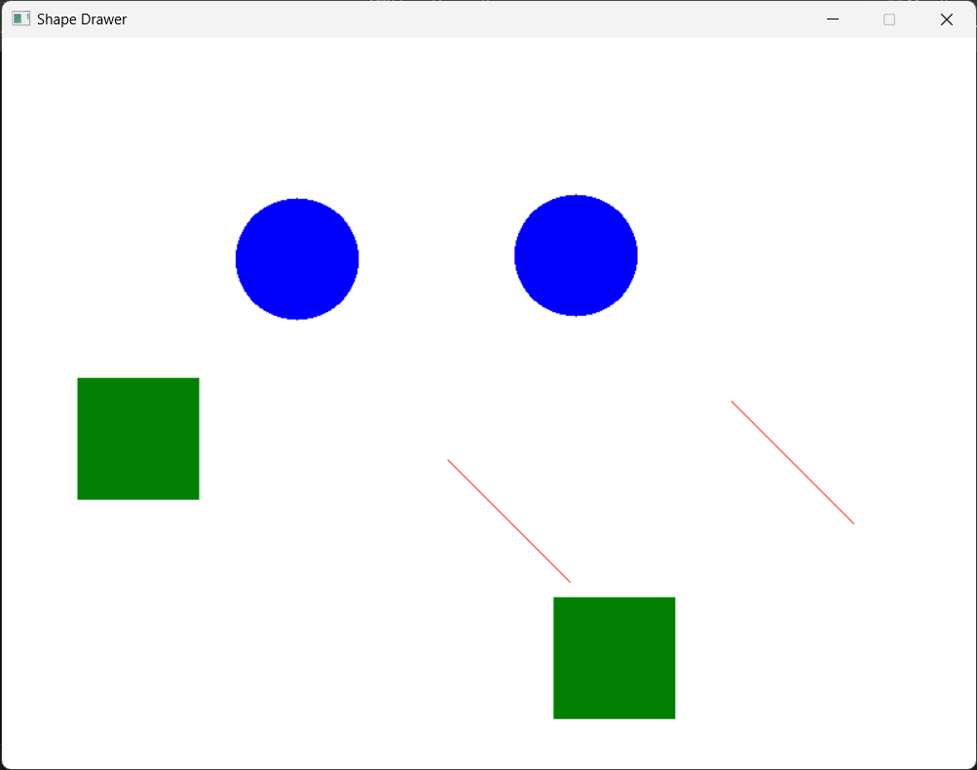

Changing background:

Saved file created in Desktop (file contents on later pages):

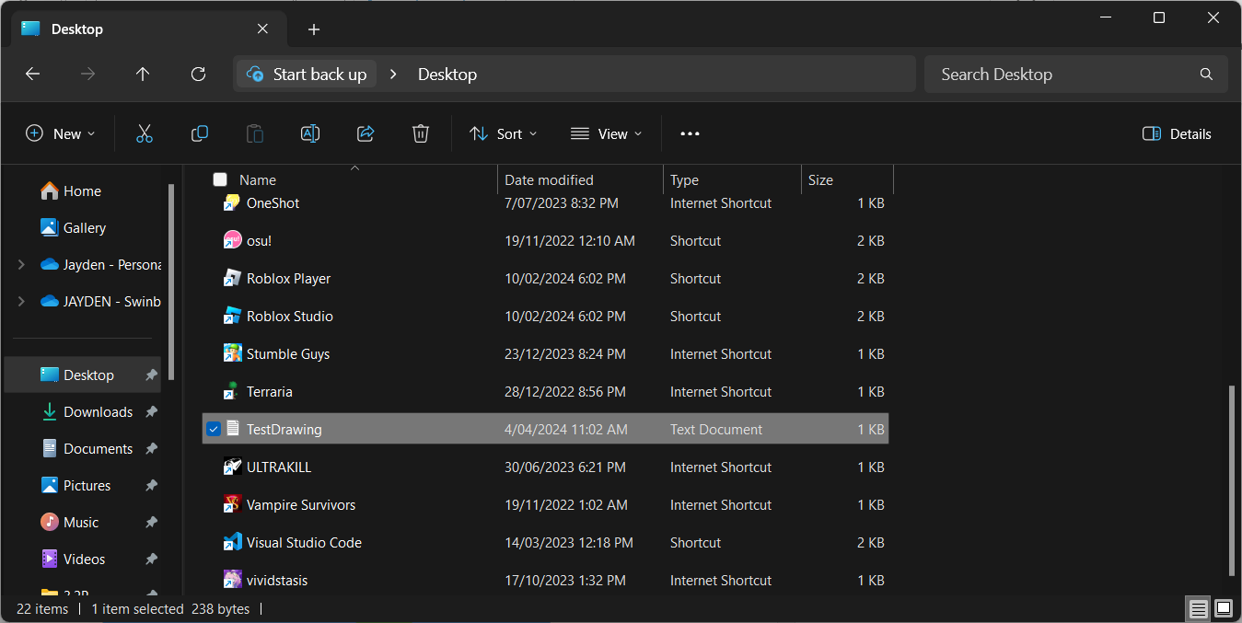

Exception for opening file with incorrect path:

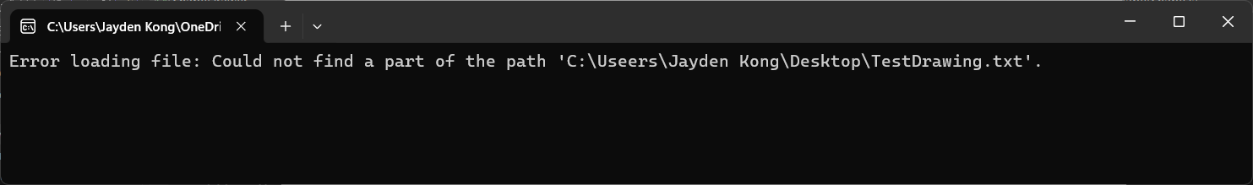

Exception for having an unknown shape kind in saved file:

