**Sensor sprint**

We will be using a wide range of sensors and an Arduino board to monitor the environment. We will then use a long range, low power wireless network (LoRaWAN) to put the data online.

**Common symbols**

**VCC power supply**

**+ power supply**

**GND ground**

**- ground**

**S signal (or data line)**

**DQ signal (or data line)**

**SIG signal (or data line)**

**Arduino stalker 2.3**

http://www.seeedstudio.com/wiki/Seeeduino_Stalker_v2.3

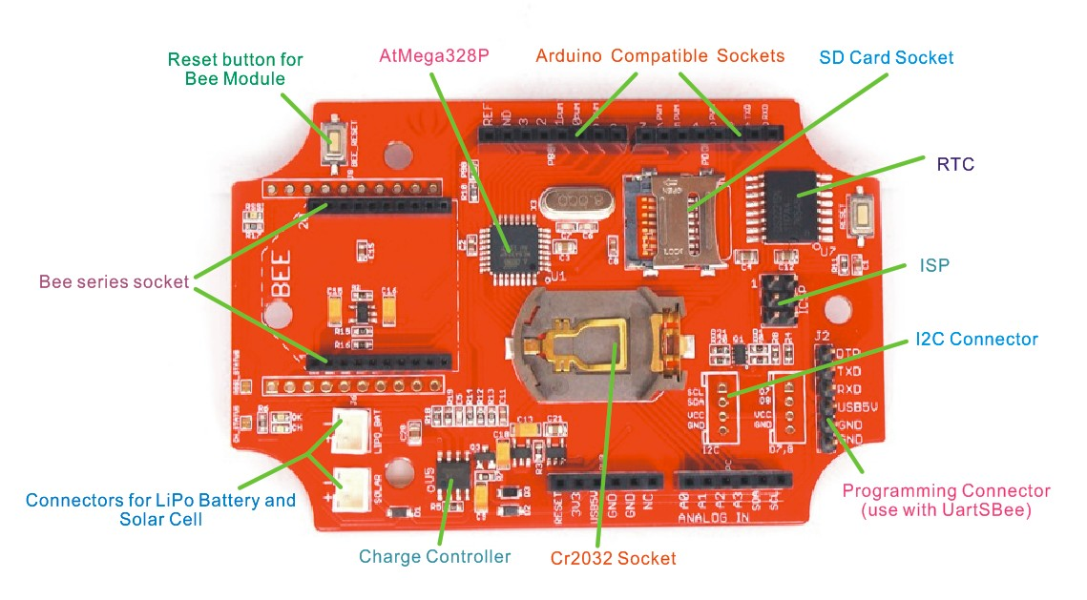

**Connecting up to the computer – CONNECT PROPERLY**

[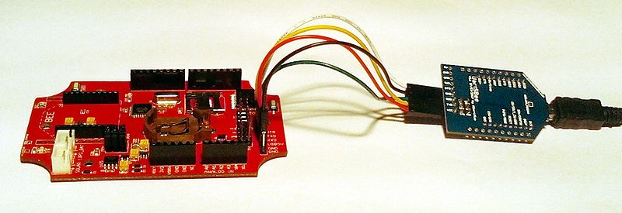](http://www.seeedstudio.com/wiki/File:Seeeduino_Stalker_v2.1_Uartsbee_3.1_Connection.jpg)

|  |  |  |
| --- | --- | --- |
| Jumper Wire connections | | |
| Seeeduino Stalker |  | UartSBee |
| USB5V | ↔ | VCC |
| RXD | ↔ | TXD |
| TXD | ↔ | RXD |
| GND | ↔ | GND |
| DTR | ↔ | DTR |

**TO DO** – solder jumpers in 2 places. This allows the stalker to go to sleep and wake up minimizing power usage.

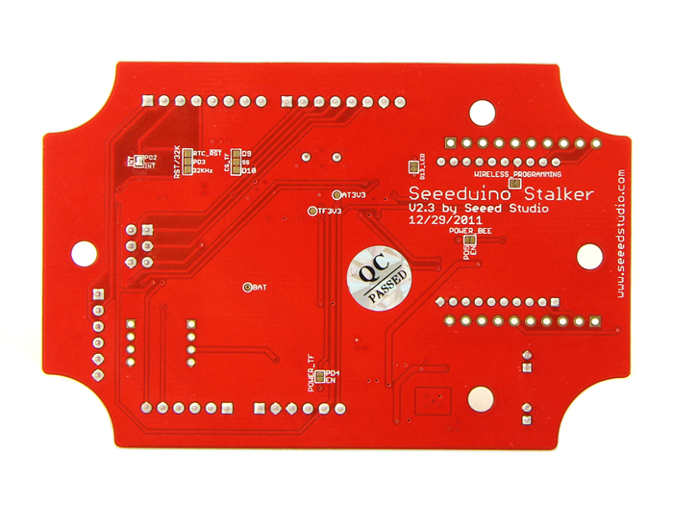

**TEMPERATURE – DS18b20**

**Parasite Mode**

Parasite power mode requires both DS18B20 GND (pin 1) and Vdd (pin 3) to be connected to ground. The DQ pin (pin 2 - the middle pin) is the data/parasite power line. The data line requires a pull-up resistor of 4k7 connected to + 5 V. The data line is connected to an available Arduino digital input.

Parasite mode should be used only with a small number of devices, over relatively short distances.

|  |  |
| --- | --- |
| https://openenergymonitor.org/emon/sites/default/files/normal%20power%20conection%20diagram.png  Figure 1: Normal Power Connection Diagram | https://openenergymonitor.org/emon/sites/default/files/parasite%20power%20conection%20diagram.png  Figure 2: Parasite Power Connection Diagram |
| https://openenergymonitor.org/emon/sites/default/files/temp%20sensors%20connection%20diagram%203%20wire.png  Figure 3: Three DS18B20's in normal power mode | https://openenergymonitor.org/emon/sites/default/files/temp%20sensors%20connection%20diagram.png  Figure 4: Three DS18B20's in parasite power mode |

**Soil Moisture**

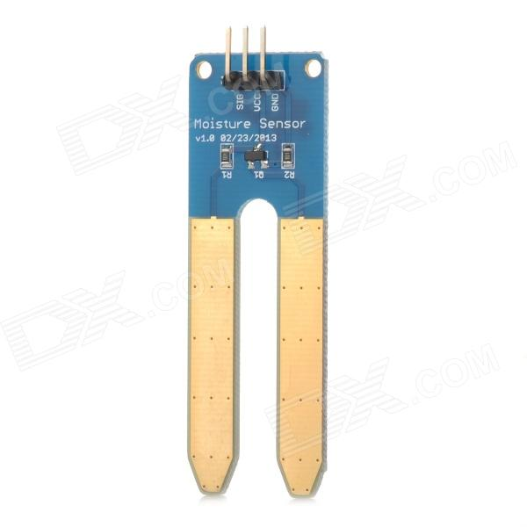

**Temperature and humidity – DHT11**

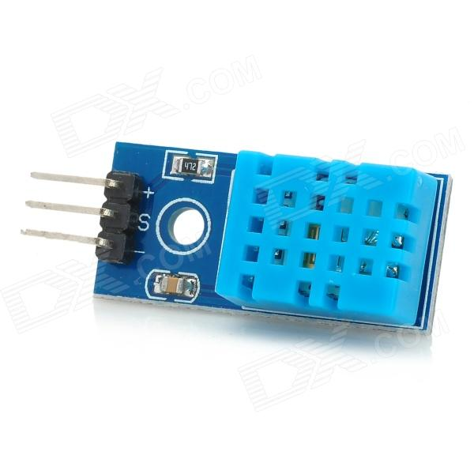

**Light sensor**

