|  |
| --- |
| **Jose joaquin villbona Bravo** |
| **Ingles guia 3** |
| **Sena Giron** |
| **Ficha 2994326** |
| **Tecnico programacion Software** |
|  |

**PREGUNTA NUMERO 1**

* What features are commonly found on a computer desktop?

Respuestas

icons

access keys

menus

screen

funds

programs

* How do users typically start programs through a GUI?

Respuesta:

icons

access keys

menus

**PREGUNTA NUMERO 2**

* Read the manual. Then, mark the following statements as true (T) or false (F).

Respuesta

1 TRUE

2 TRUE

3FALSE

**PREGUNTAS NUMERO 3**

|  |  |
| --- | --- |
| **opcion** | **letra** |
| **1** ICON | **F** |
| **2** GUI | **E** |
| **3** OPEN | **A** |
| **4** SELECT | **D** |
| **5** URSOR | **C** |
| **6 R** IGHT-CLICK | **G** |
| **7** ROPDOWN MENÚ | **B** |

A to reveal the contents of something in order to use or edit them.

B list of options that appears when an item is clicked

c. a feature on a computer screen that indicates where input will appear

D: to mark something for a particular operation

E a visual way of interacting with a computer screen

F: a symbol that indicates a file or program

G to bring up options using a particular mouse button

**PREGUNTAS NUMERO 4**

Choose the sentence that uses the underlined part correctly.

RESPUESTAS:

B Some people display pictures on their desktops.

B The folder contains the engineer’s important documents.

A Clicking on a menu option will often run a program

**PREGUNTAS NUMERO 5**

Listen and read the manual again. How does a user bring up the dropdown menu?

**RESPUESTA**

CLICK ON THE RIGHT BUTTON

**PREGUNTAS NUMERO 6**

B a program that the man cannot open

B The man did not click an icon correctly

**7.** **Listen again and complete the**

**conversation.**

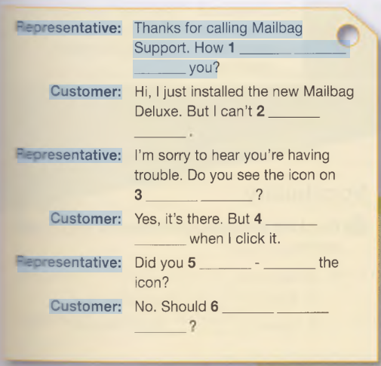

**1can i help**

**2 open it**

**3.your desktop**

**5.Nothing happens**

**6 right- click**

**7.i try that**

8

With a partner, act out the roles below

based on Task 7. Then, switch roles.OUSE

Student A: You are a tech support

representative. Talk to Student B about:

• a problem that he or she is having with a

program

• what actions he or she already tried

• what actions he or she should take

Dialogue between two students

Student1: hello

Student 2: how can i help you?

student1: I have a problem with my program

student 2: what are the problems?

student 1: I can't enter the program

student 2 enters the key in capital letters

student 1: ok thanks for the help