**Group 7 – Alyx Korth, Sarah Haas, Jesús Villa, Cecelia Fuhreman, Sam Peterson**

Assignment 4 - Sprint 2

**User Stories** **1**

**Tasks** **1**

**Sprint Backlog – Trello Board** **2**

**Burndown Charts** **3**

Day 4 4/7 3

Day 9 4/12 3

Day 14 4/17 3

**Daily Scrums** **4**

Day 4 4/7 - Sprint 2 4

Day 9 4/12 - Sprint 2 5

Day 14 4/17 - Sprint 2 5

**Sprint Review** **7**

**GitHub URL – README File** **7**

| User Stories |
| --- |

Below are our user stories for the whole project. The user stories are the focus of all of our sprints.

1. **User Stories 1:** As a user, I need to filter search results/have automatic search parameters data to assist in displaying various trends within our data.
2. **User Stories 2:** As a user, I need to be able to enter my own data, therefore, it needs to be user friendly.
3. **User Stories 3:** As a user, I need a functioning website for volunteers to be able to enter in information that will update in the database.

These user stories will be consistent for the overall project and our tasks for each sprint will vary based on previous progress.

| Tasks |
| --- |

For sprint 2, the tasks we will accomplish are as follows:

1. Modify ERD Diagram as needed from sprint 1
2. Set up database
3. Finalize website prototype
4. Start drafting HTML
5. Sprint review with client

| Sprint Backlog – Trello Board |
| --- |

**Link:** [**https://trello.com/invite/b/Xdbyb5Sg/aa138c0c9bd7894fc645596e2f436b87/is-424-group-project**](https://trello.com/invite/b/Xdbyb5Sg/aa138c0c9bd7894fc645596e2f436b87/is-424-group-project)

| Burndown Charts |
| --- |

## Day 4 4/7

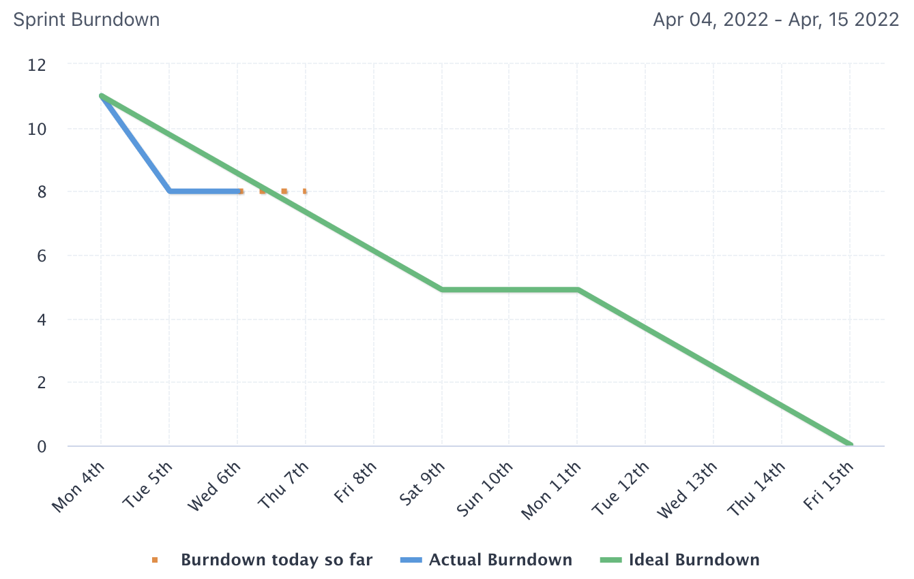

## Day 9 4/12

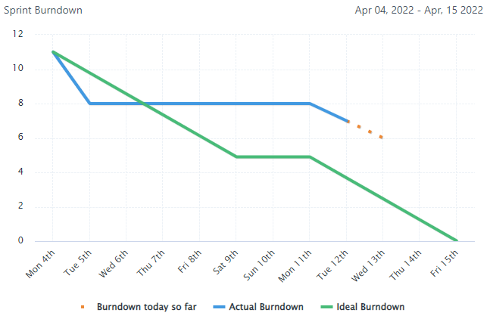

## Day 14 4/17

## 

| Daily Scrums |
| --- |

## Day 4 4/7 - Sprint 2

**Sam**

1. What did you do yesterday?
2. Updated Trello board with new tasks, also pulled tasks through that had been completed
3. What are you planning to do today?
4. Update milestone 2
5. Any problems are you facing?
6. Nope

**Alyx**

1. What did you do yesterday?
2. Work with Sarah on the ERD diagram for milestone 2
3. What are you planning to do today?
4. Finalize and submit milestone 2.
5. Any problems are you facing?
6. No

**Sarah**

1. What did you do yesterday?
2. Created the use case diagram
3. What are you planning to do today?
4. Get feedback and edit
5. Any problems are you facing?
6. No

**Jesus**

1. What did you do yesterday?
2. Implemented clients ask of a new filter
3. What are you planning to do today?
4. Communicated to client to schedule a time to meet
5. Any problems are you facing?
6. Please provide availability for me to present to client

**Cecelia**

1. What did you do yesterday?
2. Took a closer look at design of website to see if could make more user friendly
3. What are you planning to do today?
4. Publish notes from this meeting
5. Any problems are you facing?
6. None

## Day 9 4/12 - Sprint 2

**Sam**

1. What did you do yesterday?
2. Assisted with button planning and JS
3. What are you planning to do today?
4. Connect with sprint review group
5. Any problems are you facing?
6. None

**Alyx**

1. What did you do yesterday?
2. Get HTML from Jesus and decide how to split up the pages
3. What are you planning to do today?
4. Complete the prototype and upload
5. Any problems are you facing?
6. None

**Sarah**

1. What did you do yesterday?
2. Update Trello and schedule meeting
3. What are you planning to do today?
4. Create question list for client meeting
5. Any problems are you facing?

**Jesus**

1. What did you do yesterday?
2. Confirm collections and documents
3. What are you planning to do today?
4. Make sure firebase has the collections and documents as we have designed
5. Any problems are you facing?
6. None

**Cecelia**

1. What did you do yesterday?
2. Start Milestone 3B
3. What are you planning to do today?
4. Finish these notes and prepare for client meeting
5. Any problems are you facing?
6. None

## Day 14 4/17 - Sprint 2

**Sam**

1. What did you do yesterday?
2. Scheduled meeting for sprint review
3. What are you planning to do today?
4. Finish changing the checkmarks to a drop-down menu in JS
5. Will meet with sprint review soon
6. Any problems are you facing?
7. No

**Alyx**

1. What did you do yesterday?
2. Update Trello
3. Compile materials for milestone 3A
4. What are you planning to do today?
5. I can help anyone who needs it
6. Any problems are you facing?
7. No

**Sarah**

1. What did you do yesterday?
2. Assured user stories/problems fixed with project work
3. What are you planning to do today?
4. Start a project backlog for Sprint 3
5. Any problems are you facing?
6. No

**Jesus**

1. What did you do yesterday?
2. Finished splitting up html into two pages
3. What are you planning to do today?
4. Making sure firebase is connected to google sheets properly
5. Any problems are you facing?
6. Yes. Hard to know when google sheets should update firebase vs. website updating google sheets
7. Will probably ask professor

**Cecelia**

1. What did you do yesterday?
2. Look over prototype to make sure it meets clients needs
3. What are you planning to do today?
4. Compile sprint 2 to turn in
5. Any problems are you facing?
6. Make sure everyone has their parts in google drive

| Sprint Review |
| --- |

**What did you learn from doing our second sprint?**

During our second sprint, our group learned how to apply the concepts of agile in a more technical way. This included breaking down our processes through diagram’s (DFDs, Use Cases, Activity diagrams), coding, code reviews, etc. This sprint felt much closer to what we might experience in the real world as business or systems analysts.

**What did go well? Why?**

We did a really nice job communicating with one another about the technical requirements of our design and how we wanted to illustrate these requirements in our website and in our diagrams. This went well because we utilized several different mediums of communication and took our standups seriously.

**What didn’t go well? Why not?**

We struggled with implementing some capabilities in javascript as we are all not very well versed in the language. This meant some tasks took longer than we expected for them to take, and led us to shift some work around as needed.

**How can you make things better next time?**

We plan to allot more time for some of the coding challenges we might encounter in the final steps of developing our website and database.

**Are you satisfied with what you already completed?**

We are satisfied with where we are at for our second sprint and expect our final sprint to be equally ambitious and technically challenging.

**Which group was invited? What are your observations/notes? Everybody was present?**

Group 1 was invited to analyze our sprint review. ***

| GitHub URL – README File |
| --- |

<https://github.com/jjvilla6/IS424Final>