Chapter 11: Moving into Implementation

# Teaching Tips and Strategies *(from Alan Dennis)*

This is one of those chapters where students grit their teeth. The focus in this stage is on designing and executing tests and developing documentation, neither of which are high on student's lists of favorite topics. I usually spend one class on this chapter.

***I don't normally have students do detailed test plans for every part of their projects, because this quite literally doubles the programming effort. I usually only require a complete test plan for one module of their project. Likewise, depending upon the time crunch, I only require documentation for one module as well.***

In my opinion, the hardest point to get across is the need for testing. Most students have written programs and have done ad hoc testing. This seems to have worked fine for them, so the idea of spending longer testing than actually writing the software seems like a huge waste of time to many students. It is critical to convince students that the cost of a bug in production system can be enormous, far more than the cost of even several years’ salaries for the system development team. The examples in the book and the war story below may help, but it is still an uphill battle. You might ask students what might be the cost of a serious bug in system they are developing (e.g., suppose the payment for every 10th order was lost, all customer records were deleted).

I find that the students can relate to the idea of beta tests. They are used to hearing about beta code and probably don't understand why pre-release software is called beta. This section helps them fill in the missing link.

# War Stories *(from Alan Dennis)*

**Experience Counts**

I once developed a groupware system for a large consulting firm. The consulting firm hired my company to build the system because they had no idea what the system should do. Instead, they wanted me to design a prototype of the next generation system using JAVA. I decided that that the best approach would be to use undergraduate students because they had a small budget. I hired one of my best MIS students who was a crackerjack visual basic programmer to work for the summer on the prototype I designed. Although technically sharp, he had never used JAVA, and by the end of the summer all we had was a mess. After much soul searching, we both agreed that I needed to hire someone else. At the start of the fall semester, I hired a very sharp undergraduate computer science student who knew C and had taken a JAVA course. He worked 10-20 hours per week, and by April, we had working prototype but nothing near what we should have had.

As the book says, experience counts. In hindsight, I should have hired a JAVA expert, and while it would have cost more, the system would have been done the way it should have been by the end of the first summer.

**Everything that can go wrong will!**

A project Sarah was on two years ago was in the final preparation stage for a cutover to a new system. This project had been going on for about 2 years and involved over 80 resources from the client and Big 5 Consulting firm. The whole team was working late on a Saturday night running through the final round of testing to ensure that everything was ready for the cutover. Sarah herself was in the Operations room. Suddenly an alarm went off and it seemed like a tornado blew through the room - papers flew everywhere, there were huge wind currents, etc. Sarah and the others in the room raced to the door and escaped out of the room. As it turned out a fire detector had malfunctioned, initiating the release of halon and initiating the sucking up of oxygen from the room. This apparently is a common system in computer operations room to protect equipment by quickly extinguishing fire from the room (by sucking out oxygen and releasing a chemical). The process can be deadly to individuals if they do not get out of the room quickly. When Sarah and the others returned to the room, it looked like a tornado had blown through. They had not planned on this mishap but still managed to complete their testing in time for cutover.

**Defeating a "Major" Bug**

On a recent project, some of our training team members came running frantically into the Product Test room yelling about a bizarre error they were seeing in the application. They were doing a final walkthrough of their training course in preparation for the first day of training which was scheduled a few days later. Apparently a grid on one of the windows in the application was stuck in an infinite loop where it scrolled endlessly. The training team members were baffled as to what was causing the problem and wanted an emergency fix in place prior to their training class. One of the product testers went with the training team to investigate the problem. After studying the screen for a few seconds, the product tested exclaimed "This might help" and removed a binder which had been partially laying on the keyboard. Nothing was wrong with the application; the training team had unknowingly left a binder on the keyboard which was continually pressing the enter key.

**A $10 Million Bug**

A bank in the southern U.S. installed a new financial trading system to improve its stock market trading capability. It offered brokerage services as part of its services to its customers. Shortly after the system was installed, it crashed. The system -- and all of the bank's stock trading -- was out of operation for 4 days. The estimated loss of fees and the costs to mollify its angry customers was $10 million. This is about the cost to hire 200 programmers for one year. Someone should have spent an extra few person-months testing the system.

Note: As stated by Dr. Dennis, “In my opinion, the hardest point to get across is the need for testing.” I have been teaching from this text for many years, and I concur that this topic is in fact one of the most difficult to convey. It is also the one where the students from an objective standpoint (multiple choice and True/False questions) do the worst in quizzes and exams. I have had to set aside more time than normal to discuss testing and why it is so important.

# Answer to Your Turn 11-1: Test Planning for an Automated Teller Machine

Student answers will vary. The following test plan assesses the validity of the PIN as it is entered.

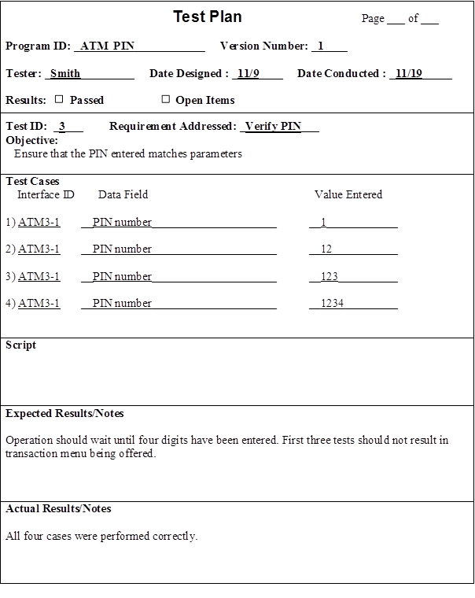

# Answer to Your Turn 11-2: Documentation for an Automated Teller

Student answers will vary. As ATMs are typically limited in their functionality, answers may include tutorials which direct the user in how to enter a card and pin, deposit funds, withdraw funds, transfer funds, and check balances. An area for defining terms may also be included.

# Answer to Concept in Action 11-A: The Cost of a Bug

The cost of identifying a bug in the system is almost directly related to the phase of development in which it is caught. One cost of not catching the bug early would have been the immediate loss of thousands of records. Once those records were lost, it would have taken time and effort not only to duplicate those records, but to determine exactly where the problem was, which means the conversion to a usable system would have been delayed. Luckily, in this scenario, the bug was caught during the testing phase rather than after the system had gone live.

# Answer to Concept in Action 11-B: Managing a Database Project

1. As the company is doing business legally, a systems analyst would approach this systems request as they would any other keeping in mind that there are restrictions as required by credit law.
2. In order to understand the requirements of the database, the analyst should interview the manager in order to understand the business processes used in collecting the data, and the end users to understand the day to day job of interacting with the proposed system.
3. Once the requirements are understood and documented, a database analyst will be able to aid in understanding how to efficiently and effectively design the database, including fields, tables, indexes, etc. This type of analyst will also be able to provide information on record size estimation and storage requirements. They will also be able to recommend a specific database (Oracle, DB2, mySQL).

# Answer to Concept in Action 11-C: Systems for Complex Electrical Systems

1. The analyst should first look at the existing system as a whole. Any documentation as to original system design should be examined to identify what capabilities each component in the original system was designed to have, paying particular attention to sub-stations. If no documentation exists, then the existing system needs to be mapped out to determine which component has what capability under what conditions. Once the mapping is complete, the analyst can then determine how to alter the system so that the sub-stations may only shut down the entire system as an exception to normal processes.
2. Most systems are not designed to be shut down for analysis and testing during real-time operations. In this case, the company is providing a critical service, and any down time severely affects their customers. During the testing phase, the most that could be done is a walkthrough of the changes to the system to simulate real-time operations.

# Solutions to End of Chapter Questions

1. *Discuss the issues the project manager must consider when assigning programming tasks to programmers.*

Project managers must consider the complexity of the modules being programmed against the programmers available, as well as the programmer’s expertise and experience. Ideally, a project manager will be able to assign experienced programmers to the more complex modules, and the less experienced programmers to the less complex modules. If the programmer’s skill and expertise are not a good match for the project, the project manager may suggest additional training or mentoring to increase the programmer’s skill level.

1. *If the project manager feels that programming is falling behind schedule, should more programmers be added to the project? Why or why not?*

Adding programmers does not shorten the project time, and can actually increase it due to the increased communication and coordination that must take place on the programming team. When the team members have to spend time coordinating their work with others, they are not spending time programming, and their productivity diminishes. [The first chapter footnote notes Frederick P. Brooks Jr.’s *The Mythical Man-Month* book. It provides a very apt exposition of this very problem.]

1. *Describe the typical way that project managers organize the programmers’ work storage areas. Why is this approach useful?*

Project managers often set up three distinct areas in which programmers work. Each of these can be a directory on a server, a separate server, or different physical locations, which all the programmers have access to. The three areas are the development area, the testing area, and the production area. The development area is limited to files created during the development process. Once the files or programs are complete, they are moved to the testing area. This area is used to test the code. Often, code is moved from development, to test, then back to development when and if problems are identified. Once all errors have been corrected, the program then moves to the production area.

1. *What is meant by change control? How is it helpful to the programming effort?*

Change control is the act of coordinating a program as it changes throughout the construction process. One technique associated with change control is a program log, which has programmers indicating ‘signing out’ module of code to work on, then ‘signing in’ modules of code when complete. Both the programming areas and program log help the analysts understand exactly who has worked on what and the program’s status. Without these techniques, files can be put into production without the proper testing, two programmers can start working on the same program at the same time, files can be overlooked, and so on. .

1. *Discuss why testing is so essential to the development of a new system.*

The cost associated with finding and fixing a major software bug after a system has been implemented is very high. Therefore, thorough testing of the system is imperative. It is not enough to have written a program; it also needs to be tested completely to verify it performs as specified. A program is not considered finished until it has passed its testing.

1. *Explain how a test case relates to a test plan.*

A test is a particular aspect of the system that needs to be evaluated. The test plan outlines all of the tests that need to be performed on the system. Test cases are the sample data that will be run through or entered into the system. A test will state its objective, list the test cases that will check the desired feature or function, and define the expected results. The test objective is taken directly from the program specification or from the program source code. Actual test results will also be recorded on the test.

*7. What is the primary goal of unit testing?*

*Unit tests* focus on one unit—a program or a program module that performs a specific

function that can be tested. The purpose of a unit test is to ensure that the module or program performs its function as defined in the program specification.

*8. How are the test cases developed for unit tests?*

Test cases are the sample data that will be run through or entered into the system. Based upon the description of what the program is supposed to do, test cases can be developed that verify that the program actually does those things.

1. *What is the primary goal of integration testing?*

*Integration tests* assess whether a set of modules or programs that must work together do so without error. They ensure that the interfaces and linkages between different parts of the system work properly.

1. *Describe the four approaches to integration testing.*

The purpose of the user interface testing is to have the user test each interface function. The purpose of the use scenario testing is to have the tester test each use scenario. The purpose of the data flow testing is to have the tester test each process using a step-by-step method. The purpose of the system interface testing is to test the exchange of data among systems. Most projects use all four approaches.

1. *How are the test cases developed for integration tests?*

If the modules have passed their individual unit tests, the focus now is on the flow of control among modules and on the data exchanged among them. Integration testing follows the same general procedures as unit testing: the tester develops a test plan that has a series of tests. *Integration tests* assess whether a set of modules or programs that must work together do so without error,

1. *Compare and contrast black box-testing and white-box testing.*

There are two approaches to unit testing: *black-box* and *white-box.* Black-box testing is the most commonly used. In this case, the test plan is developed directly from the program specification: each item in the program specification becomes a test, and several test cases are developed for it. White-box testing is reserved for special circumstances in which the tester wants to review the actual program code, usually when complexity is high. .

1. *Compare and contrast system testing and acceptance testing.*

System testing evaluates the entire system, not only to verify that it runs without error or breakdown, but also that it fulfills the business requirements of the system.

Acceptance testing is performed with the system users to confirm that the system is complete, that it meets the needs of the business area, and that it is acceptable to the users.

1. *Describe the five approaches to systems testing.*

The purpose of requirements testing is to determine whether the original business requirements have been met. The purpose of usability testing is to determine how convenient the system is to use from a user standpoint. The purpose of security testing is to test disaster recovery processes and unauthorized access processes. The purpose of performance testing is to examine the system’s ability to perform under high loads. The purpose of documentation testing is to determine the accuracy of the current documentation.

1. *Discuss the roles users play in testing.*

Users are instrumental in acceptance testing. As this is the first time the users experience the functionality of the system, it is hoped that the system has undergone an in depth systems testing to ensure that the end product is of the highest quality possible and that attention has been paid to usability of the system product. While the new product may meet all the business requirements, if it does not pass acceptance testing by the users, then the system might very well be considered a failure.

1. *What is the difference between alpha testing and beta testing.*

Acceptance testing is done in two stages: *alpha testing*, in which users test the system using made-up data, and *beta testing*, in which users begin to use the system with real data and carefully monitor the system for errors.

1. *Explain the difference between user documentation and system documentation.*

System documentation is created for the system developers, in order to document what was done during the development process, and to help them maintain the system after its installation. User documentation is designed specifically for the system users to help them work successfully with the system.

1. *What are the reasons underlying the popularity of online documentation?*

Online documentation is popular for several reasons. First, it is often easier to find information using the search index. Second, it is possible to present help information in multiple formats, increasing its utility to the end users. Third, presenting information while interacting with the computer permits novel ways of presenting the information to be employed. Fourth, the cost of distributing online documentation is considerably less than printing and distributing paper manuals.

1. *Are there any limitations to online documentation? Explain.*

Although paper-based manuals are still found, online documentation is the predominant form. Paper-based documentation is simpler to use because it is more familiar to users, especially novices who have less computer experience; online documentation requires the users to learn one more set of commands. Paper-based documentation also is easier to flip through to gain a general understanding of its organization and topics and can be used far away from the computer itself.

1. *Distinguish between these types of user documentation: reference documents, procedures manuals, and tutorials.*

Reference documents are the help system that explains how to perform a specific task or function. Procedures manuals describe how to accomplish a particular business task with the system, often involving several steps. Tutorials are training systems that teach the user how to use the system.

1. *Describe the five types of documentation navigation controls?*

A table of contents organizes the information in a logical form. An index provides access to the help topics through keywords listed in the index. Test search allows the user to search for any topics that match the text entered by the user. An intelligent agent can be used to assist the user in the search. Links can be established that permit the user to jump between related topics.

1. *What are the commonly used sources of documentation topics? Which is the most important? Why?*

One source is the set of commands and menus in the user interface. A second source is a useful set of topics focused on how to perform certain tasks, usually those in the use scenarios from the user interface design. A third source are the important terms associated with the system. The most important source is probably the topics focused on how to perform tasks, since these define how to perform needed functions with the system.

1. *What are the commonly used sources of documentation navigation controls? Which is the most important? Why?*

The table of contents is developed directly from the logical structure of the documentation topics. Index terms can come from the user interface commands and functions, the major concepts (entities) of the system, the business tasks performed by the system user, and synonyms or alternate terms for the above.

1. *What do you think are three common mistakes made by novice systems analysts during programming and testing?*

While an analyst usually has little to do with the actual programming, they may certainly assist project managers in understanding the potential pitfalls in this phase:

* + Using low-cost personnel, which usually results in lower production or a low quality of work
  + Failing to control changes in code, either allowing scope creep, or not organizing the work through the development process
  + Failing to take the time to plan and conduct testing in terms of unit, integration, system, and acceptance

1. *What do you think are three common mistakes made by novice analysts in preparing user documentation?*

* Leaving documentation to the end and not having sufficient time to do it well.
* Failing to test the documentation with users to verify its usability.
* Failing to develop the documentation in terms of tasks that users need to perform.

1. *In our experience, documentation is often left to the very end of projects. Why do you think this happens? How could it be avoided?*

It may be that documentation is viewed as less "important" than other aspects of system development; consequently, it gets left to the very end of the project. Also, some analysts may be uncomfortable with the writing that must be done to produce documentation, so it is avoided as long as possible. To avoid a mad rush to churn out documentation at the end, the team should develop notes on documentation topics throughout the project. These notes can then be assembled into polished documentation.

1. *In our experience, few organizations perform as thorough testing as they should. Why do you think this happens? How could it be avoided?*

The problem may be due to the fact that the team is up against a deadline and does not have enough time to perform thorough testing. When in a hurry, the testing tends to be ad hoc rather than carefully planned. As a result, errors can be easily overlooked. As the systems analysts complete work on program specifications, they should immediately begin developing test plans, so that complete and thorough testing is structured for the programmers as they complete the programming tasks.

1. *Create several guidelines for developing good documentation. Hint: Think about behaviors that might lead to developing poor documentation.*

* Consider what documentation the users need and understand how they will use the documentation.
* Develop a set of documentation topics; tasks to be performed, description of commands, and definition of terms.
* Develop a set of documentation navigation controls to support the documentation topics; table of contents, index, text search, intelligent agents, and links between topics
* Develop a prototype of the user interface and have users test it for navigability and usability

# Solutions to End of Chapter Exercises

1. *Develop a unit test plan for the calculator program in Windows (or other similar program for the Mac or UNIX).*

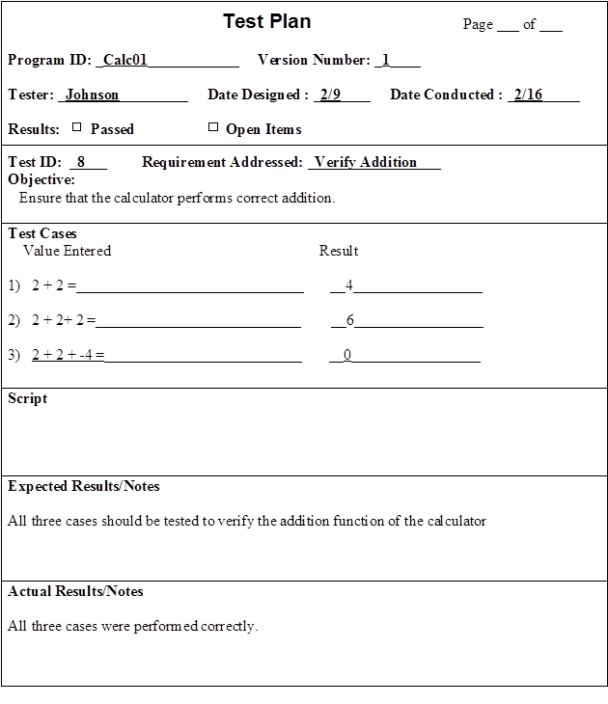

1. *Develop a unit test plan for a web site that enables you to perform some function (e.g., make travel reservations, order books).*

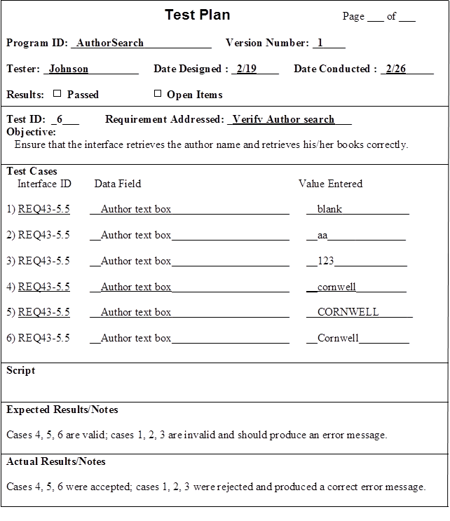

1. *If the registration system at your university does not have a good online help system, develop one for one screen of the user interface.*

Student answers will vary.

1. *Examine and prepare a report on the online help system for the calculator program in Windows (or a similar program for the Mac or UNIX). (You may be surprised at the amount of help for such a simple program).*

The online help is divided into three major parts: Contents, Index, and Find. The Contents are divided into two major categories: Performing Calculations and Tips and Tricks. The Index is an alphabetical list of keywords and topics. The Find option is a search technique that enables the user to type in keywords or phrases and brings up suggested topics.

1. *Compare and contrast the online help at two different web sites that enables you to perform the same function (e.g., make travel reservations, order books).*

Expedia.com has a link to Customer Support at top right corner of screen. This takes you to a set of task-oriented links that provide information on how to do things. There is also a link to FAQs, and a link for Additional Help.

Travelocity.com has a link to Customer Service in right side bar and also at the bottom of the home page. These links take you to a screen where you are told you can ask a question. Clicking on this link takes you to a screen full of links to categories of FAQs, organized primarily by topic rather than task.

# Answers to Textbook Minicases

*1.a. There is plenty for the project manager to do during programming. The programming activity needs to be managed; it will not just happen by itself. Along with making programming assignments, Pete should also be putting a lot of time into coordinating the work of the programmers and making sure that the required programming standards and practices are being followed. The project manager should also be monitoring the risk factors of the project, such as unrealistic time estimates, day to day slippage in progress, and difficulty with the technologies being employed in the project.*

*1.b. Pete has made several mistakes that could jeopardize the project’s successful completion, and certainly affect the likelihood of completion on time and within budget. The first obvious mistake is his unwillingness to acknowledge the underestimation of programming time requirements that were made earlier in the project. Pete has blinded himself to the realities of the situation in his quest to complete the project on time. This narrow focus on completing the project on time led to his second mistake, which was bringing in inexperienced programmers on the team in an effort to speed up the programming process. More programmers simply leads to a project team that needs more coordination and communication, and will not necessarily be more productive.*

*1.c The staff Pete has added may actually bring down overall productivity since the experienced staff will have to spend time guiding and mentoring the new hires. Finally, Pete needs to some type of control mechanism over the programs that are being developed. This mechanism does not have to be sophisticated, but it is essential that a log is maintained of each program that is written, its status, and who has worked on or is working on it. These kinds of procedures do not just happen by themselves, and it is up to the project manager to establish and enforce proper programming control practices.*

*1.d It is very unlikely that Pete will be able to complete this project on time and within budget with the current programming staff. While the new programmers may understand how to write programs, they simply don’t have the real-world experience needed to understand how code is maintained and managed. Pete would have been better off hiring fewer, but more experienced programmers.*

*2.*

*Answer:*



# Supplemental Minicases

1. Earhart Aviation operates a multi-service aviation business, including fuel, aircraft maintenance, charter flights, aircraft rentals, and flight instruction. The company has a major systems development project underway, with a comprehensive system being developed to permit online entry of all work performed in the maintenance shop, fuel purchases, online scheduling of charter flights, flight instruction, and aircraft rentals, and automated billing for the above activities.

Due to the wide range of personnel who will be interacting with the system (from shop personnel to line personnel to office personnel to flight instructors and students), the design of the user interface is important. Not only should the user interface be thoroughly tested, there must be sufficient user documentation available to help the users work with the system.

1. Because of the importance of the user interface to the ultimate success of this system, discuss the user interface testing that you believe should be conducted for this project.

*Answer: The user interface should be tested throughout the testing process. First, the individual programs that make up the user interface will be unit tested as they are created. During integration testing the entire user interface should be tested by working through each and every menu in the system. During system testing, the usability of the user interface should be evaluated by an analyst who is experienced in user interface design. Finally, the users will work with the system during acceptance testing, and should report any difficulty or confusion encountered with the user interface.*

1. The project sponsor once mentioned to the project manager that he envisioned that a procedures manual would be developed and printed and placed next to each computer station throughout the organization. That way, any user of the system could simply look up how to perform whatever function was needed. Do you agree that a printed procedures manual is the best way to provide user documentation for this system? Why or why not? Discuss the best type of user documentation that you believe should be developed for this system.

*Answer: This seems like a situation that would be better served with online user documentation rather than a printed manual. In an aviation setting, there will be many people coming and going, and keeping a procedures manual available next to all computer stations seems difficult. Also, the users of this system will probably need the support of an online reference document type of help system rather than a procedures manual. This reference documentation should be built around the common tasks that are performed by the users, such as entering service records, selling fuel, chartering a flight, reserving a rental aircraft, or scheduling a flight lesson. These common activities are probably outlined in the system’s use cases, and should be the primary source of reference documentation topics.*

1. As project manager in a new system development project, you have been careful to involve the end users whenever possible. So far, your relationships with the users have been good, and their enthusiasm about the new system is genuine. Now that programming has begun, however, there has not been that much for the users to do. Several of them have stopped by to inquire about progress, just because they’re interested. One even asked you when she could expect to get involved with the project again. “I guess I just got so involved with this project that I can’t help wondering about its status. I appreciate having more time available to do my regular job, but I find I can’t wait to get back with the team.”

Discuss how you will involve the users when the system is ready to be tested.

*Answer: Users will be heavily involved with the systems project again during acceptance testing. It is at this point that the users will work directly with the new system and ‘put it though its paces’ with their own data. The users should be involved in preparing test data for the system, following the test plans that were developed for the system testing process. Users should particularly focus on ensuring that the system performs its required functions, that they are satisfied with the user interface, and that they are comfortable with the user documentation that has been prepared for the system. It may also be valuable to test the system with ‘live’ data, so that the users are assured that the system can handle all the messy data of the real world. Following these acceptance tests, the users should be willing to confirm that the system meets their requirements, is complete and works as expected, and is acceptable to them.*

# Experiential Exercises

1. Purpose: to improve student understanding of test plans.

Divide the class into small groups. Have each group select a web site that sells textbooks (e.g., varsitybooks.com, bigwords.com, brilliantbooks.com). Have each group develop a unit test plan for the task of searching for a book. The group should then perform their test on their chosen web site. In class, discuss and compare the test plans that were developed. Then, focus the discussion on how well the sites performed on their tests.

1. Purpose: to become more familiar with usability testing.

Divide the class into small groups. Have each group select a web site that sells textbooks (e.g., varsitybooks.com, bigwords.com, brilliantbooks.com, half.com). Have each group develop three use scenarios for the textbook site (e.g., search, select, purchase). Put two groups together that selected different web sites. Have one group work through the use scenarios prepared by the other group, while the other group assesses the usability of the site. Then have the groups change roles. Each group should then prepare a short assessment of the usability of their site based on the observed experiences of the other group. Class discussion should reveal some common strengths and weaknesses observed in the sites.

1. Purpose: to become more familiar with on-line help documentation.

Divide the class into small groups. Have each group select a web site that sells textbooks (e.g., varsitybooks.com, bigwords.com, brilliantbooks.com, half.com). Have each group develop a list of six things they might want to know about the textbook web site (concepts, actions, tasks, procedures, terms, etc.). Have them go to the web site and use the on-line help to investigate the items on their list. In class discussion, concentrate on the methods that were available for help, the ease of getting the information they wanted, and the overall quality of the help provided.

1. Purpose: to become more familiar with on-line help documentation.

Assume that prospective students would like to get more information about your institution, and they go to your institution’s web site. The prospective students are interested in learning more about admissions standards and procedures. Using the web site, have your students investigate the help features that are provided for this use scenario. If weaknesses are discovered, what improvement can the students suggest?