2016年上海市初中毕业统一学业考试
英语试卷
（满分150分，考试时间100分钟）

Part 1 Listening （第一部分 听力）

I. Listening comprehension（听力理解）（共30分）
A. Listen and choose the right picture（根据你听到的内容，选出相应的图片）（6分）
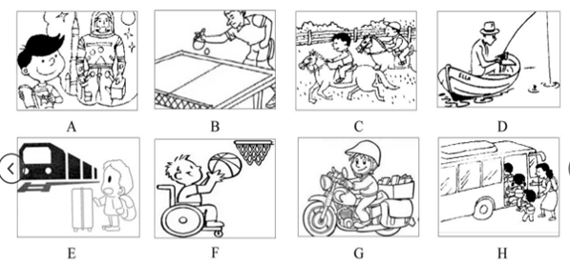

1. 2. 3. 4. 5. 6.

B. Listen to the dialogue and choose the best answer to the question you hear（根据你听到的对话和问题，选出最恰当的答案）（8分）
7. A. In March. B. In May C. In June D. In July
8. A. His son. B. His daughter. C. His father. D. His mother.
9. A. 11. B. 12. C. 13. D. 14.
10. A. Lions. B. Elephants. C. Monkeys. D. Tigers.
11. A. Because the car is too old. B. Because he needs money.
C. Because there is too much traffic. D. Because he wants to buy a new car.
12. A. At home. B. In the museum. C. At school. D. In the hospital.
13. A. Make some cakes. B. Order a meal.
C. Take him to a restaurant. D. Buy some milk.
14. A. Sleep. B. Fans. C. The kids. D. The weather.

C. Listen to the dialogue and tell whether the following statements are true or false（判断下列句子是否符合你听到的对话内容，符合的用“T”表示，不符合的用“F”表示）（6分）
15. Amy often stays up late at night to learn English.
16. The programmes Amy listens to are Canadian and American.
17. Amy thinks that talk channels are better than music channels.
18. Amy’s progress is slow, but her English is getting better than before.
19. Tom isn’t interested when Amy tells him about listening online.
20. Tom and Amy are talking about a good way to learn English.

D.Listen to the passage and complete the following sentences（听短文，完成下列句子。每空格限填一词）（10分）

21. The yearly Walk for Charity will Garden Street.
22. Money will be raised to build a children’s in the town.
23. If rain is forecast, walkers should all possible events.
24. Walkers are told to keep to in the dingle line while walking.
25. The bus leaves every half-hour and the service .

Part2 Phonetics, Grammar and Vocabulary
（第二部分 语音、语法和词汇）

II. Choose the best answer（选择最恰当的答案）（共20分）
26. Let’s take a rest and listen to some music. Which is correct for the underlined part?
A) /e/ B) /i:/ C) /i/ D) /ə/
27. The teenagers had good time in the summer camp in their sister school.
A. a B. an C. the D. /
28. When James arrived at the railway station, he tried to look a place to park his car.
A. after B. at C. up D. for
29. The local community centre is open Monday to Saturday.
A. in B. from C. for D. on
30. The retired couple have decided to go to college. It’s time for to begin a new life.
A. they B. them C. their D. theirs
31. This temple is one of buildings in the town. We must take action to protect it.
A. old B. older C. oldest D. the oldest
32. The manager sounded on the phone. He offered to show us around the company.
A. softly B. friendly C. gently D. seriously
33. The light went out suddenly. It was very dark and could be seen clearly.
A. anything B. something C. nothing D. everything
34. -- Disney amusement parks are there in China?
--Two.
A. How many B. How often C. How soon D. How long
35. The flight was delayed by the storm, the passengers had to wait at the airport.
A. but B. or C. so D. for
36. The nurse won’t leave her patients she’s sure they are all taken good care of.
A. unless B. because C. since D. if
37. A good friend is someone you share your pleasure and pain with.
A. ought B. need C. can D. must
38. Last week Vivian a dress for her mother with her first-month salary.
A. buy B. bought C. will buy D. would buy
39. This medicine millions of people’s lives since it was put into use.
A. is saving B. will save C. has saved D. had saved
40. After she finished the story, Alice wrote a review for her school newspaper.
A. read B. reads C. to read D. reading
41. I can’t tell you what she said. I’ve promised it a secret.
A. keep B. to keep C. keeping D. kept
42. The twins fond of the new idea in the magazine article.
A. be B. am C. is D. are
43. wonderful speech Emma gave at the UN conference!
A. How B. What C. What a D. What an
44. –Excuse me, where is the Moonlight Hotel?
-- . I’m a stranger myself.
A. Sorry, I don’t know. B. No, I don’t think so.
C. It doesn’t matter. D. Thank you all the same.
45. –The Are Festival is coming. We’re going to watch the play Twelfth Night.
-- .
A. That’s all right B. Never mind C. You’re welcome D. Enjoy your time

III. Complete the following passage with the words or phrases in the box. Each can be used only once（将下列单词或词组填入空格。每空格限填一词，每次只能填一次）（共8分）
A. realize B. public C. experiment D. pollution E. plastic

The scientist was in a hurry. She had to get some water for her 46 before darkness fell. She was testing the water in the rivers that went into the ocean. Her job was to find out the cause of 47 in the sea at nearby beaches. She lifted out the water and looked angrily at the rubbish in it. Old clothes, 48 bags and pieces of paper were in the dirty water. “Don’t people 49 that everything they throw onto the street gets washed into rivers? And they lead right into the ocean!” she said loudly. “How many years will it take to make it clean again?”
A. bright B. filled with C. exactly D. worried about E. immediately

The scientist felt sad deep in her heart. She 50 the ocean animals as she walked back to the beach. But when she got there, a group of students and teachers from a local primary school were carrying bags of rubbish to the bins. They had spent their after noon cleaning the beach! She was 51 joy.
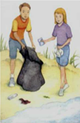
As she spoke with the teacher, the students gathered around them. With 52 smiles on their faces, they shouted, “We must do something to protect the ocean!”
“That’s 53 right,” agreed the scientist, as she smiled at their kindness.

IV. Complete the sentences with the given words in their proper forms（用括号中所给单词的适当形式完成下列句子。每空格限填一词）（共8分）
54. Tony’s father and uncle are both . They help keep the city safe. (policeman)
55. Could you pass me the dictionary from the right on the shelf? (seven)
56. Everyone believes that team will win the match this weekend. (we)
57. “Be not to touch the paintings in the museum,” Mum said. (care)
58. The artist’s helps him go further on the road to his dream. (wise)
59. The children enjoy the life in the country and live with their families. (happy)
60. I have something important to with you through video talk. (discussion)
61. Some wild animals may forever if we don’t stop hunting them. (appear)

V. Complete the following sentences as required（根据所给要求完成句子。62-67小题每空格限填一词）（共14分）
62. George wants to be a tour guide at the Bund for foreign visitors.（改为一般疑问句）
George to be a tour guide at the Bund for foreign visitors?
63. Charlie is so young that he can’t take the underground alone.（改为简单句）
Charlie is to take the underground alone.
64. They like playing basketball in the club better than going home after school.（保持句意不变）
They playing basketball in the club going home after school.
65. The Chinese graduate became a star because of his speech at Harvard.（对划线部分提问）
the Chinese graduate become a star?
66. A middle school student invented a new robot last term.（改为被动语态）
A new robot by a middle school student last term.
67. “When will you finish the project on Internet safety?” the official asked.（改为宾语从句）
The official asked I finish the project on Internet safety.
68. are good for, fruits and vegetables, to keep fit, people, fresh（连词成句）
.

Part 3 Reading and Writing（第三部分 读写）

VI. Reading comprehension（阅读理解）（共50分）
A. Choose the best answer（根据以下内容，选择最恰当的答案）（12分）

69. About children in PA State have no homes of their own.
A. 8,000 B. 14,000 C. 17,100 D. 22,000
70. The underlined expression “emotional support” means caring for a child’s .
A. food B. education C. houses D. feelings
71. Which telephone number can people call to ask about the General Meetings?
A. 492-9345 B. 492-9338 C. 492-9396 D. 492-3908
72. The General Meetings will be held .
A. every Thursday in February B. three times in February
C. between February 4th and 18th D. on February 4th and 18th
73. The purpose of the material above is to help .
A. children with no homes B. families with no children
C. schools with little money D. teachers with little training
74. We can read the material above probably from the section of a newspaper.
A. fashion B. sports C. advertisement D. business

B. Choose the best answer and complete the passage（选择最恰当的选项完成短文）（12分）

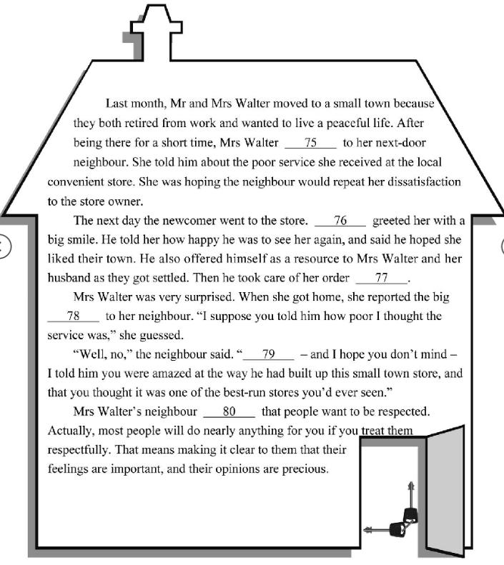
75. A. explained B. apologized C. listened D. complained
76. A. Mr. Walter B. Mrs. Walter C. The owner D. The neighbour
77. A. quickly B. sadly C. angrily D. easily
78. A. success B. change C. decision D. idea
79. A. For example B. At least C. In fact D. After all
80. A. understood B. forgot C. pretended D. denied

C. Read the passage and fill in the blanks with proper words（在短文的空格内填入适当的词，使其内容通顺，每空格限填一词，首字母已给）（14分）

The Young Person‟s Rail-card is very popular in Britain now．It gives young people the chance to buy （81）c__________ train tickets across the country．Just imagine，it could take you to festivals，to see friends，or to London for a weekend break，at a lower price．

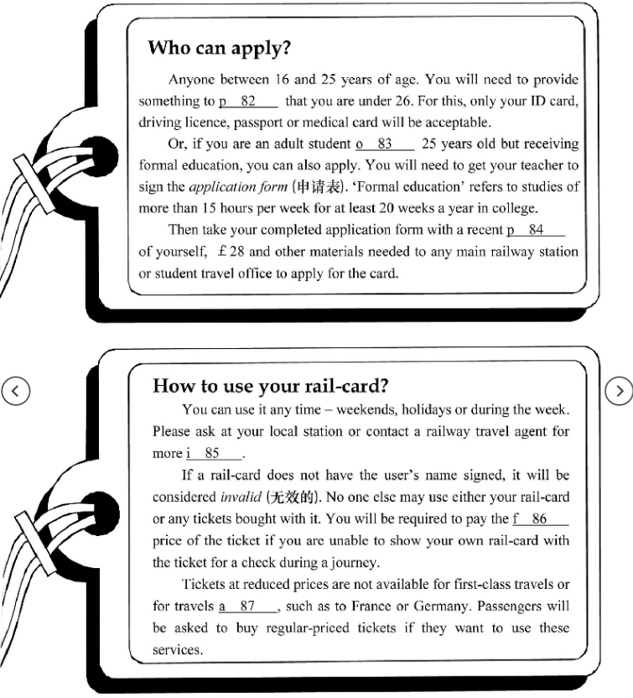

D. Answer the questions（根据以下内容回答问题）（12分）

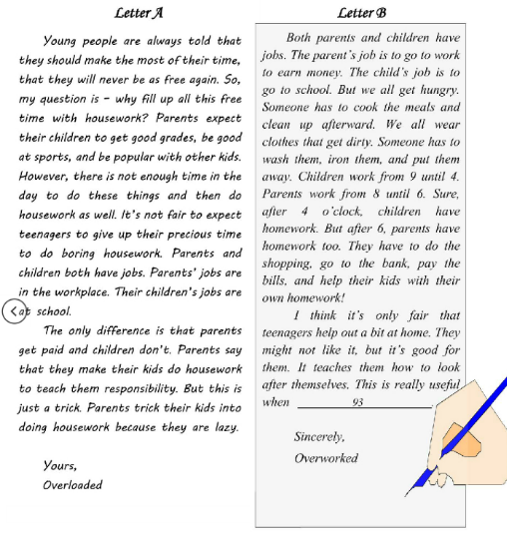
88. What is the writer’s question in Letter A?

89. How are parents’ jobs different from children’s jobs according to Letter A?

90. Why does Letter B say it’s good for teenagers to help out a bit at home?

91. Who most probably wrote Letter B, a parent or a child?

92. The two letters agree that parents and children both have jobs, don’t they?

93. What can be filled in the blank at the end of Letter B?

VII. Writing（作文）（共20分）
94. Write at least 80 words on the topic “I’m ready”（以“我准备好了”为题，写一篇不少于60个词的短文，标点符号不占格）
你对明天一定有着美好的憧憬。为此，你已经做好六哪方面的准备？请结合你的经历或特长等，选取一个角度具体谈谈你是如何做准备的。
（注意：短文中不得出现任何人名、校名及其他相关信息，否则不予评分。）
The following is for reference only.（一下内容仅供参考）

- independent
- responsible
- Hardworking

参考答案

1-6C B H E AG 7-14CBBAC DAD 15-20FFTTFT
21．start from 22．book shop 23．Prepare for 24．one side 25．is free

26-30 AADBB 31-35DBCAC 36-40ACBCD 41-45BDCAD
4 6 ．C 4 7 ．D 4 8 ．E 4 9 ．A 5 0 ．D 5 1 ．B 5 2 ．A 5 3 ．C

54. policemen
55.seventh 56. Our 57. Careful 58. Wisdom 59. Happily 60. discuss 61. disappear
62. Does want
63.Charlie is too young to take the underground alone．
64. They prefer playing basketball in the club to going home after school．
65. Why did the Chinese graduate become a star？
66. A new robot Was invented by a middle school student last term．
67. The official asked when I would finish the project on Internet safety．
68. Fresh fruits and vegetables are good for people to keep fit．

69-74BDBDAC 75-80 DCABCA

81. cheap/cheaper
82. prove
83. over
84. photo/photograph/picture.
85. Information
86. full
87 abroad

88. Why fill up all this free time with housework？
89. Parents get paid（and/but children don't）．
90.（Because the writer thinks）it teaches children how to look after themselves．
91. A parent．
92. Yes，they do．
93. they leave home to go to college or to live on their own

范文一： I’m ready!
Are you a person who always likes to get ready for everything? Do you often make a full preparation for something before doing? I am such a guy due to an unforgettable experience.
I still remember it was a final exam, I had been playing all day before it, believing that I am clever enough to get a high score, however, the result was very awful. From then on, I know if you want to succeed, the most important thing is to get ready for it.
Therefore, during the last whole year, I devote all my time to reviewing my lessons. The only reason is that I know there isn’t a lucky dog in the world, and on the way to success, hardworking is the key.

精彩亮点分析：
亮点一：疑问句开头，引发阅读兴趣
亮点二：过去完成进行时的使用使文章意思表达的更清晰
亮点三：分词做伴随状语，使文章档次提升
亮点四：be +adj.+enough to do sth. 足够…做某事
亮点五：条件状语从句的使用
亮点六：不定式做表语
亮点七：devote one’s time (in)to…把…奉献给…
亮点八：表语从句的使用

范文二： I’m ready！

As far as I’m concerned, everyone needs help and it’s time to get ready to help others. I’m ready to give my helping hand to my desk-mate who is poor at math.
First, I will teach him the methods of solving math problems and help him with problems that he can’t work out. In addition, I will also encourage him whenever he loses his heart.
As the saying goes, you share rose and get fun. I wish everyone could give out his helping hand. I’m ready to give out mine, are you ready?

精彩亮点分析：
亮点一： 开头以高分词组“as far as I’m concerned” 引出个人观点，并巧用强调句及从句， 明确表达了自己准备好帮助他人的总论点。
亮点二：中间段落运用first, in addition等连接词，将具体帮助他人的步骤较清晰地呈现。
亮点三：结尾段落用谚语提升了帮助他人的立意。
亮点四：结尾句用设问句给读者留下思考空间，且起到点题作用，为整篇文章画龙点睛。

范文三： I’m ready！
After one year’s hard work for the Entrance Examination, I believe that I’m fully prepared for the coming senior high school, a totally new period of life.
From the aspect of studying, I will get myself ready both physically and mentally. Firstly, I’m determined to read more classic English novels during the summer vacation, which will benefit me a lot. Besides, I will enter for a fitness club to build up my body.
From the aspect of daily life, I will be more independent, such as helping my parents with the housework and so on.
Good wishes can only be achieved with the determination and courage. I will try every possible way to get ready for the new leaf of our future life.

精彩亮点分析：
亮点一：活用副词修饰形容词，描写更细致。
亮点二：文章结构清晰，条理清楚。
亮点三：both physically and mentally高分短语。
亮点四：使用从句让文章句式多样化。
亮点五：such as加例子使文章细节丰富。
亮点六：结尾升华。

范文四： I’m ready！

As a famous saying goes, opportunities are only for the prepared mind. For me, I’m ready to become a singer. My reasons are as follows.
Firstly, there are a great number of people who around me like my voice, including my family members and friends , even some strangers. Secondly, singing has always been my hobby since I was young. Last but not the least, I think music is the most wonderful thing in the world. Whenever I have leisure time, I spend hours learning how to sing a song, and it can really make me exciting and relaxed.
Even though to be an excellent singer is not easy, I believe my hard work will make my dream come true some day. I’m ready!

精彩亮点分析：
亮点一：谚语引入“机会总是留给有准备的人”。
亮点二：定语从句让文章更丰富。
亮点三：用现在完成时态陈述理由。
亮点四：the most wonderful thing，用最高级表达喜爱。
亮点五：an excellent singer 比a good singer 更能打动阅卷老师。

