2021 年上海市初中学业水平考试
英语 试卷

考生注意：
- 本场考试时间 90 分钟，试卷共 9 页，满分 140 分，答题纸共 2 页。
- 作答前，在答题纸指定位置填写姓名、报名号、座位号。将核对后的条形码贴在答题纸指 定位置。
- 所有作答务必填涂或书写在答题纸上与试卷题号对应的区域，不得错位。在试卷上作答 一律不得分。
- 用 2B 铅笔作答选择题，用黑色字迹钢笔、水笔或圆珠笔作答非选择题。

Part 1 Listening (第一部分 听力)
  - Listening Comprehension (听力理解) (本大题共 20 题，共 25 分)

A.Listen and choose the right picture (根据你听到的内容，选出相应的图片) (5 分)
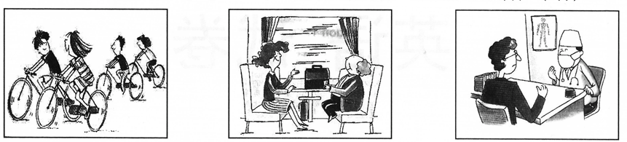
A B C
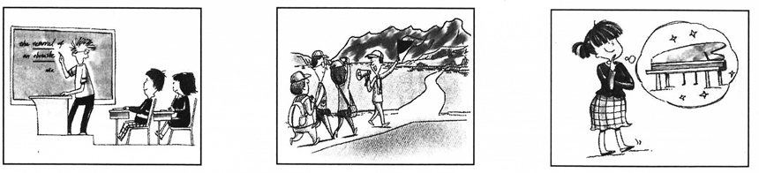
D E F

1. 2. 3. 4. 5.

B. Listen to the dialogues and choose the best answer to each question your hear (根据你听到的对话和问题，选出最恰当的答案) (5 分)

- A) The red one.  - A) By taxi. | B) The black one.  B) By underground. | C) The white one.  C) By bicycle. | D) The yellow one.  D) By bus.
8. A) At 6:00. | B) At 6:30. | C) At 7:00. | D) At 7:30.
9. A) To Hangzhou. | B) To Beijing. | C) To Dalian. | D) To Qingdao.
- A) She will drink coffee. B) She doesn’t want to lose weight.
C) She will start to work. D) She isn’t going to have any ice cream.

上海市教育考试院 保留版权 2021 初中学业水平考试 英语试卷 第1页 (共 9 页)

C.Listen to the dialogue and tell whether the following statements are true or false (判断下列句子是否符合你听到的对话内容，符合的用“T”表示，不符合的用“F”表示) (5 分)

- Brian saw his primary school teacher yesterday.
- Ms Marley let kids find things out by themselves.
- Jane lost confidence when she was put together with the big kids.
- Brian felt the care and love from Ms Marley in his primary school.
- This dialogue is mainly about when Jane and Brian will visit Ms Barley.

D.Listen to the passage and complete the following sentences (听短文，用听到的单词完成下列句子。每空格限填一词) (10 分)
- When Kate was a child, she lived in different cities with .
- As of the school singing group, Kate received a lot of training.
- With little success in Hollywood, Kate decided to to New York.
- In 2013, Kate took part in a TV singing contestand got .
- Kate released a few records of after winning the contest.

Part 2 Grammar and Vocabulary (第二部分 语法和词汇)

Ⅱ. Choose the best answer (选择最恰当的答案) (本大题共 15 题，每题 1 分，共 15 分。每题只有一个正确选项)
- Many medical workers are busy their work during lunch time.
  - to B) of C) from D) with
- I haven’t brought my dictionary with me. Can I use ?
  - you B) your C) yours D) yourself
- There was to eat at home, so I went out to get some food.
  - anything B) nothing C) something D) everything
- Yuan Longping is recognized as one of agricultural scientists in the world.
  - great B) greater C) greatest D) the greatest
- Your idea of a day on the beach sounds . Can I join you?
  - lovely B) softly C) politely D) beautifully
- – The 10th China Flower Expo is being held in Chongming. does it last?
– About 40 days.
  - How long B) How soon C) How far D) How often
- – I have two tickets for the Chinese Farmers’ Painting Exhibition?
– Sorry. The tickets are sold out.
  - Must B) Need C) Should D) May

2021 初中学业水平考 英语试卷 第2页 (共 9 页)
- Last weekend, David a visit to his grandparents in the countryside.
  - pays B) paid C) will pay D) has paid
- The headmaster is not available now. He to the new teachers.
  - speaks B) spoke C) is speaking D) was speaking
- Michael and his friends practise table tennis after school every day.
  - play B) played C) playing D) to play
- The manager asked his secretary the report before Friday.
  - finish B) finishes C) finishing D) to finish
- We should look forward to the future, never forget the past.
  - or B) so C) but D) for
- The fridge is environmentally friendly it uses less electricity.

  - because B) until C) before D) though
- The amusement park has received many visitors, ?

  - has it B) hasn’t it C) does it D) doesn’t it
- amazing the film Hi, Mom is! Mother’s love always touches myheart.
  - How an B) How C) What an D) What

Ⅲ. Choose the proper words in the box to complete the following passage. Each can be used only once (选择最恰当的选项填入空格。每空格限填一词，每词只能填一次)
(本大题共 8 题，每题 1 分，共 8 分，每题只有一个正确选项)
A) create B) product C) responsible D) influence E) unforgettable
Emily and I are twins. We love cooking healthy food together! Our parents have always cooked at home. They really 36 us a lot.
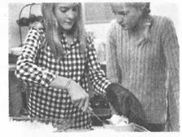
Working as sisters is interesting, as we have been through a large number of 37 experiences. However, sometimes we’d like more space of our own in the kitchen. We try to be fair. If one person manages to 38 a dish, the other person will write the process and take photos. Then we’ll change jobs next time.
Our dishes are so popular that we have been invited to be 39 for the Food and Health section in our school newspaper.
A) needs B) exactly C) efforts D) excuses E) especially
Sometimes not everything works out perfectly – and that’s OK! For example, we don’t know 40 what the readers want, so it’s quite hard to choose a widely accepted picture of the food. But we try our best to meet their 41 . We discuss the work and help each other to improve. That’s the best part about working together. We have been awarded “Best Campus Cook” several times for our 42 .
We love making new dishes, taking pictures, and then posting them on our school newspaper. It’s always good to try new things – 43 with food! When you eat healthily, it makes you feel better, and it can be twice as delicious.

2021 初中学业水平考试 英语试卷 第3页 (共 9 页)

Ⅳ. Complete the sentences with the given words in their proper forms (用括号中所给单词的适当形式完成下列句子。每空格限填一词) (本大题共 8 题，共 8 分)
- I live near my school. It takes me only ten to walk there. (minute)
- Lily and Mary have known each other for years. (seventh)
- The Bund attracts many people with beautiful night view. (it)
- The organization has set strict rules on the release of chemicals. (harm)
- Without the glasses, he can’t see the words onthe blackboard . (clear)
- Tony has made up his mind to be a soldier to the country after graduation. (service)
- Shanghai Museum has a large of works of art from home and abroad. (collect)
- Some rainforests are likely to if we don’t take action to protect them. (appear)

Ⅴ．Complete the following sentences as required (根据所给要求完成句子。52-57 小题每空格限填一词) (本大题共 7 题，每题 2 分，共 14 分)

- My deskmate borrowed some books from the library at noon.（改为否定句） My deskmate any books from the library at noon.
- The government has spent 10 million yuan improving the water quality.（对划线部分提问）
has the government spent improving the water quality?
- Doctor Wu Mengchao saved a lot of patients’ lives. （改为被动语态）
A lot of patients’ lives by Doctor Wu Mengchao.
- John is wondering how he can keep the balance between work and play.（改为简单句） John is wondering keep the balance between work and play.
- I had a good time in the ocean park the day before yesterday.（保持句意基本不变） I in the ocean park the day before yesterday.
- “Have you visited the National Book Expo?” Linda asked me.（改为间接引语） Linda asked me I visited the National Book Expo.
- a meal plan, the community, make, for the aged, is trying to（连词成句）

Part 3 Reading and Writing (第三部分 读写)

Ⅵ. Reading comprehension (阅读理解) (本大题共 25 题，共 50 分)

2021 初中学业水平考 英语试卷 第4页 (共 9 页)

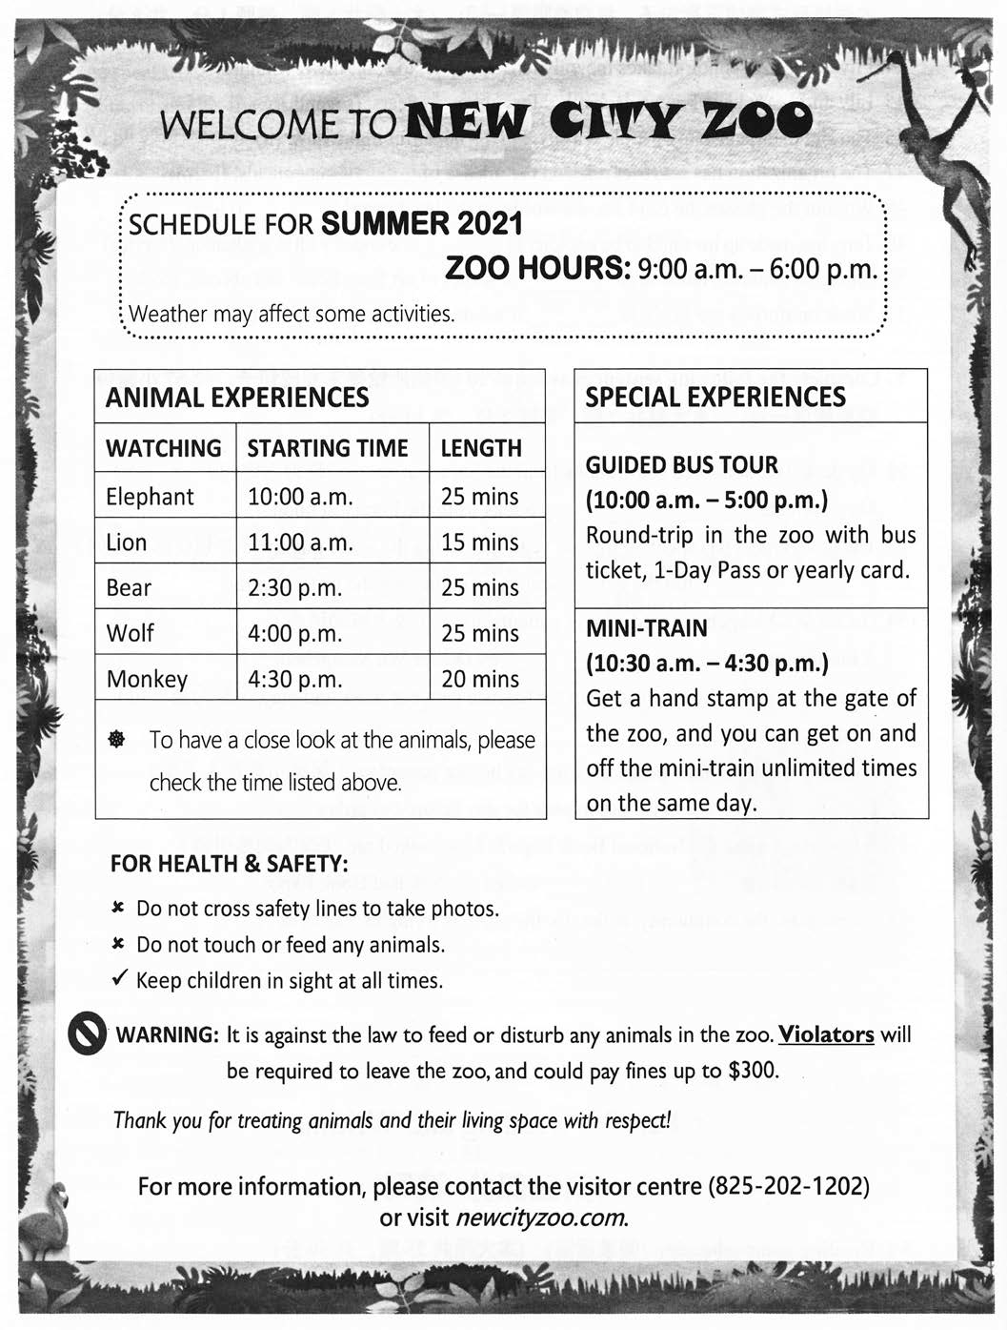
A. Choose the best answer (根据以下内容，选择最恰当的答案) (12 分)

2021 初中学业水平考试 英语试卷 第5页 (共 9 页)
- What time does New City Zoo open?

A) At 9:00 a.m. B) At 10:00 a.m. C) At 10:30 a.m. D) At 11:00 a.m.

- At 2:45 p.m., visitors can have a close look at .
A) elephants B) bears C) wolves D) monkeys

- With a , visitors can take the mini-train as many times as they want on the same day.

A) hand stamp B) 1-Day Pass
C) yearly card D) bus ticket

- The underlined word “Violators” in the material means “people who ”.

- visit the zoo regularly

- look after the animals

- feed or disturb the animals

- want to return the zoo tickets

- Which of the following about the zoo is TRUE?

- The schedule is for the winter of 2021.

- Guided bus tour is available at 9:00 a.m.

- No activities will be affected by the weather.

- Visitors can visit newcityzoo.com for more information.

- The main purpose of the material is to in the zoo.

- protect the wild animals

- stress the importance of safety

- provide choices of transportation
- introduce the activities and rules

2021 初中学业水平考 英语试卷 第6页 (共 9 页)

B. Choose the best answer and complete the passage (选择最恰当的选项完成短文) (12 分)

What do you need for an invention to be a success?
To begin with, good timing is very 65 . You can have a good idea which the public doesn’t want yet. Take Giovanni Caselli as an example. He invented the first fax machine in the 1860s. Though the quality was excellent, his invention quickly 66 . The fax machine did not become a necessary piece of equipment in every office until the 1980s.
Money also helps. The Frenchman Denis Papin had the idea for a steam engine almost a hundred years before James Watt was born. Denis never had enough money to 67 one.
You also need to be patient. It took scientists nearly eighty years to invent a light bulb.
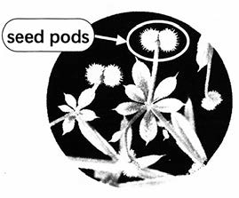
68 , you shouldn’t be too slow. In the 1870s, Elisha Gray developed plans for a telephone. Gray saw it only as “a beautiful toy”. When he finally sent details of his invention to the Patent Office ( 专 利 局 ) on February 14th, 1876, it was too 69 . Almost the same designs had arrived just two hours earlier. The young man who sent them was Alexander Graham Bell. He is
remembered as the inventor of the telephone.
Of course what you really need is a wonderful idea. If you haven’t got one, a walk in the countryside and a careful look at
70 can help. The Swiss scientist, George de Mestral, had the idea for Velcro (粘扣) when he found his clothes covered in sticky seed pods after a walk in the countryside.

- A) interesting  - A) died  - A) deliver | B) important  B) improved  B) repair | C) personal  C) spread  C) use | D) satisfying  D) appeared  D) build
68. A) However | B) Instead | C) So far | D) At last
69. A) modern | B) difficult | C) late | D) old
70. A) society | B) nature | C) pictures | D) advertisements

2021 初中学业水平考试 英语试卷 第7页 (共 9 页)

C. Fill in the blanks with proper words (在短文的空格内填入适当的词，使其内容通顺。每空格限填一词，首字母已给) (14 分)
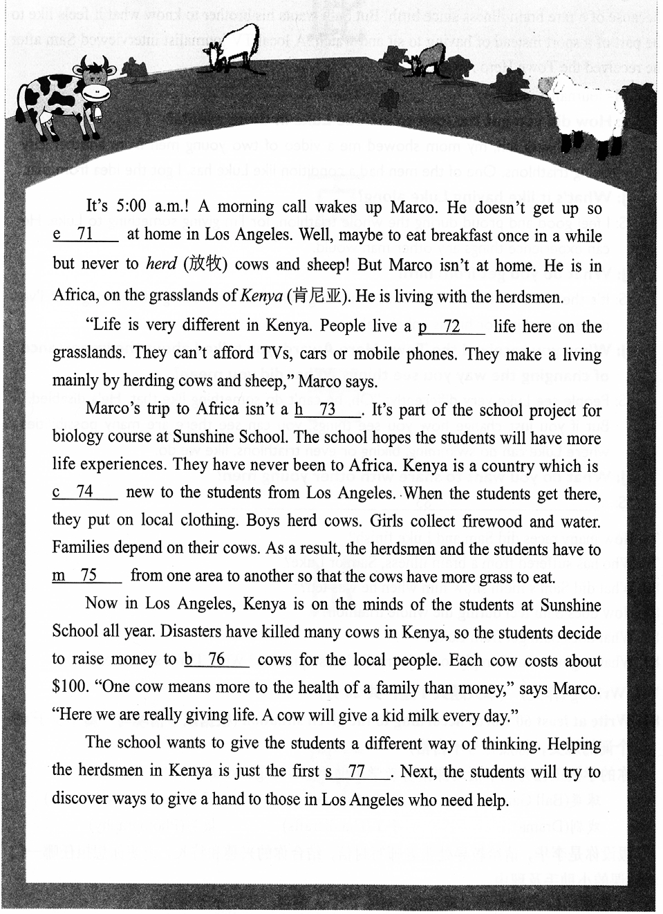

2021 初中学业水平考 英语试卷 第8页 (共 9 页)

D. Answer the questions (根据短文内容回答问题) (12 分)
Triathlon is a race in which each person swims, rides a bicycle and runs over very long distances. It has been held ten times in Hope Town. Sam, aged 20, finished nine races with his younger brother Luke. Every race was a victory for them. Luke can’t walk, talk or feed himself because of a rare brain illness since birth. But Sam wants his brother to know what it feels like to be part of a sport instead of having to sit and watch. A local TV journalist interviewed Sam after he received the Town Hero Award.
(J=Journalist, S=Sam)

J: How did you get the idea to include Luke in these events?
S: When I was ten, my mom showed me a video of two young men from another city doing triathlons. One of the men had a condition like Luke has. I got the idea from that.

J: What’s it like having Luke along?
S: I feel good and proud during the whole triathlon, for I’m giving something to Luke. He can experience things any other man would.

J: What do you get from him?
S: It’s the smile on Luke’s face. That smile brightens me. The feeling of knowing that I’ve done something for him is unbelievable.

J: When you received the Town Hero Award, you talked about the importance of changing the way you see things. What did you mean?
S: People see Luke very differently: “Oh, he can’t do something like that. He’s disabled.” But if you just change how you see things, you can see there are many possibilities where Luke can do swimming, biking or even triathlons, like we do.

J: What do you want to share with other young men?
S: 83

- How many races did Sam and Luke finish?
- Who has suffered from a brain illness, Sam or Luke?
- What did Sam’s mom show him when he was ten?
- How does Sam feel during the whole triathlon?
- What does Sam get from Luke?
- What might be Sam’s reply to the journalist’s last question? Write TWO sentences.

Ⅶ.Writing (作文) (本大题共 1 题，共 20 分)
- Write at least 60 words according to the given situation (根据以下情境写一篇不少于 60
个词的短文，标点符号不占格)
你的学校正在为以下活动课招募教学小助手(teaching assistant):
球类(Ball Games) 演讲(Speech) 器乐(Instrumental Music)
戏剧(Drama) 手工(Handicrafts) 摄影(Photography)

假设你是李华，请给教导处张老师写封信，结合你的兴趣和特长，说明你想担任哪一门 活动课的小助手及理由。
（注意：1.信．中．不．得．出．现．姓．名．、．校．名．等．个．人．信．息．，．否．则．不．予．评．分．。
2.照抄．阅．读．语．篇．不．得．分．。）

2021 初中学业水平考试 英语试卷 第9页 (共 9 页)

2021年上海市初中学业水平考试
英语试卷笔试答案
(第二部分 语法和词汇)
Ⅱ. Choose the best answer (选择最恰当的答案)(本大题共15题，每题1分，共15分。每题只有一个正确选项)
1. 【答案】D
2.【答案】C
3.【答案】B
4.【答案】D
5.【答案】A
6.【答案】A
7.【答案】D
8.【答案】B
9.【答案】C
10.【答案】C
11.【答案】D
12.【答案】C
13.【答案】A
14. 【答案】B
15. 【答案】B
Ⅲ. Choose the proper words in the box to complete the following passage. Each can be used only once (本大题共8题，每题1分，共8分，每题只有一个正确选项)
选择最恰当的选项填入空格。每空格限填一词，每词只能填一次
【答案】16. D 17. E 18. A 19. C
选择最恰当的选项填入空格。每空格限填一词，每词只能填一次
【答案】20. B 21. A 22. C 23. E
Ⅳ. Complete the sentences with the given words in their proper forms (用括号中所给单词的适当形式完成下列句子。每空格限填一词)(本大题共8题，共8分)
24. I live near my school. It takes me only ten ________ to walk there. (minute)
【答案】minutes
25. Lily and Mary have known each other for ________ years. (seventh)
【答案】seven
26. The Bund attracts many people with ________ beautiful night view. (it)
【答案】its
27. The organization has set strict rules on the release of ________ chemicals. (harm)
【答案】harmful
28. Without the glasses, he can’t see the words on the blackboard ________. (clear)
【答案】clearly
29. Tony has made up his mind to be a soldier to ________ the country after graduation. (service)
【答案】service
30. Shanghai Museum has a large ________ of works of art from home and abroad. (collect)
【答案】collection
31. Some rainforests are likely to ________ if we don’t take action to protect them. (appear)
【答案】disappear
Ⅴ．Complete the following sentences as required (根据所给要求完成句子。52-57小题每空格限填一词)(本大题共7题，每题2分，共14分)
32. My deskmate borrowed some books from the library at noon. （改为否定句）
My deskmate ________ ________ any books from the library at noon.
【答案】 ①. didn’t ②. borrow
33. The government has spent 10 million yuan improving the water quality. （对划线部分提问）
________ ________ has the government spent improving the water quality?
【答案】 ①. How ②. much
34. Doctor Wu Mengchao saved a lot of patients’ lives. （改为被动语态）
A lot of patients’ lives ________ by Doctor Wu Mengchao.
【答案】were saved
35. John is wondering how he can keep the balance between work and play. （改为简单句）
John is wondering ________ ________ keep the balance between work and play.
【答案】 ①. how ②. to
36. I had a good time in the ocean park the day before yesterday. （保持句意基本不变）
I ________ in the ocean park the day before yesterday.
【答案】had a great time##had a nice time##had a wonderful time##enjoyed myself##had fun
37. “Have you visited the National Book Expo?” Linda asked me. （改为间接引语）
Linda asked me ________ I ________ visited the National Book Expo.
【答案】 ①. whether#if ②. had
38. a meal plan, the community, make, for the aged, is trying to （连词成句）
________________.
【答案】The community is trying to make a meal plan for the aged
Part 3 Reading and Writing
(第三部分读写)
Ⅵ. Reading comprehension (阅读理解)(本大题共25题，共50分)
A. Choose the best answer (根据以下内容，选择最恰当的答案)(12分)
【答案】39. A 40. B 41. A 42. C 43. D 44. D
B. Choose the best answer and complete the passage (选择最恰当的选项完成短文)(12分)
【答案】45. B 46. A 47. D 48. A 49. C 50. B
C. Fill in the blanks with proper words (14分)
在短文的空格内填入适当的词，使其内容通顺。每空格限填一词，首字母已给。
【答案】51. (e)arly
52. (p)oor 53. (h)oliday
54. (c)ompletely
55. (m)ove 56. (b)uy
57. (s)tep
D. Answer the questions (12分)
根据短文内容回答问题。
【答案】58. Nine.
59. Luke. 60. A video of two young men from another city doing triathlons.
61. He felt good and proud.
62. The smile on Luke’s face.
63. Sometimes we need to change how we see things. And we can see there are many possibilities where we can do.
Ⅶ. Writing (作文)(本大题共1题，共20分)
64.
【答案】例文：
Dear Mr. Zhang,
I am writing to you to apply for the teaching assistant for our instrumental music lesson. The reason why I am interested in this job is that I love music and I have got the level-10 certificates of both piano and guitar. Besides, music is a way to deepen our understanding of the world as well as a way to relax ourselves. I hope more students will find its beauty through this course, which is certainly my goal. Being the teaching assistant is exactly what I am good at and what I desire. I really hope you can give me this opportunity.
Sincerely,
Li Hua

