System Architecture

Specifications

Hardware Requirements

Hardware Architecture

Modbus Register Map

PCB Architecture

Firmware Architecture

Application Algorithm

a. Callback:

b. App Task:

# System Architecture

**12 ABCDEFGHI 1234567 123456 22 22** 22 22

# Specifications

1. Lines : 1
2. Visibility Range : 20 meters
3. Single Sided
4. Data : 19 Digits, 9 Dot Matrix
5. Communication Protocol : MODBUS TCP/IP
6. Wall Mounting

# Hardware Requirements

1. PIC18F67J60 – 1No.
2. PIC18F8722 – 2Nos.
3. 2” Seven Segment Display – 19Nos.
4. 2” Dot Matrix Display – 9Nos.
5. Driver cards – 2Nos.
6. TIP127 Boards – 3Nos.
7. ULN2003A – 1No.
8. 5V Regulator Board – 1No.
9. 12v Regulator Board – 1No.

# Hardware Architecture

FROM PLC

24V DC INPUT

5V Power Supply

5V

5V

5V

PIC18F67J60

(Ethernet to Serial Board)

PIC18F8722

PIC18F4520

FROM PLC (MODBUS TCPIP)

SERIAL

SERIAL

DOT MATRIX DRIVER

ULN

BOARD

TIP127

7 SEGMENTS

**12 1234567 123456 22 22**

**ABCDEFGHI**

DOT MATRIX

TO TIP127 AND ULN BOARDS

FROM PLC

24V DC INPUT

12V Power Supply

# PCB Architecture

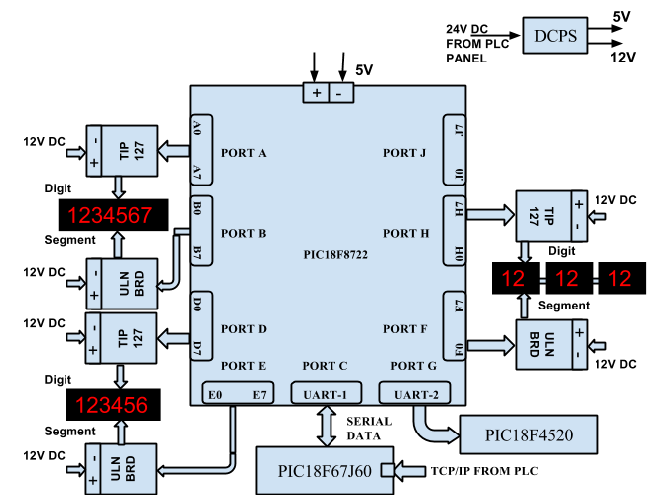

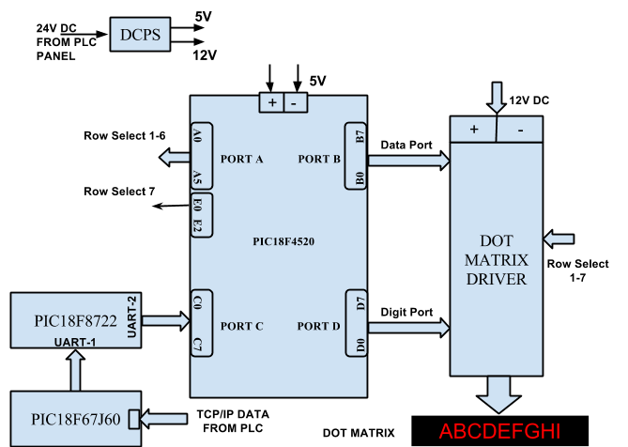

# Firmware Architecture

1. **PLC MODBUS DATA HANDLER:**

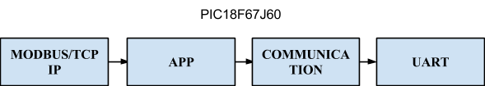

1. **DIGIT CONTROLLER:**

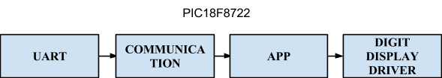

1. **DOT MATRIX DISPLAY CONTROLLER:**

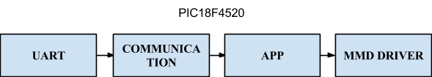

# Application Algorithm

1. Check for data on TCP/IP port.
2. if baudrate updated store new baudrate and baudrateUpdated flag to true
3. if address updated store new address and set addressUpdated flag to true
4. If starting address is greater than 3 and less than 12, store the content of buffer into app buffer and set limitUpdated flag.
5. If the starting address is greater than 12, store the content of buffer into a app buffer and set corresponding line flag.
6. Repeat step 4 and 5 till Number Register count becomes zero.