Applying Deep Reinforcement Learning in Stock Market

Jiacheng Zhu
Department of Statistics & Department of Political Science,
Pennsylvania State University
State College, PA, USA
jjz5463@psu.edu
Jingsheng Zhang
Department of Statistics & Department of Political Science,
Pennsylvania State University
State College, PA, USA
jxz5511@psu.edu
Yuyan Yang
Department of Statistics & Department of Hospitality Management,
Pennsylvania State University
State College, PA, USA
yzy5339@psu.edu

Abstract—As attention to quantitative finance increase both inside and outside of the academic fields, lots of novel and advanced stock prediction models were introduced by financial experts and researchers. This paper introduces an ensemble strategy of three popular deep reinforcement learning methods – A2C, PPO, and DDPG based on novel training period. The goal of this paper is to train an automatic trading agent(s) that can maximize the return. The result suggests that the proposed method can perform better than the market and similar ensemble method when the market has high volatility due to the novel training setup.
Keywords— deep reinforcement learning, automatic stock trading, ensemble strategy, actor-critic framework, quantitative finance

Introduction
As the attention to quantitative finance increase in recent years, financial experts and data scientists did enormous amount of research on methodologies that can potentially maximizing profits from stock market trading. However, due to the stochastic nature of the stock market, most traditional methods, such as classical machine learning methods, did not perform well comparing to the market average and human experts who perform manual trading in financial market.
In recent year, researchers start to apply reinforcement learning methods into the financial market due to the advancement in the domain of deep reinforcement learning methodologies and development in artificial intelligence in general. However, outside of the research and professional domain, the majority of the public rarely have access to the latest algorithm or trading bots created by experts in financial experts. Therefore, the motivation behind this paper is to further investigate and validate the potential of deep reinforcement learning strategies with the application of automatic stock market trading to help and assist ordinary individual traders in their trading processes and potentially increasing or maximizing their profits. The research question behind this motivation is that “How can we use modern data technologies like reinforcement learning, deep learning, and machine learning in the field of quantitative finance to help ordinary traders?” To answer this research question, this paper builds an ensemble method which is modified and expanded from previous research [1].
The rest of the paper will be organized as following: (1) literature reviewing, which will go through popular methodology in stock prediction including the one inspired this paper, (2) methodology, which will have a detail explanation of the model used to generate results, (3) results/finding, which presents the results of model introduced, and (4) conclusion.

Literature Review
Quantitative finance is an emerging field in the research domain of data science and it is extremely popular among researchers across different backgrounds. Tremendous amount of research and works have been published on introducing variety of methodologies to predict the trend/position of stock market with the goal of maximizing the return/profits. Some methods and algorithms were kept as secrets by the top financial and investing institutions. Besides those unpublished/unreleased trading strategies, some common methodologies in the research domain includes trend following, mini-variance, classical machine learning, deep learning, deep neutral natural network (DNN), long-short-term-memory (LSTM), sentiment analysis using Twitter data, etc. The most related research to paper will discuss in more details below:

Ensembled Multi-Agents Trading
This previous research has the strongest impact on this paper. It was written in November 2020. The reasons that the authors undertaking the work is to learn a stock trading strategy by maximizing investment return, which is the same as this paper. It utilizes an ensemble strategy that employs three actor-critic-based reinforcement learning algorithms including Proximal Policy Optimization (PPO), Advantage Actor-Critic (A2C), and Deep Deterministic Policy Gradient (DDPG). The ensemble method performed better than three stand-alone reinforcement learning methods and two baseline methods includes min-variance portfolio allocation strategy and the Dow Jones Industrial Average in terms of Sharpe ratio, which measures risk-adjusted return. It reaches an average annual return of 13 percent and cumulative return 70.4 percent during January 2016 and May 2020.
The authors believe that designing an automated trading system is important to investing corporations and the current strategies are not satisfactory; therefore, their team want to design a new automated trading system.
It is an important paper to the discipline because it provides a comprehensive insight of the performance of reinforcement learning agents in a stochastic, random probability, environment. Even if the research did not perform well on stock prediction, it still gives future research a general idea of performance of reinforcement learning on random probability environment.
Since previous research are only focused on picking high performance stocks rather than allocating trade positions or shares between the selected stocks, the authors want to design a model that can model positions.
The first step that the authors took is using mathematical models to describe the problem. The authors think the dynamic stock market has a stochastic nature and they employ a Markov Decision Process (MDP) to model the market. Specifically, they build the environment by defining action space, state space, reward function, and trading constraints such as transaction costs and market liquidity. They also set the goal of the research as “design a trading strategy that maximizes the change of the portfolio value” [1]
The second step that the authors took is to train the three algorithms (PPO, A2C, DDPG) which take actions in the environment built in the last step. The data used to train the model is from the Compustat database through the Wharton Research Data Services (WRDS). The data were divided into the training stage, validation stage, and trading stage(testing). The first algorithm trained is A2C. It is a typical actor-critic algorithm. It can reduce the high variance of the policy network. The second algorithm trained is DDPG. It is used to encourage maximum investment return and is effective at handling continuous action space. The third algorithm trained is PPO. PPO improves the stability of the policy networks training by restricting the policy update at each training step. In addition to training models, authors implement a load-on-demand technique to avoid the large memory consumption in training.
The third step that the authors took is to ensemble the three agents together. They used the Sharpe ratio to measures the risk-adjusted return. An ensemble strategy to automatically select the best performing agent among PPO, A2C, and DDPG to trade based on the Sharpe ratio. The authors retrain and validate three agents(models) every 3-month to pick the best performing agent with the highest Sharpe ratio. “The reason behind this choice is that each trading agent is sensitive to a different type of trends. One agent performs well in a bullish trend but acts badly in a bearish trend. Another agent is more adjusted to a volatile market” [1].
The fourth step that the authors took is to verify the performance. They verify the effectiveness also by the Sharpe ratio. The ensemble model outperforms the three individual algorithms and two baselines (min-variance portfolio allocation strategy and the Dow Jones Industrial Average) in terms of the risk-adjusted return measured by the Sharpe ratio.
The authors find that the A2C agent is more adaptive to risk and is good at handling a bearish market at max drawdown of-10.2 % and cumulative revenue of 60%. PPO agent is good at the following trend and acts well in generating more returns at 83% cumulative return, which means PPO is preferred when facing a bullish market. “DDPG performs similar but not as good as PPO at 54.8% cumulative return and -14.8% max drawdown, it can be used as a complementary strategy to PPO in a bullish market” [1]. Comparing to theories/methods used in literature review, authors claimed that their methods are better at balancing risk handling and performance.
All three agents’ performance outperforms the two benchmarks and handle the March 2020 market crash well. The ensembled method is even doing better. It outperforms three standalone methods at balancing risk-handing and performance.

Single Agent Trading
This is a clarification and expansion based on [1]. The authors of this paper are the same group of researchers of [1]. This paper was published in January 2021, which is only a few months after the publication of [1]. The paper is also on the same topic as [1], which is using deep reinforcement learning to automate stock trading. This paper introduces an open-source library, FinRL, created by the authors. The authors focused on the workflow of deep reinforcement in quantitative finance and the baseline algorithms that their team chose to include in their open-source library. The authors undertake this work because they want to help beginners to start utilizing reinforcement learning in their research and workflow. Therefore, this paper is more like an extension of the [1] that the authors published a few months ago. The authors trained and tested multiple baseline reinforcement learning algorithms like DQN, DDPG, TD3, PPO, A2C, in a single stock trading environment, multi-stock trading environment, and in a scenario of portfolio allocation. As a result, all models perform well in three situations and beat the market.
The goal of this paper is to utilize deep reinforcement learning techniques to train a trading agent that can automatically trade stocks and decide where to trade at what price, and what quantity.
Methodology has a three-layer design: market environments design, RL Agent, and Application/testing. The market environment is setting up an environment to simulate the stock market with a Markova decision process. Then, training RL agents in the simulated environment. The last step is testing the performance of agents. There are six environments in the first layer including NASDAQ-100, DJIA, S&P 500, SSE 50, CSI 400, and HSI. There are multiple fine-tunned DREL algorithms in the second layer including DQN, DDPG, Multi-Agent DDPG, PPO, etc. The third level includes multiple performance evaluation functions, and each layer communicates through API.
The authors tested the trained agents in three use cases: single stock trading, multi-stock trading, and portfolio allocation. All agents can beat baseline techniques like mini-variance, and they can beat the market average. “Performance of single stock trading using PPO in the FinRL library. The Sharpe ratio of all the ETFs and stocks outperform the market, namely the S&P 500 index” [2]. In multi-stock trading and portfolio allocation, “the Sharpe ratios of TD3 and DDPG exceed the DJIA index, and the traditional min-variance portfolio allocation strategy” [2].

Algorithmic Trading
This is a research using deep Q-Learning. Like [1] and [2], this paper also presents on using deep reinforcement learning to train a trading agent to auto trade in the public stock market. The reasons that the authors undertaking this work is to propose a reinforcement learning algorithm to determine the optimal trading positions at any point in time during a trading activity. The method that authors proposed is a novel DRL trading policy called the Trading Deep Q-Network algorithm (TDQN) to maximize the resulting Sharpe ratio performance indicator on a broad range of stock markets. This new DRL approach is inspired from the popular DQN algorithm and significantly adapted to the specific algorithmic trading problem at hand. TDQN outperforms testbench marks but only by a small margin. The authors claimed that it was due to the bullish market during testing dataset.
The problem/goal of this research is to design a deep reinforcement learning to determine the best position to trade. The logic or layout of this paper is literature review, algorithmic trading problems, design of the TDQN, a novel methodology to assess the performance of trading strategies, discussion of result, and future work. A general conclusion is that the authors propose a modified deep reinforcement learning algorithm and a performance-validation strategy which lead to a promising and rigorous result.
The authors believe that many scientific publications in finance suffer from a lack of proper scientific approach. They intend to deliver an unbiased scientific evaluation of the novel DRL algorithm propose. The question guides their research is “how to design a novel trading policy (algorithm) based on AI techniques that could compete with the popular algorithmic trading strategies widely adopted in practice”? [3]
“Resulting trading strategy, denominated the Trading Deep Q-Network algorithm (TDQN), is inspired from the successful DQN algorithm presented in [5]” [3]. DQN, a DRL algorithm, is capable of successfully learning control policies from high-dimensional sensory inputs. It is in the successor of the popular Q-learning, which is a value-based reinforcement learning. This DRL algorithm is said to be model-free, meaning that a complete model of the environment is not required and that trajectories are sufficient. Therefore, the authors did not set up an environment; instead, the agent is learning from an approximation of the state-action value function, which is represented by a DNN. The environment approximation is through artificial trajectory. A trajectory is a sequence of observations. This original trajectory is composed of the historical prices and volumes. Then, new trajectories are artificially generated from this unique true trajectory to simulate interactions with the environment. There was multiple modification made in TDQN from DQN includes “Deep neural network architecture, Double DQN, ADAM optimizer, Huber loss, Gradient clipping, Xavier initialization, Batch normalization layers, Regularization techniques, Preprocessing and normalization, Data augmentation techniques” [3].
The training set is from 01/01/2012 to 31/12/2017 and test set is from 01/01/2018 to 31/12/2019. There are several baseline models includes buy and hold (B&H), Sell and hold (S&H), Trend following with moving averages (TF), and Mean reversion with moving averages (MR). For the performance validation function, they used Sharpe ratio and they proposes a novel, more rigorous performance assessment methodology. Following this new performance assessment approach, promising results are reported for the TDQN algorithm. The author did not compare the result with previous research in deep reinforcement learning, but it was an improvement by comparing to traditional research.
The performance of TDQN outperform baselines but by a small margin. The authors suggest extending observation space, relax the constraints on action space, and potentially consider distribution instead of expected values. These strategies can help financial organizations in their quantitative trading,
The TDQN algorithm demonstrates multiple benefits compared to more classical approaches, such as an appreciable versatility and a remarkable robustness to diverse trading costs. The performance of the TDQN algorithm could still be improved, from both generalization and reproducibility. Several research directions are suggested to upgrade the DRL solution, such as the use of LSTM layers into the deep neural network which should help to better process the financial time-series data

LSTM and random forests
The purpose of this paper is to forecast directional movements of stock of the S&P 500 for intraday trading. The authors use two methods: Random Forest and LSTM. The authors had lots of background knowledge on related works of literature, and they decided to choose random forest and LSTM as their methodology and choose forecasting direction as their target. The authors train two models separately to compare the performance. The overall dataset covers adjusted closing prices and opening prices of all stocks of the S&P 500 from the period of January 1990 to December 2018 from Bloomberg. The dataset was separated into 26 sub-datasets to train and test each model 26 times. The result shows that LSTM is better than random forest and the market.
The problem/goal/purpose of this paper is to apply long short-term memory networks (LSTM) and random forests to forecast directional movements of stock prices. The authors already know that LSTM will perform better than random forest and market from related research. Rather than building a new trading model, the authors want to validate the performance of LSTM and random forest by intraday trading.
This paper contains lots of literature reviews. The most influential past research on this paper is [6] and [7]. Both used LSTM and [7] is an improvement on [6]. The author used the same trading strategies from [6] which is “the 10 stocks with the highest probability are bought and the 10 stocks with the lowest probability are sold short” [4] with equal monetary weight. Two previous papers tried to predict each stock’s probability of outperforming the market the next day. An improvement the author made based on past works is that instead of forecasting the next day’s performance, the authors focused on today’s probability of outperforming the market in terms of the closing price.
Two models were used here in this paper: random forest and LSTM. The dataset is from Bloomberg and covers adjusted closing prices and the opening process of all stocks of the S&P 500 from January 1990 to December 2018. The dataset is divided into 26 subsets. Each subset is 4 years, which contains 1 year for feature generation, 2 years for training, 1 year for testing. After feature generating, 93 features were generated from three input features, intraday returns, returns with respect to the last closing price, returns with respect to the opening price. Two models were trained in each subset and then tested (all the package sued and hyperparameters were stated in the paper). During the test, each stock at time t was divided into 2 classes of equal size, based on their intraday returns. Class 0 if stock s is smaller than the cross-sectional median intraday return of all stocks at time t, whereas Class 1 if stock s is bigger than the cross-sectional median intraday return of all stocks at time t. The result of forecasting is the probability for each stock to outperform the median intraday return. After the forecasting, the authors performed a trading strategy with buying the top 10 stocks with the highest probability and the short worst 10 stocks with equal monetary weight.
One of the findings is that LSTM, outperforms random forests, which is in line with results of past literature reviews [7]. The authors also beat the performance of two previous research on LSTM because the author use 3-features to generate other features. The final Sharpe ratio of LSTM is 4.323, which outperforms previous research and the market index.
The authors conclude that using three features instead of having a single feature and analyzing performance in the case of intraday trading instead of performing next-day performance lead to improvement in performance.

Literature Review Summarization
To summarize literature review, this paper will use the model of [1] as a base model and improve its performance by integrating preprocessing process of [4] into the environment construction of [1]. Since [2] explains the library used in [1] and can provide this paper a clear guideline how to use that library to make the implementation phase of this paper easier. We will also use [3] as a baseline model because it is weakest in term of performance compared to the other three papers. This paper will also consider the improvements some previous research suggests such as including sentiment analysis with deep reinforcement learning. Moreover, this paper will include LSTM method introduced by [4] in the ensembled strategies of this paper.

Implementation
Implementation phase of the proposed strategy can be divided into four sub-sections: data source, preprocessing, and methodology, and validation. The source code of this implementation was available on GitHub (https://github.com/jjz5463/DS340W_AutoStockTrading). The implementation was highly dependent on FinRL, a reinforcement learning library development by [2], which is also available to the public on GitHub (https://github.com/AI4Finance-Foundation/FinRL).

Data Source
Data source that the model was training on was downloaded from yahoo finance API. Yahoo Finance is a website which provides free stock data, financial news, and financial reports, etc. The data downloaded includes 30 stocks, which are the ones made up current Dow Jones Industrial Average. They are 3M, American Express, Amgen, Apple, Boeing, Caterpillar, Chevron, Cisco Systems, Coca-Cola, Disney, Dow, Goldman Sachs, Home Depot, Honeywell, IBM, Intel, Johnson & Johnson, JP Morgan Chase, McDonald’s, Merck, Microsoft, Nike, Procter & Gamble, Salesforce, Travelers, UnitedHealth, Visa, Walgreens, and Walmart. The downloaded data in final proposed model cover from 01/01/2006 to 03/21/2022. Features included in the downloaded data are date, open price, close price, lowest price in the day, highest price in the day, volume of the stock, stock ticker, and day number. The dimension of the data source is 118551 rows and 8 columns.

Preprocessing
Although the downloaded data already provides some information, preprocessing or feature engineering is still necessary to convert the raw data into a model-ready status. There are two parts of preprocessing – adding technical index and turbulence index. Technical index is derived from technical analysis, which “studies the historical price patterns or trends or any other clues that are indicative of future price movements” [10]. There are four technical indicators included in the final model.
The first one is Moving average convergence divergence (MACD). It is a trend-following momentum indicator which shows the “relationship between two moving averages of a security's price” [10][11]. Specifically, it is calculated by “subtracting the 26-period exponential moving average (EMA) from the 12-period EMA” [11]. The second indicator is the Relative Strength Index (RSI), which is also a trend-following strategy. It measures the “magnitude of recent price changes to evaluate overbought or oversold conditions in the price of a stock or other asset” [12]. Specifically, a value above 70 indicates overbought and under 30 means oversold. The third indicator is the Commodity Channel Index (CCI), which serves the same function as RSI to measure overbought and oversold [13]. The fourth indicator is the directional movement index. It “measures both the strength and direction of a price movement and is intended to reduce false signals” [14].
Besides technical indicators, a turbulence index was also added to the data. Risk-aversion reflects whether an investor will choose to preserve the capital. It also influences one's trading strategy when facing different market volatility level [2]. It controls the risk in a worst-case scenario, such as financial crisis of 2007–2008, by measuring extreme asset price fluctuation [2].

Methodology
The overall methodology of this paper is based on [1], which is an ensemble function of three reinforcement learning methods – A2C, PPO, and DDPG. A2C is a typical actor-critic algorithm. It can reduce the high variance of the policy network. The second algorithm trained is DDPG. It is used to encourage maximum investment return and is effective at handling continuous action space. The third algorithm trained is PPO. It improves the stability of the policy networks training by restricting the policy update at each training step.
However, before training the agent, a training environment need to be pre-specified, which includes a action space, state space, and reward function (Figure 1). The trading environments was modeled as a Markov Decision Process (MDP) problem due to the stochastic nature of the financial market. The framework was based on OpenAI Gym framework to simulate live stock markets with real market data according to the principle of time-driven simulation [2]. In the case of single stock trading, the action space is limited to {-1, 0 ,1}, which is corresponding to sell, hold, and buy. In the case of multi-stock trading, action space expands to {-k, …, -1, 0, 1, …, k}, where k denotes the number of shares to buy and -k denotes the number of shares to sell [2]. In the particular case of the proposed model, there are 28 action space and 169 state space.
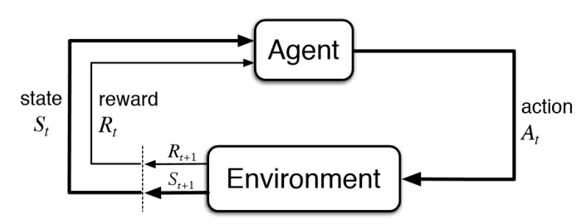
Figure 1: Source [15]

After specifying the environment, three deep reinforcement learning agents will be trained and ensembled through rolling window ensembled method. For every 63 days of the training period, the three agents will be retrained because the stock market is changing constantly. During the validation period, the revalidation window is also 63 days, which means three agents will each be validated on a 63-day period and the best performing agent during that period in terms of Sharpe Ratio (Equation 1) will be chosen as the one being ensembled in the final model for that 63-day period. In the case of final model, the training period cover from 01/01/2006 to 12/01/2020 and the validation and test period is from12/01/2022 to 03/21/2022. Table 1 gives a clear visual representation of how rolling ensembled method works. For example, for the period 12/02/2020 to 03/05/2021, the DDPG agent is the best performing agent in terms of Sharpe Ratio; therefore, it is the final model being used in that period.
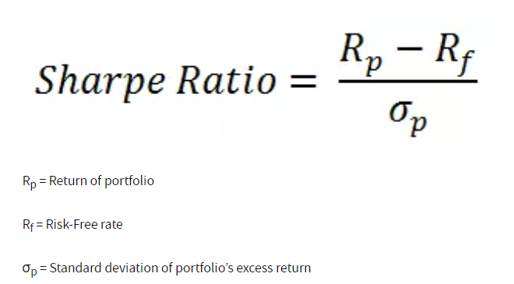
Equation 1: Sharpe Ratio [16]

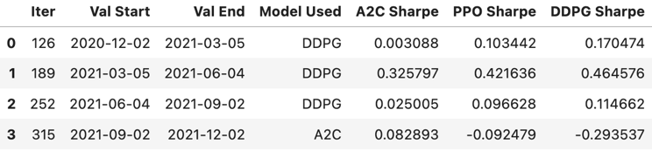
Table 1: Rolling Ensembled Method

Performance
Only a moderate result was discovered in the trading period due to high volatility and increasing inflation rate in last year (high inflation will be discussed further in the novelty section). The final model has a Sharpe Ratio of 0.94 and a cumulative return of 15.514%. The ensemble method underperforms the Dow Jones Industrial Average from March 2021 to June 2021; however, its performance increases sharply after June 2021 and outperforms the market during turbulent period from July 2021 to December 2021 and during drawdown from January 2022 to March 2022. Moreover, it outperforms [1] (-0.14 Sharpe Ratio) when validate on the same period of time (March 2021 to March 2022).
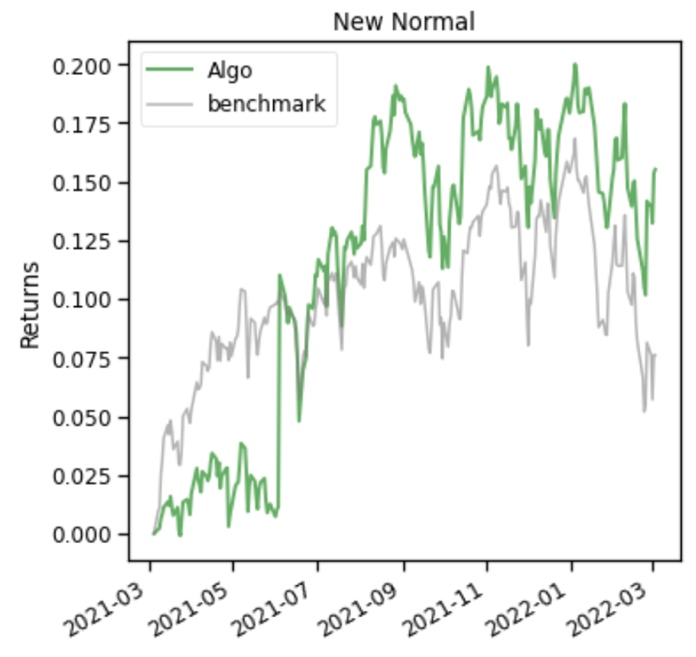
Figure 2: Ensemble Method vs. Market

Novelty
The methodology in [1] was proved to be successful on trading period 04/01/2020 to 07/06/2021 by [1] and it achieved a Sharpe ratio of 1.96. However, after updated the testing period (12/01/2020 to 03/21/2022), the performance dropped to -0.14 Sharpe ratio. The ensemble method in [1] start to encounter huge drawdown in January 2022 (Figure 3).
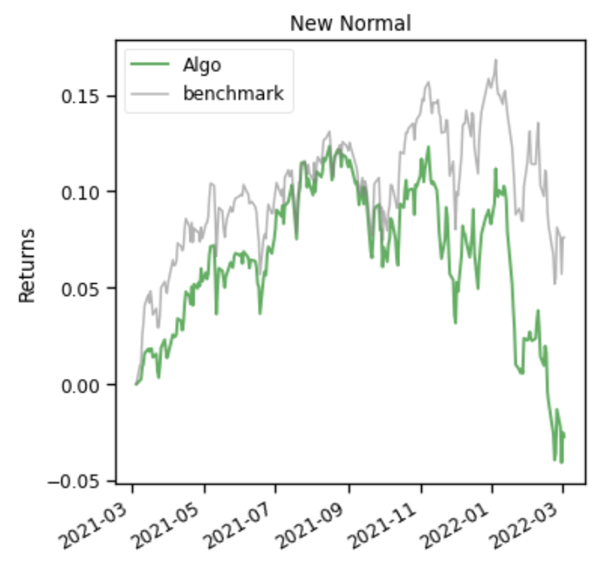
Figure 3: Ensemble Method in [1] vs Market

In order to address this large margin drawdown, five novelties were tested in this paper and each novelty was under different data science pipeline. The first novelty is under the data selection pipeline. The second novelty is under data pre-processing pipeline. The third, fourth, and fifth novelty are under the data mining/modeling pipeline (Figure 4). Although we tested five novelties during research process, we only implement one, data selection, in the final model.
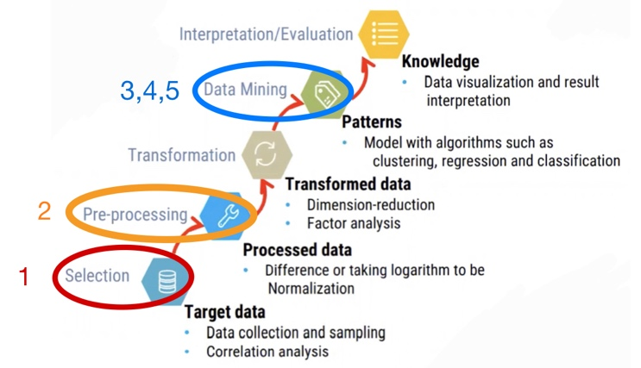
Figure 4: Novelties in Data Science Pipeline

The First Novelty – Data Selection with Different Years
The first novelty that this paper bring in is training the ensemble model of A2C, PPO, and DDPG on different timeline and testing them on the same period. The testing period is from 12/01/2020 to 03/21/2022. The training period has the same end date, 12/01/2020, but has various starting date. There are five major training starting date – 01/01/1962, 01/01/1997, 01/01/1998, 01/01/2006, 01/01/2009. Each start date will generate different performance. Specifically, starting training with the year 2006 works slightly better than the year 1998 and the year 1998 works better than the year 1962.
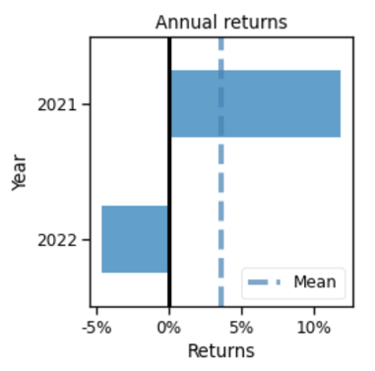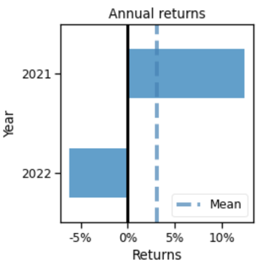
2006 1998
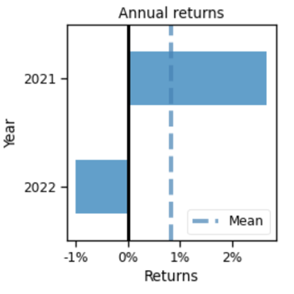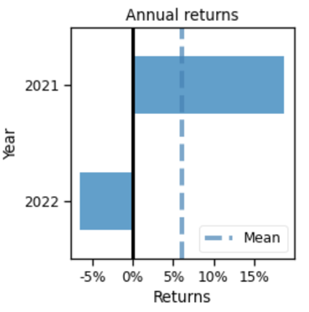
1962 2009
Figure 5: Performance of Different
Start Training Years

From Figure 5, a visual comparison can be made. All four models in Figure 5 are trained under the same condition (6 technical indicators and 3 agents in the ensemble method) except the starting training year. The year 2006 makes more profits than the year 1962 and have a smaller drawdown when compared to the year 1998. Although the year 2009 looks better than the year 2006 in the Figure 5, 2006 is still the training start year picked in the final model because when 2006 trained with 4 technical indicators than 6 indicators, which is the case in figure 5, it will outperform the year 2009.
Although the true reason behind the finding in novelty one is unknow, one of the potential reasons behind this finding might relate to the similarity between 2008 house market crash and current economic environment. Figure 6 indicates that today’s inflation rate is closer to the inflation rate prior to the crash in 2008.
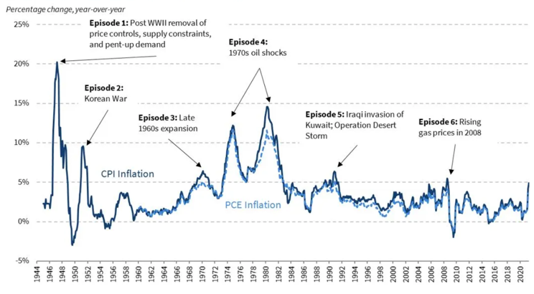
Figure 6: Historical Inflation [17]

The Second Novelty – Preprocessing with More Index
The second novelty is adding more technical indicators of stock market as new features in the pre-processing stage. There are two sets of additional technical indicators we tested. The first set contains four technical indicators - moving average convergence divergence, 30 days relative strength index, 30 days commodity channel index, and directional movement index. The second set add two more indicators based on the first set – Bollinger upper band, and Bollinger lower band, which is a trading tool used to determine entry and exit points for a trade [18]. Interestingly, adding more indicators did not bring performance boost in most cases. It only works in the setting where the training data starts in 2009.
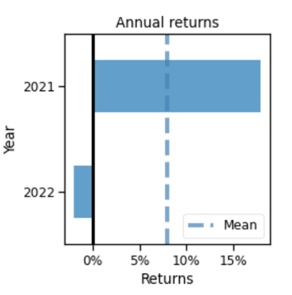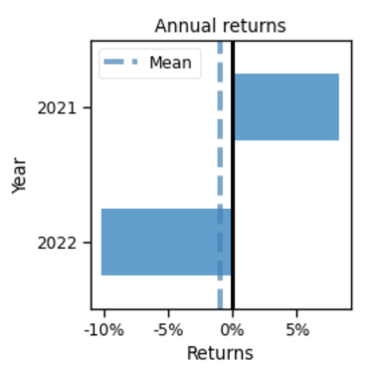
2006 2009
Figure 7: 2006 & 2009
trained with 4 tech indicators

The finding of novelty 2 match with the result in figure 5 because 2009 in figure 5 was trained with 6 technical indicators and it outperforms the other three years. When 2009 was trained only with 4 technical indicators, its performance will drop to -0.14 Sharpe ratio. Correspondently, when the other three years in figure 5 trained with 4 technical indicators instead of 6, their performance will also increase. Figure 7 provides evidence for this finding. When the year 2009 trained with 4 tech indicators, its profits in 2021 will drop and drawdown in 2022 will increase. On the other hand, when the year 2006 trained with 4 tech indicators, the profits increased in 2021 and drawdown decrease to almost 0% in 2022. One potential cause behind this finding could be that training start period from 2009 did not encounter major market crash and it need more technical indicators to help it perform more conservative; nevertheless, on the other hand, where trading start from 2006, does not require extra conservativeness.

The Third Novelty – Modeling with New Agent
The third novelty is change one of the ensembled agents in the ensemble method introduce by [1]. This paper tested the performance of replacing DDPG by TD3 in the ensemble method. TD3, twin delayed DDPG, is a reinforcement learning algorithm improved on DDPG and address the issue of overestimation of Q-values in DDPG. According to OpenAI, “while DDPG can achieve great performance sometimes, it is frequently brittle with respect to hyperparameters and other kinds of tuning. A common failure mode for DDPG is that the learned Q-function begins to dramatically overestimate Q-values, which then leads to the policy breaking, because it exploits the errors in the Q-function. Twin Delayed DDPG (TD3) is an algorithm that addresses this issue by introducing three critical tricks: Clipped Double-Q Learning, Delayed Policy Updates, and Target Policy Smoothing” [8]. After replacing DDPG with TD3, the performance was decreases from 0.97 to 0.56 in terms of Sharpe ratio (figure 8). The reason behind this result is unclear but could mean that TD3 is not a good agent when handling financial market.
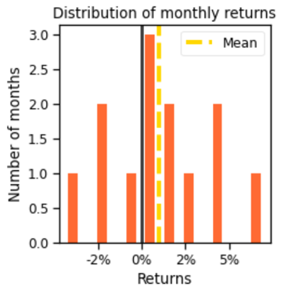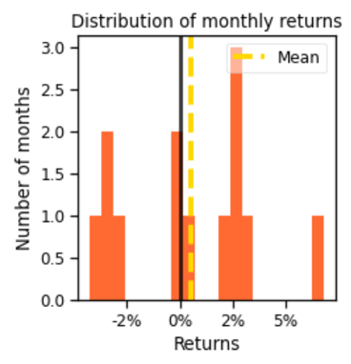
DDPG TD3
Figure 8: Ensemble with DDPG vs. TD3

The Fourth Novelty – Modeling with More Agents
The fourth novelty is ensemble two more agents (TD3, SAC) with the ensemble method introduce by [1]. SAC, soft actor critic, is a reinforcement learning algorithm that can optimizes a stochastic policy in an off-policy way. It can be considered as a successor to TD3 [9]. According to OpenAI, “A central feature of SAC is entropy regularization. The policy is trained to maximize a trade-off between expected return and entropy, a measure of randomness in the policy. This has a close connection to the exploration-exploitation trade-off: increasing entropy results in more exploration, which can accelerate learning later. It can also prevent the policy from prematurely converging to a bad local optimum” [9]. After adding TD3 and SAC to A2C, PPO, and DDPG, the performance did not change much (5 Agents 0.19 vs. 3 Agents 0.2 in the term of Sharpe Ratio). Figure 9 divided the performance of each model into months. It demonstrates that the performance of 5 agents and 3 agents is identical, even when performance was broken down into months.
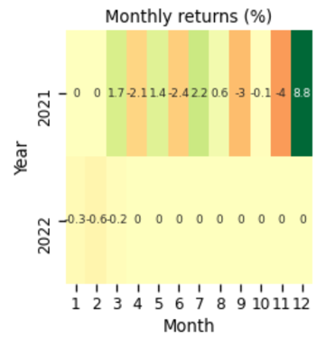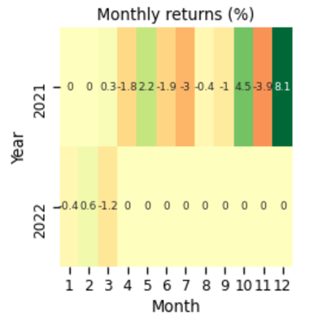
5 Agents 3 Agents
Figure 9: Ensemble with
5 Agents vs. 3 Agents

The Fifth Novelty – Modeling with Different Validation Period
The fifth novelty is using 1/6 of the stock data as validation period instead of using a constant validation period (12/01/2020 to 03/21/2022). After updating validation period to 12/01/2018 to 03/21/2022 with a start training year of 1998, the model will decrease in terms of Sharpe ratio; however, it could be a more accurate representation of the performance of a specific model.
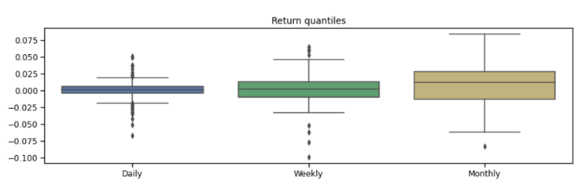
4 years of validation period
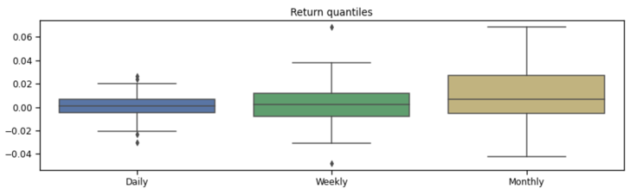
1 year of validation period
Figure 9: Validation Period 4 years vs. 1 year

Two models in figure 9 have the same set of agents and trained on the same period with same features. The only difference is extension of validation period. As a result, the longer validation period will have a slightly worse performance (0.81 vs. 0.97 in terms of Sharpe ratio). However, the better performance in a short validation period could happen by chance and a longer period of validation period can provide a better representation of the real performance of a particular method.

Summary of Novelties
Although this paper tested three different novelties in methodology, the original ensemble strategy from [1] was implemented in the final model because it can reach a moderate Sharpe ratio of 0.94 while maintaining a reasonable training time when the start training date extended to 2006.

Conclusion and Future Work
The final model this paper chosen among all the novelties test is the one with start training year of 2006 and no change in term of ensemble methodology and tech indicators of feature engineering. The final model achieved a balance between running time and performance in term of Sharpe ratio.
Unfortuantely, there is one major weakness of the proposed model, which is unstable result while validiating on self-select stocks. When users use the prosposed method on index stocks, which are the ones made up the major index like Dow Jones and S&P 500, the performace is consistent if ones training the same model on the same period of time. However, if ones training proposed models on self-selected stocks espically high volatile stocks on the same period of time for multiple times, the performance will be different for each training.
Three major improvements can be made in the future based on this proposed method. First, the proposed method is limited to sell and buy/long stocks; however, ones can short stocks like in [4], which may enhance the performance further. Second, lots of quantitative finance institution started to combine the power of natural language processing with deep learning to auto trade stocks; therefore, ones can also try to ensemble sentiment analysis based on platform like Twitter API with reinforcement learning. Third, [4] introduced a novel LSTM strategy and ones can potentially ensemble LSTM with powerful reinforcement learning method like PPO to achieve significant result.
In conclusion, as quantitative finance getting more popular in the industry, lots of novel methodologies have been introduced. Although performance of proposed deep reinforcement learning is moderate comparing to other popular methodologies, reinforcement learning is still one of the most prevalent branches in the domain of machine learning and AI. It will continue to provide novel and higher performance models to the field of quantitative finance and artificial intelligence.

References
- Yang, Hongyang and Liu, Xiao-Yang and Zhong, Shan and Walid, Anwar, Deep Reinforcement Learning for Automated Stock Trading: An Ensemble Strategy (September 11, 2020). Available at SSRN: http://dx.doi.org/10.2139/ssrn.3690996
- Liu, Xiao-Yang and Yang, Hongyang and Chen, Qian and Zhang, Runjia and Yang, Liuqing and Xiao, Bowen and Wang, Christina, FinRL: A Deep Reinforcement Learning Library for Automated Stock Trading in Quantitative Finance (November 26, 2020). Available at SSRN: http://dx.doi.org/10.2139/ssrn.3737859
- Thibaut Théate, Damien Ernst, An application of deep reinforcement learning to algorithmic trading, Expert Systems with Applications, Volume 173, 2021, 114632, ISSN 0957-4174, https://doi.org/10.1016/j.eswa.2021.114632
- Ghosh, Pushpendu & Neufeld, Ariel & Sahoo, Jajati. (2020). Forecasting directional movements of stock prices for intraday trading using LSTM and random forests.
- Mnih, V., Kavukcuoglu, K., Silver, D., Graves, A., Antonoglou, I., Wierstra, D., and Riedmiller, M. A. (2013). Playing Atari with Deep Reinforcement Learning. CoRR, abs/1312.5602.
- Krauss, C., Do, X. A., & Huck, N. (2017). Deep neural networks, gradient-boosted trees, random forests: Statistical arbitrage on the S&P 500. European Journal of Operational Research, 259, 689–702.
- Fischer, T., & Krauss, C. (2018). Deep learning with long short-term memory networks for financial market predictions. European Journal of Operational Research, 270, 654–669.
- OpenAI. “Twin Delayed DDPG.” Twin Delayed DDPG - Spinning Up Documentation, OpenAI, Jan. 2020, https://spinningup.openai.com/en/latest/algorithms/td3.html.
- OpenAI. “Soft Actor-Critic.” Soft Actor-Critic - Spinning Up Documentation, OpenAI, 2018, https://spinningup.openai.com/en/latest/algorithms/sac.html.
- Chong, Terence Tai-Leung, and Wing-Kam Ng. “Technical Analysis and the London Stock Exchange: Testing the MACD and RSI Rules Using the FT30.” Applied Economics Letters, vol. 15, no. 14, 2008, pp. 1111–1114., https://doi.org/10.1080/13504850600993598.
- Fernando, Jason. “Moving Average Convergence Divergence (MACD).” Investopedia, Investopedia, 18 Mar. 2022, https://www.investopedia.com/terms/m/macd.asp.
- Fernando, Jason. “Relative Strength Index (RSI).” Investopedia, Investopedia, 18 Mar. 2022, https://www.investopedia.com/terms/r/rsi.asp.
- Mitchell, Cory. “Commodity Channel Index (CCI) Definition and Uses.” Investopedia, Investopedia, 21 Feb. 2022, https://www.investopedia.com/terms/c/commoditychannelindex.asp.
- Mitchell, Cory. “Directional Movement Index (DMI) Definition and Uses.” Investopedia, Investopedia, 30 Sept. 2021, https://www.investopedia.com/terms/d/dmi.asp.
- Kadari , Prathima. “Introduction to Reinforcement Learning for Beginners.” Analytics Vidhya, 23 Feb. 2021, https://www.analyticsvidhya.com/blog/2021/02/introduction-to-reinforcement-learning-for-beginners/.
- Beauchamp , Chris. “The Sharpe Ratio Explained.” IG, https://www.ig.com/au/trading-strategies/the-sharpe-ratio-explained-190117.
- “Historical Parallels to Today's Inflationary Episode.” The White House, The United States Government, 30 Nov. 2021, https://www.whitehouse.gov/cea/written-materials/2021/07/06/historical-parallels-to-todays-inflationary-episode/.
- Mitchell, Cory. “Using Bollinger Bands to Gauge Trends.” Investopedia, Investopedia, 6 Mar. 2022, https://www.investopedia.com/trading/using-bollinger-bands-to-gauge-trends/.

