Dogecoin Price Prediction using Random Forest Regression
Research Summary Report

Abstract
This report presents a supervised machine learning framework for predicting DOGE-USD close prices using engineered technical indicators and market variables. A Random Forest Regressor was trained on historical data and evaluated using holdout validation metrics.

1. Problem Definition
The objective is to estimate the next close price of Dogecoin using recent market context. The model takes open, high, low, volume, and derived indicators as input features.

2. Dataset Used
Source file: DOGE-USD.csv | Raw rows: 1761 | Processed rows: 1751
Date range: 2017-11-18 to 2022-09-04 | Train/Test split: 1400/351
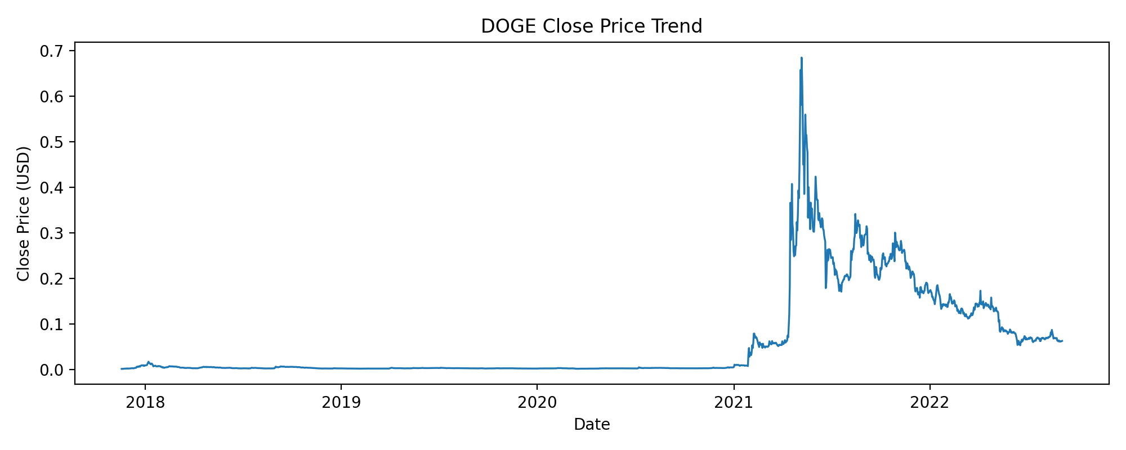

3. Model Trained
Algorithm: RandomForestRegressor
Hyperparameters: n_estimators=100, max_depth=15, min_samples_split=5, min_samples_leaf=2, random_state=42
Input Features: Open, High, Low, Volume, MA5, MA10, Daily_Return, Volatility

4. Accuracy and Evaluation
Metric | Value
MSE | 0.00001884
RMSE | 0.00434057
MAE | 0.00142236
R2 | 0.997776

5. Output Visibility
Sample | Actual Close | Predicted Close
1 | 0.005545 | 0.005598
2 | 0.002346 | 0.002346
3 | 0.002434 | 0.002412
4 | 0.002083 | 0.002076
5 | 0.200887 | 0.203924
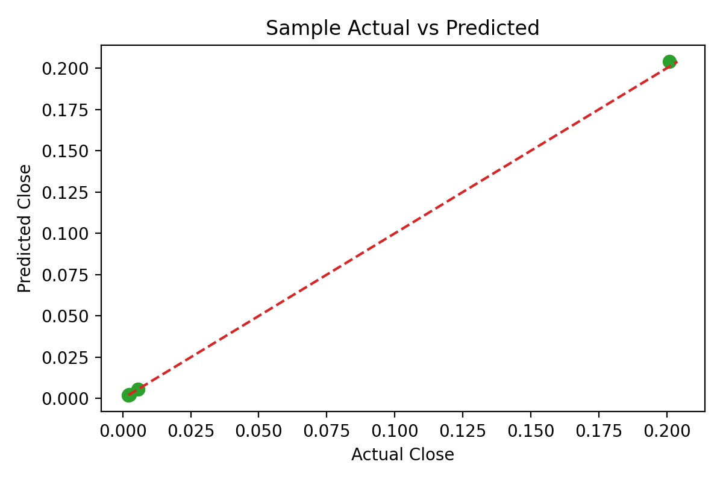
Figure: Sample Actual vs Predicted values

