

UNIVERSITY OF GHANA
ACCRA GHANA
SCHOOL OF ENGINEERING SCIENCES
DEPARTMENT OF COMPUTER ENGINEERING
CPEN 412 - MOBILE AND WEB SOFTWARE ARCHITECTURE
Lab Report: National Emergency Response and Dispatch Coordination Platform Architecture, Database Design and API Definitions.
Contributors
Daniel Agyin Manford - 11015506
Kudiabor Jonathan Kwabena Ewenam - 11254301

Table of Contents
1. System Architecture Overview
2. Service Responsibilities
3. Inter-Service Communication
4. Database Design
4.1 Auth Service - auth_db
4.2 Emergency Incident Service - incident_db
4.3 Dispatch & Tracking Service - tracking_db
4.4 Analytics Service - analytics_db
5. Message Queue Design
5.1 Exchange Definitions & Queue Bindings
5.2 Event Message Structures
5.3 End-to-End Communication Flow
6. API Definitions
6.1 Auth Service (Port 3001)
6.2 Emergency Incident Service (Port 3002)
6.3 Dispatch & Tracking Service (Port 3003)
6.4 Analytics Service (Port 3004)
6.5 API Gateway Routes (nginx)
7. Technology Decisions Rationale
8. Docker Compose Service Map

1. System Architecture Overview
The Emergency Response System is built as a microservice architecture composed of four core services, each owning its own MongoDB database. All client traffic is routed through an nginx API Gateway, which handles TLS termination and path-based proxying. Real-time vehicle tracking is delivered via Socket.io WebSockets, and asynchronous event propagation between services is handled by RabbitMQ topic exchanges.
The architecture diagram below illustrates the full system topology, including the frontend, API gateway, microservices, databases, and message broker.
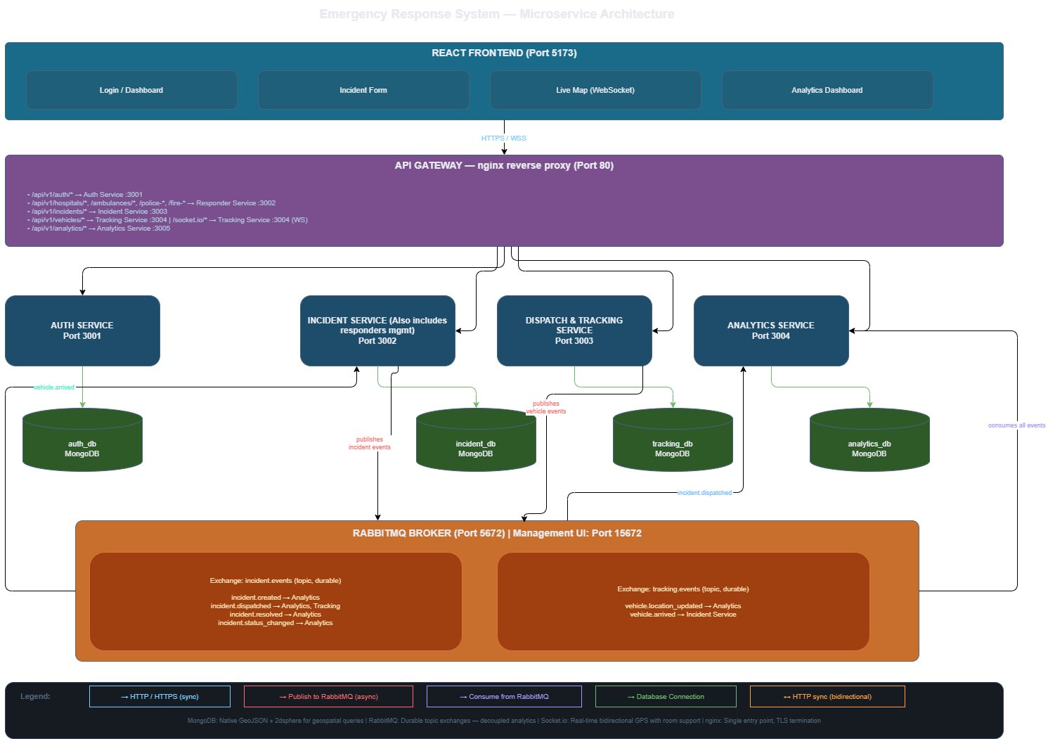
Figure 1: Emergency Response System — Microservice Architecture

2. Service Responsibilities
The following table summarises the ownership and responsibilities of each microservice.
# | Service | Port | Owns | Key Responsibilities
1 | Auth Service | 3001 | Users, refresh tokens | Registration, login, JWT issuance, role enforcement
2 | Emergency Incident Service | 3002 | Incidents, hospitals, ambulances, police stations, fire stations, officers, personnel | Incident creation, nearest-responder geospatial selection, responder CRUD, incident status lifecycle, event publishing
3 | Dispatch & Tracking Service | 3003 | Dispatch records, vehicle location history, live positions | Accept GPS pings, maintain live positions, broadcast via WebSocket, detect arrival, publish vehicle events
4 | Analytics & Monitoring Service | 3004 | Incident snapshots, response time summaries, capacity logs | Consume events, aggregate response times, resource utilisation, incident stats by region and type

Note: Responder Management was merged into the Emergency Incident Service. Incident creation and nearest-responder selection are tightly coupled - the service queries its own local models instead of making an HTTP call to a separate service. This reduces latency and eliminates an unnecessary network dependency, and aligns with the four-service requirement.

3. Inter-Service Communication
Services communicate via two mechanisms: synchronous HTTP calls using axios for operations that require an immediate response, and asynchronous RabbitMQ topic exchange events for fire-and-forget notifications.
Synchronous HTTP calls:
- Auth validation: All services validate the JWT access token using a shared secret environment variable.
- Nearest responder: The Emergency Incident Service performs a $near geospatial query internally on its own ambulance/station collections - no external HTTP call is required.
Asynchronous RabbitMQ events:
- Incident Service publishes: incident.created, incident.dispatched, incident.resolved, incident.status_changed
- Tracking Service publishes: vehicle.location_updated, vehicle.arrived
- Analytics Service subscribes to all events for aggregation.
- Tracking Service subscribes to incident.dispatched to create dispatch records.
- Incident Service subscribes to vehicle.arrived to auto-update status to in_progress.

4. Database Design
Each microservice owns its own MongoDB database. No service reads directly from another service's database. MongoDB is used across all services for its native GeoJSON and 2dsphere index support, which is critical for geospatial nearest-responder queries.
Important: GeoJSON stores coordinates as [longitude, latitude] - the reverse of the common convention. All coordinates must be stored and queried in this order.

4.1 Auth Service - auth_db
Collection: users
Field | Type | Description
_id | ObjectId | Primary key
name | String | Full name
email | String | Unique, indexed
passwordHash | String | bcrypt hash
role | String (enum) | system_admin | hospital_admin | police_admin | fire_admin | ambulance_driver
stationId | ObjectId (optional) | Links admin/driver to their hospital, station, or ambulance in Responder Service
isActive | Boolean | Default: true
createdAt / updatedAt | Date | Timestamps

Indexes: email (unique)
Collection: refresh_tokens
Field | Type | Description
_id | ObjectId | Primary key
userId | ObjectId | Ref to users._id
token | String | Hashed refresh token — unique index
expiresAt | Date | TTL index — auto-deletes expired tokens
createdAt | Date | Timestamp

4.2 Emergency Incident Service - incident_db
This service consolidates both incident management and responder management into a single database. Collections for hospitals, ambulances, police stations, fire stations, officers, and personnel all reside here alongside the incidents collection.
Collections: hospitals, ambulances, police_stations, fire_stations, police_officers, fire_personnel
Field | Type | Description
_id | ObjectId | Primary key
name | String | Name of the unit or station
address / region | String | Physical address and region
location | GeoJSON Point | Coordinates [longitude, latitude] — 2dsphere indexed
status | String (enum) | active | inactive | full (hospitals) | available | dispatched | out_of_service (ambulances)
totalBeds / availableBeds | Number | Hospital capacity (hospitals only)
vehicleNumber / badgeNumber | String | Unit identifier (ambulances, officers, personnel)
hospitalId / stationId | ObjectId | Parent reference linking ambulance → hospital, officer → station
driverId / userId | ObjectId | Auth user reference for drivers and officers
isOnDuty | Boolean | Duty status (officers and personnel only)
currentLocation | GeoJSON Point | Live location for ambulances — 2dsphere indexed
createdAt / updatedAt | Date | Timestamps

Collection: incidents
Field | Type | Description
_id | ObjectId | Primary key
citizenName / citizenPhone | String | Reporter details
incidentType | String (enum) | medical | fire | crime | accident | other
location | GeoJSON Point | Incident coordinates — 2dsphere indexed
address | String | Human-readable address from reverse geocode
notes | String | Free-text description
createdBy | ObjectId | Auth user ID of reporting system admin
assignedUnit | Object | { unitId, unitType, unitName, hospitalId } — denormalised for display
status | String (enum) | created | dispatched | in_progress | resolved | cancelled
statusHistory | Array | Array of { status, changedAt, changedBy } — full audit trail
dispatchedAt / resolvedAt | Date | Key timestamps
responseTimeMinutes | Number | Computed on resolve
createdAt / updatedAt | Date | Timestamps

Indexes: location (2dsphere), status, incidentType, createdAt (descending)

4.3 Dispatch & Tracking Service - tracking_db
Collection: dispatch_records
Field | Type | Description
_id | ObjectId | Primary key
incidentId | ObjectId | Reference to Incident Service incident ID
vehicleId | ObjectId | Ambulance, police vehicle, or fire truck ID
vehicleType | String (enum) | ambulance | police_vehicle | fire_truck
driverId | ObjectId | Auth user ID of responding driver or officer
dispatchedAt / arrivedAt / completedAt | Date | Key lifecycle timestamps
status | String (enum) | en_route | arrived | completed | cancelled

Collection: vehicle_locations
Field | Type | Description
_id | ObjectId | Primary key
vehicleId / vehicleType | ObjectId / String | Vehicle reference
incidentId | ObjectId | Active incident being responded to
location | GeoJSON Point | 2dsphere indexed
speed | Number | Optional, km/h
heading | Number | Optional, degrees
recordedAt | Date | GPS ping timestamp — compound index with vehicleId; optional TTL (7 days)

Collection: live_positions
One document per vehicle, upserted on each GPS ping for fast current-location lookups.
Field | Type | Description
vehicleId | ObjectId | Unique index
vehicleType / incidentId | String / ObjectId | Active context
location | GeoJSON Point | 2dsphere indexed
lastUpdated | Date | Timestamp of most recent ping

4.4 Analytics Service - analytics_db
Field | Type | Description
incident_snapshots | Collection | Denormalised per-incident records populated from RabbitMQ events. Fields: incidentId, incidentType, region, latitude, longitude, status, assignedUnitType, responseTimeMinutes, key dates.
hospital_capacity_logs | Collection | Time-series snapshots of hospital bed occupancy: hospitalId, name, totalBeds, availableBeds, occupancyPercent, recordedAt.
response_time_summaries | Collection | Pre-aggregated for fast dashboard queries. Fields: period (e.g. 2025-03), periodType (day|month), incidentType, region, avgResponseTimeMinutes, totalIncidents, resolvedIncidents, computedAt.

5. Message Queue Design
RabbitMQ is used for asynchronous, event-driven communication between services where the publisher does not need an immediate response and multiple services may need to react to the same event. Direct HTTP (axios) is used only when an immediate response is required (for example, JWT validation).
Broker configuration: Host: rabbitmq (Docker service name), AMQP Port: 5672, Management UI: Port 15672.

5.1 Exchange Definitions & Queue Bindings
Two durable topic exchanges are declared:
- incident.events — all lifecycle events of emergency incidents (type: topic, durable: true)
- tracking.events — vehicle location and dispatch status events (type: topic, durable: true)

Queues bound to incident.events
Queue Name | Binding Key | Consumer Service | Description
analytics.incident.created | incident.created | Analytics Service | Record new incident snapshot
analytics.incident.dispatched | incident.dispatched | Analytics Service | Log dispatch time
analytics.incident.resolved | incident.resolved | Analytics Service | Compute response time
analytics.incident.status | incident.status_changed | Analytics Service | General status tracking
tracking.incident.dispatched | incident.dispatched | Tracking Service | Create dispatch record

Queues bound to tracking.events
Queue Name | Binding Key | Consumer Service | Description
analytics.vehicle.location | vehicle.location_updated | Analytics Service | Aggregate location data
incident.vehicle.arrived | vehicle.arrived | Incident Service | Auto-update incident to in_progress

5.2 Event Message Structures
All messages are JSON with ISO 8601 UTC timestamps. Key event payloads are described below.
Event Type | Published By | Consumed By | Key Payload Fields
incident.created | Incident Service | Analytics Service | incidentId, incidentType, latitude, longitude, address, region, createdBy, createdAt
incident.dispatched | Incident Service | Analytics Service, Tracking Service | incidentId, incidentType, latitude, longitude, assignedUnit { unitId, unitType, unitName, hospitalId, driverId }, dispatchedAt
incident.status_changed | Incident Service | Analytics Service | incidentId, previousStatus, newStatus, changedBy, changedAt
incident.resolved | Incident Service | Analytics Service | incidentId, incidentType, region, createdAt, dispatchedAt, resolvedAt, responseTimeMinutes, assignedUnitType
vehicle.location_updated | Tracking Service | Analytics Service | vehicleId, vehicleType, incidentId, latitude, longitude, speed, recordedAt
vehicle.arrived | Tracking Service | Incident Service | vehicleId, vehicleType, incidentId, arrivedAt

5.3 End-to-End Communication Flow
The diagram below shows the complete flow from incident submission through dispatch, GPS tracking, vehicle arrival, and final resolution.
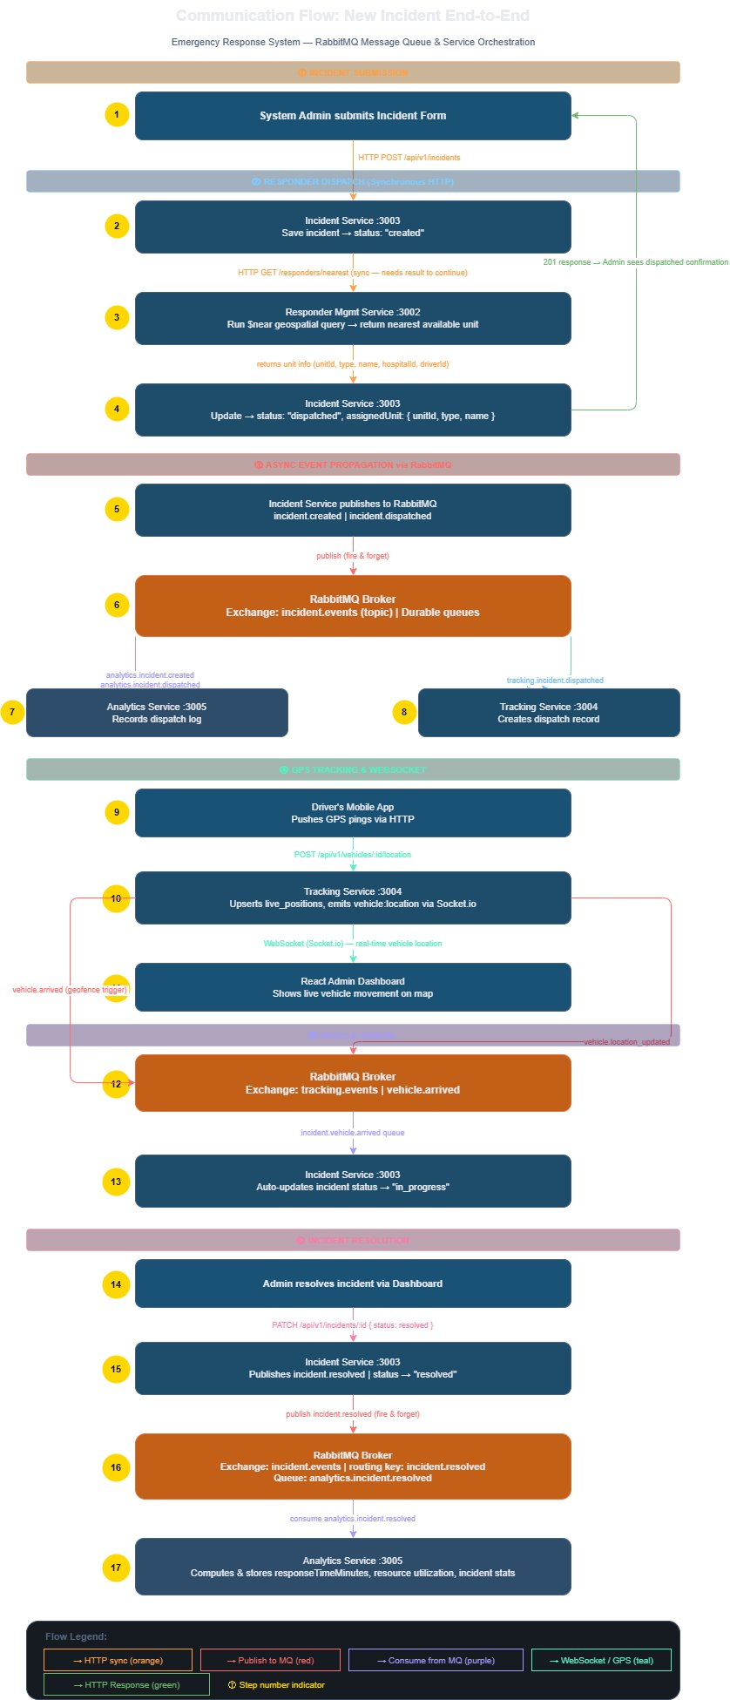
Figure 2: New Incident Communication Flow - End-to-End

The flow proceeds in six phases:
- Incident Submission - Admin submits the incident form via the React frontend.
- Synchronous Dispatch - Incident Service saves the incident, queries the nearest available responder via a $near geospatial query, updates status to dispatched, and returns a 201 response to the admin.
- Async Event Propagation - Incident Service publishes incident.created and incident.dispatched to RabbitMQ. Analytics Service records the dispatch log; Tracking Service creates the dispatch record.
- GPS Tracking & WebSocket - The driver's app pushes GPS pings to Tracking Service, which upserts live_positions and emits vehicle:location events via Socket.io to the admin dashboard.
- Vehicle Arrival - Tracking Service publishes vehicle.arrived; Incident Service consumes this and auto-updates the incident status to in_progress.
- Resolution - Admin resolves the incident; Incident Service publishes incident.resolved; Analytics Service computes and stores responseTimeMinutes and resource utilisation.

6. API Definitions
All APIs are versioned under /api/v1/. All routes except /auth/login and /auth/register require a valid JWT in the Authorization: Bearer <token> header.
Standard response envelopes:
- Success: { "success": true, "data": { ... } }
- Error: { "success": false, "error": { "code": "ERROR_CODE", "message": "Human readable message" } }

6.1 Auth Service (Port 3001)
Method | Endpoint | Auth | Role | Description
POST | /api/v1/auth/register | No | - | Register a new user
POST | /api/v1/auth/login | No | - | Login, returns JWT + refresh token
POST | /api/v1/auth/refresh-token | No | - | Exchange refresh token for new access token
POST | /api/v1/auth/logout | Yes | Any | Revoke refresh token
GET | /api/v1/auth/profile | Yes | Any | Get own profile
PUT | /api/v1/auth/profile | Yes | Any | Update own profile
GET | /api/v1/auth/users | Yes | system_admin | List all users
GET | /api/v1/auth/users/:id | Yes | system_admin | Get user by ID
PUT | /api/v1/auth/users/:id/status | Yes | system_admin | Activate/deactivate user
DELETE | /api/v1/auth/users/:id | Yes | system_admin | Delete user

Key Request/Response Notes
POST /api/v1/auth/register - Request body: name, email, password, role, stationId (optional). Returns 201 with user object.
POST /api/v1/auth/login - Returns accessToken (expires 15 min), refreshToken (expires 7 days), and user object.
POST /api/v1/auth/refresh-token - Request body: { refreshToken }. Returns new accessToken.

6.2 Emergency Incident Service (Port 3002)
Hospitals
Method | Endpoint | Auth | Role | Description
POST | /api/v1/hospitals | Yes | system_admin | Register a new hospital
GET | /api/v1/hospitals | Yes | Any | List all hospitals
GET | /api/v1/hospitals/:id | Yes | Any | Get hospital details
PUT | /api/v1/hospitals/:id | Yes | hospital_admin, system_admin | Update hospital info
PUT | /api/v1/hospitals/:id/capacity | Yes | hospital_admin | Update bed availability
DELETE | /api/v1/hospitals/:id | Yes | system_admin | Remove hospital

Ambulances
Method | Endpoint | Auth | Role | Description
POST | /api/v1/ambulances | Yes | hospital_admin, system_admin | Register ambulance
GET | /api/v1/ambulances | Yes | Any | List all ambulances
GET | /api/v1/ambulances/:id | Yes | Any | Get ambulance details
PUT | /api/v1/ambulances/:id/status | Yes | hospital_admin, ambulance_driver | Update availability status
GET | /api/v1/ambulances/available | Yes | Any | List available ambulances with location

Police Stations
Method | Endpoint | Auth | Role | Description
POST | /api/v1/police-stations | Yes | system_admin | Register police station
GET | /api/v1/police-stations | Yes | Any | List all stations
GET | /api/v1/police-stations/:id | Yes | Any | Get station details
PUT | /api/v1/police-stations/:id | Yes | police_admin, system_admin | Update station info
PUT | /api/v1/police-stations/:id/status | Yes | police_admin | Update availability
POST | /api/v1/police-stations/:id/officers | Yes | police_admin | Add officer to station
GET | /api/v1/police-stations/:id/officers | Yes | police_admin, system_admin | List officers

Fire Stations
Method | Endpoint | Auth | Role | Description
POST | /api/v1/fire-stations | Yes | system_admin | Register fire station
GET | /api/v1/fire-stations | Yes | Any | List all stations
GET | /api/v1/fire-stations/:id | Yes | Any | Get station details
PUT | /api/v1/fire-stations/:id | Yes | fire_admin, system_admin | Update station info
PUT | /api/v1/fire-stations/:id/status | Yes | fire_admin | Update availability
POST | /api/v1/fire-stations/:id/personnel | Yes | fire_admin | Add personnel
GET | /api/v1/fire-stations/:id/personnel | Yes | fire_admin, system_admin | List personnel

Incidents
Method | Endpoint | Auth | Role | Description
POST | /api/v1/incidents | Yes | system_admin | Create new incident + auto-dispatch
GET | /api/v1/incidents | Yes | system_admin | List all incidents (paginated)
GET | /api/v1/incidents/open | Yes | system_admin | List open/active incidents
GET | /api/v1/incidents/:id | Yes | system_admin | Get incident details
PUT | /api/v1/incidents/:id/status | Yes | system_admin | Manually update status
PUT | /api/v1/incidents/:id/assign | Yes | system_admin | Reassign to different unit
GET | /api/v1/incidents/stats | Yes | system_admin | Summary counts by status

Nearest Responder
Method | Endpoint | Auth | Role | Description
GET | /api/v1/responders/nearest | Yes | Any | Find nearest available responder — query params: lat, lng, type (medical|fire|crime), maxDistance (metres, default 50000)
Response includes: unitId, unitType, unitName, hospitalId, hospitalName, distanceMeters, estimatedMinutes.

6.3 Dispatch & Tracking Service (Port 3003)
HTTP Endpoints
Method | Endpoint | Auth | Role | Description
POST | /api/v1/vehicles/register | Yes | system_admin | Register a vehicle for tracking
GET | /api/v1/vehicles | Yes | Any | List all tracked vehicles
GET | /api/v1/vehicles/:id/location | Yes | Any | Get current location of a vehicle
POST | /api/v1/vehicles/:id/location | Yes | ambulance_driver | Push a GPS location update
GET | /api/v1/dispatches | Yes | system_admin | List all dispatch records
GET | /api/v1/dispatches/:incidentId | Yes | system_admin | Get dispatch for an incident
PUT | /api/v1/dispatches/:id/status | Yes | ambulance_driver, system_admin | Update dispatch status

POST /api/v1/vehicles/:id/location request body: latitude, longitude, speed (optional), heading (optional), incidentId.
WebSocket Events (Socket.io)
Clients connect to: ws://localhost:3003
Client → Server
Event | Payload | Description
subscribe:incident | { incidentId } | Subscribe to live updates for a specific incident
subscribe:all | {} | Subscribe to all vehicle movements (admin map view)
unsubscribe:incident | { incidentId } | Unsubscribe from a specific incident

Server → Client
Event | Payload | Description
vehicle:location | { vehicleId, incidentId, lat, lng, timestamp } | Real-time position update
dispatch:status_changed | { incidentId, status, timestamp } | Dispatch status update
vehicle:arrived | { vehicleId, incidentId, arrivedAt } | Vehicle arrived at scene

6.4 Analytics Service (Port 3004)
Method | Endpoint | Auth | Role | Description
GET | /api/v1/analytics/response-times | Yes | Any | Average response times by type/period — params: from, to, incidentType, periodType (day|month)
GET | /api/v1/analytics/incidents-by-region | Yes | Any | Incident counts by region and type
GET | /api/v1/analytics/resource-utilization | Yes | Any | Hospital capacity, vehicle deployment stats
GET | /api/v1/analytics/incidents-by-type | Yes | Any | Breakdown by incident type
GET | /api/v1/analytics/top-responders | Yes | Any | Most frequently deployed responders
GET | /api/v1/analytics/overview | Yes | Any | Dashboard summary stats

Overview response includes: totalIncidents, openIncidents, resolvedToday, avgResponseTimeMinutes, incidentsByType (medical, fire, crime, accident).

6.5 API Gateway Routes (nginx)
Path Pattern | Upstream Service
/api/v1/auth/ | auth-service:3001
/api/v1/hospitals/ | incident-service:3002
/api/v1/ambulances/ | incident-service:3002
/api/v1/police-stations/ | incident-service:3002
/api/v1/fire-stations/ | incident-service:3002
/api/v1/responders/ | incident-service:3002
/api/v1/incidents/ | incident-service:3002
/api/v1/vehicles/ | tracking-service:3003
/api/v1/dispatches/ | tracking-service:3003
/socket.io/ | tracking-service:3003 (WebSocket upgrade)
/api/v1/analytics/ | analytics-service:3004

7. Technology Decisions Rationale
Decision | Rationale
MongoDB for all services | Native GeoJSON and 2dsphere index support enables geospatial nearest-responder queries without any extension. The flexible schema suits incidents (notes, varying fields per type) and analytics (varying metrics). All services share the same database engine while maintaining database-level isolation per microservice.
Merging Responder Management into Emergency Incident Service | Nearest-responder selection is a core part of incident creation - the two are logically coupled. Merging eliminates a synchronous HTTP call on the critical path, reduces infrastructure complexity (one fewer service and database), and aligns with the four-service requirement.
RabbitMQ over direct HTTP for events | Without a message queue, Analytics Service would need to be called directly from multiple services, creating tight coupling. RabbitMQ decouples publishers from consumers: if Analytics is down, incidents still succeed. Events are naturally fire-and-forget, and RabbitMQ persistence ensures events are not lost if a consumer restarts.
Socket.io for real-time tracking | Provides real-time bidirectional communication: drivers push GPS location and the admin dashboard receives it instantly. Room support allows admins to subscribe to specific incidents only. Automatic fallback to long-polling if WebSocket is unavailable, with native Node.js support.
nginx as API Gateway | Single entry point for the frontend eliminates CORS issues. Handles TLS termination in production. Lightweight, widely deployed, and straightforward to configure without building a custom Express gateway.

8. Docker Compose Service Map
The following services are defined in docker-compose.yml:
Service | Port | Description
rabbitmq | 5672, 15672 | Message broker — AMQP and management UI
auth-db | - | MongoDB instance for auth_db
auth-service | 3001 | Identity and authentication microservice
incident-db | - | MongoDB instance for incident_db
incident-service | 3002 | Emergency Incident Service (includes responder management)
tracking-db | - | MongoDB instance for tracking_db
tracking-service | 3003 | Dispatch & Tracking Service
analytics-db | - | MongoDB instance for analytics_db
analytics-service | 3004 | Analytics & Monitoring Service
frontend | 5173 | React / Vite dev server (optional in docker-compose)
nginx | 80 | API Gateway — reverse proxy

