**DevOps**

DevOps is a set of practices that automates the process between software development and IT Teams, in order that they build, test, and release faster and more reliable.

Ex:

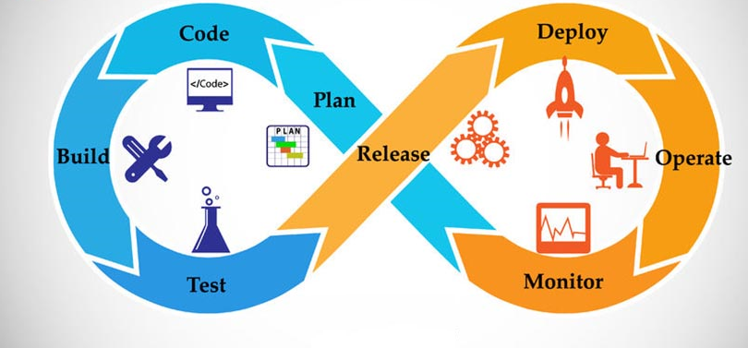

**How DevOps Works**

Under a DevOps model, development and operations teams are no longer isolated. Sometimes, these two teams are merged into single team where the engineers work across the entire application lifecycle, from development and test to deployment to operations.

