Wastewater Treatment Plant Influent Flow and Load Assessment
  - 08 December 2025

Table of Contents
1 Introduction 4
2 Objectives 4
3 Description of Dataset 4
4 Analysis 4
4.1 Historical influent flows 4
4.2 Historical average daily loads 5
4.3 Maximum month (30-day moving average) loads 6
4.4 Per capita flows 7
4.5 Per capita loads 7
4.6 Historical-average per capita parameters 9
4.7 Population growth and projection 9
4.8 Projected flows using historical per capita rates 10
4.9 Projected average annual loads using per capita rates 11
4.10 Projected maximum month loads using per capita rates 11
4.11 Design parameters at 20-year horizon (2037) 12
5 Key Findings 12
6 Recommendations 13

Figures
Figure 1 – Annual average and maximum day influent flow (historical and overall average). 5
Figure 2 – Average annual daily influent loads for BOD, TSS and total phosphorus. 6
Figure 3 – Maximum month (30-day moving average) influent loads for BOD, TSS and total phosphorus. 6
Figure 4 – Annual average and maximum day influent flow per capita. 7
Figure 5 – Average annual daily influent loads per capita for BOD, TSS and total phosphorus. 8
Figure 6 – Maximum month (30-day moving average) influent loads per capita. 8
Figure 7 – Historical and projected serviced population over a 20-year horizon. 10
Figure 8 – Historical and projected average and maximum day influent flows. 10
Figure 9 – Historical and projected average annual BOD, TSS and total phosphorus loads. 11
Figure 10 – Historical and projected maximum month (30-day average) BOD, TSS and total phosphorus loads. 12

Tables
Table 1 – Historical-average per capita flow and load parameters. 9
Table 2 – Design flows and loads at the 2037 planning horizon based on projected population and historical-average per capita rates. 12

1 Introduction
This report presents an assessment of influent flow and load conditions for a municipal wastewater treatment plant (WWTP) based on four years of historical monitoring data and associated serviced population figures. The analysis derives representative average and peak design parameters and projects future flows and loads over a 20-year planning horizon using per capita rates and population growth forecasts.
The outcomes are intended to support process engineering evaluations, capacity checks and conceptual upgrades of inlet works, biological treatment, clarification and sludge handling systems.

2 Objectives
The analysis has been structured to quantify historical influent behaviour, express it on a per capita basis and apply it to a population projection for planning purposes.
The specific objectives are to:
- Summarise historical influent flows and loads, including average annual and peak conditions.
- Derive per capita flow and load rates for biochemical oxygen demand (BOD), total suspended solids (TSS) and total phosphorus (TP).
- Characterise maximum month (30-day moving average) loads to reflect sustained peak operating conditions.
- Develop a 20-year serviced population projection and apply historical-average per capita rates to obtain projected flows and loads.
- Define design flow and load parameters at the end of the 20-year horizon and discuss implications for WWTP process capacity.

3 Description of Dataset
The assessment uses the workbook WWTP_medium.xlsx, which comprises a daily influent monitoring dataset and an annual serviced population series for the WWTP catchment.
The “WWTP Influent Data” sheet provides a continuous daily time series from 1 January 2014 to 31 December 2017 (1,461 records). Variables include influent flow rate (m³/d) and composite influent concentrations for BOD, TSS, total Kjeldahl nitrogen and phosphorus-related species. The “population” sheet reports the serviced population for each calendar year from 2014 to 2017.

4 Analysis

4.1 Historical influent flows
Average annual daily influent flows are very stable over 2014–2017, ranging from 28,658 to 29,061 m³/d, with a historical mean of 28,815 m³/d. Maximum day flows are roughly 15–25% above the corresponding annual averages, with yearly maxima between 33,771 and 36,986 m³/d and an average of the annual maxima of 35,048 m³/d. This stability indicates a mature, largely domestic catchment with limited industrial or storm-driven variability.
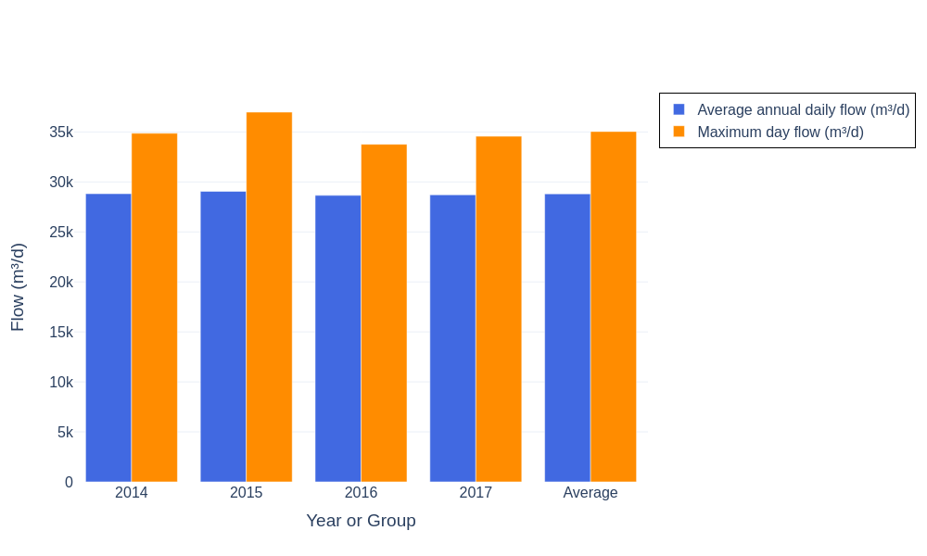
Figure 1 – Annual average and maximum day influent flow (historical and overall average).
The ratio of maximum day to average day flow, derived as approximately 1.22 (35,048 / 28,815), is consistent across the four-year record. This peaking factor is an important parameter for checking hydraulic capacity of inlet works, screens, grit removal and downstream process units.

4.2 Historical average daily loads
Average annual daily loads for BOD, TSS and total phosphorus were calculated from measured concentrations and flows. Across 2014–2017, BOD loads range from approximately 5,413 to 5,945 kg/d (historical mean 5,634 kg/d), TSS loads from 6,153 to 6,446 kg/d (mean 6,318 kg/d), and total phosphorus from 181 to 197 kg/d (mean 186 kg/d). Inter-annual variation is modest, generally less than 10%.
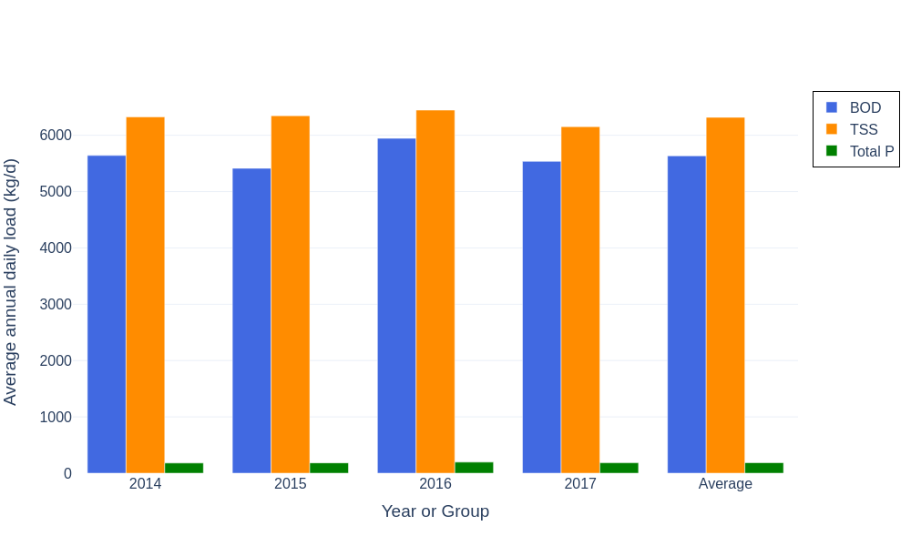
Figure 2 – Average annual daily influent loads for BOD, TSS and total phosphorus.
The relatively narrow spread of average loads suggests stable upstream contributions with no evidence of major step changes in industrial discharge. Slightly elevated BOD, TSS and phosphorus loads in 2016 are observable but do not indicate a structural change in catchment characteristics.

4.3 Maximum month (30-day moving average) loads
To capture sustained peak conditions relevant to biological process and sludge handling design, 30-day moving average loads were calculated for each year and the maximum value identified.
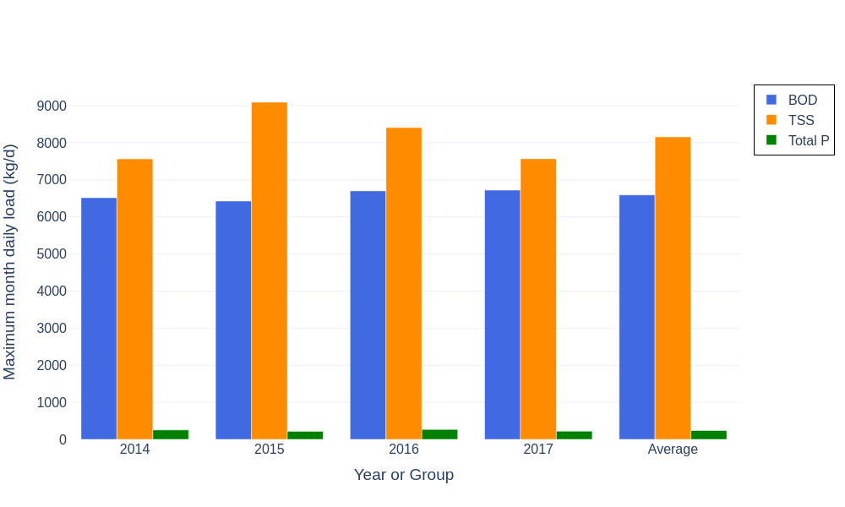
Figure 3 – Maximum month (30-day moving average) influent loads for BOD, TSS and total phosphorus.
Maximum month BOD loads lie between 6,430 and 6,723 kg/d, with a historical mean of 6,593 kg/d, approximately 15–20% above the corresponding average-day loads. TSS maximum month loads are more strongly peaked, ranging from 7,565 to 9,093 kg/d (mean 8,159 kg/d), i.e. around 25–40% above average TSS loads. Maximum month phosphorus loads lie between 215 and 267 kg/d (mean 240 kg/d), about 25–30% above average-day TP.
The highest maximum month TSS load occurs in 2015, indicating a period of sustained high-solids conditions that may have stressed primary clarification and sludge handling. Nevertheless, the data do not indicate chronic overload relative to current average conditions.

4.4 Per capita flows
Using the annual serviced population data, average-day and maximum-day flows were expressed on a per capita basis. Average per capita flows range from about 414 to 433 L/person/day, with a historical mean of 423.5 L/person/day. Maximum-day per capita flows range from about 490 to 551 L/person/day with a historical mean of 515.3 L/person/day, consistent with the plant-wide peaking factor of approximately 1.22.
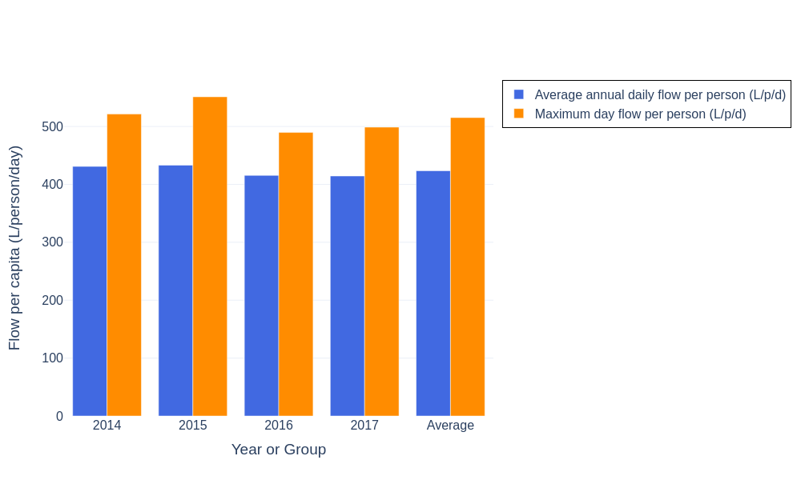
Figure 4 – Annual average and maximum day influent flow per capita.
The slight reduction in both average and maximum per capita flows in 2016 and 2017 could reflect incremental water efficiency improvements or small shifts in the serviced area. Overall, the per capita flow rates are typical for a combined domestic and minor commercial catchment.

4.5 Per capita loads
Per capita loads were derived by dividing calculated loads by the serviced population for each year. Average-day loads per capita are approximately 80–86 g BOD/person/day, 88.8–94.6 g TSS/person/day and 2.65–2.85 g total phosphorus/person/day, with historical means of 82.8 g BOD/person/day, 92.9 g TSS/person/day and 2.7 g total phosphorus/person/day.
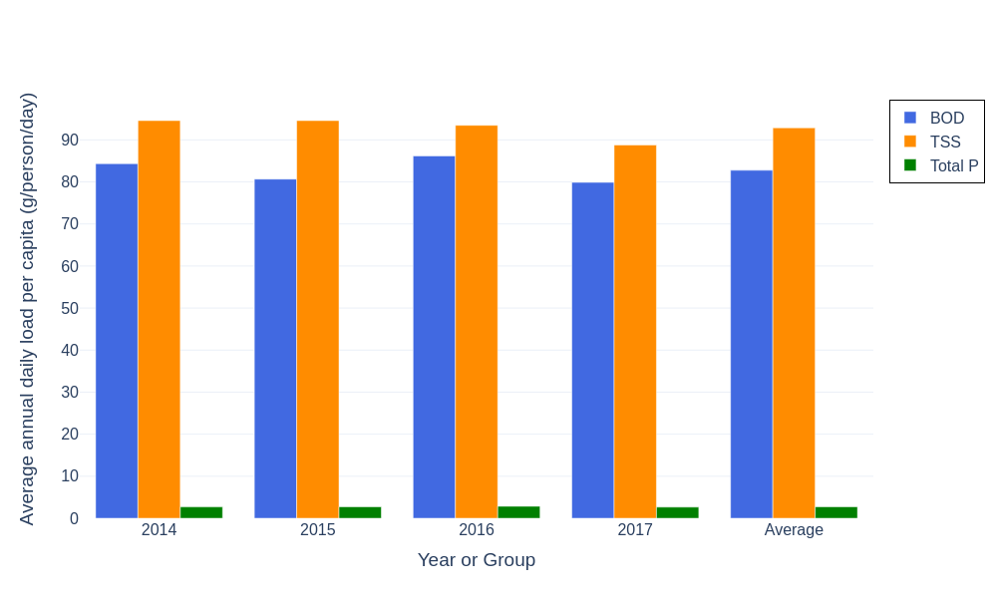
Figure 5 – Average annual daily influent loads per capita for BOD, TSS and total phosphorus.
Maximum month (30-day) per capita loads are around 95.8–97.5 g BOD/person/day, 109–136 g TSS/person/day and 3.2–3.9 g total phosphorus/person/day, with historical means of 96.9 g BOD/person/day, 120 g TSS/person/day and 3.5 g total phosphorus/person/day.
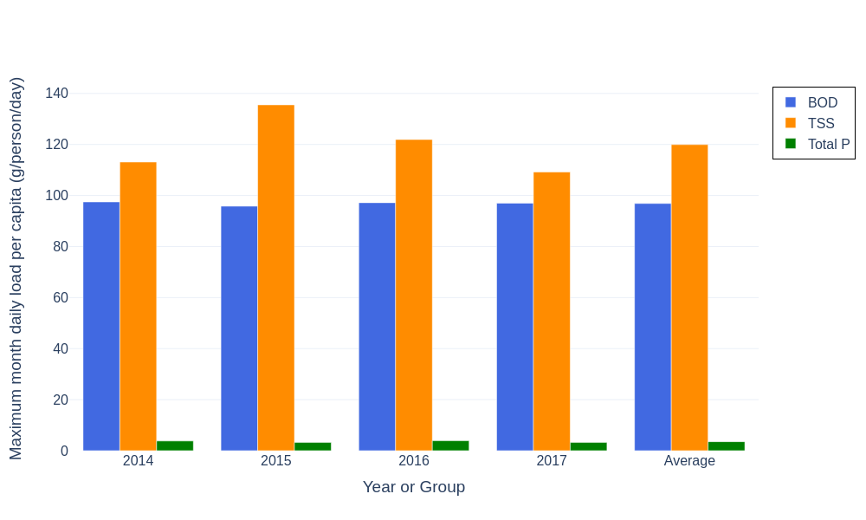
Figure 6 – Maximum month (30-day moving average) influent loads per capita.
These per capita values are consistent with typical domestic wastewater design ranges and indicate no extreme industrial contributions. The pronounced 2015 TSS maximum month peak at around 136 g/person/day suggests a temporary high-solids period that should be considered when evaluating clarifier and sludge system robustness.

4.6 Historical-average per capita parameters
Historical-average per capita flow and load parameters, averaged over the 2014–2017 period, are summarised in Table 1. These values form the basis for subsequent projections of flows and loads.
Table 1 – Historical-average per capita flow and load parameters.
Parameter | Value | Units
Average annual daily flow per capita | 423.5 | L/person/day
Maximum day flow per capita | 515.3 | L/person/day
Average day BOD load per capita | 82.8 | g/person/day
Average day TSS load per capita | 92.9 | g/person/day
Average day Total P load per capita | 2.7 | g/person/day
Maximum month BOD load per capita (30-day avg) | 96.9 | g/person/day
Maximum month TSS load per capita (30-day avg) | 119.9 | g/person/day
Maximum month Total P load per capita (30-day avg) | 3.5 | g/person/day

4.7 Population growth and projection
The serviced population increased modestly from 66,880 in 2014 to 69,300 in 2017. A compound annual growth rate (CAGR) of approximately 1.19% per year was calculated from this period and used to project population to 2037. Under this assumption the serviced population is forecast to reach about 80,800 by 2030 and 87,800 by 2037, representing an increase of roughly 27% relative to 2017.
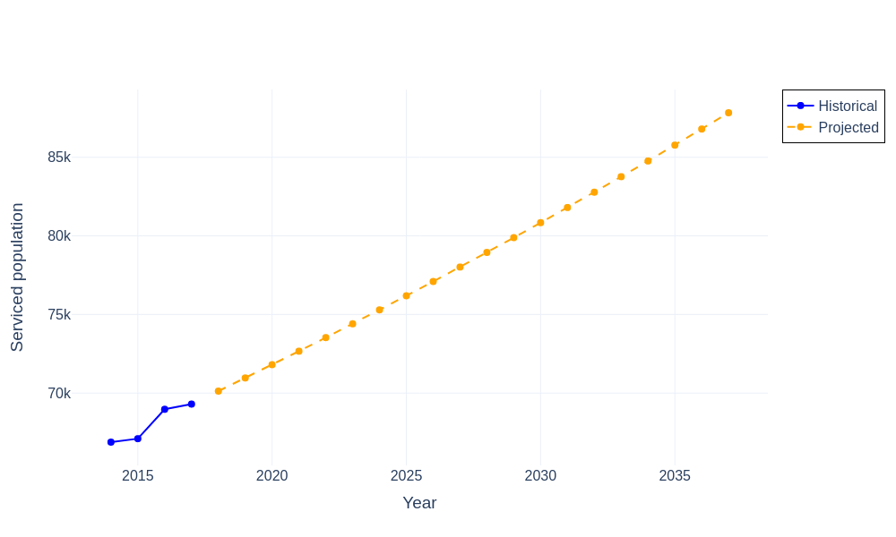
Figure 7 – Historical and projected serviced population over a 20-year horizon.
The CAGR-based projection provides a smooth and defensible planning curve in the absence of specific information about step changes such as major developments or sewerage scheme extensions. Where such information exists, the projection should be refined accordingly.

4.8 Projected flows using historical per capita rates
Projected average-day and maximum-day flows were obtained by multiplying the projected population by the historical-average per capita flow rates from Table 1, namely 423.5 L/person/day for average-day flow and 515.3 L/person/day for maximum-day flow. These rates maintain the observed peaking factor of approximately 1.22.
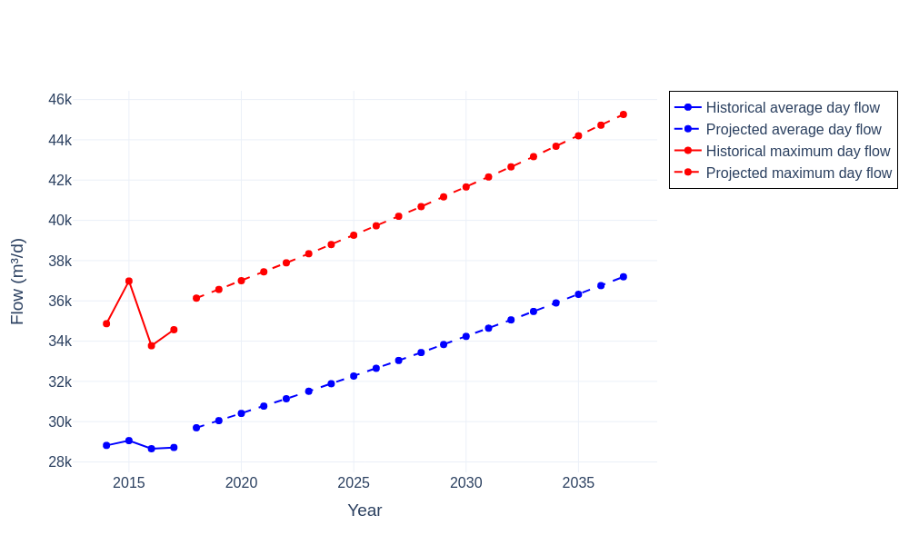
Figure 8 – Historical and projected average and maximum day influent flows.
Under the adopted growth scenario, average-day flow increases from about 29,000 m³/d in 2017 to approximately 37,200 m³/d by 2037, while maximum-day flow rises from roughly 35,000 m³/d to around 45,300 m³/d. These flows should be compared with the hydraulic capacity of inlet structures, channels and critical treatment units for the design horizon.

4.9 Projected average annual loads using per capita rates
Average annual BOD, TSS and total phosphorus loads were projected using constant historical per capita average-day loads of 82.8 g BOD/person/day, 92.9 g TSS/person/day and 2.7 g total phosphorus/person/day (Table 1), applied to the population forecast.
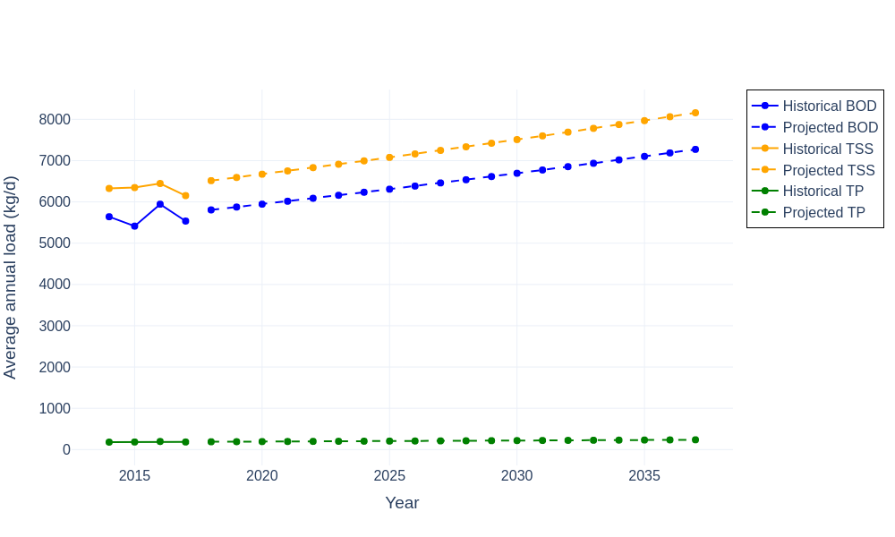
Figure 9 – Historical and projected average annual BOD, TSS and total phosphorus loads.
Under these assumptions, average BOD load increases from around 5,800 kg/d in 2018 to approximately 7,300 kg/d by 2037. TSS loads increase from about 6,500 to 8,200 kg/d and total phosphorus from about 189 to 237 kg/d over the same period. This equates to a 25–30% increase in organic and solids loading, with implications for aeration capacity, biological process sizing and sludge production.

4.10 Projected maximum month loads using per capita rates
Maximum month (30-day average) projected loads were derived by applying constant historical maximum-month per capita loads of 96.9 g BOD/person/day, 120 g TSS/person/day and 3.5 g total phosphorus/person/day (Table 1) to the population projection.
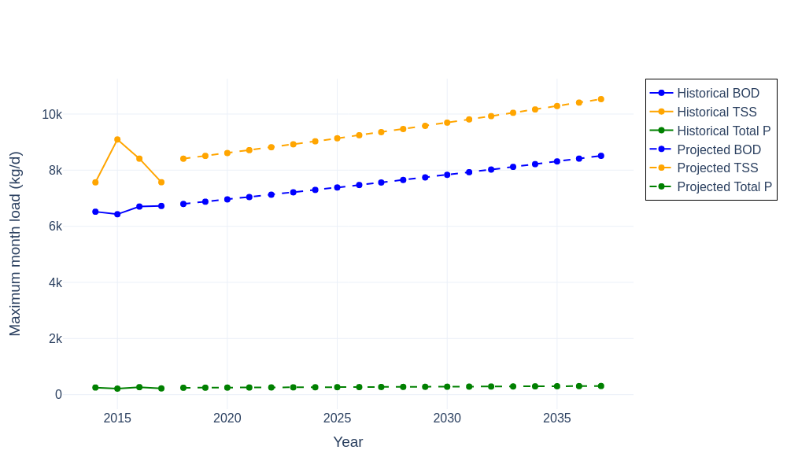
Figure 10 – Historical and projected maximum month (30-day average) BOD, TSS and total phosphorus loads.
By 2037 the projected maximum-month BOD load is approximately 8,500 kg/d, TSS about 10,500 kg/d and total phosphorus around 310 kg/d. These sustained peak loads are roughly 15–30% higher than projected average-day loads and are suitable for assessing biological process robustness, clarifier sizing and sludge handling infrastructure for extended wet weather or high-strength periods.

4.11 Design parameters at 20-year horizon (2037)
Design parameters at the end of the 20-year projection period (2037) were extracted from the projected series. These parameters represent the recommended basis for sizing new or upgraded treatment units, subject to local planning assumptions and risk appetite.
Table 2 – Design flows and loads at the 2037 planning horizon based on projected population and historical-average per capita rates.
Parameter | Value | Units
Average day flow | 37,200 | m³/d
Maximum day flow | 45,260 | m³/d
Average day BOD load | 7,270 | kg/d
Average day TSS load | 8,160 | kg/d
Average day Total P load | 240 | kg/d
Maximum month BOD load (30-day avg) | 8,510 | kg/d
Maximum month TSS load (30-day avg) | 10,530 | kg/d
Maximum month Total P load (30-day avg) | 310 | kg/d

5 Key Findings
Key findings from the historical analysis and 20-year projections can be summarised as follows.
- Historical influent flows and loads are stable over 2014–2017, indicating a mature and largely domestic catchment with limited industrial variability.
- Average annual daily influent flow is approximately 28,800 m³/d, with an average annual maximum day of 35,000 m³/d, giving a stable peaking factor of about 1.22.
- Average-day per capita flows and loads (about 423.5 L/person/day, 82.8 g BOD/person/day, 92.9 g TSS/person/day and 2.7 g total phosphorus/person/day) are consistent with standard municipal design values.
- Maximum month (30-day) loads increase per capita BOD, TSS and phosphorus by roughly 15–30% relative to average-day values, providing a suitable basis for design of sustained peak operating conditions.
- The serviced population is forecast to grow from 69,300 in 2017 to approximately 87,800 by 2037 under a 1.19% per annum compound growth rate.
- Applying constant historical-average per capita rates yields 2037 design values of 37,200 m³/d average-day flow, 45,260 m³/d maximum-day flow, average-day loads of about 7,270 kg/d BOD, 8,160 kg/d TSS and 240 kg/d total phosphorus, and maximum-month loads of approximately 8,510 kg/d BOD, 10,530 kg/d TSS and 310 kg/d total phosphorus.

6 Recommendations
Based on the observed influent behaviour, per capita characteristics and projected growth, the following recommendations are made for process engineering and further investigation.
- Use the 2037 design parameters in Table 2 as the primary basis for assessing hydraulic and treatment capacity of inlet works, biological reactors, clarifiers and sludge handling systems.
- Confirm that inlet structures and primary treatment units can reliably pass at least 45,300 m³/d for maximum-day conditions without excessive headloss or bypass.
- Evaluate biological treatment and aeration capacity against projected maximum-month BOD loads of approximately 8,500 kg/d, allowing appropriate safety factors.
- Check clarifier and sludge handling performance under maximum-month TSS loads of around 10,500 kg/d, particularly given the historically high 2015 solids peak.
Additional analyses and investigations would improve confidence in the projections and design parameters.
- Extend the influent monitoring period to include more recent years to confirm that per capita flows and loads remain stable, and to capture any recent water efficiency, industrial or catchment changes.
- Undertake seasonal and event-based analyses (e.g. wet- versus dry-weather periods) to better characterise infiltration/inflow and storm impacts on flow and solids loading.
- Review local planning information to refine the population projection, including any known major developments, sewerage extensions or industrial changes that could significantly alter flows or loads.
- Analyse nitrogen species in more detail (TKN, ammonia, nitrate and nitrite) to support biological nutrient removal design and to confirm consistency between organic and nutrient load trends.
- Consider sensitivity testing of per capita rates (for example, ±10–20%) and alternative growth rates to explore their effect on 20-year design parameters and to inform risk-based sizing.

